


Addressing corporate misuse of the Fair Entitlements Guarantee
  - Discussion paper

With the exception of the Commonwealth Coat of Arms, the Department’s logo, any material protected by a trade mark and where otherwise noted all material presented in this document is provided under a Creative Commons Attribution 4.0 International (https://creativecommons.org/licenses/by/4.0/) licence.
The details of the relevant licence conditions are available on the Creative Commons website (accessible using the links provided) as is the full legal code for the CC BY 4.0 International (https://creativecommons.org/licenses/by/4.0/legalcode)
The document must be attributed as the Addressing Corporate Misuse of the Fair Entitlements Guarantee Discussion Paper 2025.
Contents
Introduction 4
The Fair Entitlements Guarantee and the FEG Recovery Program 4
Fair Entitlements Guarantee 4
FEG Recovery Program 5
Misuse of FEG 7
Reform options 8
Addressing the use of corporate group structures to avoid or minimise payment of employee entitlements 8
Refine the existing contribution order regime 11
Other potential reform options 12
Other reforms to better protect employee entitlements in insolvency 14
Sections 596AC and 596ACA of the Corporations Act 14
Creditor-defeating dispositions 15
Adding ‘superannuation guarantee charge’ to the list of employee entitlements at section 596AA of the Corporations Act 16
Access to information held by controllers 16
Director accountability 18
Director disqualification 18
Director personal liability for employee entitlements in insolvency 18

Introduction
Through the Fair Entitlements Guarantee (FEG) program, the Australian Government advances certain unpaid employee entitlements to eligible employees who have lost their jobs due to the insolvency of their employer, where entitlements cannot be paid from another source. FEG fulfils a significant community need to protect employees who would otherwise stand to lose their employee entitlements due to the insolvency of their employer.
FEG is intended to operate as a scheme of last resort that guarantees certain employee entitlements in the event of business failure, where no alternative avenue exists to fund these entitlements. FEG is not intended to be available to relieve employers of their obligation to pay employee entitlements or to supplement business restructuring. Deliberate structuring to access FEG and shift the cost of employee entitlements from businesses onto the taxpayer puts pressure on the sustainability of FEG and confers an unfair competitive advantage on businesses which avoid their obligations to pay their employees.
Based on analysis of liquidations where FEG advances were paid in 2023-24, the Department of Employment and Workplace Relations (DEWR) estimates that the utilisation of corporate group structures that separated employee entitlement liabilities from assets and suspected employee entitlement defeating transactions/agreements were present in insolvencies that involved around $90 million of FEG advances. This accounted for 43% of total FEG advances paid in 2023-24.
To address these issues and safeguard the sustainability of FEG, DEWR is consulting on options for targeted law reform. This is also an opportunity to consider how the amendments introduced through the Corporations Amendment (Strengthening Protections for Employee Entitlements) Act 2019 are operating. As outlined in the paper below, consideration of any reforms needs to be carefully calibrated to avoid undue impacts on legitimate commercial behaviour, while strengthening the integrity of FEG.

The Fair Entitlements Guarantee and the FEG Recovery Program

Fair Entitlements Guarantee
FEG is established under the Fair Entitlements Guarantee Act 2012 (FEG Act), which commenced on 5 December 2012.
The key principle underpinning FEG (and its predecessor administrative schemes) is that employers should be responsible for meeting employee entitlements. Accordingly, FEG is designed to operate as a scheme of last resort, where no alternative avenue exists for eligible employees to be paid their employee entitlements due to the insolvency of their employer.
A FEG advance is available for the following employee entitlements, all of which are subject to a maximum weekly wage cap ($2,793 per week for 2024-25):
- unpaid wages (up to 13 weeks)
- annual leave
- long service leave
- payment in lieu of notice (up to five weeks), and
- redundancy pay (up to four weeks per full year of service).
FEG does not cover unpaid superannuation guarantee amounts required to be paid by employers.
FEG expenditure is forecast to exceed $250 million annually until at least 2027-28.
Figure 1: Actual and forecast FEG expenditure from 2012-13 to 2027-28
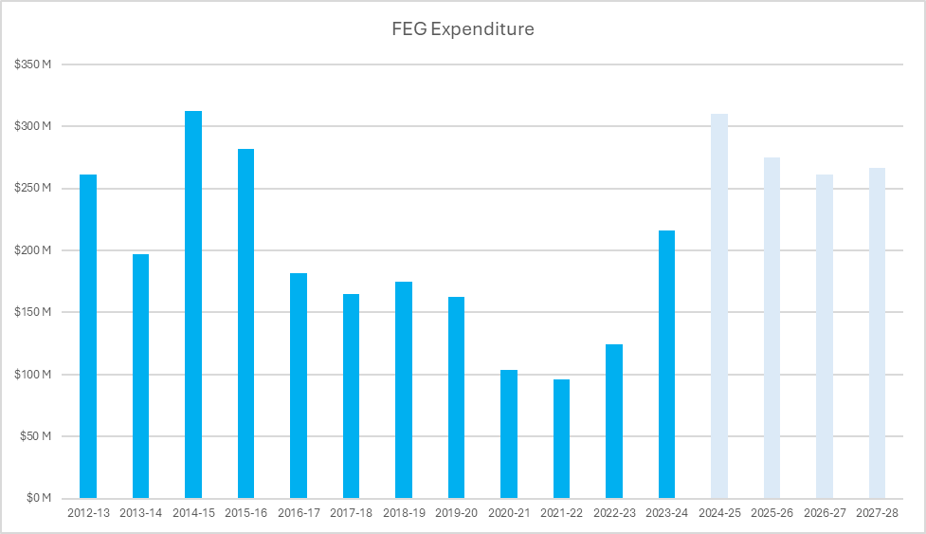
Source: DEWR program data, Employment and Workplace Relations 2024–25 Portfolio Budget Statements

FEG Recovery Program
Once a FEG advance is made to a former employee, the Commonwealth “steps into the shoes” of the former employee as a subrogated creditor and is entitled to seek recovery as a priority unsecured creditor in the liquidation process under the Corporations Act 2001 (Corporations Act).
The FEG Recovery Program (Recovery Program), which has been in operation since 2015, undertakes the following activities in order to improve the recovery of amounts advanced under FEG (and unpaid superannuation guarantee charge (SGC) amounts):
- funding liquidators’ recovery efforts, including legal proceedings, to recover assets which liquidators would not otherwise have resources to pursue, and
- minimising or preventing FEG claims from arising where existing company assets or other sources of funds are available to meet employee entitlements, increasing returns to the Commonwealth and positively influencing outcomes in liquidations through early intervention and active monitoring of insolvencies.
Since the commencement of the Recovery Program in 2015, $470.8 million of FEG advances have been recovered by the Australian Government, with the Recovery Program directly responsible for recovery of $283.5 million. Over its lifespan (to 30 September 2024), the Recovery Program has also recovered $27.6 million in non-FEG priority employee entitlements and $29.6 million of SGC amounts.
Figure 2: FEG/GEERS actual expenditure and recoveries from 2013 to 2024
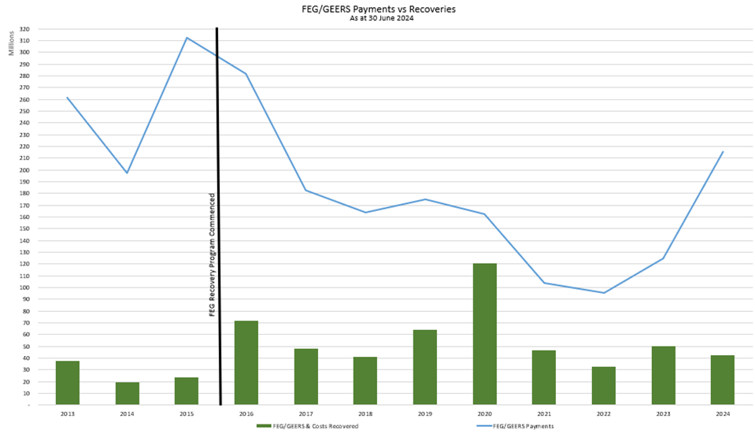
Source: DEWR program data
The activities of the Recovery Program strengthen the integrity of FEG as a scheme of last resort and are a vital safeguard against misuse. A range of legal tools are utilised to achieve recoveries that increase the asset pool available to priority unsecured creditors, including those introduced by the Corporations Amendment (Strengthening Protections for Employee Entitlements) Act 2019. Notwithstanding positive outcomes achieved by the Recovery Program, there appear to be material shortcomings in the legal framework which do not curb misuse of FEG as intended.

Misuse of FEG
Sharp corporate practices are practices that can be adopted by company officers, owners, advisors or others involved in corporate restructures and insolvencies, that seek to prevent, avoid or reduce the company’s liabilities (including in respect of employee entitlements).
Some broad examples of these practices include:
- use of corporate group structures to separate a business’ assets from its employee entitlement liabilities, so that in the event the business encounters financial difficulties, the entity liable for the employee entitlements is liquidated with minimal or no assets. The business’ assets are protected in a separate entity, enabling the business to continue trading, while the employees go unpaid
- illegal phoenix activities and arrangements, including transferring a company’s business and assets at an undervalue to another company controlled by the same owners/beneficiaries, before placing the first company into liquidation to avoid debts including employee entitlements
- deliberate practices by directors, officers, and advisors to unfairly manage an insolvency to the detriment of creditors (for example, by appointing a ‘friendly’ liquidator who does not properly investigate fraudulent transactions in the liquidation process)
- inappropriate use of restructuring processes such as deeds of company arrangement (DOCAs) to avoid liability for employee entitlements while preserving assets and fresh contributions for the ongoing business, and
- controllers appointed by secured creditors who do not comply with their duty to pay employee entitlements out of the proceeds of circulating assets of the business (such as trade debtors) but instead pay those amounts to their appointing creditor.
The use of such sharp corporate practices imposes an unfair burden on the taxpayer through increased FEG expenditure to advance employee entitlements in windings up. It also disadvantages other parties including employees (in respect of their superannuation entitlements and other entitlements not covered by FEG), unpaid suppliers of goods and services, competitors who meet employee entitlements and the community more broadly through foregone taxation revenue.
Misuse of FEG that arises through illegal phoenix activity frequently impacts unsecured creditors generally, including priority unsecured creditors. The ATO estimates that the economic cost of illegal phoenix activity $4.89 billion annually.
Potential misuses of FEG are commonly identified in large FEG cases (insolvencies where total advances paid to former employees exceed $100,000). Of 311 large FEG cases paid in 2023-24, 171 (55%) were identified as potentially involving avoidance of employee entitlements, either by pre-insolvency transactions or agreements, or by corporate structuring to separate employees from assets. Potential illegal phoenix activity has already been identified and is under investigation in 12 of these cases.

Reform options
Potential reforms set out in this paper would aim to address misuse of FEG by:
- deterring improper reliance on FEG, and
- increasing the recovery of amounts advanced under FEG.
Any reforms would need to be carefully designed to avoid unreasonably impacting legitimate commercial behaviour and restructuring efforts.

Addressing the use of corporate group structures to avoid or minimise payment of employee entitlements
It is common practice for businesses to operate using a group structure of several companies, with a parent company controlling the group, and each company in the group being a separate legal entity with limited liability. Such groups are often referred to as ‘corporate groups’.
Many medium to large enterprises operate through corporate group structures, with these groups contributing significantly to economic activity in Australia. Corporate groups are used as a vehicle to conduct enterprises for a range of reasons, including managing exposure to commercial risk, attracting investment and legitimately managing tax obligations.
Existing provisions in the Corporations Act aim to strike a balance between facilitating legitimate commercial activity and constraining the use of corporate group structures to inappropriately shift risk onto creditors.
DEWR estimates that approximately 71% of large FEG cases in 2023-24 were identified as having relationships with other companies – either through shareholdings or common directors.
Of these, 31% were identified as operating through a corporate group structure, where relevant assets were held, or trading was conducted, by another company in the group. The total advances paid to employees in these insolvencies was $51.2 million, just under a quarter of total FEG advances paid in 2023-24. The average estimated unpaid SGC in these insolvencies was just over $253,413 (relative to average FEG advances of $720,920 per case).
The Corporations Amendment (Strengthening Protections for Employee Entitlements) Act 2019 introduced reforms to the Corporations Act to address the challenges presented to FEG by the abuse of corporate group structures. The new provisions in Part 5.7B of the Corporations Act only allow contributions to be sought from certain entities in a corporate group, or entities with a closely connected economic relationship, for the payment of outstanding employee entitlements of an insolvent company, in limited circumstances. These employee entitlements contribution orders (contribution orders) aim to address circumstances where an insolvent company owes unpaid employee entitlements, and there are funds held by other entities within the larger corporate group, or in a closely connected economic relationship with the insolvent company, that have unfairly benefited from the work of those employees.
To date, no contribution orders have been made by a court, and DEWR is not aware of any applications for a contribution order having been made by a party with standing. DEWR is not aware of evidence indicating that the availability of contribution orders has led to noticeable behavioural change in the utilisation of corporate groups. DEWR, in the course of administering the Recovery Program, has identified a range of barriers to the effectiveness of the contribution order regime that may account for its limited take-up.
Case study
In a corporate group of five companies, all employees were employed by one company (Employing Company), which did not hold any assets or conduct any income-generating activity. The group operated three separate businesses, each of which was conducted by a separate trading company in the group: Companies A, B and C. The group’s principal assets were its intellectual property and plant and equipment, which was owned by Company A; a trailing commission book, which was owned by Company B and the work in progress, some of which was owned by Company A and the rest by Company C.
Some of the employees worked exclusively for one business. Other employees carried out work at different times for each of the businesses and some employees carried out work for the benefit of the group as a whole. The wages of the employees were paid from amounts paid to Employing Company by the various trading companies from time to time, depending on which trading company had funds available when payroll was due. Those amounts were recorded as intercompany loans to Employing Company in the group’s books.
All companies in the group were placed into liquidation at the same time.
A party with standing to bring an application for a contribution order needs to quantify the benefit to each of the non-employing entities. This gives rise to considerable complexity:
- Where employees worked for the benefit of more than one entity in the group, it may be difficult to determine which entities in the group received benefit. Even if employees did document the work they performed, it would be laborious to review those records and determine which work was performed for each entity.
- It is not clear how to calculate the quantum of the benefit received from the work of employees, particularly where the work performed by employees was not directly connected with the generation of income or assets (for example employees providing payroll and HR services).
Calculating the extent to which the benefit received by the non-employing entity exceeds the benefit that would be reasonable in the circumstances if the employing entity and the non-employing entity were dealing at arm's length presents further difficulties:
- a party with standing will not readily have access to evidence about what benefit would be reasonable in the circumstances if the employing entity and the non-employing entity were dealing at arm's length, and
- it is not clear how any amounts loaned by the non-employing entity to the employing entity should be treated.
Where a contribution order is made after the non-employing entities are in liquidation, it is also unclear whether the pre-appointment assets of the non-employing entity can be used to pay the contribution order.
The paper sets out potential options to address the abuse of corporate group structures, including potential reforms to the existing contribution order regime.

Refine the existing contribution order regime
One option to reduce the vulnerability of FEG to corporate group structures would be targeted refinements to address limitations of the existing contribution order regime, with a particular focus on the following elements:
- The requirement to prove that the contributing entity benefited from the work done by employees of the insolvent entity (section 588ZA(1)(d)).
- The requirement to prove that the benefit that the contributing entity has received exceeds the benefit that would be reasonable in the circumstances if the insolvent company and the contributing entity were dealing at arm’s length (section 588ZA(1)(e)).
- The requirement that it is just and equitable to make the order in the particular case (section 588ZA(1)(f)).
Options for reform could include:
- Varying the evidentiary requirements to provide for rebuttable presumption that the matters at subsections 588ZA(1)(d) and (e) are deemed to be satisfied, unless proven otherwise.
- Varying the requirement that a court must be satisfied that it is just and equitable to make a contribution order (section 588ZA(1)(f)).
- Simplifying the provisions so that they are more closely aligned with the New Zealand provisions at sections 271(1)(a) and 272 of the Companies Act 1993 (NZ). These provisions allow the court to order that a company that is, or has been, related to the company in liquidation, pay the liquidator the whole or part of any or all of the claims in the liquidation, if the court is satisfied that it is just and equitable to do so. In determining this, the court must have regard to a range of matters, including the extent to which the related company took part in the management of the company in liquidation and the conduct of the related company towards the creditors of the company in liquidation.
- Clarifying that an entity subject to external administration can be a contributing entity.
- Clarifying that a court can make an order under section 588ZA(5) that has the effect that for the purposes of an amount required to be paid under a contribution order, the amount is treated as though it is an employee entitlement owed by the contributing entity (including that it is a debt referred to in section 561 of Corporations Act in the event the contributing entity is wound up).

Other potential reform options

Joint and several liability across corporate groups
Certain state and territory laws impose joint and several liability across a corporate group for tax liabilities (for example, the Payroll Tax Act 2007 (Vic) and the Workplace Injury Rehabilitation and Compensation Act 2013 (Vic)). These laws provide for a number of pathways through which employers can be deemed to be a group, including:
- an employing entity being a related body corporate of another entity under the Corporations Act
- groups arising from the use of common employees
- where two or more persons have a controlling interest in each of two businesses.
Some of these laws confer a discretionary power on the relevant government agency to exclude a member of a group from that group, provided certain requirements are met.
One option would be to adapt this model to the circumstances of employee entitlements in insolvency. This model could be structured so that other group entities would be jointly and severally liable for employee entitlements upon the employing entity being placed into liquidation. There are a range of options for how a group could be defined under this model.

Requirement that deeds of company arrangement provide for employee entitlements of related entities in liquidation
The Corporations Act currently requires a DOCA to provide priority unsecured creditors the same priority they would have had if their employer was in liquidation.
The Recovery Program has identified several instances where an employing entity within a corporate group is placed into liquidation while asset-holding entities are restructured through a DOCA and continue to trade. The outcome is that employee entitlements are borne by the taxpayer through FEG while the shareholders and creditors of the DOCA entities benefit through not having to meet employee entitlements.
Case study
A corporate group was made up of eight companies – a company that held the contracts with all the employees (Employing Company) and seven trading companies. Employing Company did not generate revenue, conduct business activities or hold any assets and was reliant on the trading companies to fund its operating expenses.
All eight companies were placed into voluntary administration. A DOCA was adopted in respect of the seven trading companies. Employing Company was excluded from the proposed DOCA and instead placed into liquidation. All assets of value (such as book debts, plant and equipment, as well as the contribution made to the DOCA fund by the DOCA proponent) were held by the trading companies and flowed to the benefit of the creditors of the trading companies through the DOCA. Employing Company had no assets of its own to meet outstanding employee entitlements and there was little prospect of any return for its priority unsecured creditors in the liquidation.
Certain outstanding employee entitlements were met by the Commonwealth through the payment of FEG advances. Other outstanding entitlements (superannuation and the entitlements of employees who were ineligible for FEG) went unpaid. Meanwhile, the estimated return to creditors of the trading companies through the DOCA was inflated through the avoidance of employee entitlements.
At a meeting of creditors, the DOCA proponent stated that it proposed to structure the DOCA and liquidation in this way, because the Commonwealth would meet the outstanding employee entitlements and Employing Company therefore did not need to be included in the DOCA.
To remedy this, another reform option would be the introduction of a requirement that any DOCA provides for the employee entitlements of the corporate group as a whole, even if the employer is a related entity in liquidation.

QUESTIONS
- Are reforms to the existing contribution order regime desirable? If so, what changes should be made including views on the suggested options mentioned in Part 5 of this paper?
- Should other potential reform options be considered further? What are the benefits and drawbacks of these options?

Other reforms to better protect employee entitlements in insolvency

Sections 596AC and 596ACA of the Corporations Act
Part 5.8A of the Corporations Act provides for:
- A civil penalty provision with an objective ‘reasonable person’ test that applies to transactions that avoid, prevent or significantly reduce the recovery of employee entitlements.
- A mechanism to compensate those who have suffered loss or damage as a result of contraventions of the civil penalty provision.
The objective of these provisions is to deter and penalise parties entering into or facilitating agreements that prevent or avoid the recovery of, or significantly reduce the amount of employee entitlements that can be recovered in insolvency.
The civil penalty provision at section 596AC (and related compensation provision at section 596ACA) have not yet been considered by a court.
In 2023-24, a potential employee entitlement defeating transaction/agreement was identified in 39% of large FEG cases. The total advances paid in these cases was $52.7 million, just under a quarter of total advances paid in 2023-24. The average estimated unpaid SGC in these cases was $258,982 (relative to average FEG advances of $431,980 per case).
One reform option would be to introduce a rebuttable presumption that the fault elements at sections 596AC(1)(b) and (3)(c) are satisfied unless proven otherwise.
The existing provisions provide standing for various parties to bring proceedings for compensation for the loss or damage suffered by employees because of breaches of the civil penalty provision. One reform option that could be considered would be to provide that amounts recovered as compensation are treated as a debt due to the employee, including where recovery proceedings have been brought by the company’s liquidator or other parties with standing to bring proceedings.

QUESTIONS
- Are the fault elements at section 596AC fit-for-purpose or should a rebuttable presumption that the fault elements have been met be adopted?
- Are the compensation provisions adequate to ensure that employees are appropriately compensated for loss or damage suffered?
- Are any other changes to Part 5.8A desirable?

Creditor-defeating dispositions
As noted above, some instances of misuse of FEG will involve illegal phoenix activity.
Section 588FDB of the Corporations Act defines a creditor-defeating disposition as a transaction that prevents, hinders, or significantly delays property from becoming available for the benefit of creditors in the winding up, where the disposition of company property is for an amount less than the lesser of its market value or the best price reasonably obtainable in the circumstances.
Liquidators may set aside voidable creditor-defeating dispositions by applying to court (section 588FF) or requesting ASIC (section 588FGAA) to make an order to undo the disposition.
The disposition of property is deemed voidable under section 588FE(6B) if:
- it occurred during the 12 months ending on the relation-back day (depending on the manner in which the company commenced winding up), and
- the company was insolvent, or the company became insolvent as a result of the disposition.
Options for reform to the creditor-defeating disposition provision could include:
- extending the period set out in section 588FE(6B) from 12 months to 24 months from the relation-back day
- varying the definition of creditor-defeating disposition to mean dispositions of company property for less than market value (if the property has market value), or otherwise the best price reasonably obtainable in the circumstances.

QUESTION
- Are reforms to the creditor-defeating disposition provisions desirable, including the options described above?

Adding ‘superannuation guarantee charge’ to the list of employee entitlements at section 596AA of the Corporations Act
Section 596AA of the Corporations Act sets out the entitlements of employees that are protected under Part 5.8A of the Corporations Act (as well as those that can be the subject of contribution orders under section 588ZA). This list of entitlements includes ‘superannuation contributions’ but does not include SGC amounts. It may be desirable to include SGC liabilities within the meaning of employee entitlements at section 596AA of the Corporations Act, which would realign this provision with those entitlements that are afforded priority under section 556(1) of the Corporations Act. This would mean SGC is included in Part 5.8A and the contribution order provisions.

QUESTION
- Should the definition of employee entitlements at section 596AA be amended to include SGC? If not, why not?

Access to information held by controllers
A secured creditor can enforce a security interest by appointing a ‘controller’ (such as a receiver or mortgagee in possession) to take control and sell secured assets of a company. Under the Corporations Act, if there are insufficient funds to pay priority unsecured creditors in full, that controller is obliged to pay the proceeds of circulating assets to priority unsecured creditors, ahead of amounts owed to secured creditors (sections 433 and 561). In addition, controllers are obliged to take reasonable care to sell secured assets for not less than market value or, if there is no market value, the best price reasonably obtainable (section 420A).
However, priority unsecured creditors are not currently entitled to obtain information from a controller. This impedes their ability to monitor controllers’ compliance with their legal obligations. By contrast, creditors are currently entitled to obtain information from an ‘external administrator’ (within the meaning of the Insolvency Practice Schedule (Corporations)).
In 2023-24, 9% of large FEG cases involved a receivership or the appointment of a controller. The average total FEG advances in such cases was $852,031, along with average estimated unpaid SGC of $459,816.
Case study
A company was involved in leasing equipment to various customers. The company was financed by lenders who held a security interest over the equipment. The lenders appointed receivers to the company and shortly thereafter, liquidators were appointed. DEWR paid FEG advances to eligible employees for outstanding entitlements. The receivers traded the business for approximately 12 months, collecting rental revenue and selling items of equipment when their leases expired, which generated substantial trading revenue. The receivers were obliged to use the proceeds of circulating assets to pay certain employee entitlements (including to DEWR as a subrogated creditor) under sections 433 and/or 561 of the Corporations Act.
In order to ensure the receivers had complied with this obligation, DEWR sought information from the receivers about the assets realised, whether those assets were circulating assets, the receivers’ costs and the allocation of those costs between the circulating and non-circulating asset funds.
The receivers did not provide this information to DEWR. The only options available to DEWR or interested employees to compel the receivers to provide the information were to seek eligible applicant status to conduct public examinations of the receivers or seek court orders for preliminary discovery.
Reforms could provide priority unsecured creditors with a right to obtain information from a controller in order to promote transparency and foster compliance. This could be modelled on the existing right of creditors to obtain information from external administrators contained in the Insolvency Practice Schedule (Corporations) and Insolvency Practice Rules (Corporations) 2016, with adaptations as appropriate.

QUESTIONS
- Should priority unsecured creditors have the right to request information from controllers? Should there be any exceptions? If so, what should they be?
- Who should bear the cost of complying with a request for information?

Director accountability

Director disqualification
Sections 206EAB and 206GAA of the Corporations Act permit the disqualification of company directors and other officers with a track record of involvement in corporate contraventions and insolvencies where FEG has been inappropriately relied on.
These provisions have not been utilised to date, either through application by ASIC to the court (section 206EAB) or by ASIC exercising its power of disqualification (section 206GAA). This may be attributable to the fact that conduct that would be captured by these provisions would also enliven ASIC’s power of disqualification under section 206F or the court’s power of disqualification at section 206D.
One option for reform would be to bolster the existing provisions (sections 206EAB and 206GAA) for example, by removing the existing requirement that the company or the person contravened the Corporations Act or the Corporations (Aboriginal and Torres Strait Islander) Act 2006 while the person was an officer of the company (sections 206EAB(2)(d) and 206GAA(2)(d)). This would have the effect of permitting the court or ASIC to disqualify a person if, within the last seven years, in relation to two or more companies:
- the individual has been an officer of a company whose employees were paid a FEG advance
- on each occasion:
  - the Commonwealth has received a minimal or no return on a FEG advance (whether or not the corporation is still being wound up or has been wound up); and
  - the court is satisfied or ASIC has reason to believe that the Commonwealth is unlikely to receive more than a minimal return on the advance.
- the disqualification is justified.

QUESTION
- Should the director disqualification provisions at sections 206EAB and 206GAA of the Corporations Act be refined? If so, how?

Director personal liability for employee entitlements in insolvency
Under current settings, directors can be personally liable for unpaid employee entitlements through a range of mechanisms. It is unclear whether these settings provide an adequate incentive for employers to ensure they meet their employee entitlement obligations when company insolvency is imminent.
Under the Fair Work Act 2009, directors can be liable as accessories for contraventions of civil remedy provisions where they are ‘involved’ in the contravention within the meaning of section 550 of that Act. The court can order an involved person to pay compensation for the loss that a person has suffered because of the contravention.
Under the Corporations Act, section 596AC(3) operates to bring company officers within the operation of the civil penalty provision at section 596AC. Where a person has contravened the civil penalty provision, section 596ACA then enables a court to make an award of compensation for loss or damage suffered by employees.
While not extending to the employee entitlements that are covered by FEG, the director penalty regime in Schedule 1 to the Taxation Administration Act 1953 (TAA) makes directors of companies that fail to comply with their obligation to pay SGC amounts owing to the ATO personally liable for the amount that the company should have paid. Where a company reports SGC liabilities by the due date for the SGC statement (generally, one month and 28 days after the end of the quarter to which the liability to SGC relates), the penalty can be remitted by ensuring the company does one of the following within 21 days from when the Commissioner of Taxation sends/posts the director penalty notice:
- pays the debt
- appoints an administrator under section 436A, 436B or 436C of the Corporations Act
- appoints a small business restructuring practitioner under section 453B of the Corporations Act
- begins to wind the company up (within the meaning of the Corporations Act).
Where the SGC liabilities are not reported by the due date for the SGC statement, the penalty can only be remitted by paying the debt.
A number of statutory defences are available to a director under section 269-35 of Schedule 1 to the TAA, including that:
- the director did not take part (and it would have been unreasonable to expect the director to take part) in the management of the company during the relevant period because of illness or other acceptable reason
- the company treated the Superannuation Guarantee (Administration) Act 1992 as applying in a way that could be reasonably argued, was in accordance with the law, and took reasonable care in applying that Act.

QUESTION
- Do existing arrangements that impose personal liability on directors provide adequate incentives for directors to ensure companies meet their employee entitlement obligations? If not, why not? Please note adjustments to the director penalty notice regime are outside of the scope of this consultation.

Within the meaning of section 596AC of the Corporations Act 2001.
The General Employee Entitlements and Redundancy Scheme (GEERS) was the administrative predecessor to FEG.
ATO (Australian Taxation Office) (2024), Illegal phoenix activity, ATO website, accessed 29 November 2024.
Figure subject to change as investigations into 2023-24 cases are ongoing.
See for example section 588V.
Total FEG advances paid in 2023-24 was $215.8 million.
Figure subject to change, in some insolvencies included in the data, the liquidator has yet to establish an estimate of the outstanding SGC debt. In addition, these figures do not include insolvencies where no FEG advance has been paid but there exists an SGC debt owed to the ATO.
Section 444DA of the Corporations Act.
Explanatory Memorandum, Corporations Amendment (Strengthening Protections for Employee Entitlements) Bill 2018.
Figure subject to change - in some insolvencies included in the data the liquidator has yet to establish an estimate of the outstanding SGC debt.
Section 588FDB of the Corporations Act currently defines creditor-defeating dispositions as dispositions of company property for the lesser of the market value of the property or the best price reasonably obtainable in the circumstances.
Circulating assets are those such as trading stock and debtors that a company is usually able to use, dispose, and deal with, in the ordinary course of business without the need to obtain the secured creditor’s consent.
See for example, Fair Work Ombudsman v Foot & Thai Massage Pty Ltd (in liq) (No 8) [2024] FCA 483 and Fair Work Ombudsman v Pure Telecom Pty Ltd [2024] FedCFamC2G 664.

