Recognition of Prior Learning (RPL)

Reporting RPL
This guide explains how to report RPL in TCSI.
Note: Providers are encouraged to report each competency as a Unit of Study (UoS) to ensure transparency.
How RPL needs to be reported depends on the circumstances in which RPL is granted. Please follow the reporting guidance for one of the three scenarios below as appropriate.
Scenario 1 - RPL is granted as part of the Unit of Study
Scenario 2 - RPL is granted (or not granted) following an RPL assessment with assessment fee charged
Scenario 3 - RPL is granted following an RPL assessment with no assessment fee charged
A visual guide to these scenarios is at Attachment A of this fact sheet.
Further information on the definition of RPL and its requirements is available in section 4.8.11 of the VET Student Loans Manual for Providers.

Scenario 1 - RPL is granted as part of the Unit of Study
It is intended that the student will enrol in a standard Unit of Study (or the majority of it) as negotiated with the provider. Only a small proportion of the Unit of Study will be recognised as RPL.
Please report the Unit enrolment packet (VET) | TCSI Support as a typical unit as follows:

Table 1: Scenario 1
TCSI | element | Guidance
E329 | Mode of attendance | Is a required field for reporting in scope unit enrolments. This data element is an assessment - only mode of study and does not usually require any attendance. If unsure which value to report, you may use 3 which will cover all possible scenarios (Multi-modal Mode of Attendance).
E354 | Unit of Study Code | Is the same for all students enrolled in the Unit of Study. This is irrespective of whether they access RPL for some, none or all of the Unit of Study.
E355 | Unit of Study Status Code | Indicates the outcome of the Unit of Study in accordance with data element specifications. Must be either 1, 2, 3, 4 or 6 as appropriate. Do not report 5 (RPL) as this code refers to cases where the student does not undertake a standard Unit of Study.
E339 | EFTSL | EFTSL is the same for all students. Report the EFTSL value for the Unit of Study.
E384 | Amount Charged | Is the tuition fee that the student was charged for the Unit of Study. This could be the published fee or a lower fee if some of the Unit of Study was RPL’ed.
E577 | RPL Code | Must be null (to be left blank/empty). This is irrespective of whether the student is receiving RPL for some, none, or all of the Unit of Study.
E489 | Unit of Study Census Date | Is reported in accordance with data element specifications.
E600 | Unit of Study Commencement Date | Is reported in accordance with data element specifications.
E601 | Unit of Study Outcome Date | Is reported in accordance with data element specifications.

Scenario 2 - RPL is granted (or not granted) following an RPL assessment with assessment fee charged
It is intended that the student will not study the Unit of Study (or the majority of it). The student will be charged an assessment fee and may or may not be undertaking some gap training. Most or all of the Unit of Study will be recognised as RPL.
Please report the Unit enrolment packet (VET) | TCSI Support with RPL details as follows:

Table 2: Scenario 2
TCSI | element | Guidance
E329 | Mode of attendance | Is a required field for reporting in scope unit enrolments. This data element is an assessment -only mode of study and does not usually require any attendance. If unsure which value to report, you may use 3 which will cover all possible scenarios (Multi-modal Mode of Attendance).
E354 | Unit of Study Code | Is reported, as per the provider’s preference, as either:  - the Unit of Study Code for which RPL is granted or  - a unique Unit of Study Code created for reporting RPL against a unit of study.
E355 | Unit of Study Status Code | Must be ‘5’ (RPL).
E339 | EFTSL | Must be 0.000000001.
E384 | Amount Charged | Is equal to the RPL assessment fee that the student was charged.
E577 | RPL Code | Must either be ‘1’ (RPL with no gap training) or ‘2’ (RPL with gap training). Where RPL is not granted following the assessment, use ‘1’.
E489 | Unit of Study Census Date | Is reported in accordance with data element specifications.
E600 | Unit of Study Commencement Date | Is the date that the RPL assessment starts. Must align with the ‘Activity Start Date’ reported to AVETMISS for assessment only clients.
E601 | Unit of Study Outcome Date | Must align with the ‘Activity End Date’ reported to AVETMISS for ‘assessment only clients’.

Scenario 3 - RPL is granted following an RPL assessment with no assessment fee charged
It is intended that the student will not study the Unit of Study (or the majority of it). The student is not charged an assessment fee and may or may not be undertaking some gap training. Most or all of the Unit of Study will be recognised as RPL.
The RPL does not need to be reported. If the Provider chooses to report the RPL (optional), please report the Course prior credit packet (VET) | TCSI Support as follows:

Table 3: Scenario 3
TCSI | element | Guidance
E560 | Credit Value Used | Is the EFTSL value of RPL used towards the requirements of the course.
E561 | Credit Basis Code | Must be either ‘0500’ (work experience) or ‘0600’ (other). The other credit codes relate to study undertaken at another institution which does not constitute RPL for the reporting of VSL.

Attachment A

Visual guide to RPL reporting in TCSI
Figure 1: Visual Guide to RPL reporting in TCSI

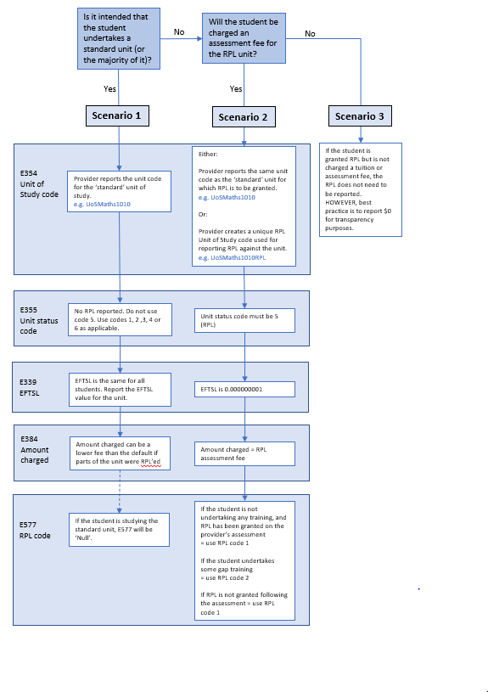

Australian Vocational Education and Training Management Information Statistical Standard

