

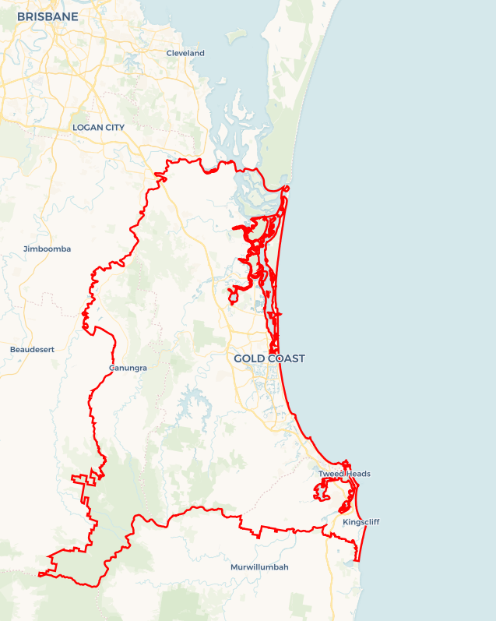Local Jobs Plan

Gold Coast Employment Region | QLD | ****July 2025****

Workforce Australia Local Jobs (Local Jobs) is a program that supports tailored approaches to accelerate   
reskilling, upskilling and employment pathways in response to current and emerging local workforce needs.

## Local Jobs elements

### Local Jobs Plan

The Local Jobs Plan sets out the skills and employment challenges and priorities of the region, and associated strategies that will drive the design and implementation of activities to be implemented to address these challenges.

### Job Coordinators

Job Coordinators and Support Officers support the delivery of the program by bringing together key stakeholders including businesses, employment services providers, higher education and training organisations.

### Local Jobs and Skills Taskforce

Each Employment Region has its own Taskforce. Representatives include local stakeholders who have demonstrated experience in upskilling, reskilling, and an ability to represent, connect and collaborate with others in the region to meet labour market needs.

### Program Funds

The Employment Region’s Local Initiatives Fund enables targeted local investments that support local labour market functioning. Further, from 2025/26, a central grants-based fund will respond to local needs and help progress broader employment service reform objectives.

Explore labour market insights for the   
[Gold Coast](https://www.jobsandskills.gov.au/work/employment-region-dashboards-and-profiles/monthly-labour-market-dashboards) Employment Region

## Local labour market challenges in the region

* High levels of unmet demand for entry-level workers in essential services areas such as aged and disability care and early education.
* High levels of unmet demand to fill entry-level vacancies in industries including, but not limited to, health, engineering, manufacturing and construction.
* Public transport remains a significant challenge for people without access to a reliable car or licence. Individuals may struggle to reach employment, education, or social opportunities due to inadequate or unavailable transport.
* Targeted solutions are required to support people experiencing challenges to enter the workforce, including First Nations people, young people, mature aged people, women, people with disability, culturally and linguistically diverse people and long-term unemployed.
* Businesses are finding it challenging to attract and recruit people. In addition to small to medium enterprises there are major projects and emerging opportunities that will require support to meet workforce requirements in the region. For example, the Gold Coast Fast Rail Project, Coomera Connect, Coomera Public Hospital and the Ormeau Rail Facility.
* Low unemployment rates have resulted in a limited supply of Workforce Australia participants. Participants are generally long-term unemployed and require preparatory or pre-employment programs to address language, literacy and numeracy deficiencies, confidence, motivation, resilience, physical and mental health and well-being.
* Limited housing supply and affordability is contributing to challenges people are facing to finding employment, particularly young people and people with limited or entry level skills and experience.

## Local jobs and skills priorities and strategies in the region

### Priority 1 – Meeting unmet demand for existing and emerging industries and projects

#### What are our challenges and opportunities?

The health care and social assistance industry is one of Australia’s largest and fastest growing industries, with vacancies across aged, disability and childcare sectors. Australia’s population is ageing, and employment demand is forecast to grow. The Gold Coast Employment Region is no exception to these trends, with health care and social assistance being the largest employer in the region. The Gold Coast continues to see increases in the emergence of blue-collar roles, particularly in manufacturing and construction. This includes all manufacturing sectors, for example, marine, textile, food and other products. Construction continues to be one of the largest employing industries in the Gold Coast, with labourers being in the top five occupations. This trend is expected to continue with upcoming projects such as the Gold Coast Fast Rail Project, Coomera Connect, Coomera Public Hospital and Ormeau Rail Facility.

#### How are we responding?

* We collaborate and co-design activities to attract people to in-demand industries and opportunities.
* We host events online and face to face for businesses to meet Employment Services Providers to educate career influencers about careers in the sector.
* We offer businesses support in hosting events for participants to meet employers and attend industry open day events.
* We support recruitment drives through a range of local networking campaigns.
* We collaborate with stakeholders to deliver local events, for example: Jobs Roadshows and Youth Festivals.
* We work with local business to develop workforce attraction, recruitment and retention strategies.

### Priority 2 – Strengthen collaboration with industry, Workforce Australia, and stakeholders to improve employment outcomes for vulnerable and underrepresented groups

#### What are our challenges and opportunities?

While the Gold Coast’s overall unemployment rate is below the national average, significant disparities remain for several cohorts. Young people in the region continue to experience higher unemployment rates than the Queensland average, often due to employment instability and limited entry-level opportunities. Mature-aged women face systemic challenges to re-entering or remaining in the workforce. Single-parent families encounter challenges in accessing flexible, family-friendly employment that accommodates caregiving responsibilities. First Nations peoples may face structural disadvantage, including lower levels of educational attainment, reduced access to training pathways, and fewer employment opportunities. Additionally, over 30% of Workforce Australia participants in the region identify as people with disability, many of whom are impacted by physical, mental health, or neurodivergent conditions that affect their employment prospects.

By promoting inclusive, dynamic workplaces and collaborating with employers, training providers, community organisations and the employment services system, co-designed, place-based projects will address challenges to participation and support inclusive hiring practices. Investment in accessible training, mentorship, flexible work options and culturally appropriate services will be critical to improving workforce participation among these cohorts.

#### How are we responding?

* We chair a Local Jobs and Skills Taskforce and co-chair a First Nations Steering Committee in the region to create, share and promote inclusive activities and opportunities.
* We encourage Employment Service Providers to develop and deliver activities which are inclusive and enhance diversity in the workplace.
* We encourage businesses and activity hosts to consider challenges people face when seeking employment opportunities such as transport, childcare, workplace confidence, skills and abilities.
* We host events for businesses to meet Workforce Australia Providers to educate career influencers about the variety of career opportunities and different types of workplaces.
* We offer businesses support in hosting collaborative events for participants to meet employers and attend industry open days and events.
* We support recruitment drives through a range of local networking campaigns.
* We work with businesses to inform, support and build knowledge and capacity in relation to funding opportunities in the region that support workforce development and retention.
* We work with businesses and employer groups to develop workforce attraction, recruitment and retention strategies, and proactively address strengthening workplace culture.
* We are committed to fostering employment pathways that lead to stable and sustainable working hours.
* We work alongside employers to implement tailored mentoring and/or workplace buddy systems to support new staff.

### Priority 3 – Preparatory programs for unemployed people

#### What are our challenges and opportunities?

There is an ongoing need to address long-term unemployment in the Gold Coast region by providing supports that foster confidence, build resilience, and address both mental and physical challenges to workforce participation. Feedback from Workforce Australia providers and community organisations indicates a growing number of individuals identify as neurodivergent are actively seeking tailored support to access employment and training opportunities. Additionally, limited public transport options and increasing housing affordability pressures present significant challenges, particularly for individuals facing socio-economic disadvantage, in accessing and sustaining meaningful employment in the region.

We will partner with Gold Coast communities and their representatives to deliver place-based initiatives that support participants in building skills for career planning and job readiness. We aim to equip individuals with the tools and confidence needed to navigate the labour market, make informed career choices, and transition into sustainable employment.

#### How are we responding?

* We work with local Workforce Australia Employment Services Providers to identify caseload trends and understand the challenges faced by participants, to enable a collaborative approach to solutions.
* We seek and promote solutions and opportunities for tailored preparatory activities to engage and prepare participants.
* We facilitate connections between business, providers and other organisations, to educate the businesses on the existing labour market and support recruitment activities to engage participants.
* We develop and promote tailored preparatory programs and training opportunities to provide participants with the skills they need to commence employment.
* We seek and promote solutions and opportunities for people experiencing housing insecurity/homelessness and transport challenges.
* We identify opportunities for the broader community to engage in skills development activities and events.
* We encourage place-based programs that foster support for long term unemployed people, to develop necessary skills to be ‘job ready’, including programs or activities that build basic skills, routine and consistency in the workplace.

## Want to know more?

* Contact: Jodi Brackenbury, Gold Coast Job Coordinator: [Jodi.Brackenbury@localjobsprogram.org.au](mailto:Jodi.Brackenbury@localjobsprogram.org.au)
* Visit: [Local Jobs](https://www.dewr.gov.au/local-jobs) or [Workforce Australia](https://www.workforceaustralia.gov.au/)