


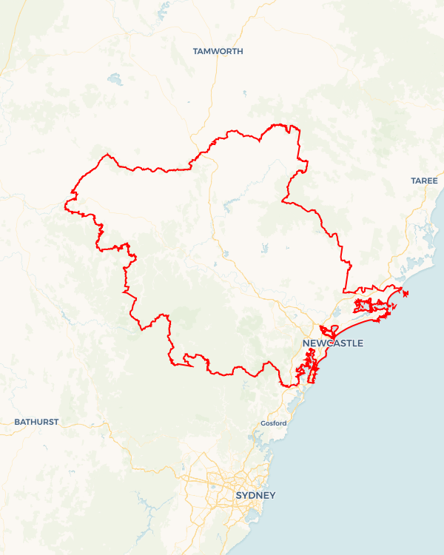
Local Jobs Plan
  - Hunter Employment Region | NSW | March 2026
Workforce Australia Local Jobs (Local Jobs) is a program that creates partnerships between business
and communities to meet local workforce needs, thereby improving employment outcomes.
Local Jobs operates in all 51 Employment Regions in Australia.

Local Jobs Overview

Local Jobs Plan
Each Employment Region has a Local Jobs Plan which outlines the labour market challenges in the region and the strategies to address these challenges.

Job Coordinators
Each Employment Region has a dedicated Job Coordinator who leverages existing resources, supports local labour markets through structural adjustments and retrenchments, and creates opportunities for collaboration between business and communities.

Local Jobs and Skills Taskforce
Each Employment Region has its own taskforce that meets regularly with the Job Coordinator to develop an understanding of challenges in the region and implement solutions. The taskforce is comprised of representatives from the region.

Local Jobs, Local People Grant
The Local Jobs, Local People grant funds activities that help people into ongoing employment or training. Activities must support local labour market needs.
Explore labour market insights for the
Hunter Employment Region

Local labour market challenges

- Growing mismatch between the region’s current skills and the skills in demand across online job advertisements, particularly across higher skills.
- Small and medium enterprises (SMEs) lack capacity to support local initiatives and pilot innovative recruitment methods, due to limited time, resources and staffing challenges.
- Limited understanding across industry around various visa pathways and employment programs, impacting skilled migrant employment.
- Growing concerns around loss of higher skills due to mining closures as a result of the region’s transition to net zero.
- Local initiatives launched simultaneously, creating confusion and fatigue across businesses.
- Ongoing retrenchments and business closures across mining, administration, retail, health care and other industries contributing to rising unemployment.
- Limited access to public transport in various parts of the region, limiting participants employment capacity and access to major industrial employment hubs. Limited learn-to-drive training options delaying participants in gaining driver’s licences, particularly in rural towns.

Local priorities

Priority 1 – Construction, infrastructure and trades

What are our challenges?
The increase in major construction and infrastructure projects across the Hunter is placing pressure on workforce capacity and skills availability. There is a clear mismatch between the region’s current and predicted skills, and the skills required across major projects. There are remaining low levels of diversification across industry.

How are we responding?
- Creation and delivery of pre-employment programs to provide industry exposure, accredited construction training/licencing and connection to tier one, two and three contractors. Initiatives include: Aboriginal and Torries Strait Islander Construction Pre-Employment Program, supporting First Nations Female participants.
- Offering taster programs and Industry awareness sessions. Initiatives include: ‘Lift Her Up’ Women in Crane Operations information session, working with Career Links EmpowerHER Program, offering information and support to women interested in entering the crane industry.
- Remaining abreast of current and upcoming major infrastructure projects across the region through various relationships, events, working groups and the Hunter Jobs and Skills Taskforce.
- Establishment of a ‘Hunter Infrastructure Projects’ resource, providing information on current and upcoming regional infrastructure projects.
- Ongoing promotion of local industry pathways and initiatives through the region’s Employment Service Providers through the Hunter Local Jobs Board.

Priority 2 – Manufacturing, advanced manufacturing and defence industry

What are our challenges?
Increased manufacturing and advanced manufacturing opportunities across the region and a rapidly growing defence sector are driving workforce shortages. Many advertised positions require higher skills, with local skill levels not meeting this demand. An aging workforce is leading to increased retirement, contributing to reduced talent and skills across the sector. There is limited knowledge across access, onboarding and the variety of occupations within manufacturing and defence industries.

How are we responding?
- Collaboratively working with various local Registered Training Organisations and industry to deliver tailored courses, pre-employment programs and local careers events, supporting entry level recruitment.
- Promotion of entry level STEM (Science, Technology, Engineering and Mathematics) programs. Promotion of STEM career pathways through the Hunter Secondary Head Teacher and Career Advisors Professional Learning Networks.
- Remaining abreast of current and upcoming industry needs across the region through various relationships, events, working groups, Group Training Organisations and the Hunter Jobs and Skills Taskforce.
- Ongoing promotion of local industry pathways and initiatives through the region’s Employment Service Providers. Offering opportunities to Workforce Australia participants including disadvantaged cohorts through the Hunter Local Jobs Board.

Priority 3 – Health, care and community services

What are our challenges?
Ongoing skills and workforce shortages across aged, disability and child-care sectors. Negative industry perceptions, particularly across limited work-life balance, emotionally taxing and challenging work conditions, limited public recognition and complex regulatory environments are contributing to limited applicants. An aging workforce is leading to increased retirement, contributing to reduced talent and skills across the sector. There is limited knowledge around access, onboarding and the variety of occupations, and career progression potential, across the sector.

How are we responding?
- Collaboratively working with various local Registered Training Organisations and industry to deliver tailored courses, pre-employment programs and local careers events, supporting entry level recruitment.
- Establishment and co-chairing of the cross-regional Central Coast and Hunter Care Working Group, consisting of 65 members representing industry, training and NSW Industry Training Advisory Bodies. This group promotes industry opportunities, supports local initiatives and collaboratively works together to develop solutions.
- Ongoing promotion of local industry pathways and initiatives through the region’s Employment Service Providers. Offering opportunities to Workforce Australia Participants including disadvantaged cohorts through the Hunter Local Jobs Board.

Priority 4 – Hospitality, tourism and customer service

What are our challenges?
Ongoing workforce demand and retention challenges. The industry is perceived as a short term or ‘stop-gap’ job, rather than a meaningful long-term career, resulting in limited entry and workforce development opportunities. The industry is typically inconsistent, particularly across hours/peak seasons, contributing to limited applicants. There is limited knowledge around access, onboarding and the variety of occupations, and career progression potential, across the sector.

How are we responding?
- Collaboratively working with various local Registered Training Organisations, community organisations and industry to deliver tailored courses and pre-employment programs, supporting entry level recruitment. Initiatives include: ‘Singleton Hospitality Pre-Employment Program’, delivered by Singleton Council and Genu Training and the ‘Double Take’ hospitality program, delivered by Nudge On.
- Establishment and chairing of the Hunter Hospitality and Tourism Jobs and Skills Working Group, consisting of 20 members representing industry and training.
- Delivery of careers expos and events, supporting connection between participants seeking employment and local industry employers.
- Ongoing promotion of local industry pathways and initiatives through the regions Employment Service Providers. Offering opportunities to Workforce Australia participants including disadvantaged cohorts through the Hunter Local Jobs Board.

Priority 5 – Net zero and emerging industries

What are our challenges?
Community understanding of net zero projects, emerging industries, and the timing and scale of future employment opportunities remains limited. Inconsistent visibility of project progress has contributed to confusion and consultation fatigue. At the same time, the closure of coal mines and coal fired power stations presents ongoing risks of workforce displacement and skills loss across the region.

How are we responding?
- Delivering place-based initiatives that support entry into emerging and transitional roles, in collaboration with the Department of Employment and Workplace Relations, the Net Zero Economy Authority, and relevant NSW Government agencies.
- Providing clear, consistent and timely information on net zero projects, in partnership with the Hunter Regional Workforce Transition Officer, to support informed workforce and community decision-making on emerging industries and employment pathways.
- Engaging with the Worker Transition Advisory Group established to advise government on workforce transition needs and opportunities, supporting alignment of effort, information-sharing and collaboration across governments, community, unions, business and other regional stakeholders.
- Supporting workers affected by coal mine and coal-fired power station closures, with a strong focus on retaining skills in the region.
- Building future workforce capability and regional resilience by promoting STEM pathways, innovation and self-employment aligned to current and future workforce needs.

Priority 6 – The Upper Hunter

What are our challenges?
The Upper Hunter is undergoing significant structural change with a skilled workforce experiencing transition. The Upper Hunter lacks diversity across career pathways and workforce development. Lack of public transport and access to learn-to-drive instructors. With minimal on-site training opportunities, many students are required to travel outside of the Upper Hunter to access in-person training. There is limited engagement and uptake across local initiatives despite the high unemployment rates across Muswellbrook, and high youth unemployment across Cessnock.

How are we responding?
- Collaboratively working with various key local Upper Hunter representatives and stakeholders to deliver local initiatives.
- Promotion of local learn-to-drive training programs to support participants in accessing driver’s licences.
- Promoting self-employment and entrepreneurship programs, including the Self-Employment Assistance Program delivered by ETC, New Hunter Business and Verto, as alternative career pathways to encourage participants to remain in the Upper Hunter and minimise workforce migration.
- Establishment and chairing of the Upper Hunter Employment and Education Network, consisting of over 100 members, with the intent to connect and collaboratively work together to support the Upper Hunter in accessing secure and meaningful employment pathways.
- Support SMEs and local business by providing information on diversification, contract/grant opportunities and procurement processes.

Want to know more?
- Contact Kempsey Litten, Hunter Job Coordinator at Kempsey.litten@hunterlocaljobs.com.au
- Visit Local Jobs or Workforce Australia
- The Regional Workforce Transition Officer is working collaboratively with the Job Coordinator in your region to support the positive and orderly transition to a net zero economy. For further information, please refer to Regional Workforce Transition Officers (RWTOs) - Department of Employment and Workplace Relations, Australian Government

