Certification of Compliance with the Guidelines on Information and Advertising Campaigns by Australian Government Departments and Agencies

I, Lisa Paul, certify that the non-English speaking background materials for the Child Care Assistance Campaign complies with the Guidelines on Information and Advertising Campaigns by Australian Government Department and Agencies and all relevant government policies and laws.

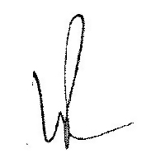
Lisa Paul, PSM
Secretary
Department of Education, Employment and Workplace Relations
11 March 2011

