


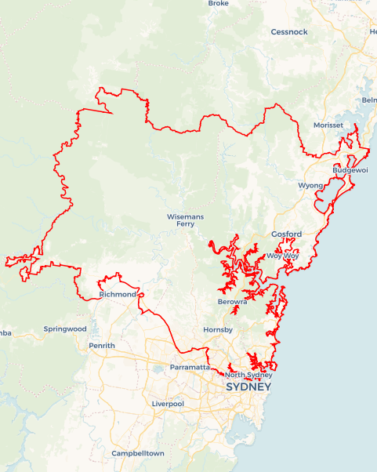
Local Jobs Plan
  - Sydney North and West Employment Region | NSW | February 2026
Workforce Australia Local Jobs (Local Jobs) is a program that supports tailored approaches to accelerate
reskilling, upskilling and employment pathways in response to current and emerging local workforce needs.

Local Jobs Overview

Local Jobs Plan
Each Employment Region has a Local Jobs Plan which outlines the labour market challenges in the region and the strategies to address these challenges.

Job Coordinators

Each Employment Region has a dedicated Job Coordinator who leverages existing resources, supports local labour markets through structural adjustments and retrenchments, and creates opportunities for collaboration between business and communities.

Local Jobs and Skills Taskforce
Each Employment Region has its own Taskforce. Representatives include local stakeholders who have demonstrated experience in upskilling, reskilling, and an ability to represent, connect and collaborate with others in the region to meet labour market needs.

Local Jobs, Local People Grant
The Local Jobs, Local People grant funds activities that help people into ongoing employment or training. Activities must support local labour market needs.
Explore labour market insights for the
Sydney North and West Employment Region

Local labour market challenges in the region

- Attracting and securing workers in growth and demand sectors with accessible entry-level work.
- Limited local employment opportunities in the remote areas and challenges with the frequency and timing of public transport services across areas within the Central Coast district of the Sydney North and West Employment Region.
- High demand for casual employment, with limited uptake of vacancies from participants. This challenge is amplified by transport related barriers that would enable participants to access employment hubs outside of the Sydney area of the region.

- A relatively high incidence of unemployment in First Nations communities in the Central Coast Local Government Area.
- An ongoing difficulty of community, care and disability service organisations to meet increasing demand for workers.
- Significant youth (aged 15- 24) unemployment across the region.
- Employers experiencing difficulty recruiting traineeships and apprenticeships across the region to develop clear employment pathways and career development opportunities

Local jobs and skills priorities and strategies in the region

Priority 1 – Health care, childcare and community services

What are our challenges?

Attracting and retaining suitable participants to the health, care, childcare and community services sector, including aged, disability and community care.

How are we responding?
- Collaborate with community services stakeholders to develop a campaign that raises awareness of employment opportunities in the sector, and which seeks to build the profile of the sector as a desirable career choice for participants.
- Collaborate with employers and key stakeholders to develop strong attraction and retention strategies to increase interest in health, care and community service roles including the development of tools that provide more visibility of, and streamlined access to, local employment and training opportunities - including employment expos, Launch into Work projects, direct recruitment drives with local employers.
- Engage across employers and training providers to ensure training pathways are effective and support participants to be appropriately skilled to start their careers.
- Continue a care working group to identify local barriers that organisations face in attraction and retention of new entrants to the health, care and community services sectors.
- Collaborate with employers, training organisations and apprenticeship/traineeship providers to create additional entry level roles with on-the-job training pathways for career development.
- Collaborate across the range of stakeholders, in particular employment service providers, to ensure the supply of participants are aware of opportunities and pathways to careers and employment in this sector.

Priority 2 – Tourism, hospitality and customer service

What are our challenges?

Ongoing hesitancy for participants to consider opportunities in tourism, hospitality and customer service-based employers across the region.

How are we responding?
- Support businesses across the region to attract and retain staff from the Workforce Australia and displaced worker caseloads.
- Collaborate with registered training organisations to create tailored pre-employment training short course packages for employers to allow the Workforce Australia caseload the opportunity to develop industry minimum qualifications.
- Support employers to be linked to suitable training organisations to allow them to identify and establish career pathway opportunities in the hospitality industry.
- Engage and work with hospitality employers in direct recruitment for their identified positions.

Priority 3 – Create employment pathways into the manufacturing, traditional trades and construction sectors

What are our challenges?

We have a strong construction and manufacturing sector with employers that are growing their labour market needs coupled with participants who have limited understanding of the available employment and career opportunities.

How are we responding?
- Collaborate with employers to build stronger pathways to employment in the region’s manufacturing sector and construction projects, including the development of tools that provide streamlined access to local employment and training opportunities and the development of pre-employment programs that lead to genuine employment opportunities for suitable participants.
- Work with employers and training providers to ensure current and future workforce needs are aligned with the training available to participants. Projects such as Manufacturing in the Hub, Metal Matriarchs, HERizon and ManufactHER.
- Support employers to be linked to suitable traineeship and apprenticeship providers to allow them to identify and establish career path within the industry.

Priority 4 – Create opportunities in digital literacy, technology, and emerging industries

What are our challenges?

Lower levels digital literacy competency, and a lack of understanding of opportunities in this sector.

How are we responding?
- Partner with registered training organisations that work in these sectors along with employers to identify opportunities for skill set or pre-employment training to create future pathways in these industries.
- Build pathways to improved digital literacy leading to employment opportunities, including programs such as One Training Digital Ready and Digital Walkabout.
- Build clearer pathways to employment and training for participants, including the development of tools that provide more visibility of, and streamlined access to, local employment and training opportunities in the tech and innovation areas.
- Develop mentorship programs that direct a range of support to participants in an ongoing and integrated way including working with Humans of Purpose – Digital Mentorship program.
- Assist employers with the creation of work from home roles in the tech industry to mitigate some of the regions transport barriers.

Priority 5 – Create employment pathways into traineeships and apprenticeships

What are our challenges?

Limited understanding between employers and participants of the ways traineeship and apprenticeship programs can improve mutual outcomes.

How are we responding?
- Collaborate with stakeholders to build stronger pathways to traineeship and apprenticeship opportunities in the region including the Apprenticeship and Traineeship Days and Central Coast Future Pathways Expo.
- Engage across employers and training providers to ensure training pathways for the new workforce are effective.
- Collaborate with Group Training Organisations to ensure that participants are aware of opportunities and pathways to careers and employment.
- Develop pre-employment skills packages that allow for transition from pre-employment training into suitable industry traineeships and apprenticeships.
- Collaborate with local employers and stakeholders to develop projects that encourage part time traineeships that can assist with the skills gaps.

Priority 6 – Targeted cohort-specific strategies that upskill and prepare First Nations people, culturally and linguistically diverse (CALD) and migrant communities and youth

What are our challenges?

Underemployment for First Nations people and youth remain high in the region. CALD and migrant communities face cultural and language challenges with employment opportunities.

How are we responding?
- Address challenges to employment by developing appropriate training pathways, with access to mentoring and opportunities for First Nations people to meet with inclusive businesses and by engaging with programs such as Digital Walkabout and Make Tomorrow in Manufacturing which provide hands on training and experience in industry and wrap around cultural support.
- Collaborate with industries, employers, education bodies, refugee, migrant and community organisations to break down the barriers for the CALD cohort.
- Continue to work with the Sydney North and West youth working group to discuss employment and further education and training pathways for youth.
- Support those who have overseas qualifications and/or work experience by investigating career options aligned to these qualifications (within the region’s context), re-credentialing, recognition or prior learning pathways where possible.
- Work with wrap around support services to address non-vocational barriers for disengaged youth, including mental health and resilience such as the Iris Foundation resilience workshops for our Transition to Work and youth participants.
- Work closely with the DEWR Indigenous Liaison Officer to develop better linkages with First Nations communities.

Want to know more?
- Contact: Anne Blackman, Sydney North and West Job Coordinator: Anne.Blackman@snwlocaljobs.com.au
- Visit: Local Jobs or Workforce Australia

