



**Empowering YOUth Initiatives**

Consolidated learnings report

**Evaluation team**

Brenton Alexander

Shelley Evans

Anthony Flint

Ulises Garcia

Robyn Henderson

Mark Jones

Bella Liao‑Masters

Bradley McKenzie

Ben McNally

Athos Nicolaou

Kate Puniard

Jo Virgona

Dean McDonald – Market Access Consulting and Research

Charmian Huggett – Market Access Consulting and Research

With the exception of the Commonwealth Coat of Arms, the Department’s logo, any material protected by a trade mark and where otherwise noted all material presented in this document is provided under a [Creative Commons Attribution 4.0 Australia](https://creativecommons.org/licenses/by/4.0/) licence.  
The details of the relevant licence conditions are available on the Creative Commons website (accessible using the links provided) as is the full legal code for the [CC BY 4.0 AU licence](https://creativecommons.org/licenses/by/4.0/legalcode).

The document must be attributed as the Empowering YOUth Initiatives Consolidated Learnings Report.

**Acknowledgement**

The department acknowledge the contribution of Market Access Consulting and Research.

Table of figures 5

List of tables 6

Executive summary 7

Background 7

Evaluation approach 7

Learnings from innovation 7

Learnings from activities delivered 8

Learnings from the delivery process 9

Learnings from intervention types 11

Departmental learnings 12

Policy design 12

1 Introduction 14

1.1 Program scope 14

1.2 Evaluation approach 16

2 Context 17

2.1 The initiatives 17

2.2 What is innovation in the context of EYI? 18

2.3 Who was the service delivered to? 27

3 Learnings from the activities delivered 37

3.1 Work experience and work-like activities 37

3.2 Intensive support 41

3.3 Mentoring services 44

3.4 Non-traditional hands-on (kinaesthetic) learning 45

3.5 Addressing barriers and building resilience 46

3.6 Incentives 47

4 Learnings from the delivery process 49

4.1 Initiative marketing and awareness 49

4.2 Community engagement 51

4.3 School engagement 52

4.4 Employer engagement 53

4.5 Referral sources (employment services providers) 54

4.6 Staffing 58

4.7 Governance 59

5 Learnings from specific intervention types 61

5.1 Social enterprise 61

5.2 Digital 61

5.3 Sport 62

5.4 Transport 62

6 Departmental learnings 65

6.1 Procurement 65

6.2 Replication and scaling 72

6.3 Cost-effectiveness 74

7 Conclusion 75

# Table of figures

Figure 2.1: Cambridge business innovation model 19

Figure 2.2: EYI risk matrix 22

Figure 2.3: Initiatives’ relative risk 25

Figure 2.4: Work readiness 27

Figure 2.5: Education retention logic model 28

Figure 2.6: Major barriers to job readiness logic model 30

Figure 2.7: Extent of participant disadvantage 33

Figure 2.8: Categorisation of disengagement and disadvantage 34

Figure 2.9: Preconditions for labour market attachment 35

Figure 3.1: Competition for work experience placements 38

Figure 3.2: Virtuous cycle of progression to job readiness 46

Figure 4.1: Initiatives’ relationships 49

Figure 4.2: jobactive and EYI involvement in the employment services system 57

Figure 6.1: Innovation process flexibility requirements 68

Figure 6.2: EYI interim and ultimate outcomes 71

Figure 6.3: Risk associated with intervention outcomes 71

# List of tables

Table 2.1: The initiatives 17

Table 2.2: Initiatives’ estimated stage in the Cambridge business innovation model at commencement 20

Table 3.1: Anglicare WA participant personas 43

# Executive summary

## Background

Empowering YOUth Initiatives (EYI) was an employment program for young people aged 15 to 24 years. It trialled innovative approaches to improving participants’ skills and helping them progress towards sustainable employment, with the aim of informing future youth employment policies and programs. There were two rounds of funding and initiatives were funded for two years. In Round One, 19 initiatives were funded, operating from 2016 to 2018; and 20 initiatives were funded in Round Two, operating from 2017 to 2019.

## Evaluation approach

All initiatives funded through Empowering YOUth Initiatives were evaluated individually, according to the approach described in A Strategy for Evaluating Empowering YOUth Initiatives.[1] Typically, these evaluations combined qualitative fieldwork with initiative participants, providers and stakeholders; initiative and departmental data; and progress reports written by EYI provider organisations.

This report summarises learnings that were common across these individual initiatives, summarising learnings into four themes:

1. Learnings from activities delivered
2. Learnings from the delivery process
3. Learnings from specific intervention types
4. Departmental learnings

Overviews of, and summarised learnings from each initiative are at **Attachment B**.

## Learnings from innovation

This report applies an innovation process framework to examine EYI innovation as a sequence of innovation stages as projects mature through ideation, prototyping, piloting and launch. Applying this lens, the report found that:

* the initiatives were at various stages in the innovation process on commencement
* initiatives’ stages in the innovation process affected their ability to identify, achieve and measure outcomes, such as participant numbers
* changes to initiative elements are likely during any innovation process
* innovating requires time in order to progress through the stages of the innovation process
* risks are inevitable in any innovation process, in that ideas will be trialled and rejected
* flexibility to adapt and respond to challenges is required at earlier stages of innovation
* services at later stages of the innovation process are generally more standardised
* adaptations over the course of an initiative present challenges for impact evaluation.

## Learnings from activities delivered

### Work experience

Employers valued young people with work experience, and having no experience in a work environment was a barrier to employment. However, work experience placements could be very limited in some areas and there was often strong competition for available placements.

Many initiatives included work‑like environments that enabled young people to gain some work experience that would otherwise not have been available. Initiative providers took an active role in facilitating placements. Some organisations used their established and attractive brands to broker placements for participants while others created work‑like environments in supported social enterprises.

### Intensive support

Initiatives with participant cohorts that had relatively high levels of disadvantage and disengagement often used intensive servicing to support young people. This typically involved one‑on‑one support, in some cases complemented by group activities or servicing. Building trust with the participants was fundamental to resolving disengagement in order to address employment barriers.

Developing relationships with participants and securing their commitment to the program was influenced by time, their involvement in the initiative at commencement, and caseload size. Sometimes factors outside the initiative’s control influenced participants’ attendance and participation, for example lacking food and housing security.

Participants in most initiatives were long‑term unemployed or at risk of becoming long-term unemployed. This suggests that while resource intensive support that assists them into sustainable employment could substantially reduce future reliance on income support.

Despite initiatives’ intentions to provide intensive support, some observed variation in participant engagement over time. In these cases, the initiatives needed to make the most of periods of high engagement and remain available when the participants were ready to re-engage after periods of low engagement.

### Mentoring services

Two main forms of mentoring took place in the initiatives: mentors external to the EYI provider, who focused on career planning; and internal mentors, who provided coaching and case management. Both types of mentoring relationships were useful for participants when well planned. Mentoring seemed more successful when:

* a sufficient number of mentors were recruited to meet participant demand
* clear systems and guidelines set expectations for mentors and mentees
* there were opportunities for rapport-building between mentors and mentees
* resources were available to upskill mentors in their role
* participants’ major non-vocational barriers were addressed before mentoring started.

### Non‑traditional hands-on (kinaesthetic) learning

Traditional, classroom‑style learning was generally not appropriate for participants who had disengaged or were at risk of disengaging from school. The most common instances of hands-on learning were in initiatives that involved work‑like environments or had work experience components. This approach was particularly successful where:

* participants were job ready (that is, they did not have substantial barriers to employment)
* the work‑like environment was closely linked to a local industry
* the local industry had demand for labour.

### Addressing barriers and building resilience

Initiatives that were most able to progress very disadvantaged participants to job readiness enabled them to experience success, which increased motivation, resilience, skills and confidence. This was achieved through a ‘virtuous cycle’ which involved participants setting attainable goals, receiving timely feedback, reaching the goal and gaining the confidence to set further goals. This process intervened in a negative cycle that some participants had experienced of failing to achieve a goal and internalising that failure, resulting in low self‑esteem and limited motivation.

### General learnings from activities

T**he following approaches can be considered effective in improving** employment outcomes for participants:

* providing participants with experience in a genuine work environment
* focusing on the provision of specialised skills with direct and immediate application
* being geographically located where there is current and anticipated future demand for the skills being taught
* providing participants an opportunity to develop their skills alongside skill specialists

the service provider has pre-existing relationships with potential employers or referrers

## Learnings **from** the delivery process

### Initiative marketing and awareness

Many initiatives had to build new relationships with stakeholders in order to deliver or facilitate referrals to their service, which took time. Initiatives run by organisations with large, established brands had success in building relationships and generating awareness as this was a key part of their existing business. When an initiative was newly established, or new to a location, substantial effort was required to build awareness among stakeholders and the community. Demonstrating the value of new initiatives was more difficult when they commenced, because they had achieved few, if any, outcomes. Most initiatives resolved initial marketing and awareness challenges.

### Community engagement

Many initiatives operated in communities where the organisation had an established presence. Where initiatives sought to operate in new locations they faced greater challenges to operating effectively. Support from the local community was particularly important for initiatives that focused on specific community groups, such as young Indigenous people.

### School engagement

Assisting students’ transition between school and work was a compelling objective. Initiatives were successful when strong relationships were built with individual schools and the benefits to the school and its students were clear. Scaling initiatives that operated in schools or with school student participants would require collaboration with state education departments. This collaboration could also facilitate access to data that would assist evaluation of school‑based initiatives.

### Employer engagement

Providers’ relationships with employers could assist participants to gain work experience or employment. Offering a commercial benefit to employers may be necessary for this approach to work at scale. For example, employers were willing to offer work experience to participants in initiatives run by organisations with popular brands (for example sports teams). For employers being associated with a popular brand was seen as providing value to the employer’s brand.

Initiatives that provided services directly to small businesses were beneficial, particularly when the businesses or their employees would not usually be able to access those services, such as employee mental health support.

### Referral sources

Initiative referral sources included schools, employment services providers, other community services providers (for example, community mental health services) and specific community groups. Initiatives received fewer referrals from employment services providers than originally anticipated. In Round Two, employment services providers were able to deliver initiatives.

Once initiatives were established and there was evidence of their benefits to participants, promoting the initiative and eliciting referrals became easier.

### Staffing

Successful initiatives had staff members who built strong relationships with participants and were invested in their success. Initiative staff were highly regarded by participants and stakeholders in the vast majority of cases, and in many instances staff were the primary mentors for young people. Initiatives in regional areas struggled to find suitably qualified staff.

### Governance

Not all EYI providers had existing policies and procedures that could be applied directly to their initiative. Those that did were at an advantage. Initiatives that could not adopt the policies and procedures of a parent organisation for topics such as ethics, confidentiality and human resources had to invest time in developing them. Established governance structures that reported about the initiative to senior management supported progress.

## Learnings from intervention types

### Social enterprise

Work experience through social enterprises enabled participants to gain skills and develop work‑like habits. Social enterprises had the potential to provide a relatively low cost and reliable source of work experience.

Social enterprises in EYI operated differently from conventional social enterprises in that participants could get experience in various roles in the business and ideally would find work elsewhere. This limited the social enterprise’s commercial efficiency because when more job ready participants who had been trained left the business they were replaced by new participants requiring training.

### Digital

Initiatives with a digital component were best suited to participants whose access to a smartphone, reliable mobile network and internet was constant. Some initiatives used a digital component to generate appeal, while for others the digital component was at the centre of the initiative’s service delivery. There was mixed success among initiatives that used a digital component as a central part of service delivery.

### Sport

Engaging participants via prominent sports brands was particularly effective when those organisations had established connections to the participants and their communities. Initiatives that incorporated sport as an activity had some success at attracting and engaging young people. It is unclear whether assisting young people to gain qualifications related to sport is an effective way to achieve employment outcomes.

### Transport

For many participants, particularly those outside metropolitan areas, transport was a substantial barrier to job readiness and employment. In some regional areas a driver’s licence and access to a vehicle is close to essential for gaining employment. Attaining a learner’s permit and driver’s licence was impeded by limited vehicle access and by supervised driving requirements. Facilitating driver’s licence attainment for unemployed youth is a useful service that also provides opportunities for building mentoring relationships between the supervisors and young people, and integration with existing state‑based driving programs.

## Departmental learnings

Identifying, measuring and enabling innovation was a challenge in the EYI procurement process as was identifying projects that could expanded and replicated. The use of an innovation framework that identifies initiatives’ maturity (from ideation to launch, adjustment and diversification) can provide a foundation for assessing future initiatives and services and better setting expectations and articulating anticipated impacts.

There were tensions between enabling new ways of working, minimising administrative burden while meeting procurement requirements, measuring performance and recognising the varying maturity of different projects. A more flexible funding mechanism that allows projects to evolve could be useful.

Having two rounds of initiatives enabled the department to adapt the Round Two assessment and implementation process based on learnings from Round One and this improved delivery of the program. For example, while funding agreements were relatively standardised for efficiency and accountability, this also reduced initiatives’ responsiveness in amending and adapting the initiative as issues were identified that required addressing. This standardised approach was particularly an issue for Round One initiatives and addressed in changed arrangements in Round Two.

Additionally, the department recognised that giving prospective initiative providers departmental insights earlier, such as through the tender process, improved understanding of the department’s objectives and led to better designed proposals. By adding a feedback stage on initiative proposals in Round Two, the department allowed the organisations to make meaningful adjustments that would enable them to better meet EYI requirements. There was stronger collaboration between the department and EYI providers in drafting Round Two funding agreements.

The departmental experience with EYI identified opportunities to improve procurement processes such as further strengthening the collaboration and co‑design process and simplifying funding agreements. In addition, successful implementation of core initiative elements before initiative commencement can minimise challenges in delivering innovative components.

## Policy design

There were some key lessons across the initiatives that can inform future policy settings and program design:

* Consider local labour market conditions when establishing a service, including acknowledging differences in local regional labour markets.
* Consider using social enterprises to provide training and work experience in a secure and safe environment for young people.
* Ensure services being offered have a sufficient supply of participants to remain viable. Referrals from employment services providers may not be sufficient to provide initiatives with a large enough caseload to be effective or financially sustainable.
* Provide work experience opportunities that are otherwise hard to obtain, by replicating work environments through training and work-like activities.
* Build trust with participants and managing barriers during participation, rather than trying to identify issues up front. Trust and rapport are important to keep young people involved.
* Support complementary tools and techniques that identify (and can be used to address) non‑vocational barriers and disengagement.

# Introduction

The Australian Government funded innovative youth employment services through Empowering Youth Initiatives (EYI). EYI consisted of a suite of initiatives (the EYIs) aimed at assisting young people at risk of long‑term unemployment to continue education, find work and address employment barriers.

The government’s objectives for EYI were to:

* help more young people at risk of long-term unemployment to find and a keep a job
* identify innovative approaches that have the greatest potential to improve employment outcomes for young people at risk of long-term unemployment and prevent long-term welfare dependency
* promote learnings from the EYIs to assist government and organisations working with young people to enhance current and future service delivery.

Through EYI, the department aimed to identify innovative approaches that have the greatest potential to improve employment outcomes for young people at risk of long‑term unemployment and prevent long‑term welfare dependency.

In total, the department funded 39 projects for approximately two years: 19 in Round One, from April 2016 to August 2018; and 20 in Round Two, from May 2017 to June 2019.

Details of each of the EYIs are provided in **Attachment A**, a summary table of all the EYIs; and **Attachment B**, summaries of each EYI, including what was delivered and learnings. These attachments provide context and summarise key learnings from these initiatives.

## Program scope

The department invited grant applications from organisations that offered an innovative approach to assisting young people who were at risk of long-term unemployment at any stage in the transition from education or unemployment to employment.

Applications could seek to:

* prevent unemployment among young people most at risk of long-term unemployment
* reduce barriers to employment for young people who were unemployed or at risk of becoming long-term unemployed
* help young people stay in work, to minimise the risk of long-term welfare dependency.

This included innovative approaches to:

* minimising or preventing long-term unemployment and subsequent reliance on income support
* improving education outcomes, retention and completion
* removing or reducing barriers to employment
* facilitating the development of employment opportunities
* maintaining employment.

The department specified that initiatives should not replicate the services delivered through existing Australian Government employment services, including jobactive, Transition to Work (TtW), Disability Employment Services (DES) and the Community Development Program.

In Round One, 197 applications were received, with 19 initiatives allocated funding totalling $15.5 million.

In Round Two, 287 applications were received, with 20 initiatives allocated funding totalling $28.3 million.

### Target participants

The target group for EYI was young people aged 15 to 24 years who were (or were at risk of becoming) long-term unemployed.[2]

Funding for Round One EYIs focused on delivering innovative approaches to preventing unemployment or reducing the risk of long-term unemployment for:

* Indigenous young people
* young people from culturally and linguistically diverse (CALD) backgrounds
* early school leavers
* young people with disability
* young people with poor mental health
* young people in regional Australia, particularly in areas undergoing structural change or with high levels of social disadvantage.

Funding for Round Two EYIs focused on delivering innovative approaches relating to:

* locations with high youth unemployment
* apprenticeship opportunities
* traineeship opportunities
* pathways to employment for young people.

Young people involved did not have to be on income support or receiving assistance in government employment services.

## Evaluation approach

The evaluation strategy outlined the process for assessing individual EYIs:

‘Each of these evaluations will seek to identify innovative activities and service delivery methods that work to support young people who are long‑term unemployed or at risk of long-term welfare dependency to become job ready, get a job, and stay in a job. The evaluations will also identify learnings which can be used to inform ongoing service delivery as well as future policy and program design.’[3]

This report consolidates key learnings from the individual reports, and other reports on the EYI, into key themes where there were commonalities and similar experiences. The reports used were:

* qualitative insight summaries of EYIs, produced by external consultants
* EYI providers’ progress and final reports about their projects
* the department’s final evaluation reports on EYI projects
* the department’s EYI process insights and learnings summaries.

This report does not assess each EYI’s level of innovation, or determine if a particular idea was innovative, or could be scaled up. The report explores the learnings thematically, including:

* Learnings from activities delivered
* Learnings from the delivery process
* Learnings from specific intervention types
* Departmental learnings.

# Context

## The initiatives

The initiatives are listed in Table 2.1. Further details about 38 initiatives, including a description of the service and its learnings, context and barriers, are in Attachment A and Attachment B. In summarising the design, service delivery, outcomes and learnings of each of these initiatives, this report categorises and groups them to explore how learnings can be applied in procuring innovative initiatives to assist young people into employment and to deliver better services to young people.

Initiatives are categorised by:

* the target cohort — Indigenous, with disability, in school, in regional/remote locations
* the type of service delivered — work experience (work-like initiative), intensive support, non‑traditional training, addressing non-vocational barriers
* the structures required for delivery — governance, staff, communities, marketing, referral sources, communities
* the primary type of intervention — social enterprise, digital service, mentoring program, training program, sports-based intervention.

Table 2.1: The initiatives

| Round | Provider organisation | Initiative name |
| --- | --- | --- |
| 1 | Big hART Inc | 20 in 2020 |
| 1 | Brain Injury SA Inc | Support SA Youth Initiative Transition (SSAYiT) |
| 1 | Brisbane Broncos Rugby League Club Ltd | Brisbane Broncos Career Club |
| 1 | Charity Bounce Ltd | Hoop Dreams |
| 1 | Eyre Futures Inc | Eyre Peninsula Journey to Work |
| 1 | Fraser Coast Training Employment Support Service (TESS) | Fraser Coast TESS Driving School Social Enterprise |
| 1 | Geelong Ethnic Communities Council Inc | Equip! |
| 1 | Graceades Community Cottage Inc | Productivity Bootcamp in Construction |
| 1 | Great Southern Employment Development Committee Inc | Young Harvest |
| 1 | headspace National Youth Mental Health Foundation Ltd | Digital Work and Study Service |
| 1 | Kiama Community College Inc | NextGEN Digital Development |
| 1 | NSW Business Chamber Ltd | Skillsroad Show |
| 1 | Settlement Services International Ltd | Youth@Work |
| 1 | Top End Group Training Pty Ltd | Becoming a Worker |
| 1 | United Synergies Ltd | Buzzing |
| 1 | Western BACE | Youth BACE |
| 1 | Whitelion Youth Agency | Solid Youth |
| 1 | Workforce Plus Inc | 20Squared |
| 1 | YMCA of Perth | Swim for Life |
| 2 | Anglicare WA Inc | Designing for an Independent Future |
| 2 | Apprentices Trainees Employment Ltd | Road2Wheels |
| 2 | Baptist Care SA Inc | Tumbelin Go |
| 2 | Black Swan Health Ltd | Youth App Empowering Employment (YAppEE) |
| 2 | Colony 47 Inc | Backswing |
| 2 | ECA Training Pty Ltd | Indigenous Apprenticeship Readiness Program |
| 2 | Employment Options Inc | Pathfinder |
| 2 | headspace National Youth Mental Health Foundation Ltd | Digital Industry Mentor Service |
| 2 | iEmpower Youth Inc | iEmpower Youth Cooperative |
| 2 | Karingal Inc | Youth Community |
| 2 | Impact Community Services Inc | Employment FirstAid (E+) |
| 2 | MAS National Ltd | Cycle of Change |
| 2 | Queensland Youth Services Inc | Recycle Your Dreams |
| 2 | Scouts NT | Motoscouts |
| 2 | Settlement Services International Ltd | Youth Pathways and Placement Project |
| 2 | The Trustee for Pathways to Resilience | Empowering Youth to Thrive |
| 2 | Vision Australia Ltd | Building Stronger Futures |
| 2 | Wirrpanda Foundation Ltd | Bidi Waalitj Project |
| 2 | Workskil Australia Ltd | Get Moving |
| 2 | Workskills Inc | Youth Entrepreneurial Services (YES) |

## What is innovation in the context of EYI?

### Innovation principles

The concept of innovation is not assessed in this evaluation; nor are attempts made to compare innovations among the initiatives or against other available services. However, an innovation model provides the opportunity to examine the stages of innovation the initiatives were in when they received funding. An innovation framework that identifies the maturity of initiatives (from ideation to launch, adjustment and diversification) can provide a foundation for assessing future initiatives and services and better setting expectations and articulating anticipated impacts. The maturity of a project may affect an EYI provider’s ability to deliver the service as outlined in its funding agreement with the department. For example, an initiative at the prototyping stage may have difficulty delivering a predetermined number of employment outcomes because they are concurrently implementing multiple, varied service models.

While there are many innovation models, they generally have some elements in common, such as commencement with an idea and progression through prototyping, piloting and launching. One such model is the Cambridge model of business innovation (Figure 2.1).

Figure 2.1: Cambridge business innovation model[4]

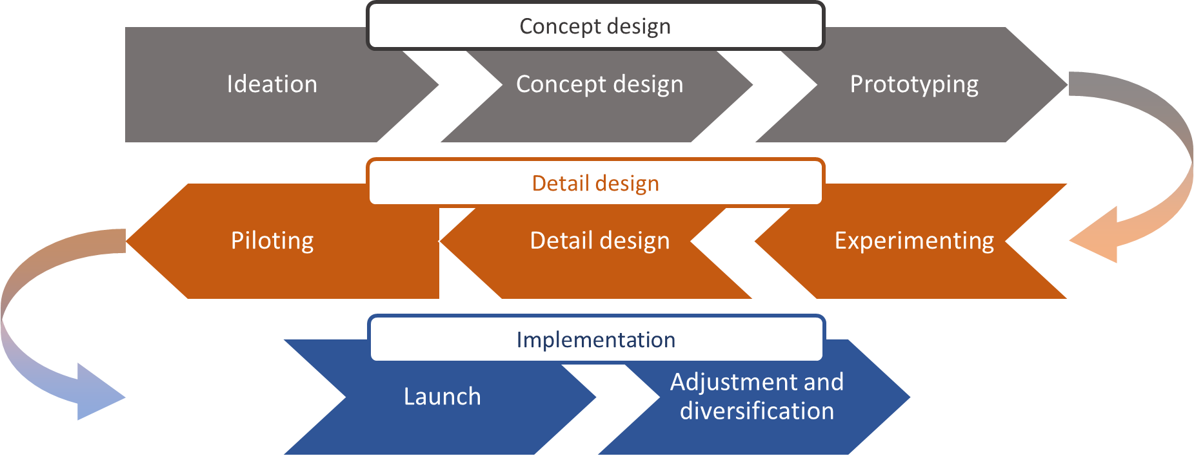

The Cambridge business innovation model consists of three broad groupings: Concept Design, Detail Design and Implementation. Each grouping can be broken down as follows:

* Concept design consists of Ideation, Concept Design and Prototyping.
* Detail Design consists of Piloting, Detail Design and Experimenting
* Implementation consists of Launch and Adjustments and Diversification.

The Cambridge business innovation model is used in this report to help clarify the distinct stage an initiative was in at the time it received funding.

Examining initiatives through the Cambridge business innovation model suggests that they ranged in scope from those where the concept design was not fully formalised to those that were ready for detailed design and launching.

This variation in the projects’ innovation stage at commencement resulted in challenges for the department and EYI providers in determining the aim of the new and innovative services and the requirements to identify, achieve and measure tangible outcomes.

Ultimately the department wanted to pilot initiatives that could be comprehensively evaluated, scaled up and implemented broadly. In progressing an initiative from ideation through to implementation, both time (progression through the multiple innovation stages) and risk (ideas will be trialled and rejected) are inevitable parts of the process.

### Applying the innovation cycle to EYIs

Table 2.2 attempts to retrospectively identify each project’s stage in the innovation cycle, noting that there is a degree of subjectivity in this assessment of each initiative. Through this categorisation, the achievements and learnings of each initiative can be better understood, as EYI providers had different requirements, risks and barriers to overcome to get their initiative to the stage of commencing young people and delivering their service.

Table 2.2: Initiatives’ estimated stage in the Cambridge business innovation model at commencement

| Round | Initiative name | Estimated innovation process stage |
| --- | --- | --- |
| 1 | Fraser Coast TESS Driving School Social Enterprise | Ideation |
| 2 | Designing for an Independent Future | Ideation |
| 2 | Youth Entrepreneurial Services (YES) | Ideation |
| 1 | Solid Youth | Concept design |
| 1 | Young Harvest | Concept design |
| 2 | iEmpower Youth Cooperative | Concept design |
| 1 | 20Squared | Prototyping |
| 2 | Cycle of Change | Prototyping |
| 2 | Indigenous Apprenticeship Readiness Program | Prototyping |
| 2 | Pathfinder | Prototyping |
| 2 | Motoscouts | Prototyping |
| 2 | Tumbelin Go | Prototyping |
| 2 | Road2Wheels | Prototyping |
| 1 | 20 in 2020 | Piloting |
| 1 | Digital Work and Study Service | Piloting |
| 2 | Digital Industry Mentor Service | Piloting |
| 1 | Support SA Youth Initiative Transition (SSAYiT) | Detail design |
| 1 | Hoop Dreams | Detail design |
| 1 | Equip! | Detail design |
| 1 | Productivity Bootcamp in Construction | Detail design |
| 1 | NextGEN Digital Development | Detail design |
| 1 | Buzzing | Detail design |
| 1 | Youth BACE | Detail design |
| 1 | Youth@Work | Detail design |
| 2 | Youth Pathways and Placement Project | Detail design |
| 2 | Empowering Youth to Thrive | Detail design |
| 2 | Bidi Waalitj Project | Detail design |
| 2 | Get Moving | Detail design |
| 1 | Eyre Peninsula Journey to Work | Experimenting |
| 1 | Becoming a Worker | Experimenting |
| 1 | Swim for Life | Experimenting |
| 2 | Youth App Empowering Employment (YAppEE) | Experimenting |
| 2 | Backswing | Experimenting |
| 2 | Youth Community | Experimenting |
| 2 | Employment FirstAid (E+) | Experimenting |
| 2 | Recycle Your Dreams | Experimenting |
| 2 | Building Stronger Futures | Experimenting |
| 1 | Brisbane Broncos Career Club | Launch |
| 1 | Skillsroad Show | Launch |

#### Managing risk when innovating

Managing and accepting risk is an important component of innovation and was a key factor in designing and implementing the initiatives. The extent to which the initiatives were completely new ventures or extensions of existing services affected the risks that needed to be acknowledged and managed by providers and the department. Some risks that vary in relevance at different stages of the innovation process include:

* staff recruitment
* stakeholder engagement
* financial viability
* governance
* service efficacy
* service continuity
* outcome achievement.

For example, an initiative piloting an existing service with a new participant cohort would be more likely to have governance processes in place compared to an initiative at the concept design stage. As a result, the concept design initiative would initially have higher risk in relation to governance.

Initiatives that were pre-existing (extensions of or small variations to existing services and programs) could use established resources and were less of a risk. For these initiatives, operational efficiency had been achieved, particularly in relation to policies, procedures and key staff. An example of this was **Big hART — 20 in 2020**. This initiative was built on a previous program called Project O and was implemented in the same community. Hence, processes and procedures were already in place for engaging local stakeholders and key staff, and the project’s focus could be on testing the components that varied.

In contrast, completely new projects that were at the concept design phase had to establish relationships and procedures. For example, the **Whitelion — Solid Youth** initiative required negotiating access to premises, recruiting new staff, developing new policies and procedures, and developing an operational vision.

Operational efficiency could be achieved more quickly when there was more existing infrastructure embedded in the project. While an initiative such as **Big hART — 20 in 2020** might not have been entirely ready for piloting, it was much closer to having a detailed design than **Whitelion — Solid Youth**.

Initiatives that emerged from pre-existing initiatives, even if not immediately prepared to implement a pilot, were much closer to being prepared and had prior learnings they could use to formulate their detailed design.

A related issue was the extent and magnitude of services and assistance the initiative provided. Some initiatives involved multiple components which were almost projects in their own right that could have been tested. Others were a single component or additional element that could be constructed comparatively quickly. Initiatives with a larger number of new components were generally higher risk compared to those that only introduced one new element.

Several providers were attempting to establish their initiative in multiple regional or remote locations where they did not have an established presence or had not established this type of service before. For example, **YMCA of Perth — Swim for Life** did not have immediate access to key resources, such as swimming pools, in some of the communities where it was implemented. Where it did have access to these resources, it did not have sufficient staff at commencement to assist young people with their barriers to employment.

Figure 2.2 outlines an approach to looking at risk associated with a project based on whether it is entirely new or an incremental change and whether the change is minor or major.

Figure 2.2, EYI risk matrix for EYIs. Four quadrants examining Major/Minor and New/Existing risks.Figure 2.2: EYI risk matrix

A figure presenting four categories of risk based on whether initiatives are small or large and use new or existing concepts. Initiatives that are already existing with minor changes are lower risk. Initiatives that are new but based on an idea with only minor changes are slightly more of a risk. Existing projects with major changes are also slightly more of a risk. New projects based on new ideas are the riskiest.

Source: Analysis undertaken for the Empowering YOUth Initiatives consolidated learnings report

From the perspective of the innovating organisation, complexity (and therefore risk), is lower when the innovation is based on pre-existing expertise requiring minimal modification, and where the proposed scale of the project is minor. By contrast, the risks of not achieving the desired evolution from ideation through to pilot become more significant when the innovation is implemented without an existing foundation and at a large scale relative to the provider’s existing operations.

Factors affecting an initiative’s complexity included:

* the number of physical locations
* the organisation’s experience of operating in the location(s) where the initiative was implemented
* the number of new staff and specialist skills required and the size and accessibility of the local labour market
* the organisation’s experience of dealing with the target group
* the organisation’s experience of achieving the outcomes sought by the initiative
* the extent to which physical infrastructure, support systems and processes had to be acquired, and the financial resources available to do so.

Figure 2.3 provides an indication of the relative complexity of some of the initiatives and therefore the risk to the implementing organisations.

This is a derived estimate of risk and is only intended to convey the range of risks across the initiatives from the department’s perspective.

Figure 2.3: Initiatives’ relative risk

Figure 2.3, EYI risk matrix for EYIs applied. For example, Equip! is Minor/Existing; YES Major/New.This figure builds on Figure 2.2 and adds EYI initiatives as examples. Equip!, 20 in 2020 and Digital Industry Mentor Service are existing projects with minor changes and therefore low risk. Moderate risk projects are Youth BACE, a new project with minor changes to an idea and Productivity Bootcamp, an existing project but with major changes. Examples of higher risk projects that are new projects with Major changes and new ideas are YES, Road2Wheels, TESS Driving School and Youth Community.

Source: analysis undertaken for the Empowering YOUth Initiatives consolidated learnings report

Source: Analysis undertaken for the Empowering YOUth Initiatives consolidated learnings report

Some level of risk is inevitable when innovating. Once initiatives had reached the point where they could finalise a detailed design (albeit sometimes without the necessary precursor stages of innovation development), they had to implement the service. This growth phase involved recruiting participants, building relationships with key stakeholders, skilling the necessary staff, resolving logistical and process issues, and establishing support systems.

Initiatives effectively commenced operations at different rates, partly as a consequence of the issues outlined above. Some seemed to be able to commence almost immediately (**Big hART — 20 in 2020**, **headspace — Digital Work and Study Service**), while others started more slowly and a few were delayed considerably (**YMCA of Perth — Swim for Life**, **Anglicare WA — Designing for an Independent Future**). Since initiatives did not immediately operate at peak efficiency and effectiveness there was a rate of growth as the initiative rolled out.

As each of these stages is designed to achieve different outcomes and requires different approaches, it is almost inevitable that a high degree of variability will occur. Inevitably there were some initiatives that commenced after completing little more than ideation (for example, **Anglicare WA — Designing for an Independent Future**). In some cases, these initiatives appear to have been reasonably successful in progressing to a service that could effectively operate as a pilot. A few appear to have struggled and might, in hindsight, have been better operated as prototypes.

Initiatives such as **headspace — Digital Work and Study Service** and **Digital Industry Mentor Service**, **ECA Training — Indigenous Apprenticeship Readiness Program**, **Baptist Care SA — Tumbelin Go** and **Graceades Community Cottage — Productivity Bootcamp in Construction** appeared to manage progression relatively well, particularly given their scale. While the ideal innovation process would allow natural progression through the stages and an associated appropriate timeline, that approach is not always viable.

A further consequence of initiatives commencing at different stages of the innovation process was that some performed less well than expected. This was not because they were unviable ideas but because they needed to proceed through innovation stages more rapidly than might have been ideal (**Fraser Coast TESS — Driving School Social Enterprise**, **Whitelion — Solid Youth**, **Kiama Community College — NextGEN Digital Development**).

Some initiatives compressed the design and implementation process over a short timeframe. This was partly an unintended consequence of funding agreements that were, when considered with the benefits of hindsight, best suited to initiatives at the piloting stage. Initiatives commencing at earlier stages of the innovation process typically require greater flexibility to adapt.

Managing the EYI development process presented issues such as:

* An intended outcome of the EYIs, from the department’s perspective, was identifying projects that could expanded and replicated. This required project outcomes to be measurable, but measurability could be inhibited by where an initiative was in the innovation process when it received funding.
* Funding agreements were relatively standardised for efficiency and accountability. However, this type of agreement could reduce initiatives’ responsiveness in relation to amending and adapting the initiative as issues were identified that required addressing. This was particularly an issue for Round One initiatives.
* Funding agreements did not specifically incorporate elements that would automatically allow the flexibility of substantive project redesign and re-scoping that might be expected through a prototyping or experimenting phase of the innovation process. Although the department facilitated amendments to the funding agreements in consultation with individual EYI providers, this was administratively burdensome due to the need to amend a legal document. In Round Two, this only required amendments to an attached Project Plan that outlined the detail of what would be delivered and how.

An additional outcome related to initiatives being at different stages of the innovation process was that initiatives changed and evolved as they uncovered insights. While this is an expected occurrence following progression through the different stages of the innovation process, it created challenges for evaluating the initiatives as pilot projects.

For example, throughout **Big hART — 20 in 2020** not all participants received the same level of servicing. Participants were split into cohorts A and B and serviced differently. The Cohort B participants, who were engaged through an elective class at Wynyard High School, received more intensive and frequent servicing. Initially Cohort A participants were dispersed in the region and the activities they undertook were smaller group creative workshops and one-on-one mentoring. They were later integrated into the in-class training and workshops but were engaged for shorter periods of time. Similar variations occurred across many of the initiatives, meaning that outcomes could reflect participants’ responses to somewhat different interventions. These circumstances require analysis that differentiates between initiative participants based on the service components they received. For example, **Baptist Care SA — Tumbelin Go** included two ‘streams’ that determined what activities the participants attended. Determining the initiative’s overall effectiveness at achieving employment outcomes required large participant numbers in both streams.

## Who was the service delivered to?

### An overview

The young people targeted as part of the suite of initiatives varied from school aged to effectively job ready. Figure 2.4 shows EYI participants’ circumstances relative to employment, highlighting various points where EYIs intervened to prevent or address long‑term unemployment. Specifically they engaged people who were:

* not currently in the job market and possibly at risk of long-term unemployment
* identified as not being immediately employable
* currently employed but at risk of not maintaining that employment.

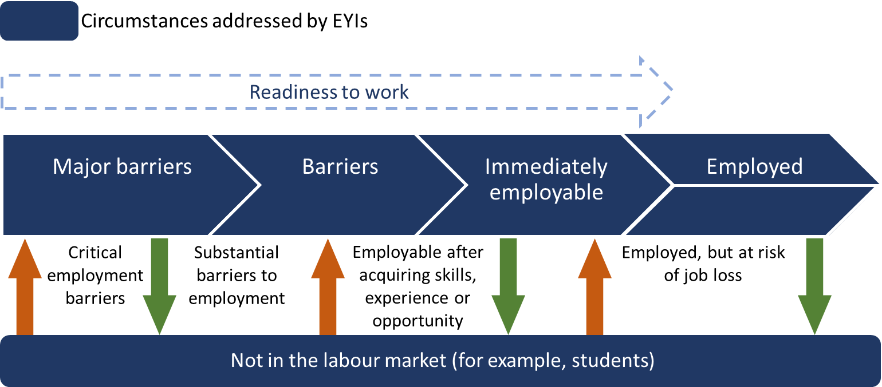Figure 2.4: Work readiness

Figure 2.4 presents circumstances EYI participants may be experiencing that impact on their readiness to work. Participants can face Major Barriers, Barriers, be immediately employable, employed or Not in labour force. The figure suggests that as participants address these circumstances their work readiness can improve and they can move towards being Employed. The figure also shows that even when employed, participants can move to not in labour market.

### School-based initiatives

Initiatives with a preventive focus for young people not yet in the job market primarily provided services to school students. The logic model associated with education retention differs from that associated with employment attainment and retention, and is presented in Figure 2.5.

While the importance of education and training has always been acknowledged, changes affecting the types of work available and the skills required to perform those tasks include:

* an increase in services sector employment — both absolute and in proportion to all vacancies
* an increase in employment in higher skilled occupations relative to lower skilled.

This reinforces the need for and value of education and training to compete in the labour market. Early school leavers have been identified as being at particular risk of long‑term unemployment.

Figure 2.5: Education retention logic model

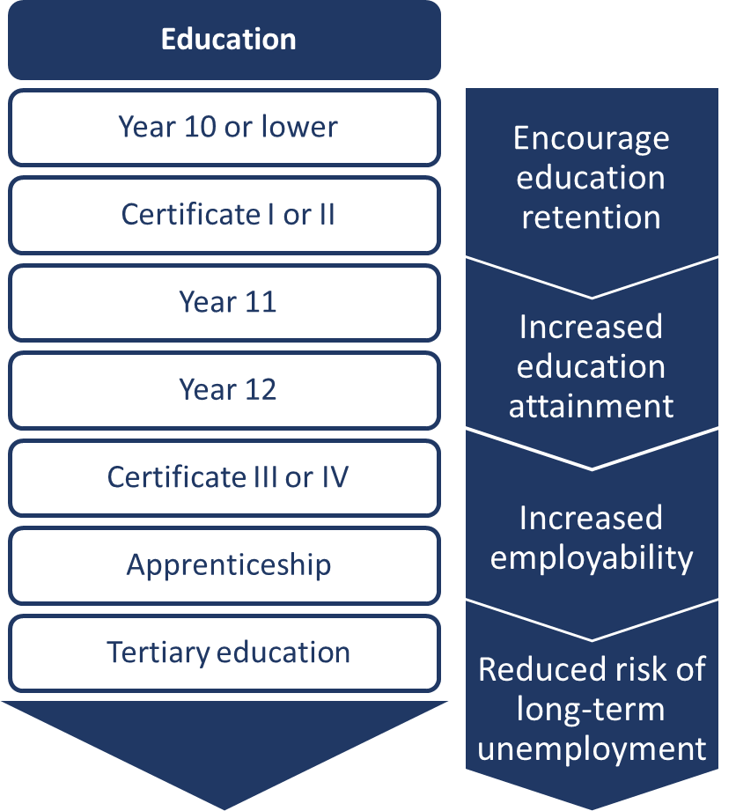Figure 2.5 presents increasing education levels, from “Year 10 or Below” through to “Tertiary education” and presents four areas of focus to reduce participants’ risk of long-term unemployment. For participants with Year 10 or below, focus on education retention. For participants with Year 11 or 12, encourage focus on education attainment. For those with certificates or apprenticeships, focus on increased employability, and for those with tertiary qualifications focus on reduced risk of long-term unemployment.

As an outcome, education retention is difficult to measure. This was an issue for several initiatives, such as the **Brisbane Broncos Career Club**, **MAS National — Cycle of Change**, **Big hART — 20 in 2020** and **NSW Business Chamber — Skillsroad Show**.

While factors affecting students and job seekers were often different, common issues included career planning and development, awareness of job opportunities, and the benefit of work experience. The immediacy with which pre-employment attributes were required differed between school students and other participant groups. Students would benefit (eventually) from improved employability over a long time period, whereas job seekers needed to improve their employability relatively urgently.

Students received services that aimed to provide them with direction and motivation to continue education. While this function is generally performed within the schooling system, EYIs showed that providing education outside the education system and with a stronger business focus appeared to be of value. Specifically this was demonstrated by **Graceades Community Cottage — Productivity Bootcamp in Construction** and **Colony47 — Backswing**.

Given the longer term pay-off from student-focused employment initiatives, they are difficult to assess using departmental metrics, such as time spent receiving employment services or income support. Student‑focused initiatives may also be less well suited to establishment, delivery and evaluation within a two year timeframe due to the need for longer term outcome measures.

### Not immediately employable

Participants frequently had a greater number of and more severe barriers than identified by referring organisations or initially disclosed by the participants themselves. This included high levels of participant disengagement and disadvantage.

Initiatives varied substantially in how they addressed participant barriers. In general, staff in most initiatives dealt with participants disclosing barriers as a component of their role in the initiative in the context of the relationship they had developed with the participant. If the issues were challenging, most initiatives were structured such that advice could be sought from peers, supervisors, internal experts and external experts (for example, counsellors, social workers, psychologists, mental health workers and agencies that specialised in specific issues).

Barriers faced by initiative participants included a lack of formal identification documents, unstable accommodation, legal and financial issues, disability, substance misuse and mental health issues, limited access to support services, and distance from services and employment opportunities.

Many initiatives discovered that although their initial focus had been on eliminating a specific barrier this was not necessarily sufficient and might have been minor in comparison with other previously undisclosed or unidentified barriers.

Certain barriers were of such magnitude that a participant would have difficulty securing employment until they were addressed. Addressing these barriers was essential to progress these unemployed youth towards job readiness but was not necessarily sufficient to ensure their employability. Without intervention it is unlikely that these young people would progress to employment. The logic model underpinning this is outlined in Figure 2.6.

Figure 2.6: Major barriers to job readiness logic model

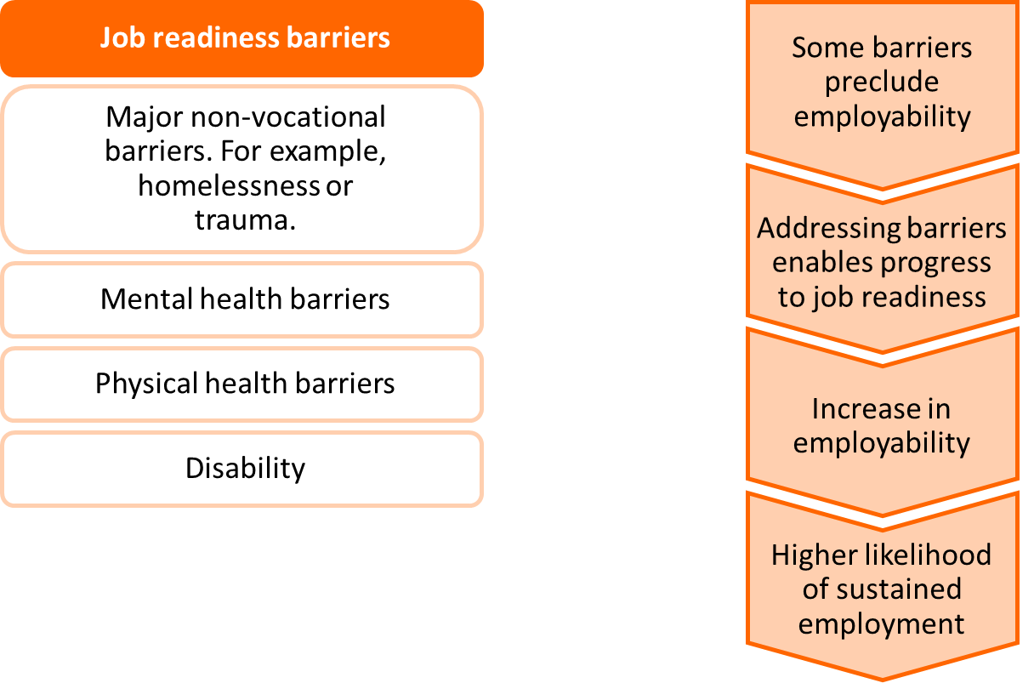

Figure 2.6 highlights job readiness barriers, such as homelessness, mental health barriers and disability and steps through four steps to employment. The first step is noting that some barriers preclude employability. The second is addressing barriers to enable progress to job readiness. The third is increasing employability. The fourth is enabling a higher likelihood of sustained employment.

Some initiatives, particularly in Round One, aimed specifically for participants to achieve employment. For these initiatives it was possible to determine with some level of accuracy their success in achieving that outcome, using departmental data. For initiatives aiming to facilitate progress towards work readiness, assessing that outcome is less clear as there is no definitive measure of such progression. This led to a degree of subjectivity about the initiatives’ success. Sufficiently comprehensive evaluation data is difficult to capture without a universally accepted and applied measurement tool. The need for better data would have to be addressed if an initiative focused on increasing work readiness or decreasing disadvantage or disengagement were to progress to the pilot phase.

Qualitative research clearly showed that initiatives focused on participants with disability, such as **Brain Injury SA — SSAYiT** and **Vision Australia — Building Stronger Futures**, were able to assist participants to address pre-employment barriers. These initiatives achieved increases in motivation, confidence, self-esteem and direction. While these were important achievements for the initiatives and participants, and supported by the relevant program logic, there remains a need to connect them to existing or future employment outcomes.

Time spent driving with participants created an opportunity for service providers to build relationships with young people, enabled genuine disclosure and provided an opportunity to identify and address fundamental non-vocational barriers in the **ATEL — Road2Wheels** initiative.

**Anglicare WA — Designing for an Independent Future** and **Whitelion — Solid Youth** were explicitly attempting to work with homeless youth. It is widely accepted that security, including secure accommodation, is a fundamental precondition for employability.

The extent of unanticipated barriers reported by initiatives suggests that this was a problem among long‑term unemployed youth and that any future initiative should include contingency planning for this eventuality.

#### Participant disadvantage and disengagement

The overall target group for EYI was young people identified as experiencing, or at risk of, long-term unemployment. Two factors that affect long‑term unemployment are disadvantage and disengagement.

The terms disadvantaged and disengaged are somewhat subjective. Disadvantage generally comprises finances, social supports, personal experiences, and personal and family characteristics. The department uses a tool called the Job Seeker Classification Instrument to provide a proxy of the level of disadvantage a job seeker is experiencing. This tool was not used as a primary means for assessing EYI participants’ levels of disadvantage as there were many participants who were not registered with employment services. In some instances providers also developed their own tools.

While there is no agreed set of measures of disadvantage, disadvantage is generally measured in terms of economic situation (e.g. income), social support (e.g. social networks) and personal characteristics (e.g. health and educational attainment).[5]

Factors that can influence the extent of disadvantage include:

* language and literacy problems
* insecure housing and homelessness
* substance abuse
* criminal history
* generational unemployment
* physical and mental health issues
* sole parenting responsibilities
* abuse and trauma.

For EYIs, the extent of participants’ disadvantage was derived from qualitative research with EYI participants, providers and stakeholders. The results can be largely categorical and dependent on disclosure and self-reporting from the individual.

Disengagement is likely to be influenced by multiple related and concurrent vicious cycles. Factors that contribute to and reflect disengagement include:

* low self-worth (a function of self-confidence and perceived competence)
* distrust of organisations, institutions, and people
* disillusionment (loss of hope) in relation to the future and attainable opportunities
* disenfranchisement (perceived rejection) from mainstream society
* limited participation in work or study.

#### Provider experiences with disadvantage and disengagement

The department required that disadvantage be identified as part of information management and so that it could inform providers’ servicing. Despite this, some initiatives had anticipated less disadvantage than they encountered. Key learnings from providers’ servicing of disadvantaged and disengaged young people include:

* Organisations with experience in dealing with disengaged and disadvantaged youth were surprised at the extent of participants’ barriers. That is, many participants referred to their services had more significant barriers and challenges in their lives than the providers had initially anticipated.
* Intensive interaction in a trusting environment eventually resulted in an increased willingness to disclose barriers, thus clarifying the reality of the personal situations faced by initiative participants.
* Disengagement can significantly diminish willingness to disclose and increase the time required to build a relationship that might permit disclosure.

An issue raised in several of the initiatives was that within a group of disadvantaged and disengaged youth the extent of these issues can vary significantly. It was felt that current classification data (on literacy, numeracy, disability, risk of homelessness et cetera) did not adequately distinguish between the different degrees of disadvantage participants experienced. This meant that the reported range of disadvantage among groups of participants could be assumed to be narrower than what actually existed. Figure 2.7 shows a hypothetical situation where disadvantage is on a spectrum and some disadvantages may be greater barriers to employment for some participants than others. There were also disadvantages that had a profound impact on an individual but would not have received significant weighting in any categorisation of disadvantage. For example, a physical ailment such as severe psoriasis does not impede work capacity but may result in low self-esteem and social exclusion, affecting employability.

Figure 2.7: Extent of participant disadvantage

Figure 2.7, Extent of participant disadvantage, shows that actual disadvantage as a line and a hypothetical line partially underneath not capturing the actual disadvantage.  

Figure 2.7 shows a hypothetical situation where disadvantage is on a spectrum and some disadvantages may be greater barriers to employment for some participants than others. The figure is a hypothetical graph that aims to show that Classifications of disadvantage do not fully capture actual disadvantage.

Participants’ willingness to disclose disadvantage and disengagement is crucial and not doing so can be a barrier in itself. The implications of non-disclosure include:

* Without accurate details about participants’ circumstances and barriers, constructing a comparison cohort in order to conduct impact analysis based on participant outcomes becomes challenging.
* The amount of effort required for a participant to achieve job activation, or even job readiness, increases as relevant and effective services cannot be identified and provided in a timely way.

Disadvantage and disengagement can be considered to exist on a continuum from moderate to extreme, see Figure 2.8 as a visual representation. Categorisation across these dimensions creates a simplified process for classifying participants as having:

* few barriers and general willingness to engage
* multiple and potentially significant barriers and a general willingness to engage
* few barriers but unwillingness to engage
* multiple and potentially significant barriers and unwillingness to engage.

Figure 2.8: Categorisation of disengagement and disadvantage

Figure 2.8, Categorisation of disengagement and disadvantage, a four segment model from Moderate disadvantage to extreme disadvantage and moderate disengagement to extreme disengagement.A figure presenting four categories of disengagement and disadvantage to describe the likelihood of participants engaging. First, participants with Moderate disengagement and Moderate disadvantage participants face few barriers and are willing to engage. Second, participants with moderate disengagement and extreme disadvantage face substantial barriers but are willing to engage. Third, participants with extreme disengagement and moderate disadvantage face few barriers but are unwilling to engage and are likely feel a sense of hopelessness and disillusionment. Fourth, participants with extreme disengagement and extreme disadvantage face substantial barriers and are unwilling to engage, are likely to distrust services and are disenfranchised.

It seemed that initiatives that specifically focused on addressing these barriers, rather than an employment first approach, were configured in ways that made them more suited to differing levels of disadvantage and disengagement. The following were important in the design of initiatives for people with substantial disadvantage and disengagement:

* Shorter term initiatives were better suited to less disadvantage and disengagement.
* Extreme disengagement and disadvantage requires substantial time to address and, as a result
* improved job readiness may be a realistic measure of success
* 12 months to two years may be insufficient to measure a project’s success, particularly where success is defined as achieving employment outcomes.

Participant disadvantage and disengagement were not homogenous within initiatives. Initiative design, implementation and outcome measurement requires more detailed understanding of the degrees of disengagement and disadvantage.

Job-seeking EYI participants varied in terms of their actual readiness to work, largely as a function of the number, type and extent of their barriers to employment and level of disengagement.

Figure 2.9: Preconditions for labour market attachment

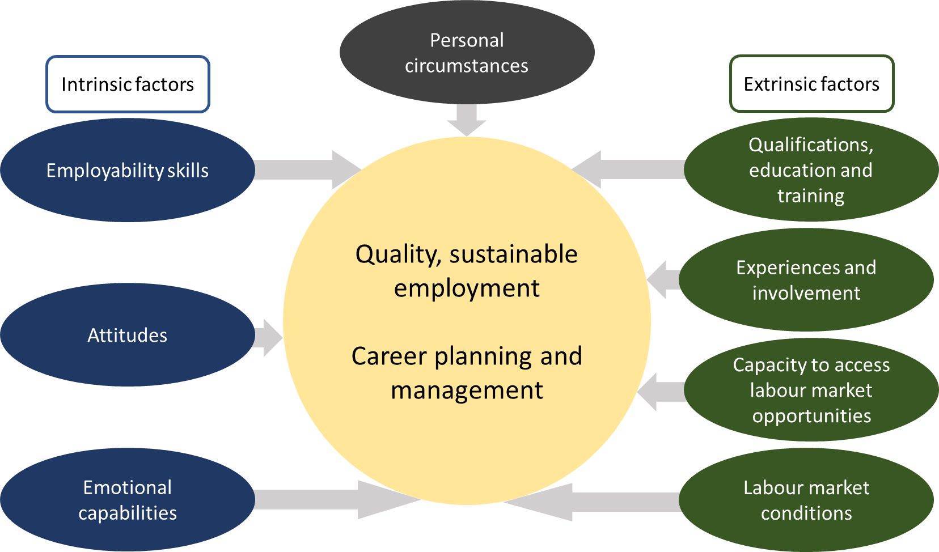

Figure 2.9 Identifies Intrinsic and Extrinsic Factors and Personal circumstances that are required or contribute to quality, sustainable employment and career planning management. The Intrinsic Factor are Employability Skills, Attitudes, Emotional capabilities, the Extrinsic factors are Qualifications, education and training, Experiences and Involvements, Capacity to access labour market opportunities and labour market conditions. The figure suggests that creating a network of stable economic and social support is a precondition for labour market attachment.

Some disadvantaged and disengaged participants were capable of obtaining and retaining employment with little additional intervention. Other participants required specific training and experience, and perhaps additional soft skills and confidence.

There were some participants with serious barriers who were assessed as far from being ready to be employed, as depicted in Figure 2.9 Identifies Intrinsic and Extrinsic Factors and Personal circumstances that are required or contribute to quality, sustainable employment and career planning management. The Intrinsic Factor are Employability Skills, Attitudes, Emotional capabilities, the Extrinsic factors are Qualifications, education and training, Experiences and Involvements, Capacity to access labour market opportunities and labour market conditions. The figure suggests that creating a network of stable economic and social support is a precondition for labour market attachment.

. This appeared to be more prevalent in Round Two than in Round One primarily due to the participant eligibility criteria used in Round Two. The majority of initiatives were reported to have progressed participants towards job readiness, as employment outcomes were not a primary goal within the initiative period.

### Employed but at risk

Several initiatives, such as **headspace — Digital Work and Study Service** and **Digital Industry Mentor Service**, **Black Swan Health — Youth App Empowering Employment**, and **Impact Community Services — Employment FirstAid (E+)**, were focused on providing support, particularly in relation to mental health, for those already employed.

Placing a value on and measuring youth mental health is very difficult, and therefore difficult to evaluate using criteria available to the department. What can be concluded with certainty is that many disadvantaged and disengaged job seekers experience emotional and mental health challenges. Initiatives working towards reducing such challenges may provide benefits to job seekers, communities and ultimately society and could be integrated with employment services.

# Learnings from the activities delivered

This section summarises and analyses activities delivered by EYI providers. It incorporates:

* Success factors — initiatives and initiative components that worked and the elements that seemed to have influenced that success
* Initiative challenges — barriers and challenges to initiatives achieving their goals
* Learnings — insights for future programs, and the department more broadly, that did not fit directly into one of the previous categories.

## Work experience and work-like activities

Lack of work experience was a key barrier to employment. Employers value potential employees with a demonstrated ability and willingness to attend work regularly and in a timely manner, do what is requested of them and be motivated to remain positively engaged.

Work experience and work-like activities underpinned the vast majority of initiatives. Many initiatives focused on employment outcomes and attempted to improve their participants’ work experience. Some student-focused initiatives also incorporated work experience.

### Temporary unpaid placements

Temporary unpaid work experience placements were a key component of several initiatives, including **Top End Group Training — Becoming a Worker**, **Geelong Ethnic Communities Council — Equip!**, **Workforce Plus — 20Squared**, and **Fraser Coast TESS — Driving School Social Enterprise**.

While it appeared that such initiatives presumed that securing unpaid work experience placements would be relatively straightforward, establishing these placements often proved to be an insurmountable challenge. In many instances this requirement was removed from providers’ funding agreements.

There were examples of successfully arranging temporary unpaid placements, such as in the Sydney Kings **Charity Bounce — Hoop Dreams** initiative. This was achieved by using an established and well-recognised brand with broad corporate connections that were leveraged to secure internships, job placements and unpaid work experience. While the Sydney Kingsbrand was fundamental to establishing relationships with businesses, it was probably more critical that the relationships already existed.

Temporary unpaid work experience placements are a viable and beneficial approach to addressing a lack of work experience, but face a number of challenges. Competition for work experience placements between providers from other programs, including school-based work experience, is a significant issue, particularly in regional and remote areas of Australia. There is a need to identify pre‑existing relationships between potential providers and the organisations from which they plan to obtain work experience placements.

Figure 3.1: Competition for work experience placements

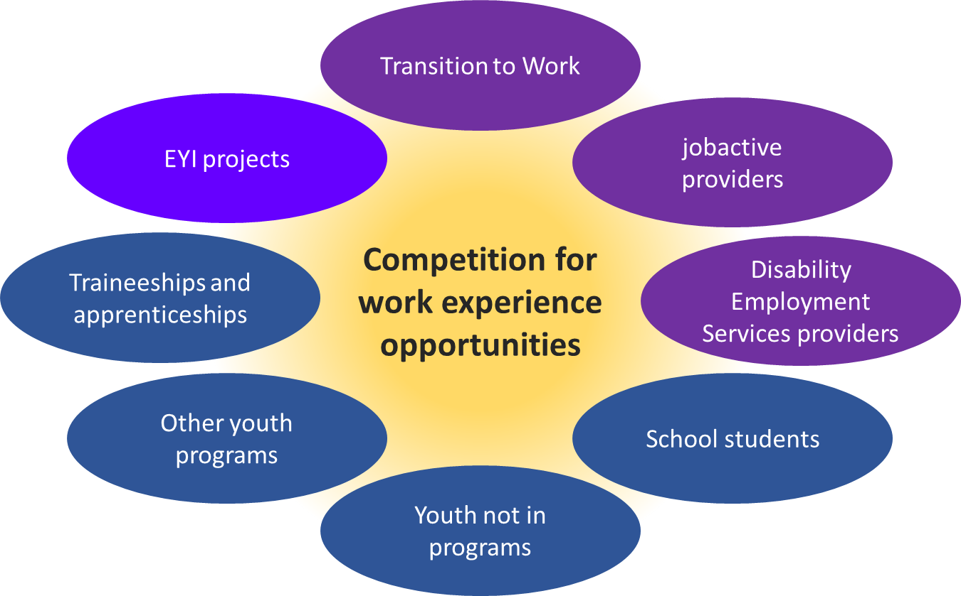Figure 3.1, depicts the many types of activities and programs that compete for work experience opportunities, these being: Transition to Work; jobactive providers, Disability Employment Services providers; school students; youth not in programs; other youth programs; Traineeships and apprenticeships and EYIs.

### Workplace creation

A number of initiatives elected to create or use a pre-existing workplace in which participants could gain work experience. Some initiatives created work environments tailored to their specific project objectives:

* **Big hART — 20 in 2020** developed a community arts project venture.
* **Graceades Community Cottage — Productivity Bootcamp in Construction** created a construction work yard.
* **Kiama Community College — NextGEN Digital Development** developed a consulting business.
* **Workforce Plus — 20Squared** created virtual reality (VR) development teams.
* **Colony 47 — Backswing** established a range of simulated workplace projects where participants pitched their ideas to a panel of local community representatives, including local employers.

Others created social enterprises or quasi social enterprises (replicating a social enterprise but not employing participants permanently):

* **Great Southern Employment Development Committee — Young Harvest**
* **United Synergies — Buzzing**
* **Whitelion — Solid Youth**
* **Workskills — Youth Entrepreneurial Services**
* **Settlement Services International — Youth Pathways and Placement Project**
* **Queensland Youth Services — Recycle Your Dreams**
* **iEmpower Youth — iEmpower Youth Cooperative.**

Some key advantages of social enterprises was averting the need to identify and arrange work experience with employers and across locations and providing cost‑effective work experience. These advantages were particularly evident in some regional communities where there were limited job opportunities. A balance is required, however, given that cycling new participants through work experience roles means these staff are less skilled and their lack of experience can increase the cost of delivery for the social enterprise. Failing to recognise and address this can reduce the financial viability of the social enterprise.

Creating a work-like environment was useful as it could be adapted and configured to meet the initiatives’ and the participants’ needs. There were substantial variations in the types of work environments created by initiatives.

**Graceades Community Cottage — Productivity Bootcamp in Construction** appeared, to a greater degree than other initiatives, to require participants to fit the mould of the initiative. Its activities and structure were the most like full-time employment, with participants spending eight weeks in a construction yard, progressing towards attending for full work days five days per week. In particular, through attending Productivity Bootcamp, participants became accustomed to a work routine and developed a good work ethic which was highly valued by employers.

**Great Southern Employment Development Committee — Young Harvest** had a strict requirement to attend (unpaid) personal and professional development one day a week in order to qualify for paid work (at award wages) the next day in the social enterprise. This approach was well received by participants, staff and stakeholders. The rules for participation, while strict, were developed in consultation with the young people. This level of autonomy and responsibility itself built trust between participants and staff.

Payment at market rates improved participants’ financial position, provided a work‑like environment and improved morale. Given the disadvantages faced by some participants, requiring only two days per week of training and work was an appropriate level of intensity as they transitioned to being work ready.

Initiatives such as **United Synergies — Buzzing**, **Big hART — 20 in 2020** and **Workskills — Youth Entrepreneurial Services** tailored participation to fit participants’ needs.

Participants could respond positively to a multiplicity of approaches to initiative structure and engagement. Success across such varied initiatives suggests that the creation of work and work-like initiatives that are designed around local community needs provides a clear opportunity for the department to address the critical work experience barrier. The most significant challenge with workplace creation is how to achieve this cost-effectively.

### Job placement and employment outcomes

Initiatives differed in their specific focus and emphasis on employment outcomes. Some initiatives, particularly in Round One, were explicitly focused on achieving employment outcomes rather than addressing barriers as part of this process. Others, most notably in Round Two, were more focused on addressing employment barriers and facilitating progression to employment as and when appropriate for the participant.

While most initiatives achieved job placement successes, these tended to be idiosyncratic rather than systematic. This meant that each placement required new and additional work on the part of the providers, with limited opportunity to achieve any scale efficiency in these approaches. In part this occurred because initiatives were often dealing with levels of disadvantage that meant participants were not job ready and also because the initiatives were evolving and developing.

**Graceades Community Cottage — Productivity Bootcamp in Construction** was in part the exception. It was relatively successful in achieving employment outcomes. Elements that contributed to this included:

* providing participants with experience in a genuine work environment
* focusing on the provision of specialised skills with direct and immediate application
* being geographically located where there is current and anticipated future demand for the skills being taught
* providing participants an opportunity to develop their skills alongside skill specialists (tradespeople)
* pre-existing relationships with potential employers or referrers
* integration with a construction-focused labour hire company.[6]

Success in achieving job placements is influenced by the availability of potential job opportunities. Where an initiative provides a specific set of skills (in this case construction), multiple large employers are needed for participants to move from the initiative into employment. For this reason, rural and many regional locations may find it harder to achieve job placement and employment outcomes.

The availability of local employment opportunities constrained employment placements. Many initiatives were located in places where there was substantial competition for entry-level jobs. In some regional locations there were multiple initiatives, including several funded by the department, all seeking job placements for a limited number of participants. In such environments, initiatives were competing for job placements with other agencies and with young people who found their own employment.

This makes it more challenging for disengaged and disadvantaged youth (and, by association, any initiative providing support to them) to find employment, compared to young people (and programs) in labour markets where demand exceeds supply. As a consequence, any employment outcomes in highly competitive labour markets are achievements against the odds.

### Student work experience

While job placement was not a primary goal of most of the interventions focused on school students, there was a strong view that work experience with organisations whose references would be well regarded was of value when participants eventually sought employment. This was a goal of the **Brisbane Broncos Career Club**, in which work experience arrangements were implemented with employers who had no previous experience of employing young Indigenous people. Although not all participants wanted or obtained job placements while studying, many did secure employment. Employers also gained the confidence to recruit additional Indigenous participants and expand the work experience initiative. In addition, the potential for long-term casual employment opportunities for Indigenous students was built with local employers.

## Intensive support

Many initiatives took on a caseload of young people who were disproportionately disadvantaged and disengaged relative to the community area in which the service was being run. Even initiatives that were not targeted at such participants discovered that many of their participants faced significant barriers that had previously not been identified or disclosed. Initiatives dealing with such participants consistently provided intensive assistance, which is defined in relation to EYI as follows.

Intensive assistance is the most personalised and intensive form of assistance and is offered to eligible job seekers who are long-term unemployed or who are at risk of becoming long‑term unemployed. It supports job seekers to overcome multiple and complex non‑vocational or vocational barriers to employment. Intensive assistance is generally more individualised and may include vocational training, work experience, literacy and numeracy training, English as a second language classes, wage subsidies, workplace modifications or referral to additional specialist services.

One element of the intensive support was significant one-on-one assistance and time dedicated to each participant. Further, there was often a willingness, where possible, to engage with participants for as long as required for a positive outcome to be achieved for the participant. As would reasonably be expected, this increased the cost per participant and put substantial pressure on the EYI providers’ time and resources.

Fundamental to the provision of this type of intensive support was the capacity for building trust with participants and managing barriers during participation. Establishing trust and building rapport was an important element of keeping young people involved and engaged. In addition to requiring staff with appropriate skills, attributes and attitudes, time was a key component. It was identified across initiatives such as **Colony 47 — Backswing, Great Southern Employment Development Committee — Young Harvest**, **Brain Injury SA — SSAYiT**, **Whitelion — Solid Youth**, **headspace — Digital Work and Study Service** and **Digital Industry Mentor Service**, and **Baptist Care SA — Tumbelin Go** that:

* participant ‘attachment’ took at least six weeks
* early involvement by a participant in initiative activities was a strong indicator of subsequent engagement
* participant barriers were a reason and sometimes an excuse for poor early engagement
* additional preparation time might be required if group participation is required
* to provide optimum support, programs may need to operate with small, intensive caseloads
* staff need to support young people holistically across all areas of life, not just education or employment
* basics such as adequate food and stable accommodation cannot be assumed
* partnerships with soft entry[7] organisations are enormously valuable when reaching vulnerable young people
* certain participant groups may require case management services on an outreach basis
* some support needs were of higher priority than employment
* small group sessions could provide a safe environment for young people to connect with peers who had similar problems, making them feel validated, supported and understood.

### Personal, direct and holistic support

The nature of interactions with participants was an important component of the successful delivery of intensive support.

In successful initiatives, participants felt there was genuine concern and commitment to helping them improve their situation, resulting in a genuine sense of agency for the young person.

Features that facilitated a positive learning or work environment included:

* A holistic approach: all elements of the participant’s life were important — work skills, emotional wellbeing, mental health, diet, physical health et cetera.
* Respect: participants were offered things that would benefit them and whatever decision they made was respected.
* Involvement: the initiative ensured that participants were involved in considering options and making decisions.
* Limits and rules: the initiative had limits that were clearly articulated and for which a compelling logic could be articulated.
* Expectation: the initiative operated with the assumption that participants could and would succeed.
* Individual support: the initiative offered different types and levels of individual support, be that addressing initiative-related issues with staff or being referred to an external service for issues beyond the scope or skill of the initiative staff.
* Personal goals and targets: staff worked to identify individuals’ strengths and weaknesses and to identify options that would facilitate personal progression.
* Judgement: staff worked hard to ensure that participants did not feel judged and to separate critical advice about what a participant was doing (or not) from criticism of them as a person.
* Tailoring: activities were tailored, in part, to meet the needs of individuals.

The extent and intensity of a young person’s engagement could vary over time, particularly for the most disadvantaged and disengaged participants. Providing support for these participants required a capacity to capitalise on periods of high motivation, acknowledging fluctuations in motivation and engagement.

For example, during the **Anglicare WA — Designing for an Independent Future** initiative, which supported homeless young people, four ‘personas’ were developed that mapped job readiness, time and motivation. This concept, outlined in Table 3.1**,** is a useful framework for comprehending some of the variability that might be observed among participants. This could be used as the foundation for a more comprehensive analytic tool based on the identified underlying dimensions, including:

* initial job readiness
* initial motivation
* subsequent motivation
* ongoing motivation
* motivation constancy or variability.

Table 3.1: Anglicare WA participant personas

|  |  |
| --- | --- |
| Persona 1  Not job ready  Motivation starts high  Motivation then variable | Persona 2  Job ready  Initially motivated  Motivation declines over time |
| Persona 3  Not job ready  Motivation starts low  Motivation then highly variable | Persona 4  Job ready  Motivation starts low then peaks  Motivation then declines quickly |

## Mentoring services

Mentoring in the EYIs consisted of:

* external mentors with a primary focus on work and career facilitation
* internal mentors who operated more like coaches or case managers.

The latter application was closely related to the provision of intensive support, and key elements included those previously addressed in relation to:

* Intensive support
* Personal, direct and holistic support
* building resilience.

External mentoring is versatile and is used to help participants prepare for work, to support new employment placements and as a post-placement support tool. Mentoring was generally considered a productive way of providing guidance to young people. In the EYIs it was delivered face to face and through phone calls, online conferencing and email.

**Geelong Ethnic Communities Council — Equip!** intended to link young people with mentors from an industry of interest to the participant. This was not achievable, and feedback suggested it was unnecessary for the target audience.

The **headspace — Digital Industry Mentor Service** included volunteer industry mentors. While the service was developed to connect participants with industry experts, many participants were mostly interested in general career advice and assistance.

Although securing mentors was a challenge for some initiatives, it was achievable.

Preparation was essential for a successful mentoring program. Clear systems and guidelines for the operation of the program were required so that mentors knew their role. Attempting to acquire mentors on an ad-hoc basis did not resonate with mentors, and leaving the mentor to their own devices to make contact with the mentee and undertake administration was likely to lead to a breakdown in the relationship between all parties.

Both the initial mentor matching and rapport building between mentors and mentees were important. Depending on the profile of the participant group, sufficient time was required to identify and potentially address participants’ barriers to ensure they were in appropriate personal circumstances for mentoring.

Skilling up and supporting mentors is an essential and often underestimated requirement. A mentor handbook was developed by **headspace — Digital Industry Mentor Service** to support its volunteer industry mentors, and this was expanded to incorporate general career support and the resources provided to participants.

## Non-traditional hands-on (kinaesthetic) learning

Initiatives with participants who were disengaged from school or at risk of becoming disengaged recognised that learning environments replicating that experience would be inappropriate.

A number of initiatives focused on activities that were hands on, largely kinaesthetic and associated with non-traditional training approaches. This was particularly valuable to participants for whom conventional mainstream schooling was not well suited. Most of the initiatives that created a work (or work-like) environment, as discussed above, used a somewhat hands-on approach to training and skills acquisition. The opportunity to learn and be active simultaneously was very positively regarded by participants and strongly endorsed by initiative staff.

A key element of **Graceades Community Cottage — Productivity Bootcamp in Construction** was the industry-based training that was delivered in a non‑traditional style in construction yards. This was more closely aligned with coaching than a typical classroom setting. This non-traditional approach of training on a work site proved well suited to developing construction skills. A similar approach was used in other initiatives, such as **United Synergies — Buzzing** and **Great Southern Employment Development Committee — Young Harvest**, and was generally considered to be positive.

It is important to emphasis that the more traditional classroom learning environment can still be applied, as it depends on context. The initiatives **ECA Training — Indigenous Apprenticeship Readiness Program**, **Apprentices Trainees Employment Ltd (ATEL) — Road2Wheels** and **Workskills — Youth Entrepreneurial Services** had some elements that might have been considered traditional ‘book learning’. The key to their success was that the classroom environment was:

* generally not a key focus
* generally clearly linked to a specific purpose
* interspersed with alternative activities that engaged participants
* implemented in a manner that enabled successful completion by participants.

**ECA Training — Indigenous Apprenticeship Readiness Program** included learning with elements that had to be school-like. While not the mode of training best suited to this cohort, it was provided with sufficient coaching and individualised support to make it acceptable.

**ATEL — Road2Wheels** delivered some initiative elements in what might be considered traditional classroom circumstances but this was positively regarded by participants. It was suggested that the personal style of those conducting the sessions made a fundamental difference. The relationship of **ATEL — Road2Wheels** staff with participants was considered to be one of coach, mentor, supporter and friend, adopting the personal, direct and holistic approach outlined in the previous section. **Workskills — Youth Entrepreneurial Services** involved both classroom activities with the ‘Coaching Young People For Success’ training program and hands-on product development and retail selling.

## Addressing barriers and building resilience

For many disadvantaged job seekers, transition to a point of job readiness required changes to their motivation, resilience, skills, self‑perceived competence and confidence.

The initiatives most able to implement this enabled participants to experience and build on success. While not restricted to initiatives with a controlled work‑like environment, it appeared to be most easily implemented in these environments.

Figure 3.2, Virtuous cycle of progression to job readiness, a cycle diagram from participants sets an individual goal through to improved confidence and willingness to take risks to achieve goals. Figure 3.2: Virtuous cycle of progression to job readiness

Figure 3.2, is a circular flow model illustrating a virtuous cycle. The cycle starts with participants setting individual goals with a focus on the achievable ones, and links this in turn to a series of steps that form a circular positive feedback loop including:

* Goals are aligned with behaviour in the program
* Behaviours are practised and demonstrated within the program
* Participants receive relatively immediate feedback
* Achievement build a sense of competence
* A growing sense of competence builds confidence
* Improved confidence encourages a willingness to take greater risks and attempt to each more challenging goals then back to Participants set individual goals an focus on the achievable ones.

For many participants, not achieving a goal had historically resulted in a perception that they, as a person, were a failure. Initiatives that increased participants’ confidence, motivation and resilience were ones that broke this nexus so that not succeeding did not make participants perceive themselves as failures. Many participants had been conditioned by this cycle of failure and negative self‑perception for a considerable period of time. It was not always a rapid transformation; there were often setbacks and careful nurturing was needed.

Critical to this was setting goals that could be achieved, allowing participants to experience a sense of achievement and, once a level of mastery was attained, set new goals that were still achievable.

In combination these factors created a virtuous cycle through which improvements in self-confidence were integrated with goal achievement, which improved participants’ sense of being competent. Participants received feedback relatively immediately in a positive manner. Where necessary, individual coaching and support enabled improvements to be implemented, turning something that might otherwise have been perceived as critical into an opportunity to improve.

Continued positive feedback created the conditions for improving participants’ self-efficacy, which was foundational for achieving a sense of agency, in relation both to work and to life more broadly.

A further advantage of using a workplace or workplace‑like environment as the context for addressing barriers was that participants were learning skills that would have direct application in a work environment. Enabling participants to develop soft skills was valuable beyond the work environment, but the skills could also be practised and mastered in the work‑like context.

## Incentives

Some initiatives developed different incentives to engage young people and reward active participation. In the cases of **MAS National – Cycle of Change**, **Great Southern Employment Development Committee – Young Harvest**, **Workskills — Youth Entrepreneurial Services**, and **Fraser Coast TESS — Driving School Social Enterprise** the initiatives attempted to implement reward systems such as a pseudo‑currency, physical rewards (a bicycle and related equipment) or cash payment model.

Learnings from initiatives with rewards systems indicated that in order to motivate participants or encourage a desired behaviour:

* participants had to be aware of the reward and regularly reminded about it
* rules for how to obtain the reward had to be clear, transparent and applied consistently
* participants had to be able to see their progress towards obtaining the reward
* the reward had to be perceived as worthwhile by participants
* the reward had to be delivered as soon as possible following the activity being rewarded.

Not applying rules consistently caused issues for some EYIs, particularly where multiple locations and different staff were involved in recognising achievement, monitoring progress (or accumulation of pseudo‑currency) and providing the agreed reward. When there were clear stages in the initiative and the reward was equal for all participants (as in **MAS National – Cycle of Change**, **Great Southern Employment Development Committee – Young Harvest**) there was less difficulty in applying rules, monitoring achievements, providing and tracking the accumulation of rewards.

The rewards varied from providing bike parts intended to indicate that upon completion a BMX bike would be given to the participant, pseudo currencies that could be used to purchase services or products to a cash payment at the award wage in return for work. The cash payment (**Great Southern Employment Development Committee – Young Harvest**) was the most similar to work‑like conditions and its application, with very strict eligibility rules, was well regarded by young people and the provider as an incentive.

Incentives themselves were well regarded by participants even if clear rules were lacking and were inconsistently applied, as it was perceived as an acknowledgement, yet a consistent message was that the best incentive was obtaining a job. This finding is consistent with the Job Commitment Bonus[8] for Young Australians Evaluation, which found that job seekers did not necessarily perceive the bonus as an incentive in comparison with what they could earn from working.

# Learnings from the delivery process

## Initiative marketing and awareness

As outlined in Figure 4.1, EYI awareness and marketing involved developing relationships with potential participants, potential referrers, the community, and one or a combination of potential employers and educators.

Figure 4.1: Initiatives’ relationships

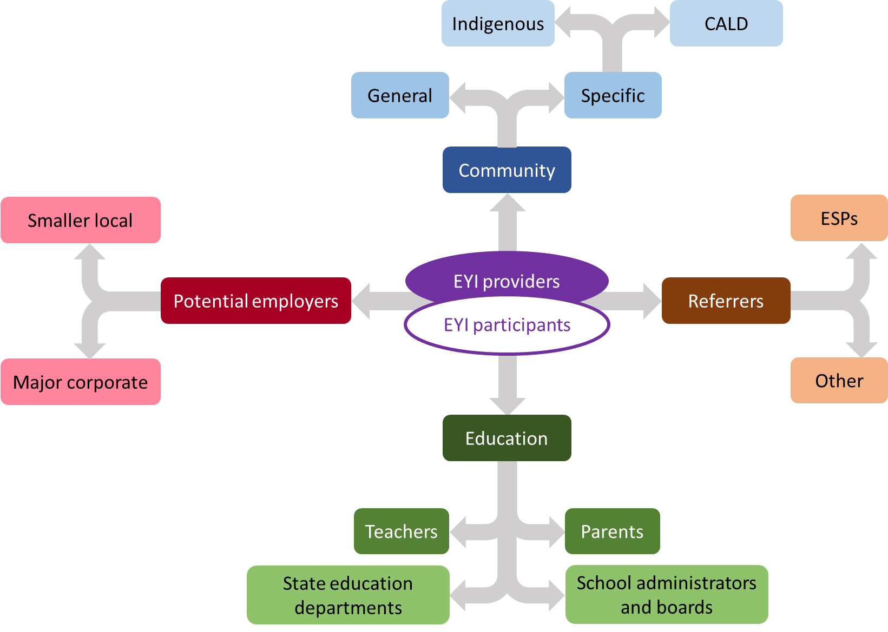Figure 4.1 is a data flowchart illustrating the relationship of EYI providers and participants, with other key stakeholders, these being Community, Referrers, Education and Potential employers. Examples of education stakeholders are Teachers, Parents, State education departments and school administrators and boards. Referrers can be to ESPs and other; Potential employers can be smaller local and Major corporates; and Community can refer to General and Specific services including Indigenous and CALD.

Note: Employment Services Providers (ESPs)

EYI providers generally required support from at least some of these stakeholders. In many instances some relationships already existed but others had to be newly established.

As the EYIs offered a new suite of interventions and services, stakeholders (employers, service providers, community organisations and young people) were not initially aware of them. An exception was some initiatives’ capacity to build early relationships with relevant potential referral organisations, such as employment services providers and community organisations.

Initially it appeared that initiatives struggled to establish sufficient awareness and support, although ultimately most initiatives benefited from positive word of mouth and achieved increased awareness over time.

Awareness was generally better when:

* the target audience was both clearly and appropriately defined and easily accessible (such as students at a school)
* the initiative ran in a location that the target audience already frequented (such as a school)
* the initiative was based on a pre-existing initiative which the target audience was already aware of or participating in
* the organisation implementing the initiative had pre-existing contacts and connections
* the initiative had clear benefits for the participants and referral organisations
* the organisation running the initiative had existing high levels of brand awareness
* the initiative was achieving outcomes valued by participants or stakeholders, generating positive word of mouth.

Challenges to building awareness that were common to more than one initiative were:

* Initiatives at the concept design stage were less able to clearly articulate their potential benefits and how these would be delivered, as they were still evolving.
* Community organisations often ran programs that did not require direct marketing to potential participants.
* Some initiatives needed to engage with stakeholders that they were less familiar with, or with known stakeholders in unfamiliar ways.

Once participants are aware of an initiative, misalignment between their perceptions of it and what the initiative actually delivers can produce unintended consequences. For example, the **Workskills — Youth Entrepreneurial Services** initiative was initially perceived as an opportunity to become an entrepreneur and thus attracted some participants who were effectively job ready but wanted guidance on how to operationalise their entrepreneurial idea. These participants were better suited to a program such as the New Enterprise Incentive Scheme (NEIS). Because what they wanted could not be delivered in **Workskills — Youth Entrepreneurial Services**, they were ultimately not engaged with the initiative.

YMCA and headspace were also established and well-known brands. This benefited the headspace initiatives but not YMCA. This may have been a result of brand alignment, in that:

* headspace was offering initiatives to youth in areas aligned with mental health — probably the core focus and the core attribute of the headspace brand
* YMCA was operating in regional Indigenous communities, with which it had no obvious brand association and where its experience may not have been as well established.

The big corporate brands of the Sydney Kings and Brisbane Broncos were used to leverage their marketing expertise immediately and with great effect.

Notwithstanding brand value, initiative appeal was ultimately determined by what was offered and delivered to participants. Important elements included:

* expectation of work experience or job placement
* staff who cared about participants
* unthreatening opportunities to gain skills and experience
* specific skills of interest (for example, obtaining a driver’s licence or construction training)
* rewards, such as payment or acquisition of other benefits
* inviting physical environments.

While marketing challenges were encountered by many initiatives, particularly towards the start, it appeared that most had been adequately resolved by initiative completion.

## Community engagement

Initiatives were generally implemented by organisations that were locally based and tended to have local premises and local staff and to be known in that location. This meant initiatives commenced with a degree of local awareness and existing relationships. Initiatives attempting to operate in communities where they had no previous, or a limited, foundation, such as **Fraser Coast TESS — Driving School Social Enterprise**, **Top End Group Training — Becoming a Worker**, and **YMCA of Perth — Swim for Life** struggled to achieve operational effectiveness.

Community support was important, particularly for initiatives that focused on specific communities such as the **Brisbane Broncos Career Club**.

Findings from several EYIs suggested that, in Indigenous communities, the community’s support for an initiative was an important factor for success. The close familial nature of Indigenous communities meant that initiatives without community support faced substantial challenges to their viability. It is important that community representatives are aware that:

* the initiative will benefit their youth and the community more broadly
* initiative staff have genuine respect for, understanding of and desire to improve the situation of Indigenous Australians
* the initiative will allow genuine community input and collaboration.

Some areas contained many employment programs (federal, state and local) that focused on working with Indigenous youth. This reduced the potential value of EYI to some communities and increased competition for participants between the available services. Communities that had limited, if any services of this kind may have benefitted more from these EYIs than those where employment services for young indigenous people were already available.

CALD communities were also quite connected, enabling information about an initiative to be communicated relatively effectively and word of mouth to directly affect the initiative. Initiatives such as **Geelong Ethnic Communities Council — Equip!** and **Settlement Services International — Youth Pathways and Placement Project** benefited from their ability to generate awareness through pre-existing contacts and networks.

Smaller regional communities were similar in that they were connected, with the potential for word of mouth to spread quite efficiently.

## School engagement

While the logic of addressing school to work transition and pre-empting youth unemployment is compelling, for such initiatives to succeed they need to be accepted and ideally embraced by the participating schools.

While this seems to have been achieved by initiatives, it appears to have been largely a result of building relationships with individual schools. However, scaling of initiatives involving schools is likely to require some interaction with the departments that are ultimately responsible for schools. This might entail negotiation and collaboration on a state by state basis. Collaboration with departments of education would also support the department’s desire to make evidence‑based decisions about initiatives by enabling access to relevant student records.

School stakeholders included school administration and management, teachers, parents, and in some cases state departments of education. Initiatives operating in specific schools, such as **Brisbane Broncos Career Club** and **Big hART — 20 in 2020**, achieved high levels of awareness within the school community.

The initiatives most successful in demonstrating appeal and engaging schools:

* demonstrated the benefits for students
* clearly elucidated which students would benefit
* demonstrated understanding of the schools’ needs and priorities
* demonstrated understanding of the requirements of key school stakeholders (for example, parents and potentially departments of education).

Elements contributing to a positive relationship with schools included:

* staff who could speak knowledgeably to schools, ideally with prior experience in education
* addressing student needs across the academic spectrum
* elements that appealed to the entire school and its broader community (for example, visits from Brisbane Broncos players)
* ensuring no additional burden on the school.

The attraction for schools was outcome related, and obtaining their commitment to an initiative required a discernible education benefit, such as:

* increased school attendance
* improved grades
* reduced classroom disruption
* student retention and continued education
* paths (for example, to employment) for those leaving education.

## Employer engagement

Employer support was beneficial for many initiatives and particularly important for those with work experience placement and job activation goals. While many initiatives were not explicitly focused on employment outcomes, this was the ultimate goal.

Leveraging associations with local employers contributed to positive employment outcomes.

Organisations with pre-existing connections to employers were already familiar with the processes of building business relationships. Staff at **ATEL — Road2Wheels** had significant relationships from their previous employment, and these were used to create opportunities for initiative participants.

While employers might engage with an initiative for philanthropic reasons, this would have limited potential if an initiative was to operate on a larger scale. It was clearly advantageous to offer a clear commercial benefit to businesses. For example, with **Brisbane Broncos Career Club** there was the attraction of the Brisbane Broncos brand and players, plus the opportunity to provide employment for young Indigenous people and consequently support fulfilment of corporate employment goals.

Sydney Kings **(Charity Bounce — Hoop Dreams)** andBrisbane Broncos **(Brisbane Broncos Career Club)** were established and well‑known brands with close to universal awareness and inherent appeal. They were able to leverage their marketing expertise rapidly and with great effect.

Association with these brands was appealing, a factor that was enhanced by any perceived opportunity to engage with players. These (and probably similar sports brands) appealed to potential participants and other stakeholders, such as employers. These organisations were particularly good at building relationships with larger corporate businesses, due to the perceived value of association and their experience liaising with corporate organisations.

Initiatives could also focus on servicing employers as part of their strategy. This was evident with **Impact Community Services — Employment FirstAid (E+)**, where the focus was on providing assistance to employees to retain their job and consult with the employer where appropriate to manage any issues (such as mental health support or transport assistance) that may have impeded employment sustainability. This approach was particularly beneficial to small businesses who are not sufficiently resourced to offer services to staff such as mental health support.

## Referral sources (employment services providers)

Ensuring a sufficient flow of young people referred to an initiative was essential for fulfilling participant targets and to demonstrate proof of concept. Referrals came from the following sources:

* School-based initiatives were, to varying degrees, able to access participants according to processes agreed with the specific school.
* Job seeker participant referrers comprised organisations already in employment services and those that interfaced with this space, such as local housing, community and mental health providers dealing with youth.
* Initiatives focused on specific community groups such as **Settlement Services International — Youth@Work** and **Youth Pathways and Placement Project** (migrants and refugees) and **Vision Australia — Building Stronger Futures** (vision impaired) were able to refer people already engaged with the organisation to their initiative and use existing contacts and resources.

Some participants self-referred. For many of the community-based initiatives, self-referral was initially generated from marketing initiatives such as brochures and pamphlets, and those from positive word of mouth increased over time.

Initiatives that were extensions of existing programs, such as **Big hART — 20 in 2020**,benefited from pre-existing awareness.

Initiatives also referred internally from other parts of their own organisation or from close associates. Initiatives such as **Settlement Services International — Youth@Work** and **Youth Pathways and Placement Project** and **Workskills — Youth Entrepreneurial Services** were able to refer internally. Others such as **United Synergies — Buzzing** and **Black Swan Health — Youth App Empowering Employment** exchanged referrals with a co-located and associated headspace centres.

A clear benefit from changes to the Round Two initiatives was that existing jobactive providers were able to deliver initiatives, providing an obvious source of internal referrals.

It had been anticipated by most of the initiatives dealing with job seekers, particularly in Round One, that referrals would flow readily and smoothly from jobactive and other employment services providers (ESPs). While some initiatives generated referrals from jobactive and Disability Employment Services providers, the numbers of these were generally lower than initially anticipated.

For initiatives focused on assisting job seekers, most initial referrals were from organisations and networks with which the initiative provider had pre-existing connections. This was the case for **Charity Bounce — Hoop Dreams**.

Initiatives’ experiences with referral reflected their overall experience of establishing and commencing the initiative. They could not engage in substantial marketing and promotion until they had fully specified the initiative content and were ready to accept participants. Delays in initiative commencement had a direct impact on marketing and consequently on the timing and rate of referral.

Once initiatives were established, and particularly once there was evidence of participant benefit, initiative marketing could use case examples for promotion. This was a powerful communication tool, outweighed only by a referring agency experiencing positive outcomes for a participant it had referred.

Factors that influenced the extent of referral success included:

* the extent to which the initiative provider was already known to referring organisations
* pre-existing connections with referring organisations
* the effectiveness of the marketing activities undertaken
* the initiative’s ability to demonstrate positive outcomes for participants.

To a degree, securing ongoing referrals was a process of building awareness and confidence, something that inevitably took time.

### Limitations on referrals

Initiative planning, particularly for the Round One EYIs, presumed that jobactive providers would be a primary and consistent source of referrals. For most initiatives this did not eventuate, and alternative strategies were implemented with varying success. For Round One EYIs this was a major barrier, particularly earlier in the initiatives.

While some of these issues were addressed for the Round Two initiatives it remained challenging to recruit the number of participants specified in funding agreements.

Initiatives struggled to comprehend why they were not strongly supported by ESPs, given that from their perspective:

* they were not competing with jobactive providers for outcome payments
* jobactive providers would benefit from any employment outcomes contributed to by the initiative that were likely to result in an outcome payment
* prospective participants were less employable
* there was no cost to the employment services provider for referral, although some of the initiatives on offer may not have fulfilled a job seeker’s Mutual Obligation Requirements
* the initiative would help progress participants towards job readiness, if not directly to employment.

EYI providers felt that these factors comprised a distinct and attractive value proposition for providers. This was not borne out by referrals from ESPs. Stakeholders from several EYIs suggested that a combination of factors might have created barriers, including:

* ESP staff did not easily accommodate new and unfamiliar initiatives. Some ESP staff interviewed had limited awareness about EYIs, and confusion around how EYI interacted with a young person’s mutual obligation requirements. Initiatives did not automatically integrate with other elements of employment services, resulting in jobactive providers needing to source other activities. The additional paperwork this created may have been a deterrent to referring to EYIs.
* EYI providers assumed that helping a job seeker was inherently of value to an ESP.
* EYI providers assumed that providing value to an ESP would automatically translate into action by ESP staff.
* ESPs’ experiences with short‑term initiatives that did not continue may not have been positive.
* Some jobactive providers were hierarchical, with limited decision-making by provider staff and sometimes even the local office.
* jobactive staff caseloads afforded limited time and opportunity to consider the needs of individual participants.
* The initiatives on commencement[9] were not always fully formulated, sometimes resulting in initial value propositions that were too complex or insufficiently clear.
* Turnover of ESP staff required repeated ‘re-selling’ of the initiative.

While some initiatives did eventually develop strong referral relationships with jobactive providers, this was the exception. In some instances Round Two initiatives overcame this issue, particularly when the EYI provider was also an employment services provider.

Challenges securing job seeker referrals contributed to decisions by some initiatives to focus on students rather than on job seekers as initially intended. It also resulted in initiatives sourcing participants from organisations other than ESPs (capturing young people who were not on income support but may not have been in employment, education or training), increasing the number of participants not formally engaged with the employment services system.

While initiatives demonstrated some capacity to achieve positive outcomes with participants, their role within and interaction with the overall employment services system remained unclear.

Initiatives could be viewed as standalone modules, interfacing with but not integrated within the overall employment services system. For initiatives focused on facilitating employment continuation and education retention such an approach has a compelling logic, as both are somewhat removed from the immediate activity of progressing the unemployed to employment. Figure 2.4 illustrates stages on a path to employment, including where initiatives focused on education retention and maintaining employment would apply.

For initiatives focused on participants whose ultimate goal was employment, integration within the employment services system was a more fundamental question.

Some initiatives attracted and worked with participants closer to job readiness (**Graceades Community Cottage — Productivity Bootcamp in Construction**) while others were focused on those with very substantive barriers (**Anglicare WA — Designing for an Independent Future**). While these targeted initiatives were often successful in addressing issues related to their area of focus, how they integrated with other employment services was less obvious. While an initiative might resolve some barriers and progress a job seeker towards job readiness, it was unclear what the next step would be for the participant when returning to the more traditional employment services.

The challenge of building referral relationships with jobactive providers suggests integration planning and design will be critical for future projects or programs such as EYI.

Figure 4.2: jobactive and EYI involvement in the employment services system

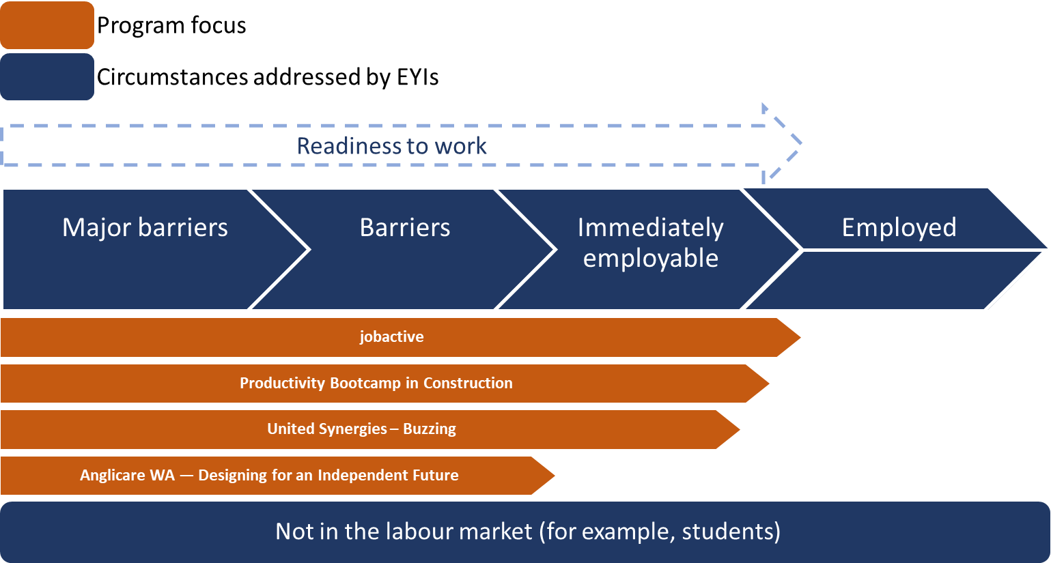Figure 4.2, is a Work readiness diagram of the barriers to readiness to work with employment service programs, such as jobactive, and EYIs being depicted as involved with participants through addressing major barriers, barriers and initial employment. This involvement fades away once young people are employed.

To aid integration of innovative initiatives with larger employment services programs such as jobactive, Transition to Work and ParentsNext, options that emerged from the EYI experiences included:

* co-location of a range of services, as demonstrated by **United Synergies — Buzzing** and **Anglicare WA — Designing for an Independent Future**
* operation of discrete services by a single provider, such as **Workskills — Youth Entrepreneurial Services**
* partial integration of services, such as **Graceades Community Cottage — Productivity Bootcamp in Construction**, where one partner focused on addressing barriers and the other provided skills and employment pathways.
* Greater integration at the policy development phase, for example regarding mutual obligation requirements.

## Staffing

Staff with the right skills, knowledge, and motivation were critical to initiatives’ success. The qualitative fieldwork from many initiatives indicated that staff were highly regarded by participants and other stakeholders.

Staff availability was the first consideration for many initiatives. Metropolitan initiatives, as might be expected, had little difficulty finding and attracting good staff. The exception was **iEmpower Youth — iEmpower Youth Cooperative**, where the initial salaries were below market rates and the operational challenge of obtaining Registered Training Organisation accreditation inhibited securing appropriate staff.

In locations with smaller populations, staffing was commensurately more difficult. In some locations, appropriate staff proved almost impossible to find. This was the case for **YMCA of Perth — Swim for Life***,* where difficulties securing staff led to significant delays. **Baptist Care SA — Tumbelin Go** identified similar challenges in regional locations.

Successful initiatives generated strong and productive relationships between staff and participants. Disengaged and disadvantaged youth benefited from continuity of contact that was warm, empathetic and genuine, with staff sometimes operating as trainers, coaches, mentors, case managers and counsellors all in one. Providing the required intensive support demanded spending time together.

Initiatives focused on specific industry skills needed to identify staff with occupational skills who were capable of dealing with disadvantaged youth and then align them with staff skilled in addressing non-vocational barriers. In some instances, staff meeting these requirements were scarce. Involving tradespeople as trainers in **Graceades Community Cottage — Productivity Bootcamp in Construction** drew on their knowledge, their practical experience in construction and also their connections in the construction sector, facilitating job opportunities for initiative graduates. **United Synergies — Buzzing** was fortunate to have an experienced barista who was also trained as a youth worker. These industry-focused initiatives were highly leveraged on access to staff with the right mix of skills. **Brisbane Broncos Career Club** showed the importance of having inspiring Indigenous staff members to provide leadership to young Indigenous people.

Staff were passionate about improving the lives of young people and this passion was reflected in their approach to work. Many initiatives identified staff contributing unpaid hours, making themselves accessible to participants as needed and using personal contacts to facilitate their progression towards employment.

While they were generally well supported, staff in some initiatives did not always have access to the internal support and training that would have been beneficial. These would certainly be required if the initiatives operated for more extended periods.

## Governance

As with staff training and support, not all providers had pre-existing policies and procedures covering topics such as a code of conduct and ethics, confidentiality, human resources, financial management and occupational safety and health. Those that did generally fared better than those that had to establish these procedures and processes before the initiative began or while it was operating.

As noted in

Figure 2.3, some initiatives involved greater risk. Clear oversight and procedures for managing issues provided more transparency and capacity for the early identification and resolution of issues.

Larger organisations (for example, headspace and Sydney Kings), those operating initiatives in which they already had substantive grounding (for example, headspace) andthose familiar with operating large standardised programs (for example, Anglicare WA and Workskills) were more likely to have pre-existing approaches to oversight and operational governance that were consistent with initiative requirements and departmental expectations.

Where steering committees were specifically developed to report to the governing board and senior management within the organisation, this level of structure supported progress, as demonstrated with **Brisbane Broncos Career Club**.

This was demonstrated by **Great Southern Employment Development Committee —Young Harvest** which, despite developing a social enterprise at the ideation and concept design phase, had these types of policies in place at the organisation level that could be applied to the initiative.

Conversely, **Fraser Coast TESS — Driving School Social Enterprise** and **Wirrpanda Foundation — Bidi Waalitj Project** did not have these processes well developed, a factor that for **Fraser Coast TESS — Driving School Social Enterprise** was exacerbated by operation across multiple sites.

While some processes and required documentation contributed to administrative burden, they also ensured accountability and transparency, which provided clear direction to staff and stakeholders.

# Learnings from specific intervention types

## Social enterprise

The EYIs that categorised themselves as social enterprise initiatives (**Workskills — Youth Entrepreneurial Services**, **Settlement Services International — Youth Pathways and Placement Project**, **Queensland Youth Services — Recycle Your Dreams**, **Great Southern Employment Development Committee — Young Harvest**, **Whitelion — Solid Youth**) provided participants with opportunities to gain work experience, acquire specific skills or develop work-like habits. It is important to emphasise that, unlike at conventional social enterprises, participants cycled through different roles within the enterprise rather than being employed by it. This provided opportunities that might otherwise have been unattainable to gain experiences in a less intense environment.

Initiatives established within the broad definition of a social enterprise might eventually have become self‑funding but did not in the short to medium term. This was understandable given that their goal was to provide training and support to young people, not to optimise business efficiency.

Being focused on training and development might be advantageous because such initiatives are less likely to be seen as competing with commercial providers.

Social enterprises seemed to require a longer implementation time than other initiatives to commence participants, resolve issues, and reach an optimal level of service delivery. Several years would probably be required for such initiatives to become mature businesses, the point at which efficiency and effectiveness are optimised.

Created work environments provided an excellent context in which to address barriers, particularly in regional areas where limited opportunities for work experience exist.

## Digital

There were two main types of digital initiatives, one in which the digital element was fundamental and another where the digital component supported the initiative.

While digital service delivery has great appeal, it seems best suited to those for whom access to the technology can be guaranteed. This tends to exclude some of the more remote locations, due to a lack of reliable infrastructure. It also tends to exclude job seekers who are most disadvantaged, as it cannot be assumed that they have:

* any device other than a phone
* a sufficiently new device to ensure access to more recently developed software
* sufficient funds to ensure reliable access to the internet.

Initiatives based on digital delivery had mixed success. Both headspace initiatives were successful, while **Top End Group Training — Becoming a Worker** was unable to implement its proposed remote delivery due to infrastructure and system constraints.

The **Workforce Plus — 20Squared** initiative produced a VR simulation of a disability carer’s work environment. This type of simulation has potential, certainly as part of a suite, for broader integration into the process of career awareness and exploration. Online tools used by **NSW Business Chamber — Skillsroad Show**and **Employment Options — Pathfinder** could also be used as part of a suite for career awareness and exploration.

**Brisbane Broncos Career Club** developed an app (Popt.ag) to support academically oriented Indigenous students that was integrated with the NSW curriculum. This was regarded as particularly valuable but required real-time operation from a uniquely skilled staff member.

Several other initiatives included elements that were valued by some participants and offer potential value as supporting elements in future initiatives. These included digital games, wellness and mood apps, and online assistance references and resources.

## Sport

Several initiatives were built around sport.

Brisbane Broncos (**Brisbane Broncos Career Club**) and Sydney Kings (**Charity Bounce — Hoop Dreams**) were able to successfully use their massive brand power to good advantage. Both of these sports brands had pre-existing history with and commitment to their target audience.

**YMCA of Perth — Swim for Life** was focused on sport as an occupation: training students to become lifeguards. This attempt to replicate an initiative that had operated successfully in Perth was not successful in regional locations with Indigenous populations. The dual challenge of operating in smaller communities and attempting to engage Indigenous students was too substantial.

In instances where there are pre-existing relationships with a particular target audience, major sports brands can be leveraged to engage students and job seekers.

While not specifically sport focused, some initiatives were activity focused:

* **Baptist Care SA — Tumbelin Go** involved an adventure therapy component.
* **MAS National — Cycle of Change** involved BMX riding workshops.
* **Scouts Association of the NT — Motoscouts** involved teamwork to build a motorkhana-style car.

These types of engagement, which are interactive and activity based, were generally successful at attracting and retaining disengaged young people. Such engagement can also support learning, assist behaviour management and address other non-vocational challenges.

## Transport

Transport was a major challenge for many job-seeking participants and was a critical barrier outside metropolitan areas. Virtually all of the regional initiatives that required youth transport (either to the initiative or once employed) identified this as a barrier. Similarly **Vision Australia — Building Stronger Futures**identified transport as a significant barrier to participation for vision‑impaired youth.

In regional locations it was possible that no transport options existed. Even when local transport was available, challenges included infrequent and expensive public transport services and unsuitable timetables and routes.

Lack of a driver’s licence is a very significant barrier to employment for young people outside the major metropolitan regions.

Driving seemed the only viable solution to the transport challenges. A driver’s licence is essentially a requirement, holding additional employment value, in that it:

* enables the use work transport if required
* conveys personal responsibility associated with other positive attributes, such as reliability, which are valued by employers.

Although clearly an issue outside metropolitan centres, this was also identified as a barrier to obtaining an apprenticeship in construction or trade for graduates of **Graceades Community Cottage — Productivity Bootcamp in Construction**, as it was likely to be a prerequisite for such employment*.*

Not driving as an employment barrier was identified as a sufficiently substantive issue that it was the primary focus of **Fraser Coast TESS — Driving School Social Enterprise** and **ATEL — Road2Wheels** and was introduced as an option in other initiatives (such as **Eyre Futures — Eyre Peninsula Journey to Work**).

While costs impose a barrier, the more significant issue is obtaining a prescribed number of supervised driving hours. Barriers for disadvantaged youth include:

* availability of a licensed driver who is willing and able to supervise
* having a registered and insured car available for use
* lacking the personal information required to obtain a learner’s permit.

Variations between states in the requirements for obtaining a learner’s permit and driver’s licence complicate this issue. For example, age limits and unpaid debts can prevent someone from obtaining a learner’s permit. In the large eastern states, over 100 supervised driving hours are required before a driver’s licence test can be taken. Given different state requirements, one full-time driving instructor facilitating all supervised driving hours could progress between 13 and 20[10] unlicensed youth to the attainment of their license each year. This assumes that the instructor does nothing other than supervise driving.

Facilitating the attainment of driver’s licences for unemployed youth remains a challenge; however, it was noted that:

* accompanied driving provided a unique opportunity for building trust with a participant, providing advice and coaching. Anecdotal feedback from EYI providers also indicated that participants were more willing to discuss their barriers and personal circumstance and that this enabled better servicing
* integration with existing state-funded programs may provide a viable alternative.

# Departmental learnings

## Procurement

### Context

The procurement of the EYIs was resource intensive and varied from the department’s traditional approach in procuring employment services. The number and diversity of applications (197 in Round One and 287 in Round Two) to assess against the selection criteria was challenging as each submission offered something different.

There was also the challenge of identifying what was innovative and how to determine an appropriate ranking to approve the successfully tendered initiatives.

Splitting the initiatives into two separate rounds provided the department an opportunity to learn from Round One and to adapt in and incorporate into the assessment and implementation of Round Two.

### Learnings between tendering rounds

On completion of the Round One funding, an internal review of the departmental tendering was conducted. Some key results from the findings and conclusions were:

* Improvements to the assessment and submission processes, specifically a greater ability to discuss individual proposals and undertake market analysis to test claims. Introducing a two‑stage process allowed the department to assess initial proposals against a set of criteria and then:
  + provide specific advice to individual organisations about the appropriateness of their proposals
  + give providers the capacity to make meaningful alterations to proposals and initiative elements
  + better align initiatives with the goals of the program
  + enhance evaluation or testability.
* Improvements to the processes associated with establishing funding agreements, including stronger collaboration in refining the services to be offered, how they would be delivered, whether they were realistic, and whether they could be evaluated effectively.

Many organisations’ proposals had minor elements that met the goals of the EYI. However, often these elements could not be practically scaled up to meet the minimum number of participants (100), or higher participant targets that were set at the beginning of the initiatives. In some cases, reaching this requirement became part of a broader service plan that more closely resembled existing employment services models.

It was identified that a staged assessment process would smooth departmental processes and improve outcomes. Legal advice indicated that with such a process, innovation only needed to be assessed in the initial shortlisting phase. This approach was employed in Round Two.

Grant documentation and resources in Round Two provided a stronger definition of innovation for applicants and departmental staff compared to Round One. Assessors were trained to identify and rate innovation through early engagement with the innovation team and using an external innovation expert.

The shortlisting processes to assess innovation used in the grant assessment were generally successful, including:

* co-design meetings between applicants and the department
* written feedback for applicants before these meetings, which helped to focus discussions
* engagement through co-design, which developed positive relationships and a common understanding of initiative aims.

It was felt that the grant processes were clear and defensible, were completed on time and resulted in a sufficient number of grant proposals being selected.

Improvements to the process to develop funding agreements included:

* closely linking grant questions to funding agreements
* involving program staff with good funding agreement drafting skills, which allowed legal advisers to focus on technical matters
* holding three-way meetings with providers, legal advisers and the department to clarify and finalise funding agreements
* co-management and collaboration between the Delivery and Engagement Group and the program area in preparing funding agreements.

### Further procurement learnings from EYI

Challenges are inevitable during any process that involves developing, implementing and operating a diverse range of employment programs and services that are not standardised across the market. Insights from the EYI procurement process offers opportunities to minimise both time and risk in developing new services and programs that are tailored to local labour markets or cohorts of individuals at risk of long‑term unemployment. For example, consideration could be given to smaller scale initiatives that are faster to establish and lower risk to deliver targeted services — smaller both in absolute terms and relative to the size of the implementing organisation, noting that this would complicate the management of, and evaluations, of these initiatives.

### Refining the co-design process

A two‑stage process for assessing submissions was introduced for Round Two. This process proved effective for information sharing and further refining the service to be delivered, which helped to ensure value for money. A two‑stage process can be implemented consistent with the Commonwealth Procurement Rules or Grant Guidelines. Criteria for assessing submissions can be developed that meet the objectives of the procurement exercise as part of the first stage. Consideration should be given to incorporating the innovation framework, outlined in this report, as part of the initial assessment process for programs and services. This would inform the second stage of the process, which involves identifying risk, ensuring comparability in making assessments and determining value for money.

Opportunities exist for the department to facilitate implementation and risk mitigation through:

* ensuring that beneficial initiative elements are implemented before the initiative commences service delivery. For example, established referral relationships, processes and volume from employment services providers, which would provide some certainty about participant numbers and the project’s viability.
* ensuring information and existing departmental insights (about what potentially works and what does not) are available to prospective initiative providers to ensure their endeavours are adding to the knowledge base, that they are testable and that issues and challenges can be preemptively addressed.

### Flexible funding

The funding agreement (contract) for Round One was amended for Round Two to have standard contractual requirements and a separate project plan that outlined specific requirements for the initiative to deliver. This simplified the process and provided further flexibility in service delivery. A licensing approach could add further flexibility to adjust servicing and encourage initiatives to progress though the innovation cycle[11].

Funding agreements lead providers to deliver a relatively fixed business model that does not deviate from the original idea. This does not lend itself to the ‘fail fast’[12] model of innovation. For example, where funding agreements specified that an initiative would deliver specific pre‑employment training modules, changing the number and type of modules in response to participant engagement or feedback may have required a contract variation. In contrast, an agreement that supported a ‘fail fast’ approach would enable a provider to vary the modules delivered on a weekly basis, if necessary, without requiring the administration involved in varying a funding agreement. In reality, terminating failing grants is resource intensive and high cost, with the accompanying implication that the provider has failed.

A flexible funding mechanism that allows projects to evolve could also be useful.

Efforts were made to allow a degree of flexibility in the operation of the EYIs. However, flexibility can increase the degree of risk associated with a particular project. Alternative levels of flexibility and associated risk are presented in Figure 6.1.

Figure 6.1: Innovation process flexibility requirements

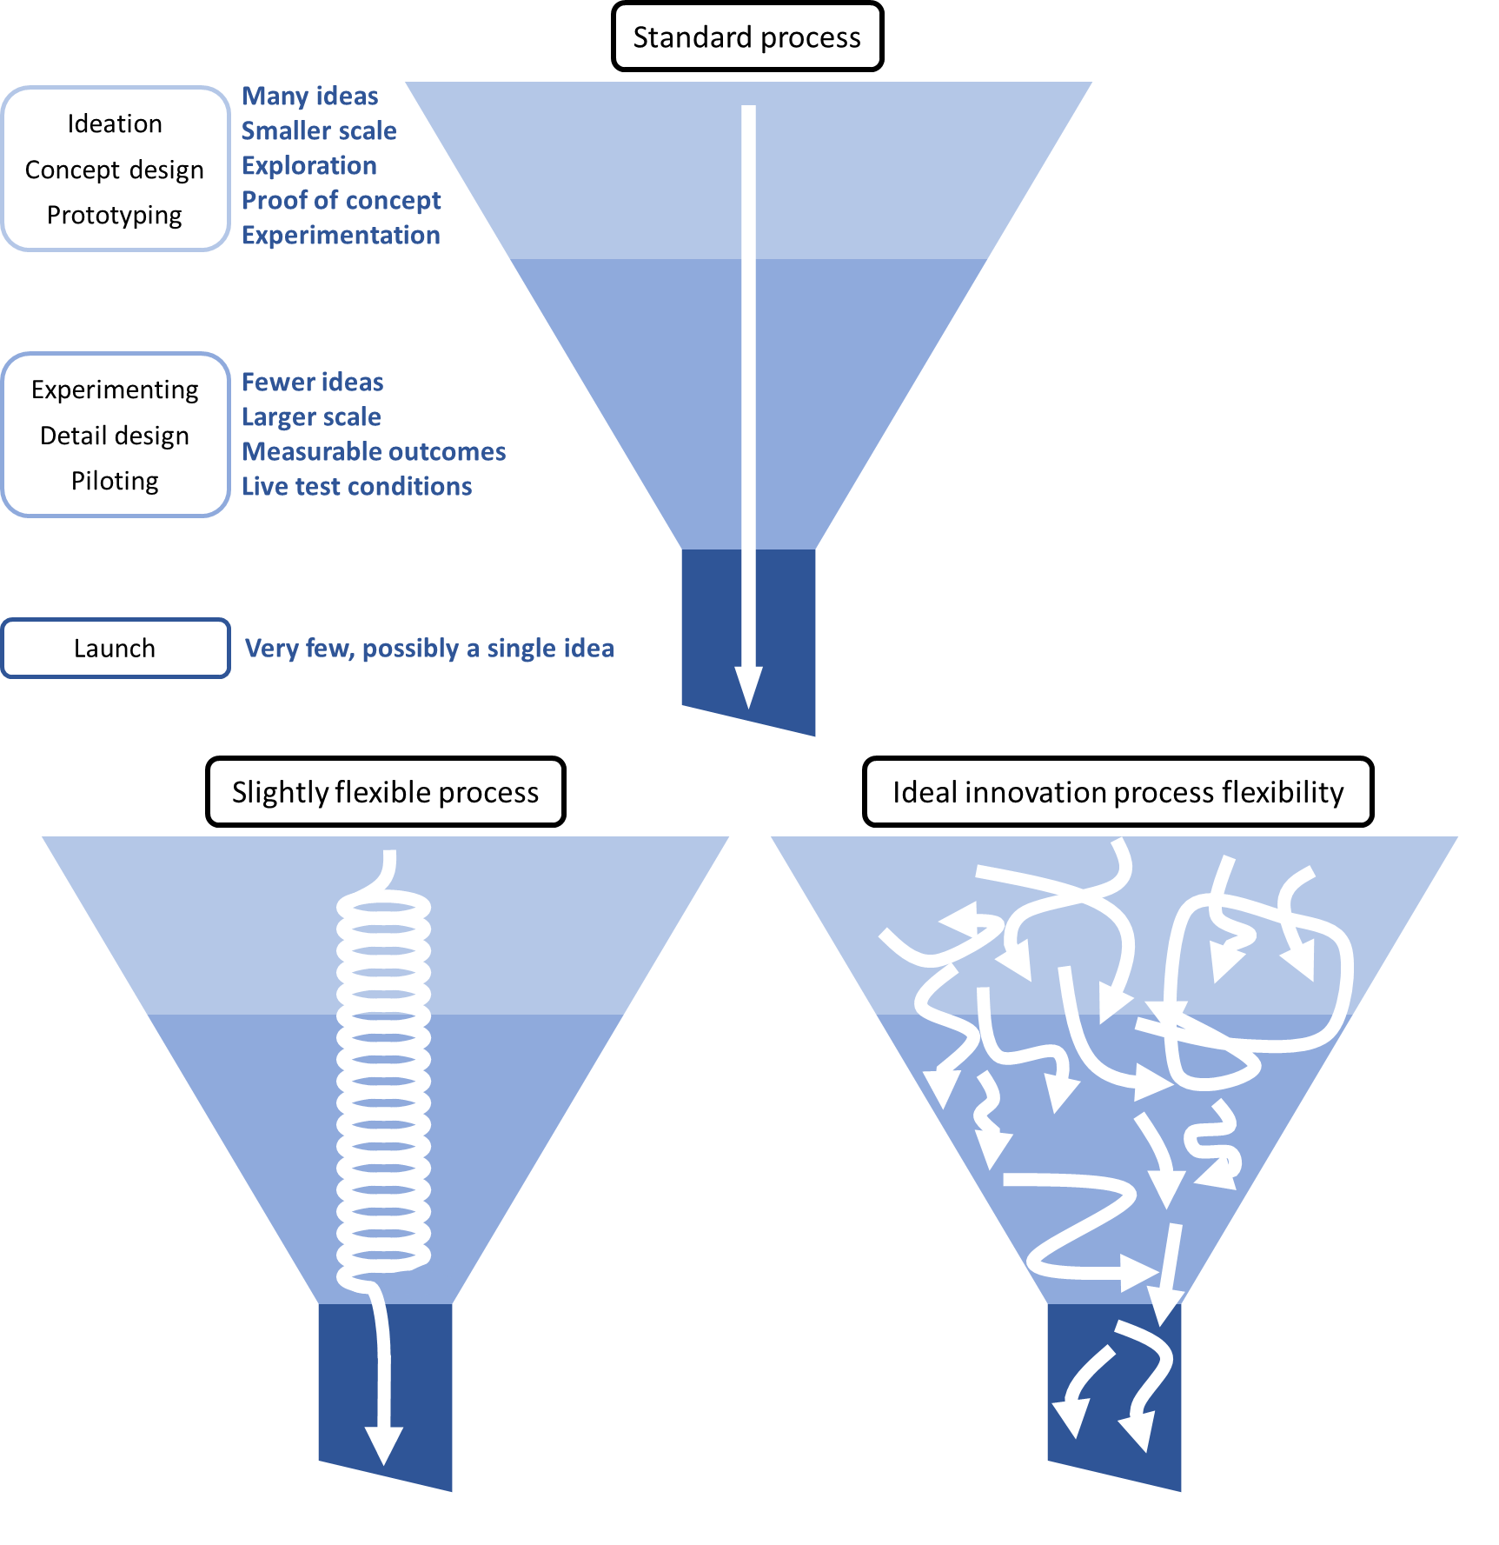Figure 6.1 presents three examples of different ways of achieving innovation in the Cambridge Innovation Model. The first is standard concept design, where innovation is presented as a series of steps that moves from ideation, concept design and prototyping, to experimenting with detail, design and piloting and then onto launch. Ideation, concept design and prototyping involve many ideas, is smaller scale and involves experimentation, exploration and proof of concept. Once experimenting with detail, design and piloting, there are fewer ideas, the innovation is larger scale, there are measurable outcomes and live testing of the approach. Finally, at launch there are very few or only one idea being used.

This is contrasted with a second approach to innovation, represented by a spiralling line, representing some fluidity through these elements. Finally, a third approach to an innovation of a is presented where multitude lines moving in different direction through concept design to detail design to launch, pointing to a far less sequential approach.

Innovation, particularly in its early phase, operates most successfully without constraint. If it were possible to predict in advance what was required to make an initiative successful, the earlier innovation phases would no longer be required.

A key departmental skill is managing for operational efficiency of outsourced and standardised large‑scale programs. Departmental systems, processes and to some extent culture are built around core principles and ideas, including:

* Probity in the expenditure of taxpayer funds is fundamental, including the capacity to justify any such expenditure.
* Probity requires the establishment of metrics that can be applied equally and objectively to all similar initiatives.
* Ultimately the department is responsible for maximising the opportunity for positive employment outcomes.
* Standardisation is an almost inevitable consequence of prioritising probity, allowing limited time for preparation and achieving scale in the context of a substantive history of working with standardised large-scale programs.

A key question arising from the individual EYI evaluations is: ‘How can the department create the flexibility required for the evolution of genuine innovation?’

A competitive grant with a fixed two-year timeline may not be ideal for funding innovative projects.

### Learnings from EYI scope

The initiatives addressed a range of issues and participants, including:

* current students potentially at risk of disengaging and becoming unemployed
* unemployed youth with substantive non-vocational barriers
* unemployed youth with disability, health and mental health challenges.

The logic of the department supporting such initiatives is compelling. However, it meant that those initiatives’ immediate short‑term goals and outcomes were related to health, social wellbeing and education, not to placing their participants in employment, as depicted in

Figure 6.2.

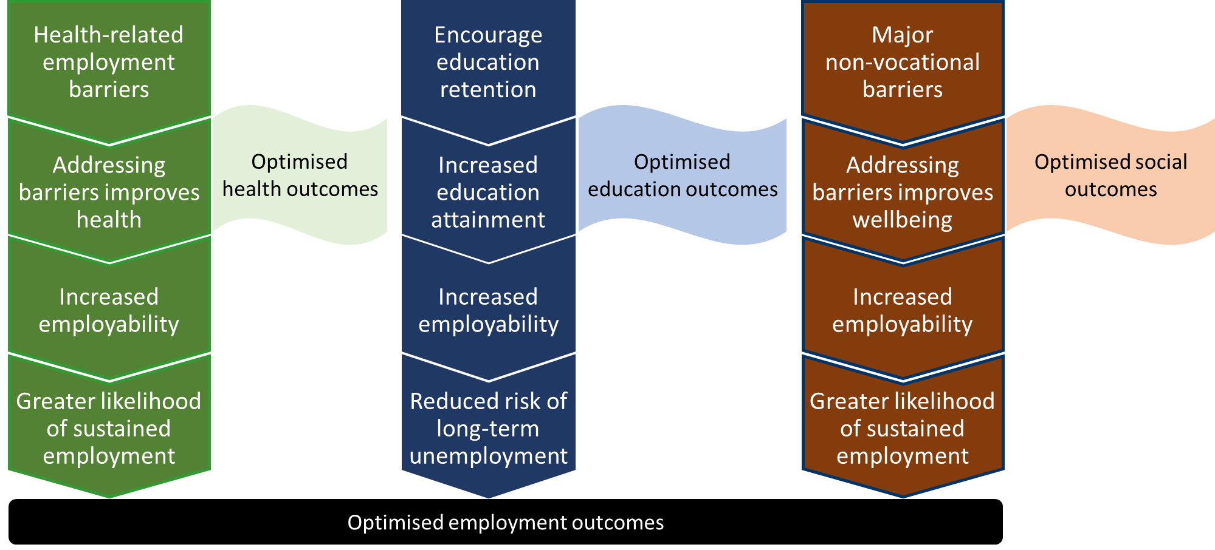Figure 6.2: EYI interim and ultimate outcomes  
Figure 6.2, is a chart showing three elements travelling in parallel: 1 Optimised health outcomes, 2 optimised social outcomes, 3 optimised educational outcomes. These optimised outcomes need to combine to optimise employment outcomes.

The optimised health outcomes flow is Health-related employment barriers, through to Addressing barriers to improve health leading to increased employability and greater likelihood of sustained employment.

The Optimised Social Outcomes flow is from Encourage education retention to Increased education attainment to increased employability and reduced risk of long-term unemployment.

The Optimised social outcomes flow is from Major non-vocational barriers to addressing barries improves wellbeing leading to increased employability and Greater likelihood of sustained employment.

In the case of education, some initiatives facilitated education retention in the process of achieving their goal of optimising employment outcomes. In the case of disability, physical health and mental health, the EYIs facilitated improved health in the process of optimising employment outcomes. In the case of major non-vocational barriers, the EYIs facilitated improved social wellbeing in the process of optimising employment outcomes.

While program logic strongly supports the department funding such initiatives, there are two distinct requirements for these initiatives to deliver employment outcomes. The first is that the initiative can deliver on its specific goal. The second is that the achievement of that goal leads to improved employment outcomes. The dilemma this creates for the department, as outlined in Figure 6.3, is:

* The achievement of improved mental health is a primary goal in itself.
* For the government, achieving improved mental health is more valuable if it then improves employment.

Figure 6.3, Risk associated with intervention outcomes, a flow chart combining initiative design with Optimised employment outcomes and the risks at each stage. Figure 6.3: Risk associated with intervention outcomes

Figure 6.3, is a logic chain that incorporates an initiative’s innovations with addressing education, health and social outcomes to improve employability. It aims to show there are risks at all of these stages and by addressing and managing these risks employability can be improved. Starting at the top and travelling vertically is the Cambridge innovation stage of Concept design, Detailed design to Implementation/Launch, leading to Initiative participant goals; then along to the right from Initiative participant goals is positive participant outcome, education, health and Social outcome, increased employability and optimised employment outcomes. In between each of these flows are risks.

For each of these initiatives, the logic chain leading to employment outcomes involved elements of risk at multiple stages. There was the inherent risk associated with the innovation process, compounded by the risk associated with linking immediate health, education, or social outcomes to a positive employment outcome.

An option for reducing risk and increasing flexibility to facilitate innovation would be to require that initiative components associated with addressing major barriers need to have already been proven. The department’s interest is then how to progress from having addressed these barriers to the next steps of reintegrating into education or progressing to employment.

The department could consider flexible mechanisms (for example, the City of Adelaide’s contract with a social innovation accelerator[13]) that allow projects to ‘fail fast’ or expand gradually as they demonstrate success. Installing an intermediary would enable the department to form a contractual relationship consistent with its core requirements while allowing individual initiatives to be managed according to key requirements for successful innovation.

Finally, as noted earlier, the integration of system elements is crucial. For the initiatives that demonstrate viability, the next critical step is determining how they can be integrated into the larger employment services system.

While several initiatives commenced with students as a primary or secondary target audience, there were also several that shifted their emphasis away from unemployed youth and towards students.

One of the key challenges faced, particularly by several Round One initiatives,[14] was working with unemployed young people, in particular identifying how to recruit and engage them and facilitate their employment. By shifting the emphasis away from dealing with unemployed youth, initiatives avoided addressing these challenges to their success. While this resolved some of the difficulties associated with delivering important project elements (such as participant recruitment), it also prevented potentially valuable learnings about how the organisations could overcome those challenges.

## Replication and scaling

There is a standard process for bringing innovations from ideation to broad implementation, and this process has implications for replicating or scaling the initiatives.

Based on the innovation process stages, the step preceding replication and scaling is a pilot. Critically, a pilot operates in a standardised manner and generally occurs after most of the substantive challenges have been identified and resolved in the prior phases.

Many initiatives were amended and adapted throughout the two-year period to improve and address operational challenges identified. While this responsiveness and adaptability was a strength of some initiatives, it did mean that in some instances these initiatives were operating more like prototypes than pilots. This made it less likely that comprehensive data would be available to assess the potential for replication and scalability. Without comprehensive data about participants who have received a relatively standardised service, measuring an initiative’s effectiveness and determining whether it could be scaled up or applied to other labour markets may not be possible.

Some initiatives appear to have taken a very flexible approach, modifying the specifics of what was delivered to each group of initiative participants. In essence these initiatives were designed to be tailored, almost co-designed, with each cohort of participants. For these initiatives a broad framework might be standardised and the detailed operations of the initiative left deliberately flexible.

For many of the initiatives, the department might achieve the greatest value by treating them as prototypes. Key learnings and available evidence could then be used to determine whether a detailed design can be formulated and progressed into a more clearly defined pilot.

Notwithstanding these caveats, some of the initiatives were sufficiently close to operating as pilots that they could be considered in greater detail for replication. Examples are:

* **NSW Business Chamber — Skillsroad Show**
* **headspace — Digital Work and Study Service and Digital Industry Mentor Service**
* **Graceades Community Cottage — Productivity Bootcamp in Construction**.

The key characteristic of these initiatives that made them suitable for replication was the level of standardisation in their operations.

A final consideration for understanding an initiative’s success is its stage in the innovation process at commencement and at completion — that is, how far it progressed in the innovation process over two years. Few initiatives were sufficiently standardised to be considered pilots. Many initiatives were flexible and adaptive, tailoring elements to better address participant needs and address challenges they encountered.

In determining success, consideration needs to be given to the evolutionary nature of initiatives. While the scope and broad parameters were defined, the different experiences of participants over the course of an initiative had implications for evaluating it and determining its impact. In the case of **Workskills — Youth Entrepreneurial Services**, working towards standardisation resulted in substantially different experiences over the course of the initiative. Specifically:

* Early participants were engaged in establishing the production and packaging processes and the behaviour and process guidelines, through a co-design approach.
* The next waves of participants were involved in refining the earlier elements and establishing a retail operation.
* Subsequent intakes were engaged in relatively standardised operations.

Such initiatives were not standardised for a sufficient period to be considered pilots. They were potentially prototypes and, as such, provided value for the department in the materials they developed (tools, activities and documentation), how challenges were overcome, and initiative elements modified or eliminated. These elements could be incorporated (or avoided) in the design of future initiatives.

## Cost-effectiveness

In delivering services to assist young people into employment or to sustain employment, cost-effectiveness is essential. The EYI was in part experimental and, as already highlighted, each initiative was unique and potentially at a different stage of the innovation cycle. This variability limits the department’s ability to assess cost-effectiveness.

Many initiatives’ funding covered costs to establish the service, such as purchasing equipment or running a co‑design process. These fixed costs diminish proportionately to the number of participants who join the initiative. This also means that employment outcomes that participants achieve cost substantially less with each additional outcome. As a result, calculating the cost per outcome in any initiative would not be likely to reflect the cost per outcome if the initiative were to run over a longer period at full operational capacity. In other words, fixed costs per participant and per outcome reduce dramatically as the caseload and number of outcomes increases. It would also be inappropriate to calculate the cost per outcome between initiatives because of substantial differences in their participant cohorts, locations, service types and innovation process stages at commencement. However, several learnings about service models that have the potential to reduce costs per outcome were evident from the initiatives.

For example some initiatives provided services in a group setting. This was effective when participants in those groups were peers and had shared experiences, such as living with disability. Meeting other young people who were in similar circumstances was beneficial for participants and helped to build confidence and self‑esteem. In some cases, participants supported one another with job search or provided advice based on their own learnings. An important component of this approach was being able to provide one‑on‑one support to participants in parallel to the group‑based activities or when required. A participant who disengaged from the group sessions could receive counselling, which might uncover separate issues affecting their engagement that required additional support. Using this approach to group servicing, core initiative components could be delivered efficiently while reducing participant disengagement from the service.

Participants in most initiatives were long‑term unemployed or at risk of becoming long-term unemployed. This suggests that assisting them into sustainable employment could substantially reduce future reliance on income support.

# Conclusion

Empowering YOUth Initiatives provided the department a wealth of information on the servicing needs of young people throughout Australia. The initiatives were diverse in the services they delivered, ranging from using new ways to deliver services digitally, using sports and sports brands as a means of engaging young people, providing targeted intensive support, and providing work experience opportunities through replicating work environments.

It is important to note that this report presents common learnings across the initiatives rather than directly comparing EYIs. In addition, these common learnings are indicative rather than definitive about what works and what does not. This is because the small scale and diversity of EYI projects meant:

* very few EYIs provided a sufficient level of evidence to determine net impacts
* many of the EYIs had multiple innovative aspects or service delivery models that differed from traditional employment services, but the effectiveness of each of these could not be isolated
* there were unmeasurable factors affecting the success of EYIs, such as staff, governance and local community support.

There were common learnings across the initiatives, such as:

* Considering local labour market conditions when establishing a service. For example, regional labour markets may not provide the same opportunities to young people as in metropolitan areas. Social enterprises may be appropriate to provide training and work experience in a secure and safe environment for young people.
* Ensuring that the services being offered have a sufficient supply of participants to remain viable. Referrals from employment services providers may not be sufficient to provide initiatives with a large enough caseload to be financially sustainable if a demand-driven model is employed rather than a fixed funding agreement.
* Providing work experience opportunities that are otherwise hard to obtain, by replicating work environments through training and work-like activities. This gives young people the experience they need and improves their sense of worth.
* Building trust with participants and managing barriers during participation, rather than trying to identify these issues up front. Establishing trust and building rapport was an important element of keeping young people involved and engaged and gave them agency to learn appropriate decision-making.
* Looking at complementary tools and techniques that were used by the initiatives for identifying non‑vocational barriers and disengagement.

For the department there were learnings about how to procure these services effectively and efficiently. By framing a service in line with an innovation model, the department can better target resources, set realistic goals for the service to achieve, and provide appropriate flexibility to the service provider.

A key step going forward is to share these learnings with stakeholders and discuss with them the potential opportunities and issues that may arise in servicing young people. For example, employment services providers could implement ways of engaging young people to ensure appropriate identification of barriers to employment that may not always be disclosed, by providing services and activities that are more likely to elicit this information. Regular contact through activities over time can build trust, resulting in the young person disclosing their circumstances. Providers could also look at creating or supporting Work for the Dole activities that replicate some of the services and activities used to great effect by EYI providers — for example, creating work-like environments that provide hard skills and develop soft skills.

Sharing findings with industry groups is essential as there are opportunities to co‑fund ideas to better meet the needs of employers with appropriately targeted training and work experience in a safe and secure environment for young people at risk of long-term unemployment. Ideas could be further tested to isolate factors, products, or services that demonstrate successful progress by scaling up the idea and conducting Randomised Controlled Trials.

Finally, by sharing experiences with other Australian Government agencies and with state and local governments, service duplication can be reduced and a systems‑based approach can be employed to tackle barriers to employment while ensuring local community needs are met. For example, there are opportunities to tackle transport barriers in regional and remote Australia through innovative ways of providing driver’s licensing assistance.

1. [Department of Employment, ‘A strategy for evaluating Empowering YOUth Initiatives’ Web published (2016)](https://docs.employment.gov.au/documents/strategy-evaluating-empowering-youth-initiatives)
2. Unemployed for 12 months or more.
3. [Department of Employment, ‘A strategy for evaluating Empowering YOUth Initiatives’ Web published (2016)](https://docs.employment.gov.au/documents/strategy-evaluating-empowering-youth-initiatives)
4. Martin Geissdoerfer, Paulo Savaget and Steve Evans (2017). The Cambridge Business Model Innovation Process. Procedia Manufacturing. 8. 262–269.
5. Deborah Kikkawa (2014). Research Summary No. 1/2014: Multiple Disadvantage. [National Centre for Longitudinal Data (NCLD)](https://www.dss.gov.au/about-the-department/national-centre-for-longitudinal-data). Australian Government Department of Social Services.
6. Productivity Bootcamp continues to operate with no reference to the department or Graceades Community Cottage, and Graceades makes no mention of the ongoing Productivity Bootcamp. Productivity Bootcamp’s website indicates that the program has been running since 2015. If correct, this suggests the program pre-dated EYI, making it a continuation of a pre-existing program, rather than a newly created program.
7. ‘Soft entry’ refers to services that prospective participants can attend without formally registering or being referred to the organisation providing services. People can opt into services provided by the soft entry organisation and receive referrals to other relevant support.
8. Department of Jobs and Small Business, ‘Job Commitment Bonus for Young Australians Evaluation’ Web published (2017)
9. Particularly initiatives that were in much earlier phases of the innovation process.
10. Fewer in Queensland (100 hours) and more in NSW and Victoria, each of which requires 120 logbook hours.
11. A long-form funding agreement is standard for projects over $100,000.
12. A strategy of trying something, getting fast feedback and then rapidly inspecting, changing and adapting. In the presence of high levels of uncertainty, it is often less expensive to start working on a service or product, learn whether it meets its objectives and, if not, stop it or amend it.
13. [Adelaide City Council, ‘Social Ventures Incubator Program: on a mission to make a difference?’ Web published (2016)](https://www.philanthropy.org.au/images/site/misc/About_Us/Initiatives/2016/528248_Social_Ventures_Incubator_Project_Booklet_vF_LR.pdf)
14. ESPs were prohibited from applying for Round One EYI funding.