

Workforce Australia

Brand Style Guide for Providers

**September, 2022**

Contents

Introduction 5

Simplifying Government employment services 5

Brand architecture 6

Values 7

Brand elements 8

Identity typeface: Carnero 8

Support typeface: Public Sans 8

Optional support typeface: Calibri 8

Primary colours 9

Secondary colours 10

Tertiary colours 11

Accessibility 13

Primary colours 13

Secondary colours 14

Digital applications – Secondary colours 14

Tertiary colours 15

Digital applications – Tertiary colours 16

The ‘Dot Bracket’ 17

Identity – without Crest and with descriptor text 18

Sub brands and identity – with category descriptor 19

Provider logo – stacked without Crest 20

Provider logo – long horizontal without Crest 21

Provider logo – category descriptor without Crest 22

Ratios 23

Exclusion zones 24

Minimum sizes 25

Incorrect use 26

Incorrect use continued 27

Provider use of the logo 28

Positioning of the logo 29

Shopfront – building externals and front doors 30

Shopfront co-branding 33

Shopfront co-branding continued 34

Shopfront co-branding continued 35

Stationery and publications 36

Websites 39

Contact 39

**The Workforce Australia brand has been developed as   
a Masterbrand to frame employment services delivered   
by the Australian Government.**

The Department of Employment and Workplace Relations’ employment services, programs or initiatives will be promoted under the Masterbrand.

Organisations engaged by the Australian Government to deliver employment services (referred to in this document as Providers) must use the Workforce Australia Masterbrand in accordance with this style guide.



## Introduction

### Simplifying Government employment services

#### Introduction

Welcome to the Workforce Australia style guide for Providers of Workforce Australia employment services, on behalf of the Department of Employment and Workplace Relations (DEWR).

This style guide has been developed to ensure that the Workforce Australia brand and identity system – including the brandmark, colour palette and graphic devices – are used consistently across all branded material to deliver clear, consistent and compelling communications.

DEWR implements the policies to equip Australians with the skills they need to experience the wellbeing and economic benefits that quality training and employment provide. Workforce Australia is how we deliver those benefits.

This identity system has been designed to simplify Government employment services, using a Masterbrand to clearly communicate about our employment programs to Australian citizens.

The identity system:

* puts the citizen at the heart of all that we do
* simplifies the employment portfolio
* stands out in a complex category
* provides consistency across all touch points from Providers, digital to communications.

### Brand architecture

The Workforce Australia brand architecture determines how we organise our employment services and programs to ensure the right audience is targeted. This simplifies navigation for our users, making it easier for them to find what they require.

Workforce Australia is a Masterbrand. It is designed to create a streamlined experience for our audiences.

Using a Masterbrand, we build awareness of a single brand. Making it easier for our audiences to recognise our services in a crowded market. Program brands come under the umbrella of Workforce Australia.

Our program and services are navigated through descriptors: Employment. Skills. Support.

Workforce Australia is linked to MyGov and other whole of government websites and channels (from Services Australia to Australia.gov.au).

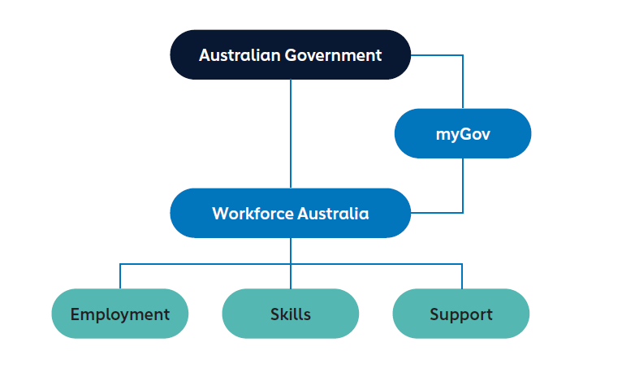

### Values

The Australian workforce is adapting to new technologies, sectors and markets. It requires a dynamic and capable workforce that will match business needs, now and into the future.

Through Workforce Australia we aim to equip Australians with the skills and resources they need to obtain sustainable and satisfying employment, bolster the Australian workforce and contribute to future economic prosperity and social wellbeing.

To do this we need to be simple, supportive, connected and respectful in everything we do.This means:

1. **Simple:**  
   Everything in one place
2. **Supported:**  
   Providing personalised support
3. **Connected:**  
   Connecting people to learning and job opportunities
4. **Respectful:**  
   Treating citizens, our stakeholders and each other with respect

The Workforce Australia brand is simple, restrained, considered and consistent.

We put our stakeholders at the heart of everything we do.

## Brand elements

### Identity typeface: Carnero

The Carnero typeface is the font used for the words Workforce Australia in the logo.

This font is only part of the logo, which will work as a ‘supplied file’. It is not to be used as the font for body content.

### Support typeface: Public Sans

Public Sans was chosen as the Workforce Australia support typeface for body content as it is a commonly used webfont. As Workforce Australia is a digital-first experience, it is important to have consistency across applications whether print or digital.

Public Sans has a number of font weights in the type family, which makes it efficient and practical, and it is very legible at various sizes.

### Optional support typeface: Calibri

Calibri font can also be used as the typeface for body content. It is a standard modern sans serif font that is suitable for both digital and print.

### Primary colours

The primary colours are used in the Workforce Australia identity mark, but they can also be used in applications. These primary colours have been specifically chosen for practical reasons including legibility, contrast ratios and accessibility requirements.

|  |  |  |  |
| --- | --- | --- | --- |
| Pantone 276 C C=96 M=86 Y=48 K=62 R=005 G=021 B=050 HEX: #051532 | Pantone 3005 C C=87 M=49 Y=00 K=00  R=000 G=118 B=189 HEX: #0076B |  |  |

### Secondary colours

Secondary colours have been chosen to aid content visibility in various applications. These colours should be used to highlight aspects of content. The objective is to keep the designs and layouts simple, restrained and contemporary.

|  |  |  |  |
| --- | --- | --- | --- |
| C=74 M=33 Y=100 K=19 R=073 G=118 B=055 HEX: #497537 | C=100 M=46 Y=45 K=20 R=000 G=097 B=113 HEX: #006170 | C=64 M=07 Y=34 K=00 R=086 G=182 B=177 HEX: #55B5B1 | C=53 M=03 Y=08 K=09 R=100 G=182 B=207 HEX: #63b6cf |

The colours below are for digital applications excluding text.

|  |  |  |  |
| --- | --- | --- | --- |
| R=102 G=134 B=064 HEX: #668640 | R=000 G=106 B=136 HEX: #006A88 | R=002 G=178 B=166 HEX: #02B2A6 | R=119 G=189 B=246 HEX: #77BDF6 |

### Tertiary colours

Tertiary colours are additional colours for illustration, graphs, diagrams and infographics.

|  |  |  |  |
| --- | --- | --- | --- |
| C=00 M=20 Y=100 K=08 *R=236 G=188 B=009* HEX: #ecbb08 | C=00 M=73 Y=100 K=15 R=210 G=092 B=028 HEX: #d15b1c | C=85 M=40 Y=12 K=00 R=001 G=129 B=180 HEX: #0181b4 | C=15 M=14 Y=17 K=00 R=215 G=209 B=203 HEX #d7d1ca |
| C=00 M=19 Y=40 K=00 R=254 G=210 B=159| HEX: #fed29f | C=52 M=22 Y=91 K=04 R=120 G=155 B=074 HEX: #789b49 | C=88 M=68 Y=09 K=01 R=050 G=093 B=158 HEX: #325d9e | C=14 M=11 Y=12 K=00 R=217 G=216 B=214 HEX #d8d7d6 |
| C=00 M=68 Y=85 K=00 R=243 G=116 B=058 HEX: #f3733a | C=56 M=16 Y=16 K=00 R=111 G=176 B=199 HEX: #6fb0c6 | C=99 M=85 Y=36 K=27 R=027 G=053 B=094 HEX: #1b355e | C=27 M=21 Y=22 K=00 R=187 G=188 B=187 HEX #bbbcbb |

The colours below are for digital applications excluding text.

|  |  |  |  |
| --- | --- | --- | --- |
| R=250 G=186 B=028 HEX: #FABA1C | R=171 G=068 B=010 HEX: #AB440A | R=000 G=141 B=181 HEX: #008DB5 | R=216 G=216 B=216 HEX: #D8D8D8 |
| R=250 G=196 B=165 HEX: #FAC4A5 | R=128 G=168 B=080 HEX: #80A850 | R=011 G=095 B=164 HEX: #0B5FA4 | R=244 G=244 B=244 HEX: #F4F4F4 |
| R=242 G=107 B=031 HEX: #F26B1F | R=119 G=189 B=246 HEX: #77BDF6 | R=008 G=035 B=084 HEX: #082354 | R=188 G=188 B=188 HEX: #BCBCBC |

### Accessibility

Workforce Australia Providers are required to meet the Web Content Accessibility Guidelines (WCAG) 2.0 Level AA, which includes Level A. The Australian Government has a legal requirement to ensure our services are usable and accessible to people with disabilities (see the Disability Discrimination Act 1992). *

WCAG 2.0 level AA requires a contrast ratio of at least 4.5:1 for normal text and 3:1 for large text. WCAG Level AAA requires a contrast ratio of at least   
7:1 for normal text and 4.5:1 for large text. Large text is defined as 14 point (typically 18.66px) and bold or larger, or 18 point (typically 24px) or larger.

#### **Primary colours**

|  |  |  |  |
| --- | --- | --- | --- |
| **Pantone 276 C** White AAA | **Pantone 3005 C** White AA Normal text and AAA Large text |  |  |
| **Pantone 276 C Pantone 3005 C** AA Large text only | **Pantone 3005 C** Black AA Large text only |  |  |

#### **Secondary colours**

|  |  |  |  |
| --- | --- | --- | --- |
| **Pantone 276 C**  C=74 M=33 Y=100 K=19  AA Large text only | **Pantone 276 C**  C=64 M=07 Y=34 K=00  AAA | **Pantone 276 C**  C=53 M=03 Y=08 K=09  AAA |  |

#### Digital applications – Secondary colours

|  |  |  |  |
| --- | --- | --- | --- |
| **Pantone 276 C**  R=102 G=134 B=064  AA Large text only | **Pantone 276 C**  R=002 G=178 B=166  AAA | **Pantone 276 C**  R=119 G=189 B=246  AAA |  |

#### *

#### **[https://www.dta.gov.au/help-and-advice/digital-service-standard/digital-service-standard-criteria/9-make-it-accessible]( https://www.dta.gov.au/help-and-advice/digital-service-standard/digital-service-standard-criteria/9-make-it-accessible)**

#### **Tertiary colours**

|  |  |  |  |
| --- | --- | --- | --- |
| **Pantone 276 C**  C=00 M=20 Y=100 K=08  AAA | **Pantone 276 C**  C=00 M=19 Y=40 K=00  AAA | **Pantone 276 C**  C=00 M=68 Y=85 K=00  AA Normal text and AAA Large text | **Pantone 276 C**  C=00 M=73 Y=100 K=15  AA Large text only |
| **Pantone 276 C**  C=52 M=22 Y=91 K=04  AA Normal text and AAA Large text | **Pantone 276 C**  C=56 M=16 Y=16 K=00  AAA | **Pantone 276 C**  C=85 M=40 Y=12 K=00  AA Large text only | **Pantone 276 C**  C=15 M=14 Y=17 K=00  AAA |
| **Pantone 276 C**  C=15 M=14 Y=17 K=00  AAA | **Pantone 276 C**  C=27 M=21 Y=22 K=00  AAA | **Pantone 3005 C**  C=00 M=19 Y=40 K=00  AA Large text only | **Pantone 3005 C**  Pantone Warm Grey 1 C  AA Large text only |
| **Pantone 3005 C**  C=15 M=14 Y=17 K=00  AA Large text only |  |  |  |

#### **Digital applications – Tertiary colours**

|  |  |  |  |
| --- | --- | --- | --- |
| **Pantone 276 C**  R=250 G=186 B=028  AAA | **Pantone 276 C**  R=250 G=196 B=165  AAA | **Pantone 276 C**  R=242 G=107 B=031  AA Normal text and AAA Large text | **Pantone 276 C**  R=171 G=068 B=010  AA Large text only |
| **Pantone 276 C**  R=128 G=168 B=080  AA Normal text and AAA Large text | **Pantone 276 C**  R=119 G=189 B=246  AAA | **Pantone 276 C**  R=000 G=141 B=181  AA Normal text and AAA Large text | **Pantone 276 C**  R=216 G=216 B=216  AAA |
| **Pantone 276 C**  R=244 G=244 B=244  AAA | **Pantone 276 C** R=188 G=188 B=188 AAA | **Pantone 3005 C** R=250 G=196 B=165 AA Large text only | **Pantone 3005 C** R=216 G=216 B=216 AA Large text only |
| **Pantone 3005 C** R=244 G=244 B=244 AA Large text only |  |  |  |

### The ‘Dot Bracket’



A key feature of the Workforce Australia brand mark is the Dot Bracket – two lines connecting two dots. It represents how Workforce Australia links individuals to available jobs and training opportunities and matches employers with workers who have the skills they need. It is how we connect the dots.

Essentially, this device conveys:

* connecting individuals in the job market
* linking individuals, skills and companies to available opportunities
* gender neutrality and equal opportunities
* individual and collective journeys
* equipping individuals to progress.

In its simplest form, the Dot Bracket has been designed to convey a ‘journey’.

In applications, the Dot Bracket can be used to demonstrate the concept of connecting things, steps in a journey, or steps to be completed (eg. on a website).

If the Dot Bracket is configured as above (logo configuration), it should only be presented in Primary Pantone 3005 C.

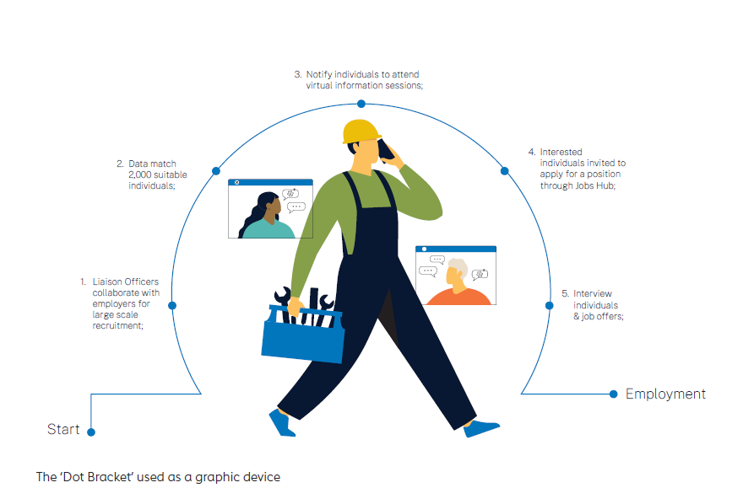

The ‘Dot Bracket’ used as a graphic device

**Brand identity**

### Identity – without Crest and with descriptor text

The logo displayed below is the generic Workforce Australia logo for Providers. It does not contain the Australian Government Crest.

This logo can be used by Providers on the following items: Website | Brochures | Factsheets | Flyers | Instore displays | Pull up banners or indoor portable signage for shops or trade events.

|  |  |  |  |
| --- | --- | --- | --- |
| Employment.  Skills. Support.  Colour |  | Employment.  Skills. Support.  Colour reversed |  |
| Long horizontal  Employment. Skills. Support. Colour |  | Long horizontal  Employment. Skills. Support.  Colour reversed |  |

### Sub brands and identity – with category descriptor

A few departmental programs have unique versions of the Workforce Australia logo with their program names included in the logo. These are called sub brands. Employment programs that fit under a set category should use specific versions of the Workforce Australia logo.

|  |  |  |  |
| --- | --- | --- | --- |
| Inline  Sub brand  Jobs Fair  Colour |  | Inline  Single descriptor  Employment  Colour |  |
| Inline  Sub brand  Workforce Specialists  Colour |  | Inline  Single descriptor  Self-Employment Services  Colour |  |
| Inline  Sub brand  Local Jobs  Colour |  |  |  |

### Provider logo – stacked without Crest

The logos displayed below are examples of custom Workforce Australia logos for Providers – stacked version. It does not contain the Australian Government Crest. A custom Workforce Australia logo will be created for all contracted Providers and should be used for shopfront signage if the display space is more of a vertical/portrait shape. Providers can also opt to use their custom Workforce Australia logo on marketing items noted on page 12 of this guide. Again, the stacked version is to be used when the display space is more of a portrait shaped space.

|  |  |  |  |
| --- | --- | --- | --- |
| Employment  Services  Delivered by  Third Party  Colour |  | Employment  Services  Delivered by  Third Party  Colour reversed |  |
| Single use version  Employment  Services  Colour |  | Single use version  Employment  Services  Colour reversed |  |
| Self-Employment  Services  Delivered by  Third Party  Colour |  | Self-Employment  Services  Delivered by  Third Party  Colour reversed |  |

### Provider logo – long horizontal without Crest

The logos displayed below are examples of custom Workforce Australia logos for Providers – long horizontal version. It does not contain the Australian Government Crest. A custom Workforce Australia logo will be created for all contracted Providers and should be used for shopfront signage if the display space is more of a long/horizontal shape. Providers can also opt to use their custom Workforce Australia logo on marketing items noted on page 12 of this guide. Again, the horizontal version is to be used when the display space is more of a long/horizontal shaped space.

|  |  |  |  |
| --- | --- | --- | --- |
| Employment  Services  Delivered by  Third Party  Colour |  | Employment  Services  Delivered by  Third Party  Colour reversed |  |
| Single use version  Employment  Services  Colour |  | Single use version  Employment  Services  Colour reversed |  |

### Provider logo – category descriptor without Crest

The logos displayed below are examples of custom Workforce Australia logos for Providers – stacked and long horizontal versions. It does not contain the Australian Government Crest. A custom Workforce Australia logo will be created for all contracted Providers and should be used for shopfront signage. Providers can also opt to use their custom Workforce Australia logo on marketing items noted on page 12 of this guide.

|  |  |  |  |
| --- | --- | --- | --- |
| Stacked  Self-Employment  Delivered by  Third Party  Colour |  | Stacked  Self-Employment  Delivered by  Third Party  Colour reversed |  |
| Long horizontal  Self-Employment  Delivered by  Third Party  Colour |  | Long horizontal  Self-Employment  Delivered by  Third Party  Colour reversed |  |

**Ratios, exclusion zones, minimum sizes and incorrect use**

### Ratios

|  |  |  |  |
| --- | --- | --- | --- |
| **Without Crest**  Employment.  Skills. Support. |  | **Without Crest**  Self-Employment Services  Delivered by  Third Party |  |
| **Without Crest**  Employment  Services  Delivered by  Third Party |  |  |  |

### Exclusion zones

|  |  |  |  |
| --- | --- | --- | --- |
| **Without Crest**  Employment.  Skills. Support. |  | **Without Crest**  Employment  Services  Delivered by  Third Party |  |
| **Without Crest**  Skills and Support Services  Delivered by  Third Party |  |  |  |

### Minimum sizes

|  |  |  |  |
| --- | --- | --- | --- |
| **Without Crest**  Minimum width:  20mm = print  43px = general digital |  | **Without with Crest**  Long horizontal  Minimum width:  54.5mm = print  116px = general digital  272px = in main banner for website |  |
| **Without Crest**  Long horizontal  Minimum width:  33mm = print  77px = general digital |  | **Provider logo without Crest**  Stacked  Minimum width:  30.5mm = print  65px = general digital |  |
| **Without Crest**  Employment.  Skills. Support.  Minimum width:  30.5mm = print  65px = general digital  153px = in main banner  for website |  | **Provider logo without Crest**  Long horizontal  Minimum width:  54.5mm = print  116px = general digital |  |

Descriptor text should not appear less than 6pt for print or 10px on main banner for website.

Suggested alt text for logos: “Logo for Workforce Australia – Employment, Skills, Support.” when the logo is used on its own. “Visit the [Workforce Australia website](https://www.workforceaustralia.gov.au/)” if the image is wrapped in a link to the Workforce Australia site, **see example.**

### Incorrect use

|  |  |  |  |
| --- | --- | --- | --- |
| Do not use colours that are not brand colours |  | Do not change the colour of the Dot Bracket |  |
| Do not change the colour of the text |  | Do not change the layout |  |

### Incorrect use continued

|  |  |  |  |
| --- | --- | --- | --- |
| Do not change the hierarchy - Workforce Australia text must take precedence |  | Do not change the orientation of the Dot Bracket |  |
| Do not move the descriptors |  | Do not place the identity on patterned, transparent or low contrast backgrounds |  |

**How Providers will use the brand**

### Provider use of the logo

Providers are contractually obligated to clearly display and give prominence to the Workforce Australia logo (Provider logo) on all applications, where possible, unless otherwise agreed.

Ensuring the Workforce Australia logo is clearly displayed helps increase brand recognition and reinforce that the services being provided are funded by the Australian Government.

Organisations delivering Workforce Australia services must use the Workforce Australia logo in all Workforce Australia information and marketing material, including (but not limited to):

* Shopfront (Building externals and front door)
* Website
* Letterheads
* Business cards
* Brochures (DL, A4, etc.)
* Fact Sheets
* Mailouts
* eNewsletters
* Mobile website
* Mobile app
* Video
* PowerPoint Templates
* Press Ads / Radio ads / TV ads
* Pull up banners (used at events)
* Expo Stands

### Positioning of the logo

As an organisation delivering Australian Government employment services, you are acting under the umbrella of the Workforce Australia brand. When your organisation is promoting your relationship with Workforce Australia, your identity is supported by the Workforce Australia brandmark (this indicates Australian Government endorsement).

The stacked or long horizontal version of the Workforce Australia logo can be used, depending on the size and format of the application.

|  |  |  |  |
| --- | --- | --- | --- |
| **Identity**  Employment. Skills. Support. |  | **Identity (Provider logo)**  Stacked  Employment Services  Delivered by Third Party |  |
| **Identity (Provider logo)**  Long horizontal  Employment Services  Delivered by Third Party |  |  |  |

### Shopfront – building externals and front doors

To ensure maximum awareness and recognition of the   
Australian Government’s branding, Workforce Australia   
signage must be prominently displayed at sites where Providers are delivering Australian Government employment and skills services.

#### General principles on shopfront branding

The examples provided in relation to shopfront branding on the previous page/s are indicative only, as each shopfront is unique, and it is not possible to provide an example for every scenario.

As such, the following general principles apply to all shopfront branding:

Every effort must be made to ensure the Workforce Australia brand is located in a prominent position on shopfronts, making it easy for individuals to recognise Workforce Australia Providers.

Providers can use their own branding on the shopfronts where appropriate.

Shopfront branding must also comply with any lease or strata requirements of the premises, noting the general principle is   
for the Workforce Australia brand to have prominence.Minimum signage required on Workforce Australia sites

All Providers must display Workforce Australia signage prominently   
on their shopfront with a view to it being the prominent signage   
where possible.

Where a contracted Provider has no external signage on a building (in a multi-tenanted site, such as a multi-storey building or a shopping centre), at a minimum, signage must be displayed at eye level on the front door, beside the front door or on an external window of the premises.

Where contracted Providers have tenancies with a stand-alone shopfront, or in a building where external signage is permitted or required, Workforce Australia branding should be the prominent branding   
on all signage.

As each Provider shopfront is unique, signage requirements cannot be specified for each individual tenancy. The images in this section are for illustrative purposes only.

The minimum size signage for shopfront doors is 500mm w x 500mm h. The Provider version of the logo should be used (logo with service descriptor and provider name/logo with service descriptor). This signage must be displayed either on the site door, directly beside the site door   
or windows. The bottom of the sign should be no lower than 1.3m from   
the ground and no higher than 1.5m. The minimum size signage for   
large shopfronts is 1200mm w x 500mm h. The Provider version of the logo should be used (logo with service descriptor and provider name/logo   
with service descriptor).

This signage must be displayed either on the fascia or awning of the building, or windows. Refer to ‘Shopfront co-branding’ mock-ups on pp 25–27.

Contracted Providers can continue to use their own branding on shopfronts and building, but must ensure the Workforce Australia logo is the prominent logo.

If contracted Providers deliver additional Australian Government employment services (for example Disability Employment Services) or services for state government or private entities, the Workforce Australia brand must be the first brand featured in the list of services promoted on the shopfront or building.

Any exemptions to any of the requirements will need to be submitted to the department and will be considered by exception, on a case by case basis.

*Note: All examples are indicative only, the final details and requirements will be outlined in final contractual arrangements.*Confirmation of branding plans

Prior to incurring the costs of installing signage, if a Provider is unsure or would like to have their proposal for signage checked, they are encouraged to contact the department to review the proposal to ensure it is in line with requirements set out in this document and the relevant program deed, contract or funding agreement.

The department welcomes seeing how your Workforce Australia signage has been installed on your site or shopfront. Please send a photo to

[workforceaustralia-brand@dewr.gov.au](mailto:workforceaustralia-brand@dewr.gov.au).

The department will work with you to finalise all branding plans to ensure they adhere to the requirements.

#### Shopfront branding costs

Providers are expected to cover the costs associated with branding their shopfronts.

|  |  |
| --- | --- |
| Single glass door with only Workforce Australia logo  Minimum signage requirements. | Internal entry single glass panes with Workforce Australia logo.  Headline shop sign. |
| shopfront with only Workforce Australia logo displayed above shopfront entry.  Potential large shopfront, giving prominence to the Workforce Australia logo. | Internal entry single glass door with Workforce Australia logo.  Shopfront with no street frontage, sign on entry door. |

### Shopfront co-branding

|  |  |
| --- | --- |
| Example of shop front co-branding. Insitu shot of double door entry and a single door entry.  Double door entry, left door has Workforce Australia logo, right door has provider logo. Single door has Workforce Australia logo centre top aligned. The provider logo sit underneath mid-centre aligned.  Single and double doors with co-branding, giving prominence to the Workforce Australia logo. | Example of shop front co-branding. Insitu shot of double door entry and solid glass panes one to the left and one to the right. Top center pane has the Workforce Australia logo to the left and the provider logo to the right. Far left pane has provider logo in reversed identity, left door has Workforce Australia logo, right door has provider logo, right pane has Workforce Australia logo.  Potential shopfront with co-branding, giving prominence to the Workforce Australia logo. |

### Shopfront co-branding continued

|  |  |
| --- | --- |
| Example of shop front co-branding. Insitu shot of double door entry and a single door entry.  Double door entry, left door has Workforce Australia logo, right door has provider logo. Single door has Workforce Australia logo centre top aligned. The provider logo sit underneath mid-centre aligned.  Single and double doors with co-branding, giving prominence to the Workforce Australia logo. | Example of shop front co-branding. Insitu shot of double door entry and solid glass panes one to the left and one to the right. Top centre pane has the Workforce Australia logo. Far left pane has provider logo, left door has Workforce Australia logo, right door has provider logo, right pane has Workforce Australia logo.  Potential shopfront with co-branding, giving prominence to the Workforce Australia logo. |

### Shopfront co-branding continued

|  |  |
| --- | --- |
| Example of shop front co-branding. Insitu shot of double door entry and a single door entry.  Double door entry, left door has Workforce Australia logo, right door has provider logo. Single door has Workforce Australia logo centre top aligned. The provider logo sit underneath mid-centre aligned.  Single and double doors with co-branding, giving prominence to the Workforce Australia logo. | Example of shop front co-branding. Insitu shot of double door entry and solid glass panes one to the left and one to the right. Top center pane has the Workforce Australia logo. Far left pane has provider logo, left door has Workforce Australia logo, right door has provider logo, right pane has Workforce Australia logo.  Potential shopfront with co-branding, giving prominence to the Workforce Australia logo. |

### Stationery and publications

The Workforce Australia logo (Provider logo) should be the prominent logo on all stationery and collateral promoting or providing information about Workforce Australia services (collateral includes, but is not limited to, brochures, flyers, booklets, posters etc).

Please use the Workforce Australia letterhead template that was included in your provider custom brand kit.

The Workforce Australia logo should be placed on the left hand side of the header of the document.

If a Provider logo, or additional logos, are to be included on the document, they are to be located on the bottom of the page (or rear cover on a multi-page document) and right aligned.

|  |  |  |  |
| --- | --- | --- | --- |
| **Identity in colour** | **Identity in colour. Workforce Australia crest sits top left. contact information sit in footer bottom right. Provider logo sits in footer, bottom right corner.** | **Identity reversed** | **Identity reversed. Workforce Australia crest sits top left. contact information sit in footer bottom right.** |
| **Identity in colour – A4 brochure cover** | **Identity in colour A4 brochure cover. Workforce Australia crest sits top left** | **Identity in colour – A5 brochure cover** | **Identity in colour A5 brochure cover. Workforce Australia crest sits top left** |
| **Identity in colour – DL brochure cover** | **Identity in colour DL brochure cover. Workforce Australia crest sits top left** | **Identity reversed – A4 brochure cover** | **Identity reversed A4 brochure cover. Workforce Australia crest sits top left** |
| **Identity reversed – A5 brochure cover** | **Identity reversed A5 brochure cover. Workforce Australia crest sits top left** | **Identity reversed – DL brochure cover** | **Identity reversed DL brochure cover. Workforce Australia crest sits top left** |

### Websites

The Workforce Australia logo must be placed in a prominent position on the homepage of the Provider website.

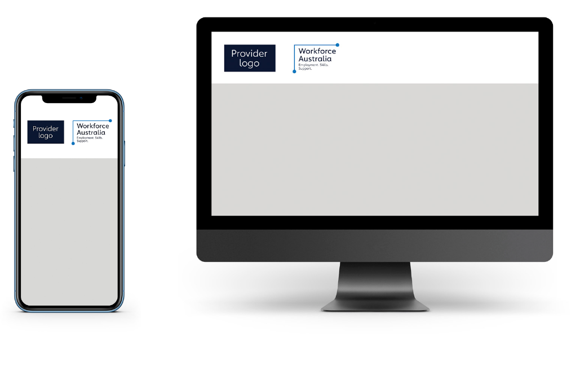

### Contact

For any brand application or style guide enquiries, email workforceaustralia-brand@dewr.gov.au or view the Workforce Australia Provider FAQs on the Brand Resources page via the Provider Portal.

[WorkforceAustralia.gov.au](https://www.workforceaustralia.gov.au/)