

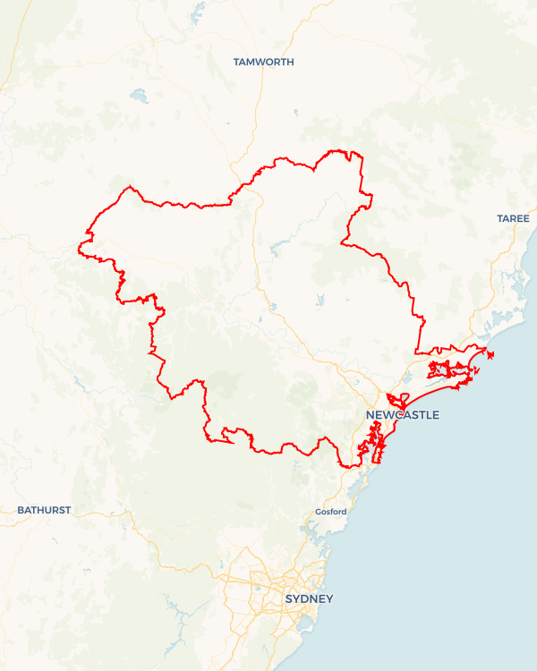Local Jobs Plan

Hunter Employment Region | NSW | ****March 2025****

Workforce Australia Local Jobs (Local Jobs) supports tailored approaches to accelerate   
reskilling, upskilling and employment pathways in response to current and emerging local workforce needs.

## Local Jobs elements

### Local Jobs Plan

The Local Jobs Plan sets out the skills and employment challenges and priorities of the region, and associated strategies that will drive the design and implementation of activities to be implemented to address these challenges.

### Job Coordinators

Job Coordintors and Support Officers support the delivery of the program by bringing together key stakeholders including businesses, employment services providers, higher education and training organisations.

### Local Jobs and Skills Taskforce

Each Employment Region has its own Taskforce. Representatives include local stakeholders who have demonstrated experience in upskilling, reskilling, and an ability to represent, connect and collaborate with others in the region to meet labour market needs.

### Program Funds

The Employment Region’s Local Initiatives Fund enables targeted local investments that support local labour market functioning. Further, from 2025/26, a central grants-based fund will respond to local needs and help progress broader employment service reform objectives.

Explore labour market insights for the   
[Hunter](https://www.jobsandskills.gov.au/work/employment-region-dashboards-and-profiles/monthly-labour-market-dashboards) Employment Region

## Local labour market challenges in the region

* Difficulty in securing adequately skilled workers in growth and demand sectors with accessible entry-level work.
* Additional challenges and a lack of a streamlined approach to training and recruitment for individuals across several cohorts, including First Nations, youth, mature age, women, culturally and linguistically diverse, refugees and people with disability.
* Limited take-up and understanding of apprenticeship and traineeship opportunities, mentoring and supports available across the region.
* The community and industry impacts of the Hunter’s transition to net zero.
* Ongoing business concerns regarding soft skills and/or employability skills.
* Uncertainty around the skills and qualifications required for future and emerging industries.
* Limited access to transport including public transport and access to driver training, particularly in rural and larger regional towns.

## Local jobs and skills priorities and strategies in the region

## Priority 1 – Health, care and community services

#### What are our challenges and opportunities?

#### There is critical workforce demand across the care sector, specifically aged, disability and child care. There is an opportunity to meet growing workforce demand by creating sector-specific solutions and pathways to employment within the care and community services sector while supporting associated supply chain.

#### How are we responding?

* Building profiles of care careers as a desirable career choice for individuals, including raising awareness of long-term career progression of other roles within the industry (e.g. support services, human resources and maintenance).
* Undertaking industry consultation to refine and tailor pathways into entry level roles, such as increasing the availability of traineeship options and industry endorsed training programs.
* Supporting small and micro businesses in the sector to employ through collaborative programs, connection to funding and incentives and tailored supports.
* Leveraging existing funding opportunities, projects and programs, including Fee Free TAFE, to enhance the training opportunities within the care sector.

## Priority 2 – Construction, infrastructure and traditional trades

#### What are our challenges and opportunities?

#### The increase in major construction and infrastructure projects across the Hunter are driving workforce and skills shortages, with remaining low levels of diversification across industry and small and medium enterprises. There is opportunity to engage and collaborate with small to major contractors to promote apprenticeships and traineeships and entry-level training across various construction and trade roles to assist businesses diversify.

#### How are we responding?

* Collaborate with industry to build clear pathways into construction and trades, increasing local skills levels and increasing gender diversification.
* Working with businesses to create streamlined access to programs and projects that provide a direct pathway to employment.
* Working with industry to ensure training meets future workforce demand, specifically for large-scale projects to ensure local workforce is available.
* Using a proactive approach to training and skilling individuals and the community in collaboration with Training Services NSW to ensure suitably skilled pools of candidates are available to meet workforce demand in infrastructure projects.
* Improving traditional skills to meet the needs of renewable energy projects via the promotion of apprentice and trainee opportunities in the sector.

### Priority 3 – Manufacturing and defence industry

#### What are our challenges and opportunities?

#### There is increasing manufacturing and advanced manufacturing opportunities across the region with a rapidly growing defence sector, with local skill levels not meeting this demand. There is opportunity to engage and collaborate with manufacturers and the defence industry supply chain to increase skill level and workforce participation.

#### How are we responding?

* Collaborating with industry to build clear pathways into manufacturing and defence industry.
* Working with businesses to create streamlined access to programs and projects that provide a direct pathway to employment.
* Working with industry to ensure training meets future workforce demand, specifically for large-scale projects to ensure local workforce is available.
* Using a proactive approach to training and skilling Workforce Australia participants and the community in collaboration with TAFE Advanced Manufacturing Centre of Excellence to ensure suitably skilled candidates are available to meet workforce demand.
* Building awareness and knowledge on the opportunities coming to the region across these sectors and supporting preparation across community.

### Priority 4 – Hospitality, tourism and customer service

#### What are our challenges and opportunities?

There is growing workforce demand within the hospitality, tourism and customer service sector. There is an opportunity to challenge perceptions for people to consider careers in this industry. We aim to meet growing workforce demand by creating sector-specific solutions and pathways to employment within the hospitality, tourism and customer service sectors.

#### How are we responding?

* Building collaborative employment and training solutions which align to Destination Management and Economic Development strategies of local and state governments.
* Developing projects which address attraction and retention issues with input from industry, community and Workforce Australia Employment Services Providers.
* Building awareness and attraction campaigns around long-term career pathways within the industry.
* Leveraging existing funding and initiatives across the region.
* Utilising existing working groups and industry groups to minimise duplication and provide specific focus on workforce development and industry activity.

### Priority 5 – Net zero, emerging industries, skills and innovation

#### What are our challenges and opportunities?

Limited community knowledge of net zero projects, emerging industries and what potential jobs and opportunities the net zero transformation will bring to the region. There is an opportunity to support net zero projects in the Hunter that align to our net zero targets by preparing participants for immediate and long-term employment opportunities through collaborative projects with government, business and community.

#### How are we responding?

* Building collaborative employment and training solutions which align to Economic Development strategies of federal, state and local governments.
* Leveraging existing opportunities to support businesses emerging within the Hunter-Central Coast Renewable Energy Zone and surrounding areas.
* Leveraging existing funding models and programs, including other federal departments and state-led programs and initiatives and the NSW Future Jobs and Investment Authority and Australian Government Net Zero Economy Agency.
* Proactively approaching training and awareness activities in collaboration with all levels of government to address opportunities in net zero. This includes science, technology, engineering, mathematics and medicine Precinct/Regional Transformation Hub, circular economy opportunities and Muswellbrook innovation precinct.
* Increasing knowledge and awareness of regional activity through existing networks and groups, including Hunter Defence Taskforce, Hunter Young Business Minds, the University of Newcastle, TAFE NSW and other relevant Registered Training Organisations and key community groups and stakeholders.

### Priority 6 – The Upper Hunter

#### What are our challenges and opportunities?

#### The Upper Hunter is undergoing significant structural change with a skilled workforce experiencing transition. There is an opportunity to support the Upper Hunter and work closely with key stakeholders, community groups and local industries to facilitate a collaborative approach to future skills and workforce development.

#### How are we responding?

* Assisting industries with immediate workforce demand, including equine, mining, meat product manufacturing and agriculture, through pre-employment and skill-set based training programs.
* Building regional skills capability by mapping future workforce and skill requirements within the region, particularly with the introduction of net zero projects.
* Conducting education pieces across the Upper Hunter to assist in showcasing the emerging industries and opportunities for the future workforce and the positive impacts this will have across the region.
* Building engagement with local governments across the Upper Hunter to determine their industry priorities and economic development outlook as well as to respond to employment opportunities as they emerge.
* Supporting self-employment and entrepreneurship opportunities across the Upper Hunter.
* Leveraging existing funding across all levels of government and local agencies as well as existing programs and groups including Upper Hunter Education and Training Working Group, Self-Employment Assistance program and Singleton Council Skills and Employment Exchange Program.

## Want to know more?

* Contact: Kempsey Litten, Hunter Job Coordinator: [kempsey.litten@hunterlocaljobs.com.au](mailto:kempsey.litten@hunterlocaljobs.com.au) or Grahame Irwin, Regional Workforce Transition Officer: [HunterNSW.RWTO@dewr.gov.au](mailto:HunterNSW.RWTO@dewr.gov.au)
* Visit: [Local Jobs](https://www.dewr.gov.au/local-jobs) or [Workforce Australia](https://www.workforceaustralia.gov.au/)
* The Regional Workforce Transition Officer is working collaboratively with the Job Coordinator in your region to support the positive and orderly transition to a net zero economy. For further information, please refer to [Regional Workforce Transition Officers (RWTOs) - Department of Employment and Workplace Relations, Australian Government](https://www.dewr.gov.au/supporting-worker-transition-through-energy-system-changes/regional-workforce-transition-officers).