


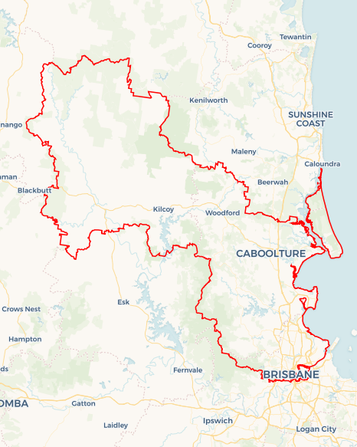
Local Jobs Plan
  - Somerset Employment Region | QLD | January 2026
Workforce Australia Local Jobs (Local Jobs) is a program that creates partnerships between business
and communities to meet local workforce needs, thereby improving employment outcomes.
Local Jobs operates in all 51 Employment Regions in Australia.

Local Jobs Overview

Local Jobs Plan
Each Employment Region has a Local Jobs Plan which outlines the labour market challenges in the region and the strategies to address these challenges.

Job Coordinators
Each Employment Region has a dedicated Job Coordinator who leverages existing resources, supports local labour markets through structural adjustments and retrenchments, and creates opportunities for collaboration between business and communities.

Local Jobs and Skills Taskforce
Each Employment Region has its own taskforce that meets regularly with the Job Coordinator to develop an understanding of challenges in the region and implement solutions. The taskforce is comprised of representatives from the region.

Local Jobs, Local People Grant
The Local Jobs, Local People grant funds activities that help people into ongoing employment or training. Activities must support local labour market needs.
Explore labour market insights for the
Somerset Employment Region

Local labour market challenges

1. Recruitment and retention difficulties
- Employers across established, growth, and emerging industries face ongoing challenges to attract and retain staff.
- The region is experiencing high unmet demand for entry-level workers in sectors such as health care and social assistance, engineering, manufacturing, construction, accommodation and food services, tourism, and transport, postal and warehousing.
- Major infrastructure and Olympic-related projects are accelerating workforce demand across the Somerset region. This is amplifying demand for a highly skilled, job-ready workforce. Significant regional investments, such as the $180 million North Lakes Town Centre Precinct, $250 million upgrade of Sandstone Point Resort, continued delivery of the Cross River Rail project (with services commencing in 2029), are intersecting with major Brisbane-based works including precinct upgrades at the Gabba, Brisbane Arena (Roma Street), the Brisbane Aquatic Centre, and transport network improvements gearing up for the 2032 Olympics. These projects are reshaping labour requirements across construction, hospitality, tourism, transport, and operations. The region faces a growing challenge in assembling, preparing, and sustaining a workforce with the scale, capability, and readiness to meet demand.

2. Barriers to vocational pathways and access
- A preference for immediate income and higher hourly rates in labouring roles is reducing uptake in trade qualifications and resulting in local trade skill and labour shortages.
- Limited public transport or lack of access to a car or driver’s licence restricts access to many industrial precincts.
- Rapid population growth is pressuring housing affordability and impacting accessibility and stability for job seekers.

3. High proportion of long-term unemployed
- Across the Somerset employment region, approximately 24,500 people are registered on the Workforce Australia caseload, with more than half (14,440) who are long-term or very long-term unemployed. Necessitating the need for multi-layered support and intensive preparation to develop skills, confidence and capability to re-engage with the workforce.
- Extended periods away from the workforce can contribute to a range of additional challenges, including literacy and numeracy, low digital capability, reduced familiarity with current workplace expectations, social isolation, and gaps in foundational employability skills. Together, these factors can diminish confidence and impact motivation, resilience, social connectedness, wellbeing and capacity to participate in training or employment.

4. Employer capacity and inclusive workplaces
- Data outlines that approximately 72% of the region’s caseload is from identified priority cohort groups, including First Nations people, youth (15-24 years), mature age (45+ years), women, people with disability, and culturally and linguistically diverse people.
- Small to medium businesses are highly committed to supporting local talent, although lean operating models can make it challenging to offer the more intensive, individualised support some job seekers may require.
- Building inclusive, culturally appropriate, and psychologically safe workplaces is critical for workforce attraction, retention, productivity and organisational resilience.
- Lack of awareness about workforce supports, wage subsidies, and tailored pathways contributes to early exits from employment. With the right capability-building and supportive frameworks in place, employers are well-positioned to create environments where job seekers can perform and thrive.

Local priorities

Priority 1 – Increasing training and employment pathways for priority cohorts

What are our challenges?
- Individuals from priority cohorts have the capability to work but require clearly structured pathways and support to gain and retain employment.
- Some employers are still building an understanding of inclusive recruitment, onboarding, and retention practices.
- Stronger connections are required to generate more robust targeted pathways that align with regional workforce needs.

How are we responding?
- Deliver targeted rapid recruitment events for women, youth, First Nations peoples, multicultural communities and mature age job seekers, creating direct connections with employers.
- Promote inclusive employer best practices and culturally safe workplaces.
- Co-design pre-employment and entry pathways with employers and key stakeholders aligned with real job outcomes.
- Work alongside First Nations organisations to ensure initiatives are culturally appropriate.
- Provide information to employers regarding wage subsidies, funded training and supports to improve attraction and retention.

Priority 2 – Promoting the engagement and retention of Australian Apprenticeships and Traineeships

What are our challenges?
- Limited understanding among job seekers of trade careers, employer expectations and long-term benefits.
- Declining employer investment in mentoring, supervision and structured on-the-job training.
- Limited visibility of women in non-traditional industries and roles continues to reinforce gender stereotypes, constraining participation and reducing the diversity of the future workforce.
- Limited opportunities for youth to explore a range of trades prior to entry restrict informed decision-making, contributing to mismatched expectations, early attrition and lower apprenticeship commencements and completions.
- Barriers such as transport access, financial pressure and limited foundation skills can impact participation and retention.
- Limited awareness of the available supports, incentives, and advisory services for apprentices is reducing the region’s ability to strengthen apprenticeship engagement, retention, and successful completions.

How are we responding?
- Broker stronger pathways between employers, registered training organisations and Australian Apprenticeship Support Services.
- Deliver rapid recruit and pathway-focused events showcasing apprenticeships, traineeships, pre-employment programs and mentoring support.
- Promote ‘you can’t be what you can’t see’ storytelling by sharing real examples of diverse cohorts succeeding in trades and technical roles.
- Support employers to adopt flexible, inclusive practices (e.g. mentoring, family-friendly shifts, transport solutions).
- Raise awareness of long-term career and earnings benefits, balancing short-term income pressures with future stability.
- Promote opportunities in emerging industries (e.g. net zero, digital and technical roles) aligned to future workforce demand.
- Local Jobs will undertake responsive engagement with local businesses and industry stakeholders to strengthen understanding of workforce requirements and promote the benefits of employing apprentices and trainees. This includes rapid recruitment events, forums and direct employer outreach to emphasise the critical contribution of apprenticeships and traineeships to a sustainable and skilled local workforce.

Priority 3 – Long-term and very long-term unemployed

What are our challenges?
- A significant proportion of the region’s unemployed population is long-term or very long-term unemployed, requiring intensive preparation and multi-layered support to rebuild confidence, capability and work readiness.
- Extended time away from the labour market can create multiple, compounding barriers to training and employment. Addressing these barriers requires coordinated support that combines practical skill development (including literacy, numeracy, digital and job-specific skills) with personal supports such as mentoring and wellbeing assistance to enable sustainable workforce participation.
- Many long-term unemployed job seekers have low digital literacy, a lack of qualifications or limited work history. This disparity reduces their competitiveness even in a tight labour market with a strong demand for workers.

How are we responding?
- Apply a collaborative, co-design approach with employers and stakeholders to address job seeker barriers and industry needs by aligning supports, improving job readiness, and strengthening pathways into training and employment.
- Deliver rapid recruitment events to facilitate employer connection and access to employment and training opportunities.
- Strengthen locally connected pre-employment pathways that build employability, digital skills and job readiness.
- Use local labour market insights to guide training and pathway design aligned to industry demand.
- Actively promote and facilitate access to wage subsidies, mentoring and wrap-around supports to reduce risk of disengagement and improve retention rates for employers and job seekers.

Want to know more?
- Contact Kim Dawson, Somerset Job Coordinator at kimdawson@somersetlocaljobs.com.au | 0417 266 911
- Visit Local Jobs or Workforce Australia

