Decision about stopping Centrelink money

For losing your job

  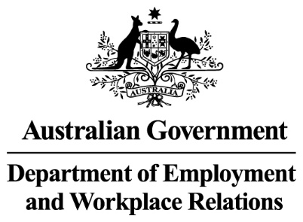 | The Australian Government  - Department of Social Services wrote this.  We say DSS for short.  - Department of Employment and Workplace Relations  We say DEWR for short.  When you see the word we it means DSS and DEWR.
 | We wrote this in an easy to read way.  We use pictures to explain some ideas.
 | We have some words in bold.  This means the letters are thicker and darker.  These are important words.
 | This is an Easy Read summary of another document.  This means it has the most important ideas.
 | You can ask for help to read this document.  You can ask  - A friend  - Family members  - A support person.

Contents

What is unemployment failure | 5
Decisions we have made | 8
Why we have made this decision | 9
Who will be affected | 10
What you need to do | 14
Past decisions | 15
Support | 16
Other decisions that are stopped for now | 17
What is next | 18

What is unemployment failure

 | We have laws for  - People who get Centrelink money for not having a job  We call this job seeker.
 | - The things they need to do to get their Centrelink money.  We call these activities.  Laws are rules for how we live.
 | You can read about the different activities on our website.  www.dewr.gov.au/resources/assuring-integrity-targeted-compliance-framework  It is in Easy Read.
 | Unemployment failure is when you get Centrelink money and no longer have a job because  - You choose to leave  - Your actions make you lose your job.
 | You can have your Centrelink money stopped if you  - Choose to leave your job
 | - Get told you are not allowed to work at your job anymore because you did the wrong thing.  This can be called dismissed for misconduct.
 | You will not get your  - Regular Centrelink money  - New Centrelink money  For 4 weeks after you left your job.  We call this a non payment period.
 | The law says we can do this.
 | It would not be unemployment failure if you  - Can show you acted the way anyone else would at the time
 | - Are the main carer of at least 1 child  Or  - Are able to work some of the time  And  Stopped working at a job that was for more than 15 hours every week.

Decisions we have made

On 5 March we stopped for now cancelling Centrelink money if people

- Choose to leave their job.

- Get told they are not allowed to work at their job anymore because they did the wrong thing.

You will get your

- Regular Centrelink money
- New Centrelink money

Right away while this decision is stopped.

You will not have to wait for 4 weeks.

Why we have made this decision

 | We think some of the decisions to stop Centrelink money might not have been right.
 | We are checking that the way we do things  - Are fair  - Follow the law.
 | We have stopped these decisions while we make changes.

Who will be affected

 | While the decision is stopped for now you will not have  - Your Centrelink money stopped for unemployment failure
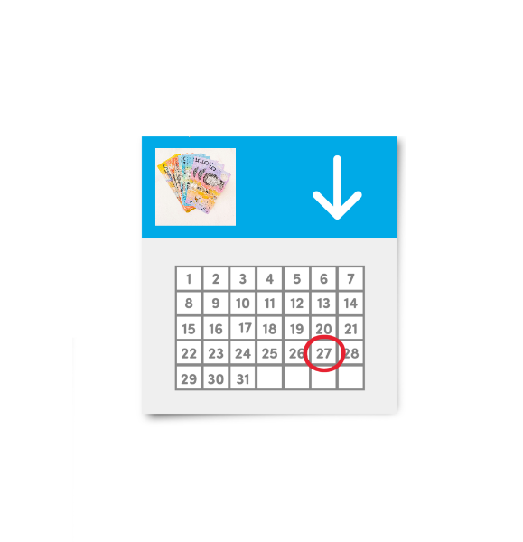 | - To wait 4 weeks for your Centrelink money.
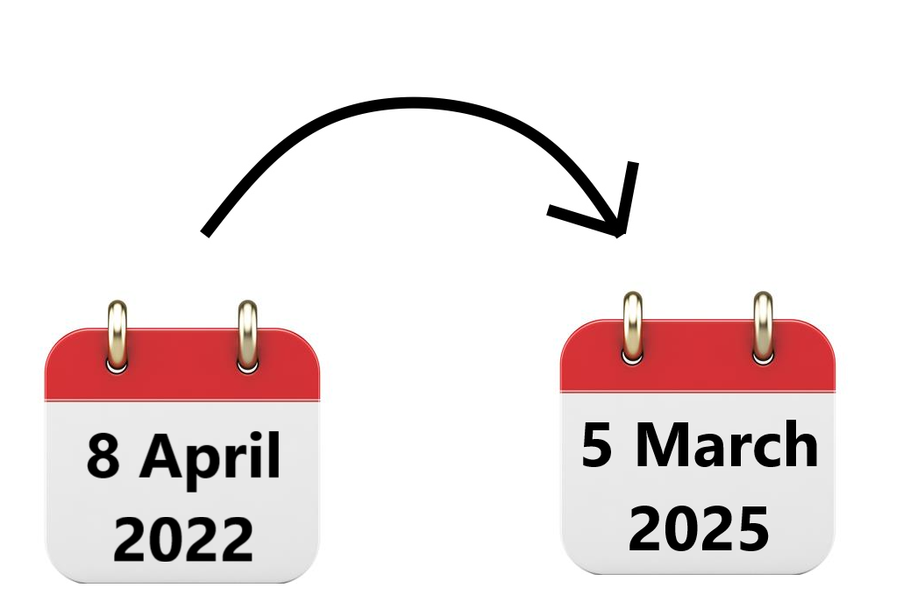 | We are looking at the payments between  - 8 April 2022  - 5 March 2025.
You might be affected if you

- Got Centrelink payments for finding a job
 | - Had your Centrelink money stopped because of unemployment failure
 | - Had to wait 4 weeks for your Centrelink money to start again because of unemployment failure.
 | Some of the people who are affected got Centrelink money for  - Job seeker
 | - Youth allowance other
 | - Parenting payment single  After your youngest child is 6 years old.
 | - Special benefit for nominated visa holders.  This is for people from overseas working here.
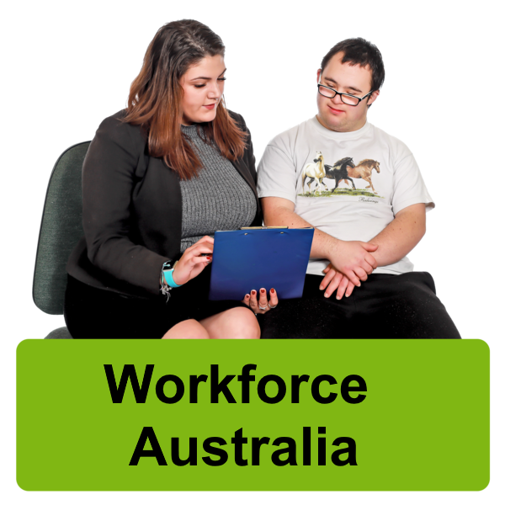 | It could also be anyone who took part in  - Workforce Australia
 | - Disability Employment Services  We call it DES for short.
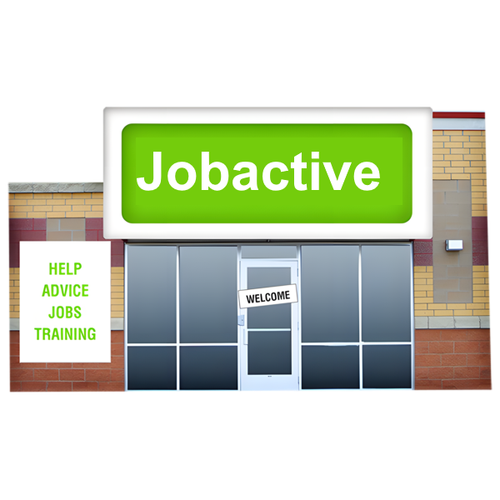 | - The Jobactive program
 | It does not affect anyone who was in the Community Development Program.
 | This program supports people who live in remote areas to get  - Fair money for work they do  - Jobs that help the community.

What you need to do

 | You do not need to do anything at the moment.
 | You need to keep doing your activities.
 | Talk to  - Your employment provider
 | - The Digital Services Contact Centre  1800 314 677  To make sure your activities are right for you.

Past decisions

 | We are looking at decisions we have already made.  They are called past decisions.
 | We are still working out what we need to do next.

Support

 | You might  - Have questions
 | - Be worried
 | - Want to make a complaint.  Complaints are when you tell someone they have not done a good job.  Everyone has the right to make a complaint.
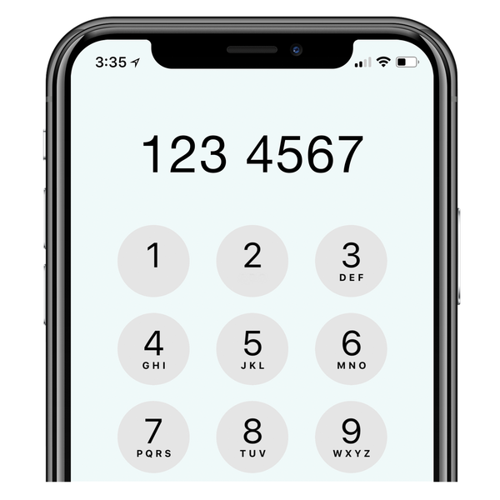 | You can call the DEWR National Customer Service Line  1800 805 260

Other decisions that are stopped for now

There are other decisions that have been stopped for now.
You can go to our website to read about the other decisions we have stopped for now.

www.dewr.gov.au/resources/assuring-integrity-targeted-compliance-framework

It is in Easy Read.

What is next

 | We have updated our computer systems.  They will not stop Centrelink payments for unemployment failure.
 | We will keep working to make sure the decisions  - Follow the law  - Are fair.
We are doing a review of this law.

A review is when you check what

- Works
- Needs to change.

 | We have made sure the review is  - Done in a fair way  - Following the law.
 | We have an independent person checking our computer systems.  Independent means separate to the government.
 | This means we are checking if our computer systems are following the rules.
If we do not believe the decisions

- Follow the law
- Are fair

We will stop them right away.
 | We need to make sure that any changes to  - The way we do things
 | - Our computer systems
- The law

Are done in the right way.
 | We are working on this.
 | We will let you know when we make more decisions.

Images in this Easy Read must not be used or copied without permission

