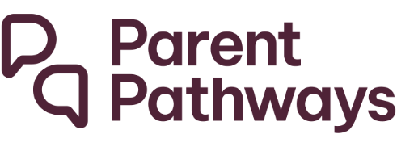

Participant Individual Fund factsheet
When you start with Parent Pathways you are assigned $1,250 (GST inclusive). This is your Individual Fund which you get every 12 months you are active with the service. Funds that are not spent are not carried over to the next year. Your Individual Fund can be used to buy items and supports that help you achieve your goals. This includes education and training courses, transport, driver’s licence costs, engagement support vouchers, non-vocational training and work-related training.
The information below shows how you can view and track your Individual Fund balance.
Please contact your provider if you have any questions.

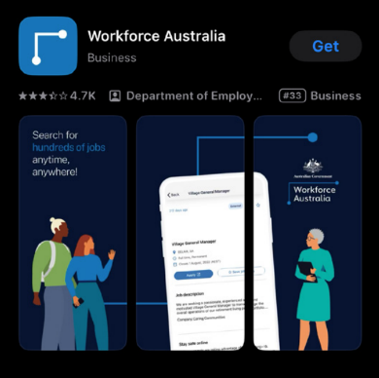
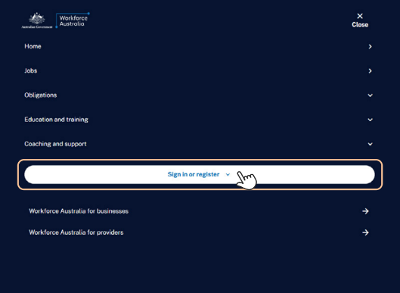
Step 1
Log into your Workforce Australia Online for Individuals account (or Download the app)
You can download the free app from your app store:
- Apple App Store
- Google Play.

Step 2
Once you’ve logged in, find the ‘Individual Fund balance’ and select ‘View my purchase history’.
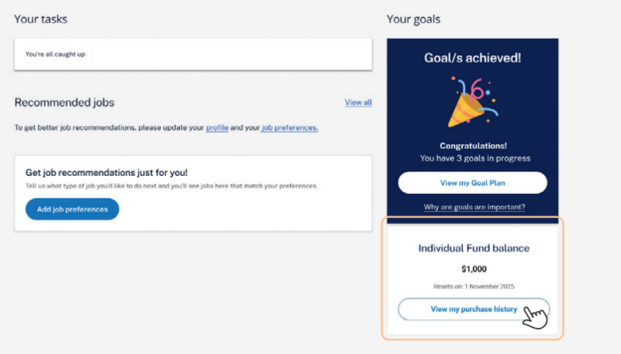
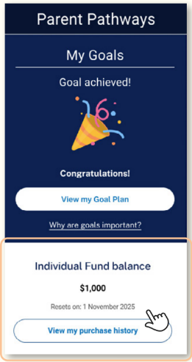

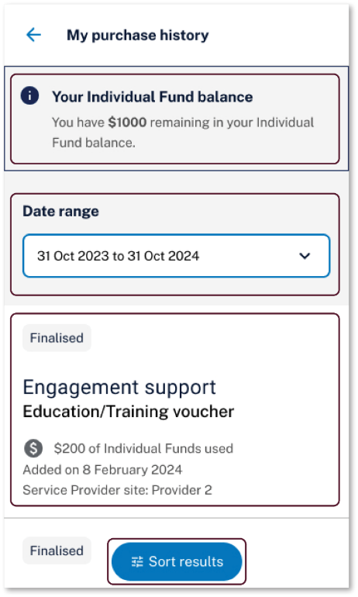
Step 3
The Individual Fund ‘My purchase history’ page will open.
Here you can:
- View the balance of your Individual Fund
- Filter by date range
- See a record of what purchases have been made with your Individual Fund
- Sort by:
  - Added on date
  - Amount
  - Category
  - Service Provider site.

Step 4
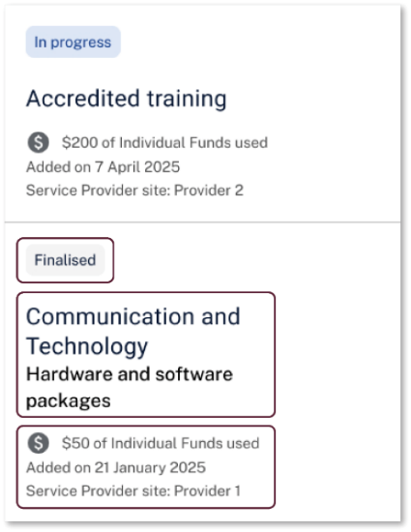
On the ‘My purchase history’ page, you can view the details of each Individual Fund purchase.
- The status of the purchase:
  - In progress: This means your provider is
waiting to be reimbursed for the purchase
made using your Individual Fund. There is nothing you need to do.
  - Finalised: This means your provider has
been reimbursed for the purchase made using your Individual Fund.
- What was purchased.
- The details of the purchase, including:
  - how much of your Individual Fund was used (inclusive of GST, if applicable)
  - the date the purchase was added
  - your provider.

Step 5
If the purchase is linked to a goal, you can see these details by:
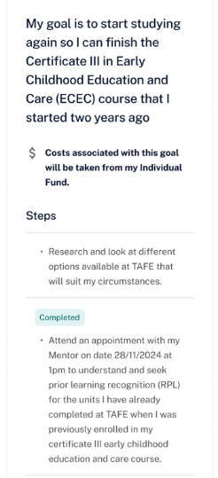
  - Selecting the 3 dots next to an Individual Fund purchase on the website version, or
  - By clicking the ‘view related goal’ button at the bottom of an Individual Fund purchase on the App version.
  - Once you select ‘view related goal’, a page will display with information about the related goal and steps.
When you have achieved the goal, the status will be shown as ‘achieved’.
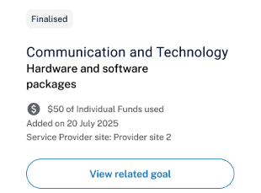

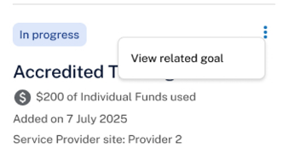
If the dots do not appear, the Individual Fund purchase has not been linked to a goal.
App Version
Website Version

