Quick Guide – Processes and Procedures
This quick guide explains processes and procedures that you must have in place.

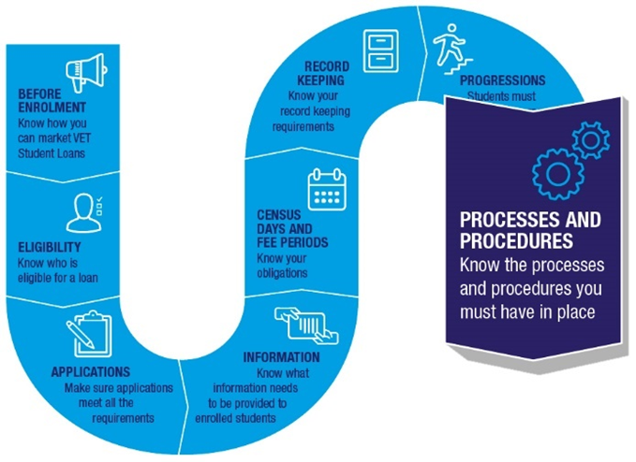

Processes and procedures
You must have in place, and act in accordance with, the processes and procedures set out at section 48 of the VET Student Loans Act 2016 (the Act).
You should ensure your staff understand the processes and procedures relating to their duties.
Your processes and procedures must provide for equal and fair treatment of all students seeking to enrol in an approved course.

Publishing processes and procedures
You must publish your processes and procedures on your website. This information needs to be easily accessible without the need for login information. This means a person should not need to submit personal information to view this information. Refer to section 4.8.2 of the VET Student Loans Manual for Providers.

Student entry
Your student entry procedures must:
- specify the requirements a student must meet to be academically suited for a particular course
- specify that, when required, the student’s reading and numeracy competency results must be reported to:
- the student as soon as practicable after the assessment and
- the Department of Employment and Workplace Relations (the department)
- describe the process (including the tools) for assessing a student’s competence in reading and numeracy against the Australian Core Skills Framework.

Loan applications
Your processes and procedures must require the collection and verification of certain documents for students who apply for a VET Student Loan. This includes:
- information about the student’s identity and date of birth
- information and documents to establish that the student meets the VET Student Loans citizenship and residency requirements
- where the student has applied for, but not been issued with a Tax File Number (TFN), a certificate from the Australian Tax Office showing that the student has applied for a TFN.

Handling student’s personal information
You must have processes and procedures for handling information.
The processes and procedures must:
- provide for the management of student’s personal information in accordance with the Australian Privacy Principles
- allow students to access their personal information
- allow students to have incorrect personal information corrected
- provide accurate information about the use and disclosure of personal information collected by you including that the information may be disclosed to the Commonwealth and tuition assurance scheme operators.

Tuition fees
You must determine the tuition fees for each approved course you offer. In determining tuition fees for an approved course you must not consider:
- any matter related to the manner or timing of payment of tuition fees (for example, different fees should not be charged based on whether a student pays upfront or requests a VET Student Loan)
- fees payable for anything other than assessing academic suitability, enrolment, tuition, assessment and awarding of a qualification on completion for a course.
Tuition fees must not include other fees payable for goods and services, whether essential to the course or not, or be affected any fine or penalty that may be imposed on a student.
Tuition fees cannot include the provision of a good or service that is not essential for all or part of the course.
Section 118 of the VET Student Loans Rules 2016 sets out the full requirements in relation to determining tuition fees.

Student’s withdrawal from a course
Your processes and procedures must include a procedure for students to:
- withdraw from an approved course (or part of a course) and
- enrol in part of an approved course where the student had earlier withdrawn from that part of the course.
The procedures for student withdrawal before a census day must not involve financial, administrative or other barriers to withdrawal.
You may require a student to follow your internal withdrawal procedure. This can only be done if it does not impede a student from withdrawing on, or before, the census date.
A withdrawal procedure may include an optional counselling service for students wishing to withdraw from their studies. However, the counselling may not pressure the student to remain enrolled or to enrol in a different course. It cannot cause them to withdraw after the census day.
If a student withdraws from study you must not re-enrol the student without their written permission.

Cancelling a student’s enrolment after the census date
You must have processes and procedures for cancelling a student’s enrolment after the census date. These processes and procedures must:
- require you to inform the student of a proposed cancellation of enrolment
- provide the student with at least 28 days to initiate grievance procedures before the cancellation takes final effect
- provide for the cancellation to take final effect only after any grievance procedures initiated by the student have been completed
- set out the circumstances in which tuition fees will, or will not, be refunded.

Re-crediting a student’s FEE-HELP balance
You must have processes and procedures for explaining the re-crediting of student FEE-HELP balances under Part 6 of the VET Student Loans Act 2016. See section 4.8.15 of the VET Student Loans Manual for Providers for further information on the requirements for this.

Student complaints
You must have a grievance procedure to deal with complaints from students about both academic matters and non-academic matters. The grievance procedure must:
- clearly set out the procedure including internal and external stages
- encourage the timely resolution of complaints including specifying reasonable periods for dealing with each stage of a complaint
- clearly state that there is no charge for the internal stage or external stage
- provide for implementation of decisions made following the grievance procedure
- provide for due consideration of recommendations from the external stage
- allow parties who have used the procedure to access records of their use but otherwise keep the records confidential.

VET Student Loans Ombudsman
The VET Student Loans Ombudsman (VSLO) acts as the external dispute resolution body. The VSLO conducts investigations and makes recommendations about VET Student Loans assistance and compliance by VET providers. The VSLO reports on their investigations and recommends that providers and others act or stop certain behaviour to address identified problems and provide redress to affected students.
For matters which do not fall within the scope of the VSLO (for example, matters relating to personal information held by the provider or matters that do not relate to loan assistance disputes), you must ensure that the external stage of the grievance procedure makes appropriate provision for external and independent review.
More information about the VSLO is available from the Commonwealth Ombudsman’s website.

Further information
For further information on the processes and procedures you must have in place, refer to the VET Student Loans Manual for Providers (see Chapter 4.8 Processes and procedures).
For the legislation governing the requirements around processes and procedures, please see section 48 of the VET Student Loans Act 2016, and sections 76-79, 85-88, 93, 118 of the VET Student Loans Rules 2016.

