

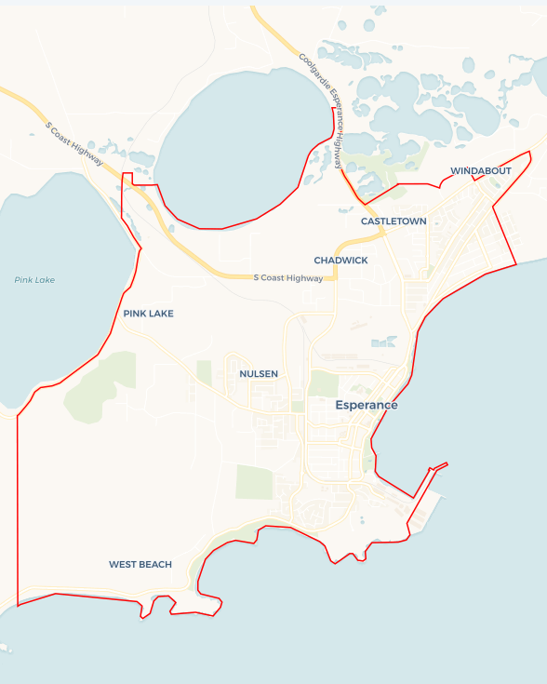Local Jobs Plan

Esperance Employment Region | WA | ****March 2025****

Workforce Australia Local Jobs (Local Jobs) is a program that supports tailored approaches to accelerate   
reskilling, upskilling and employment pathways in response to current and emerging local workforce needs.

## Local Jobs elements

### Local Jobs Plan

The Local Jobs Plan sets out the skills and employment challenges and priorities of the region, and associated strategies that will drive the design and implementation of activities to be implemented to address these challenges.

### Job Coordinators

Job Coordinators and Support Officers support the delivery of the program by bringing together key stakeholders including businesses, employment services providers, higher education and training organisations.

### Local Jobs and Skills Taskforce

Each Employment Region has its own Taskforce. Representatives include local stakeholders who have demonstrated experience in upskilling, reskilling, and an ability to represent, connect and collaborate with others in the region to meet labour market needs.

### Program Funds

The Employment Region’s Local Initiatives Fund enables targeted local investments that support local labour market functioning. Further, from 2025/26, a central grants-based fund will respond to local needs and help progress broader employment service reform objectives.

Explore labour market insights for the   
[Esperance](https://www.jobsandskills.gov.au/work/employment-region-dashboards-and-profiles/monthly-labour-market-dashboards) Employment Region

## Local labour market challenges in the region

* Lack of accommodation/housing.
* Lack of childcare placements.
* Limited tertiary learning opportunities.
* Need for culturally safe workplaces.
* High amounts of staff burnout and turnover in business.
* The locally available workforce is relatively small.
* Disengaged youth facing challenges completing high school and transitioning from education to employment.
* Skills shortages across multiple industries.
* High levels of underemployment and casualisation in some sectors.

## Local jobs and skills priorities and strategies in the region

### Priority 1 – Leveraging programs for creative pathways into employment

#### What are our challenges and opportunities?

The Esperance region is experiencing increased demand for workers in agriculture, hospitality, transport, tourism, retail, construction, health care and social assistance industries. The locally available workforce remains small, creating challenges in meeting demand. Opportunities exist to focus on supporting several cohorts in the region including youth, long-term unemployed and mature age individuals and First Nations peoples, leveraging programs to create targeted pathways to empower their employment journey.

#### How are we responding?

* Industry collaboration: connecting local Workforce Australia Employment Services Providers with key representatives in agriculture, hospitality, health care, social assistance, construction and other industries to develop and promote specific career paths.
* Skill transferability: identify transferable skills across industries and explore alternative employment pathways through labour market insights.
* Cohort-specific support: engaging with youth, mature age and First Nations support services to develop workforce initiatives tailored to these cohorts.
* Workshops and information sessions: delivering regular sessions to highlight current opportunities and available support services.
* Collaborative engagement: hosting and attending events with community support services to enhance education, training and alternative entry pathways into local industries.

### Priority 2 – Supporting smarter recruitment and retention

#### What are our challenges and opportunities?

The region faces significant challenges, including labour shortages, high turnover, skill gaps and difficulty retaining young talent, as well as underutilised diverse labour pools, such as people with disability, youth and mature age individuals and First Nations peoples. Strengthening collaboration, targeted upskilling and inclusive hiring practices can address these challenges.

#### How are we responding?

* Business engagement: promote innovative and inclusive recruitment practices. Support the improvement of workplace culture to enhance retention.
* Skills development: partner with training providers to deliver targeted upskilling programs. Facilitate apprenticeships and mentoring initiatives to bridge skill gaps.
* Community support: enhance volunteer initiatives to engage diverse cohorts. Advocate for solutions to address housing challenges that impact workforce retention.

### Priority 3 – First Nations pathways to employment

#### What are our challenges and opportunities?

First Nations peoples in the Esperance region frequently face systemic challenges to employment, including limited access to culturally appropriate training, a lack of workplace diversity and inclusion and challenges in securing sustainable job opportunities. Programs designed specifically to empower First Nations employment pathways can create meaningful and lasting workforce participation.

#### How are we responding?

* Culturally safe workplaces: partnering with businesses to promote culturally safe and inclusive work environments.
* First Nations-led training and upskilling: collaborating with First Nations organisations to develop training programs that respect and incorporate cultural knowledge and skills.
* Community-based employment initiatives: supporting employment programs that are led by or closely connected to First Nations communities to ensure relevance and long-term success.
* Entrepreneurship and business development: encouraging and supporting Indigenous-owned businesses through training, funding opportunities and networking support.

### Priority 4 – Disability employment and workplace inclusion

#### What are our challenges and opportunities?

People with disability in the Esperance region frequently face significant challenges to employment, including workplace accessibility, bias in hiring practices and limited tailored training opportunities. Enhancing pathways to employment through inclusive hiring, workplace adjustments and employer education will support greater workforce participation.

#### How are we responding?

* Accessible and inclusive workplaces: collaborating with businesses to improve workplace accessibility and implement inclusive hiring practices.
* Employer awareness and support: running workshops to educate employers on reasonable workplace adjustments, inclusive recruitment and the benefits of hiring people with disability.
* Advocacy and influence: collaborating with local government, industry bodies and employers to advocate for enhanced employment initiatives that support people with disability in the region.

## Want to know more?

* Contact: Andrea Wynne, Esperance Job Coordinator: esp@esperancelocaljobs.org.au
* Visit: [Local Jobs](https://www.dewr.gov.au/local-jobs) or [Workforce Australia](https://www.workforceaustralia.gov.au/)