


Utilising soft skills training to enhance work readiness

ISBN
978-1-76114-777-7 [PDF]
978-1-76114-666-4 [DOCX]
With the exception of the Commonwealth Coat of Arms, the Department’s logo, any material protected by a trade mark and where otherwise noted all material presented in this document is provided under a Creative Commons Attribution 4.0 Australia licence.
The details of the relevant licence conditions are available on the Creative Commons website (accessible using the links provided) as is the full legal code for the CC BY 4.0 AU licence.
The document must be attributed as the Utilising soft skills training to enhance work readiness.

Contents
List of figures 4
List of tables 5
Executive summary 6
Testing ‘soft skills’ or work readiness training 6
Our key findings 7
Part 1: The importance of soft skills 8
Psychological work readiness skills and job search 8
Part 2: Developing the training program 9
Key explore phase findings 9
Improvements in psychological work readiness 9
Key training elements 9
Soft skills training 10
Part 3: Evaluating the training 11
Part 4: Was the trial successful? 13
Positive changes in psychological work readiness 13
Was there an impact on employment outcomes? 17
What did the training participants say? 18
Part 5: What did we learn? 19
Reference list 20
Technical Appendix 22
How were eligible job seekers identified? 22
Random assignment 23
Statistical analysis 23
Primary outcome measures 24
Instrumental variables analysis 25
Intention-to-treat analysis 27
Appendix II 31
Soft skills training methodology 31

List of figures
Figure 1: Soft skills trial design 12
Figure 2: Proportional change of Satisfaction with Life scores pre- to post-treatment 14
Figure 3: Proportional change of Rosenberg Self-Esteem scores pre- to post-treatment 15
Figure 4: Proportional change of Brief Resilience Scale scores pre- to post-treatment 16
Figure 5: Proportional change of Career Self-Efficacy Scale scores pre- to post-treatment 17
Figure 6: Mean change in scores – participant assessments 18

List of tables
Table 1: Key findings 7
Table 2: Primary outcome measures 24
Table 3: Instrumental variables regression models 25
Table 4: Satisfaction with Life Instrumental Variables Results 25
Table 5: Rosenberg Self-Esteem Scale Instrumental Variables Results 26
Table 6: Career Self-Efficacy Instrumental Variables Results 27
Table 7: Brief Resilience Scale Instrumental Variables Results 27
Table 8: Intention to treat regression models 28
Table 9: Satisfaction with Life Intention to Treat Results 29
Table 10: Rosenberg Self-Esteem Scale Intention to Treat Results 29
Table 11: Career Self-Efficacy Intention to Treat Results 30
Table 12: Brief Resilience Scale Intention to Treat Results 30

Executive summary
The Australian Government provides a range of support to help unemployed people into work. Many job seekers can find work relatively quickly and may only need basic support, such as help with job search. On the other hand, job seekers with more complex barriers to employment (and further education) will often require a significant change in personal circumstances and a conducive external economic environment to find work.
Time spent unsuccessfully looking for work can also erode individuals’ confidence and reduce their motivation to search for work, compounding the existing barriers to employment. Long-term joblessness can therefore have scarring effects, resulting in a greater chance of future periods of unemployment, lower lifetime earnings and poorer physical and mental health.
This context highlights the potential benefits of government support that works with disadvantaged job seekers, often with long durations of unemployment, to recover and strengthen their work readiness. This improvement in work readiness may also complement other forms of employment assistance or other courses of action undertaken by the job seeker to find work.

Testing ‘soft skills’ or work readiness training
The Department of Education, Skills and Employment (the department) assesses the relative disadvantage of job seekers using the Job Seeker Classification Instrument (JSCI), which is a questionnaire used to measure the risk of becoming long-term unemployed. Responses to a series of questions are used to help identify what level of support the job seeker will need to help them find work. Based on their JSCI scores and other supplementary assessments, job seekers are initially allocated to either Stream A (where job seekers are the most job ready) or Stream B (where job seekers need a greater level of support to help them become job ready). The JSCI also identifies whether a job seeker has multiple or complex barriers to employment that require more intensive support through Stream C.
The department’s Behavioural Economics Expertise Section set out to test a training solution to improve work readiness, with a particular focus on more disadvantaged job seekers in Stream B and C. The objectives for the solution included:
- Initially build confidence, resilience and motivation to go out and find work.
- Build on this by ensuring job seekers had the tools and resources they needed to find work, such as practical advice to improve their job search skills.
The department collaborated with Bounce Australia (Bounce) to help develop and deliver the training program. The training program incorporated techniques underpinned by behavioural insights, which helped job seekers make positive steps to building their confidence, self-esteem, resilience and life satisfaction. These psychological work readiness indicators can be thought as a category of soft skills – the other being more traditional forms of soft skills, such as communication and teamwork skills. Specifically, the trial tested a 3-week training program aimed at maintaining and building job seeker’s soft skills, focusing on improving the psychological work readiness of Stream B and C job seekers.
A randomised controlled trial (RCT) methodology was used to assess the effectiveness of the training. To assess their change in soft skills over the course of the trial, job seekers were sent a soft skills assessment to complete prior to the trial and the same assessment after the trial. The assessment contained four different psychometric tools used to assess soft skills and psychological work readiness (32 questions). The trial ran from March 2019 to December 2019 and involved 319 job seekers.

Our key findings
Overall, the trial found the training to be beneficial for Stream B and C job seekers, having a positive and statistically significant impact on their life satisfaction, self-esteem and resilience. Table 1 illustrates the number of job seekers that moved from low levels self-esteem, resilience and life satisfaction to higher levels after attending the training.
Table 1: Key findings
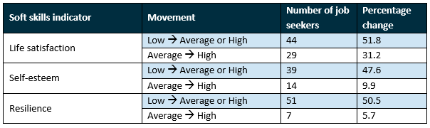  Soft skills indicator | Movement | Number of job seekers | Percentage change
Life satisfaction | Low to Average or High | 44 | 51.8
Life satisfaction | Average to High | 29 | 31.2
Self-esteem | Low to Average or High | 39 | 47.6
Self-esteem | Average to High | 14 | 9.9
Resilience | Low to Average or High | 51 | 50.5
Resilience | Average to High | 7 | 5.7
Note: Percentage change is calculated by dividing the number of job seekers who moved into a higher scoring bracket following the training by the base number of job seekers in that group after the pre-intervention survey. For example, there were 85 job seekers who had low life satisfaction after completing the pre-intervention survey. Of that, 44 job seekers increased their life satisfaction to average or high in the post-intervention survey, equalling a 51.8 per cent change.
These findings suggest improvements to the precursors to employment, or job seekers’ psychological work readiness, are possible by utilising soft skills training. Particularly when implemented alongside other tailored support, such as occupational, foundation and job search skills, this may help disadvantaged job seekers maintain or build the confidence and positive habits that lead to a return to employment (Koopman et al, 2017). That is, increased self-esteem, resilience and life satisfaction in turn may improve job search effectiveness and therefore the likelihood of employment.
The rest of the report flows as follows. Part 1 discusses soft skills in more detail and outlines further reasons for our focus on psychological work readiness. Part 2 discusses the training program and the explore findings that supported its development. Part 3 outlines the methodology used to trial and evaluate the effectiveness the training program. Part 4 presents the results, while Part 5 concludes.

Part 1: The importance of soft skills
‘Soft’ skills, also called ‘employability’ or ‘interpersonal’ skills, are a broad range of non-technical, personal attributes that are becoming increasingly important for entry and success in the workplace. As noted above, they are important precursors to finding employment, and unlike technical skills that are required by some jobs, are malleable and transferable. In other words, soft skills can be improved with an open mind and focused training, and they can move with people from one job to another.
Soft skills can fall into one of two categories:
- Traditional work-readiness soft skills, such as communication skills, leadership skills, conflict resolution skills, time management skills and teamwork skills.
- Psychological work-readiness indicators, such as a positive attitude, self-efficacy, self-esteem, resilience and life satisfaction.
For this study, we focused on improving disadvantaged job seekers’ psychological work readiness using rigorously developed scales, which are connected to job search, employment and workplace outcomes. Four separate psychometric scales were used to measure job seekers’ psychological skills – the Rosenberg Self-Esteem scale, the Career Self-Efficacy scale, the Brief Resilience scale and the Satisfaction with Life scale. How they are connected to job search and employment outcomes is discussed directly below.

Psychological work readiness skills and job search
Previous researchers have been able to demonstrate that soft skills measures such as self-esteem, self-efficacy, resilience and life satisfaction are positively associated with job search behaviours and employment outcomes. For instance, it has been shown that higher resilience in job seekers is associated with increases in the likelihood of assertive job searching (Moorhouse and Caltabiano 2007). Researchers have also found that self-esteem and self-efficacy are positively correlated with persistence in job search (Wanberg et al. 2005). Job search intensity is then itself correlated with employment outcomes (van Hooft et al. 2020). Finally, a low level of life satisfaction is associated with a decrease in the likelihood of reemployment compared to moderate or average life satisfaction (Rose and Stavrova 2019).

Part 2: Developing the training program

Key explore phase findings
The department undertook a qualitative explore phase in 2018 prior to developing and trialling the training program in 2019. During the explore phase, 20 Stream B and C job seekers who had recently completed some type of soft skills training were interviewed to seek their views on whether: 1) the training led to increases in their psychological work readiness and employment and 2) what elements of the training did they feel were the most successful in contributing to their improved outcomes.

Improvements in psychological work readiness
During the interviews, almost all job seekers who had completed a soft skills course described it as having a positive impact on their psychological job readiness. Most commonly, the soft skills training led to increases in job seekers’ confidence, which then encouraged them to talk to more employers (when handing résumés in) and submit more job applications.
Job seekers who initially felt they struggled with their confidence and/or motivation reported the soft skills course helped boost their confidence and motivation. This in turn contributed to them gaining employment successfully or making the decision to participate in further education. Some job seekers also talked about how the training lead them to broaden their applications into other industries and move to labour markets in other states.

Key training elements
Overall, the job seekers regarded the goal- and action-focused content of the soft skills courses as helpful for breaking up larger goals such as finding a fulfilling job into smaller achievable steps. This in turn increased job search effectiveness, and in some instances, helped them gain employment.
The interviews also identified three key behavioural elements of soft skills training that ultimately informed the design of our trial.

A trusting relationship with the trainer
During the interviews, most job seekers reported that the perceived relationship they had with their trainer had the greatest influence on whether they found the soft skills course beneficial. When job seekers viewed their trainer as more trusting and relatable, this led to two things: 1) they were generally more engaged in the course content and 2) they felt safe enough to address their negative habits and thought patterns more meaningfully.
Job seekers also noted that informal conversations with the trainer, in-class or through one-on-one sessions, helped build their motivation and encouraged job search more generally. During these conversations, trainers offered personalised advice on the job seekers’ immediate goals and solutions to current problems.
The trainer created a comfortable environment, she was in charge but treated as us equals, we were not looked down on.
Job seeker, female, 18–24, Stream C, Victoria

A dynamic and social learning environment
During the interviews, job seekers reported courses which included interactive elements, such as group discussions and role-play, helped build their confidence by allowing them to hear and learn from people like themselves and share their own experiences in return. This higher confidence in turn motivated them to apply for more jobs and/or approach employers with their résumés.
… being in a room with other people who are in the same situation, feel the same way and struggle with different social aspects. It does help to be able to bounce things off other people, you know.
Job seeker, female, 35–44, Stream C, New South Wales

The importance of pre-course information
Many job seekers noted the importance of having information prior to attending the soft skills course, particularly when the information was framed in terms of the benefits of the training. This encouraged them to attend the course with a more positive and open mindset. On the other hand, when little information was provided prior to attending the course, job seekers were more likely to attend the course with a negative mindset, not attend at all or drop out early.
I wasn’t told much other than the title ... I think [it would be good] to give somebody more preparation, maybe send out a fact sheet to them prior to the course. You know, just bullet points. We didn’t see what the course entailed till day one. If you got that presentation printed out you’d know what to expect on those days
Job seeker, male, 35–44, Stream C, NSW

Soft skills training
The department engaged Bounce to help develop and deliver the training program. As noted above, the aim of the training program was to maintain and build the soft skills of Stream B and C job seekers, but with a focus on their psychological work readiness. However, as part of a comprehensive approach, the training also sought to improve traditional work readiness skills and job search skills.
Key elements of the training were informed by the explore phase research conducted in 2018. The techniques used in the training to encourage behaviour change came from a range of disciplines, including positive psychology, cognitive behavioural therapy and other social science models.
Bounce employed skilled trainers to deliver the training, who were also able to build rapport and trust with job seekers and adapt to personal learning styles. All trainers had to undergo a 3-day intensive ‘Train the Trainer’ workshop to ensure they were able to deliver Bounce’s methodology and the techniques to encourage behaviour change outlined above.
In addition, the training included social networks and norming elements. For example, most of the training was done in a group setting and trainers brought in past training participants with similar experiences to share their stories with current participants. To encourage attendance at the training, Bounce used information sessions to provide pre-course information to job seekers, while the department used SMS nudges to remind job seekers to attend their training.
These elements taken together provided job seekers a safe place to identify and tackle negative behaviours that contributed to their difficulty in finding and securing work. Once job seekers understood which behaviours might be holding them back, they were able to overcome them using a range of techniques provided in the training (e.g., reframing a negative attribute such as being fussy into a positive one such as being detail-oriented). This then allowed job seekers to think more positively about their attributes and skills, which contributed to increase their psychological work readiness – that is, their self-esteem, resilience and life satisfaction. As noted above, this subsequently may have led to increases in job search effectiveness. Given the training also seeks to improve job search skills, we may also see improvements in employment outcomes. In the next chapters, the results of the trial are examined to determine if the training increased psychological work readiness.

Part 3: Evaluating the training
An RCT methodology was used to assess the effectiveness of the training. The trial ran from March 2019 to December 2019, involved 17 training courses and 319 job seekers.
During the trial, eligible Stream B and C job seekers within the trial areas (Melbourne, Sydney, Brisbane, Newcastle and Regional Victoria) were sent an invitation to complete a pre-intervention assessment (32 questions). The assessment contained four different assessment tools used to provide indicators of soft skill development – particularly changes in psychological job readiness. Participants that completed the assessment were then randomised into either the control or the treatment group. Control group participants continued to receive ‘business as usual’ support from their employment services provider, while the treatment group were invited to take part in soft skills training. Figure 1 outlines our trial design.
Figure 1: Soft skills trial design
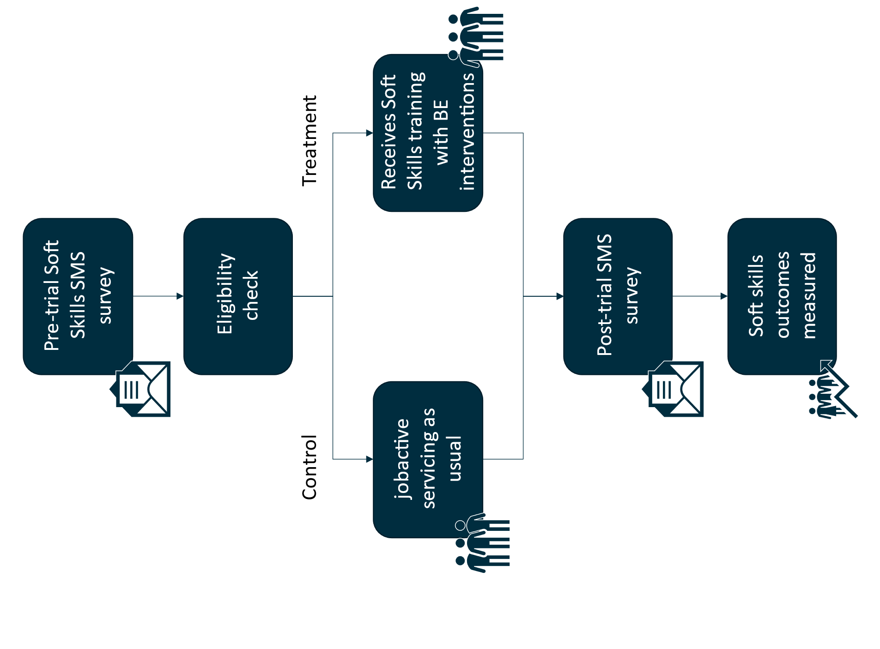
Approximately 4 weeks after the trial, participants (both the control and treatment groups) were sent a post-intervention assessment. This second assessment was a copy of the pre-intervention assessment and was used to measure a change in responses (or psychological job readiness indicators). This was the primary outcome measure for the trial. It sought to measure a positive change in the treatment group relative to the control group.
Bounce also undertook a survey with participants on their thoughts about the training, which enabled a qualitative analysis of participants’ experiences during the training program. Taking both the RCT and qualitative analysis together provides a more holistic picture of the outcomes of the training and the aspects of the training that lead to those outcomes.
For further information on the trial methodology, refer to the Technical Appendix.

Part 4: Was the trial successful?
The assessment consisted of four separate psychometric scales: the Satisfaction with Life scale, the Rosenberg Self-Esteem scale, the Career Self-Efficacy scale and the Brief Resilience scale. Analysis of these scales suggests that there was a significant positive impact on participants’ soft skills and psychological work readiness. While all four scales use different scale ranges, broadly speaking the higher the score, the better the perception of that soft skill. Our regression analysis found statistically significant results (at the 0.05 level) for:
- the Satisfaction with Life scale
- the Rosenberg Self-Esteem scale and
- the Brief Resilience scale.
We did not, however, find a significant positive relationship between the training and the Career Self-Efficacy scale. This result might be explained by the fact the measure was originally designed for people who were employed at the time of their assessment and not job seekers.
To simplify the interpretation of these findings, the survey results were converted into proportional changes in participant scores from the pre- to the post-assessment. That is, rather than using the differing scale ranges from the regression analysis, which can be difficult to interpret, we have displayed results in a more intuitive way. For the full regression results from the RCT, please see the Technical Appendix.

Positive changes in psychological work readiness
Figure 2 demonstrates the change in participant responses for the Satisfaction with Life scale following the trial. After attending the training, fewer participants reported dissatisfaction, while more reported higher levels of satisfaction with life. There was a 32.9 per cent reduction in participants reporting low satisfaction with life and a 35.7 per cent increase in those reporting high satisfaction with life following attendance at the training. Another way of looking at this is if 1,000 people undertook the training, this would result in 218 people moving from being dissatisfied to average or high satisfaction with life, while 124 people moved from being average to high satisfaction with life following training attendance.
Figure 2: Proportional change of Satisfaction with Life scores pre- to post-treatment

Attendance status | 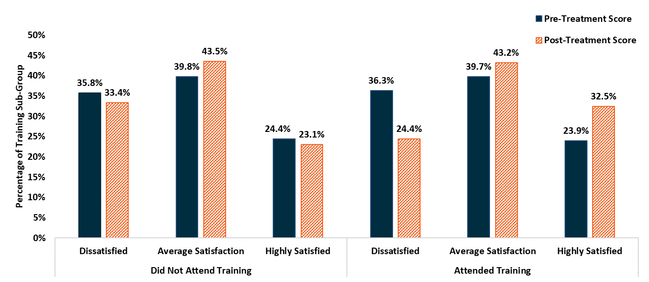  Satisfaction level percentage | Pre-treatment score % | Post-treatment score %
Did not attend training | Dissatisfied | 35.8 | 33.4
Did not attend training | Average satisfaction | 39.8 | 43.5
Did not attend training | Highly satisfied | 24.4 | 23.1
Attended training | Dissatisfied | 36.3 | 24.4
Attended training | Average satisfaction | 39.7 | 43.2
Attended training | Highly satisfied | 23.9 | 32.5
Note: Did Not Attend Training group contains both the control group and people in the treatment who did not attend the training. Data has been presented as such to aid in the interpretation of our analysis, please see the Technical Appendix for the full regression results. Ranges are classified as: Dissatisfied 5 to 14; Average satisfaction 15 to 24; Highly satisfied 25 to 35. Percentage changes may not align with what is reported due to rounding.
Source: Departmental survey data from the Soft Skills trial.
Figure 3 demonstrates the change in participant responses for the Rosenberg Self-Esteem scale following the trial. After attending the training, fewer participants reported low self-esteem while more reported high self-esteem. There was a 26.8 per cent reduction in participants reporting low self-esteem and a 170.0 per cent increase in those reporting high self-esteem. Alternatively, if 1,000 people undertook the training this would result in 167 people moving from low self-esteem to average or high self-esteem, while 60 people moved from being average to high self-esteem following attendance at the training. There was also an increase in the proportion of participants in the Did Not Attend Training group that reported high self-esteem, with a small decrease in average self-esteem. However, this change was not as pronounced as in the treatment group.
Figure 3: Proportional change of Rosenberg Self-Esteem scores pre- to post-treatment
Attendance status | Self-esteem level | Pre-treatment score % | Post-treatment score %
Did not attend training | Low self-esteem | 36.4 | 36.9
Did not attend training | Average self-esteem | 57.9 | 55.9
Did not attend training | High self-esteem | 5.8 | 7.2
Attended training | Low self-esteem | 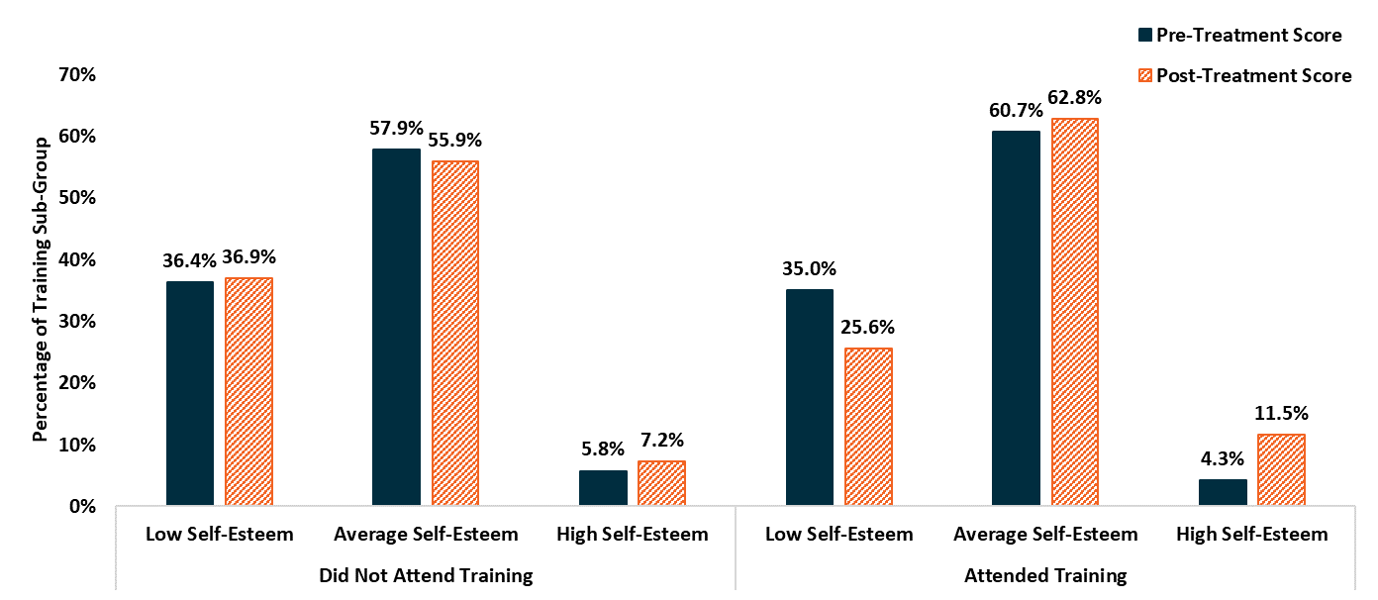  35.0 | 25.6
Attended training | Average self-esteem | 60.7 | 62.8
Attended training | High self-esteem | 4.3 | 11.5
Note: Did Not Attend Training group contains both the control group and people in the treatment who did not attend the training. Data has been presented as such to aid in the interpretation of our analysis, please see the Technical Appendix for the full regression results. Ranges are classified as: Low self-esteem 0 to 14; Average self-esteem 15 to 24; High self-esteem 25 to 30. Percentage changes may not align with what is reported due to rounding.
Source: Departmental survey data from the Soft Skills trial.
Figure 4 demonstrates the change in participant responses for the Brief Resilience scale following the trial. After attending the training, a smaller proportion of participants reported low resilience while a larger proportion reported high resilience. There was a 40.6 per cent reduction in participants reporting low resilience and a 20.0 per cent increase in those reporting high resilience. Alternatively, if 1,000 people undertook this training it would result in 218 people moving from low resilience to average or high resilience, while 30 people moved from average resilience to high resilience. In contrast, there was no change in the proportion of participants in the Did Not Attend Training group reporting low resilience and a small increase in participants reporting high resilience.
Figure 4: Proportional change of Brief Resilience Scale scores pre- to post-treatment
Attendance status | Resilience level | Pre-treatment score % | Post-treatment score %
Did not attend training | Low resilience | 43.1 | 43.1
Did not attend training | Average resilience | 52.4 | 51.6
Did not attend training | 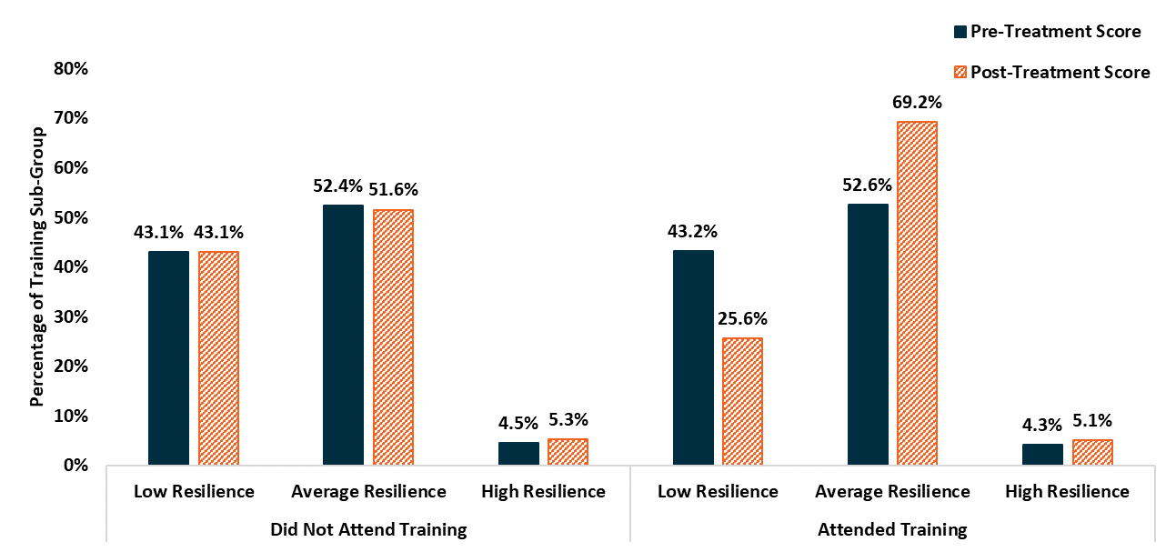  High resilience | 4.5 | 5.3
Attended training | Low resilience | 43.2 | 25.6
Attended training | Average resilience | 52.6 | 69.2
Attended training | High resilience | 4.3 | 5.1
Note: Did Not Attend Training group contains both the control group and people in the treatment who did not attend the training. Data has been presented as such to aid in the interpretation of our analysis, please see the Technical Appendix for the full regression results. Ranges are classified as: Low resilience 1 to 2.99: Average resilience 3 to 4.30: High resilience 4.31 to 5. Percentage changes may not align with what is reported due to rounding.
Source: Departmental survey data from the Soft Skills trial.
Figure 5 demonstrates the change in participant responses for the Career Self-Efficacy scale following the trial. After attending the training, a larger proportion reported high Career Self-Efficacy. There is a 31.8 per cent increase in those reporting high Career Self-Efficacy. However, it should be noted, despite the above results, the analysis found no statistically significant difference in the scores between the control and treatment groups.
Figure 5: Proportional change of Career Self-Efficacy Scale scores pre- to post-treatment
Attendance status | Career self-efficacy level | Pre-treatment score % | Post-treatment score %
Did not attend training | Low career self-efficacy | 4.7 | 5.2
Did not attend training | Average career self-efficacy | 67.6 | 70.2
Did not attend training | 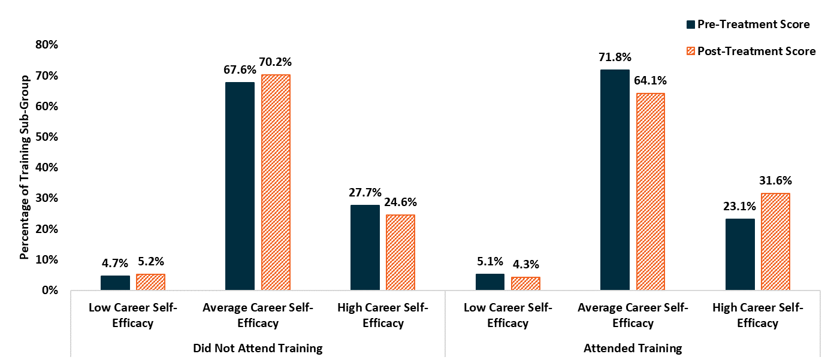  High career self efficacy | 27.7 | 24.6
Attended training | Low career self-efficacy | 5.1 | 4.3
Attended training | Average career self-efficacy | 71.8 | 64.1
Attended training | High career self efficacy | 23.1 | 31.6
Note: Did Not Attend Training group contains both the control group and people in the treatment who did not attend the training. Data has been presented as such to aid in the interpretation of our analysis, please see the Technical Appendix for the full regression results. Ranges are classified as: Low career self-efficacy 10 to 25: Average career self-efficacy 26 to 40: High career self-efficacy 41 to 55. Percentage changes may not align with what is reported due to rounding.
Source: Departmental survey data from the Soft Skills trial.

Was there an impact on employment outcomes?
Given the potential link between psychological work readiness, job search and employment outcomes, the impact of the trial on participants’ employment outcomes was analysed. However, a significant difference in job placements between the control and treatment groups was not found. There could be a few reasons for this:
- The sample size was not large enough to detect differences in job placements between the groups.
- There is some evidence to suggest that job search assistance training has most of its impact in the first year (Cottier et al, 2018). Noting that any gains in self-esteem, resilience and life satisfaction need to be built on with other skills and possibly work experience within this timeframe, the opportunity to do so for trial participants was severely restricted given the impact of COVID-19 in 2020 (recall the trial ended at the end of December 2019). The potential for the soft skills training to have any impact on employment or further education was therefore very limited.
- Due to both COVID-19 and the 2019–20 bushfires, the labour market softened significantly as the trial was operating, with fewer vacancies available. As such, some of the participants were not able to move into vacancies that would have ordinarily existed. With good labour market conditions, the soft skills training would be expected to help some of the participants move closer to securing employment.
The analysis found limited evidence suggesting that job seekers who attended training earlier in the trial period were more likely to have obtained employment compared to the control group. However, the effect size was small and the result was statistically insignificant. As already stated, this result may have also been affected by the impact of COVID-19.

What did the training participants say?
The positive changes in psychological work readiness outlined above align with survey data collected by Bounce. Bounce asked participants to rate themselves on a range of indicators related to soft skills and psychological work readiness before and after the trial. Analysis was undertaken on the change in participants’ self-rated assessment scores. Figure 6 outlines this analysis.
Figure 6: Mean change in scores – participant assessments
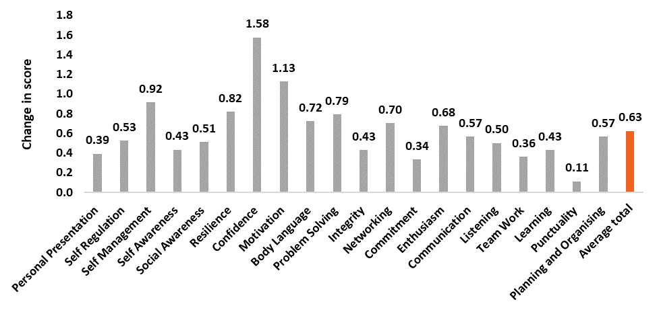
Source: Bounce post-training survey of participants.
Participants identified confidence as being the most improved soft skill. Participants also rated their motivation, self-management and resilience as areas of improvement following the training. In addition, elements of the training were identified that might have caused an increase in soft skills as measured by our four separate tools. For example, some participants noted the training gave them increased self-confidence and helped them establish a more robust social network.
I’ve learned a lot of self-worth and improved my confidence. I’ve improved several skills that will help me obtain work, my résumé and my cover letter look better than ever, and [I] have started to plan my days more efficiently.
Job seeker, female, 18–24, Soft Skills training participant
Participants also identified aspects of the training that were of value to them. Notably, anchoring and reframing techniques to manage negative thoughts was identified as an area they found important throughout the training.
I also realised a lot of my negative thought patterns and how to anchor or replace them with good positive thoughts.
Job seeker, female, 25–34, Soft Skills training participant
Furthermore, some participants noted that the trainer played a significant role in helping them engage with the training.
[Trainer name] managed to get everyone the ability to open up and not just about career but life in general. He was very approachable.
Job seeker, female, 45-54, Soft Skills training participant

Part 5: What did we learn?
Overall, the trial was successful at increasing Stream B and C job seekers’ self-esteem, resilience and life satisfaction. While career self-efficacy was also measured, no effect was detected.
Results suggest that training that considers the breadth of soft skills (including psychological work readiness) can help disadvantaged job seekers with complex barriers build the confidence, resilience and motivation to become more job ready. Previous research with job seekers identified that improving aspects of psychological work readiness (including self-esteem and resilience) is linked with motivation to apply for jobs and talk to employers, and increased confidence at job interviews. This suggests this form of training, particularly when complemented with other relevant assistance, may help disadvantaged job seekers find employment, and with it, increase their living standards and wellbeing.
Finally, several components of the training that resonated with job seekers were discovered. This included anchoring and reframing techniques to overcome negative thoughts, the development of social networks and the perceived overall quality of the trainer.

Reference list
Cottier L, Flückiger Y, Kempeneers P, and Lalive R (2018) Does job search assistance really raise employment? IZA, Discussion paper 11766, accessed 21 October 2021.
Deloitte Access Economics (2017) Soft skills for business success, report to DeakinCo, Deloitte Access Economics website, accessed 21 October 2021.
Department of Employment (2016) Employability Skills Training: Consultation Paper, DESE website, accessed 21 October 2021.
Department of Jobs and Small Business (2018) I want to work, Employment Services 2020 Report, DESE website, accessed 21 October 2021.
Dockery AM (2003) Happiness, life satisfaction and the role of work: Evidence from two Australian surveys [PDF 188KB], School of Economics and Finance, Curtin University of Technology, accessed 21 October 2021.
Headey B, Wooden M (2004) The effects of wealth and income on subjective well‐being and ill‐being, Economic record, 80:24-33.
Jensen R (2010) The (perceived) returns to education and the demand for schooling. The Quarterly Journal of Economics, 125(2):515-48.
Koopman MY, Pieterse ME, Bohlmeijer ET, Drossaert CH (2017) Mental health promoting interventions for the unemployed: a systematic review of applied techniques and effectiveness, International Journal of Mental Health Promotion, 19(4):202-23.
Lippman LH, Ryberg R, Carney R, Moore KA (2015) Workforce Connections: Key “soft skills” that foster youth workforce success: toward a consensus across fields, Washington, DC: Child Trends.
Lucas RE, Clark AE, Georgellis Y, Diener E (2004) Unemployment alters the set point for life satisfaction, Psychological science, 15(1):8-13.
Moorhouse A, Caltabiano ML (2007) Resilience and unemployment: Exploring risk and protective influences for the outcome variables of depression and assertive job searching, Journal of Employment Counseling, 44(3):115-25.
Rose D and Stavrova O (2019) Does life satisfaction predict reemployment? Evidence form German panel data, Journal of Economic Psychology, 72:1–11
Wanberg CR, Glomb TM, Song Z, Sorenson S (2005) Job-search persistence during unemployment: A 10-wave longitudinal study, Journal of applied psychology, 90(3):411.
Whelan N, McGilloway S, Murphy MP, McGuinness C (2018) EEPIC-Enhancing Employability through Positive Interventions for improving Career potential: the impact of a high support career guidance intervention on the wellbeing, hopefulness, self-efficacy and employability of the long-term unemployed-a study protocol for a randomised controlled trial. Trials, 19(1):1-8.
Wooldridge JM (2015) Introductory econometrics: A modern approach, Cengage learning.
van Hooft EA, Kammeyer-Mueller JD, Wanberg CR, Kanfer R, Basbug G (2020) Job search and employment success: A quantitative review and future research agenda. Journal of Applied Psychology, 106(5):674, doi.org/10.1037/apl0000675.

Technical Appendix

How were eligible job seekers identified?
The department sampled 10,184 job seekers between March and October 2019. Eligible participants within the trial areas (Melbourne, Sydney, Brisbane, Newcastle and Regional Victoria) were sent an invitation to complete a pre-intervention assessment. Job seekers had two weeks to complete the assessment. The assessment contained four different psychometric scales that were used to assess an individual’s life satisfaction, self-esteem, career self-efficacy and resilience (32 questions). 3,385 job seekers completed the pre-intervention assessment and were randomised into the trial, with 1,695 job seekers allocated to the control group and 1,690 job seekers into the treatment group. Control group participants continued to receive ‘business as usual’ support from their employment services provider, while the treatment group were invited to take part in the soft skills training.
For a job seeker to be considered eligible for the trial, several criteria had to be met before inclusion in the trial. Eligibility criteria for this trial were as follows:
- A participant must be in Stream B or C
- Active job seekers currently on the jobactive caseload (excludes suspended or pending job seekers)
- Must be on the caseload of a designated trial site
- Must have a valid phone number that is not shared by multiple people
- Participants must have full-time participation requirements
- Participants must not be younger than 18 or older than 60
- Participants must not have a ‘sensitive flag’
- Participants must not be tracking towards an employment outcome
- Participants must not already be undertaking an accredited or non-accredited training
- Exclude job seekers who are marked as deceased, in prison, experiencing a medical issue or a major personal crisis based on the department’s administrative data
- Excludes those marked as being in paid work or study

Random assignment
The R package ‘SeqAlloc’ was utilised, in conjunction with the caralloc() function to perform covariate adjusted sequential allocation. Covariate-adjusted-imbalance-tolerance sequential allocation was used with equal weights to each balancing variable.
Selection was balanced using the following variables:
- Stream
- age
- gender and
- length of time unemployed.
To ensure potential participants were still eligible for the trial, the department conducted a second eligibility check after the close of the pre-intervention assessment using administrative data prior to randomisation. This was done to ensure potential participants had not found employment or moved to education during the pre-assessment phase. Where possible, confirmation of employment or educational status of a participant with their jobactive provider was sought.

Statistical analysis
An estimate for the treatment effect, which is interpreted as the average causal impact of our interventions on the outcome was derived using two different regression models. Both these regression models calculate an effect size, which is the difference in soft skill measures between the control and treatment conditions.
The Department undertook two different types of analysis to generate robust results:
- We conducted an instrumental variables analysis to determine a local average treatment effect. Instrumental variables analysis recovers the impact of the treatment on those participants that actually attended the training. The instrumental variable (Z) is the allocation to treatment or control, the outcome (Y) is the post-assessment score and the variable of interest (X) is if the job seeker attended the training or did not attend training. A discussion of the mechanics of instrumental variables is beyond the scope of this paper.
- We also conducted an intention-to-treat analysis that allows us to draw unbiased and accurate conclusions from an intervention. Intention-to-treat analysis is a method for analysing results for all participants based on the group (control or treatment) they were assigned to, regardless of their actual attendance at the training. While intention-to-treat provides us with an unbiased estimate for those allocated to the treatment group, regardless of their attendance of the training, it likely underestimates the effect of the treatment on the treated.
Given the above, there was attrition in our samples that may have impacted the results of this trial. Complete case analysis was used for each outcome measured.

Primary outcome measures
The intention of the trial was to improve the soft skills development of Stream B and C jobactive participants. The researchers hypothesised the soft skills training would lead to an improvement in participant soft skills due to three main factors:
- The training focused on building confidence, motivation, personal principles and resilience.
- The training used behavioural insights to encourage attendance, including having flexible teaching methods in response to personal learning styles as well as the usual notification methods such as SMS to ‘nudge’ attendance.
- The training utilised a strength-based approach and actively reframed negative ideas into positive ones.
Table 1 outlines the four assessment tools used to measure changes in soft skills during the trial. Specifically, the assessments aim to measure the wellbeing, self-esteem, career self-efficacy and resilience of the control and treatment groups, before and after the trial period. The assessments are supported by peer-reviewed research and can be thought of as proxies for measures of soft skills (Whelan et al, 2018).
It is important to note that these measures are dependent on a participant comparing their own perceptions of their level of soft skills from one point in time to another, and therefore do not use a standardised scale. This makes the results somewhat difficult to interpret. However, the measures can simply be interpreted as the higher the score, the better the participant’s perception of that soft skill. For example, a score of 15 for Satisfaction with Life is better than a score of 10.
Table 2: Primary outcome measures
Assessment tool | Measuring | Questions | Scale range
Satisfaction with Life | Wellbeing | 5 | 5 to 35
Rosenberg Self-Esteem Scale | Self-esteem | 10 | 0 to 30
Career Self-Efficacy Questionnaire | Career self-efficacy | 11 | 11 to 55
Brief Resilience Scale | Resilience | 6 | 1 to 5

Instrumental variables analysis
For our main analysis, an instrumental variables analysis was utilised to measure the average effect of the treatment on those who attended the soft skills training. Using this method, three different regression models were analysed, which are specified below in Table 2. The preferred model is ‘Model C’ as this includes key variables that potentially have an association to the dependent variable (i.e. assessment scores).
Table 3: Instrumental variables regression models
Parameters | Model A | Model B | Model C
Outcome | Post-assessment result (continuous) | Post-assessment result (continuous) | Post-assessment result (continuous)
Instrument | Allocation | Allocation | Allocation
Covariates | Attended training | Attended training, age, unemployment, stream, gender, pre-assessment result | Attended training, age, unemployment, stream, gender, pre-assessment result, and participation wave (one to 17)

A statistically significant impact on the soft skills of participants who received the training was found. In other words, there was a positive effect from the training, namely an average:
- 2.46 point improvement in the Satisfaction with Life scale (p < 0.05)
- 1.56 point improvement in Rosenberg Self-Esteem scale (p < 0.05) and
- 0.38 point improvement in the Brief Resilience scale (p < 0.01).
The results for this analysis can be found below in Tables 3 to 6.
Table 4: Satisfaction with Life instrumental variables results
Parameters | Model A | Model B | Model C
Treatment group | 2.45*  (1.37) | 2.33**  (1.05) | 2.46**  (1.05)
Controls for age, gender, unemployment duration and Stream and pre-intervention assessment result | No | Yes | Yes
Controls for waves of participation | No | No | Yes
R-squared | 0.01 | 0.42 | 0.42
Observations | 2114 | 2114 | 2114
Note: * p-value less than 0.1; ** p-value less than 0.05; *** p-value less than 0.01. Numbers in brackets are the heteroskedasticity-robust standard error.
Table 5: Rosenberg Self-Esteem Scale instrumental variables results
Parameters | Model A | Model B | Model C
Treatment group | 1.63  (1.01) | 1.55**  (0.71) | 1.56**  (0.72)
Controls for age, gender, unemployment duration and Stream and pre-intervention assessment result | No | Yes | Yes
Controls for waves of participation | No | No | Yes
R-squared | 0.01 | 0.50 | 0.51
Observations | 2103 | 2103 | 2103
Note: * p-value less than 0.1; ** p-value less than 0.05; *** p-value less than 0.01. Numbers in brackets are the heteroskedasticity-robust standard error.
Table 6: Career Self-Efficacy instrumental variables results
Parameters | Model A | Model B | Model C
Treatment group | -0.60  (1.33) | -0.11  (0.99) | 0.00  (0.98)
Controls for age, gender, unemployment duration and Stream and pre-intervention assessment result | No | Yes | Yes
Controls for waves of participation | No | No | Yes
R-squared | 0.00 | 0.45 | 0.51
Observations | 2083 | 2083 | 2083
Note: * p-value less than 0.1; ** p-value less than 0.05; *** p-value less than 0.01. Numbers in brackets are the heteroskedasticity-robust standard error.
Table 7: Brief Resilience Scale instrumental variables results
Parameters | Model A | Model B | Model C
Treatment group | 0.20  (0.15) | 0.38***  (0.11) | 0.38***  (0.11)
Controls for age, gender, unemployment duration and Stream and pre-intervention assessment result | No | Yes | Yes
Controls for waves of participation | No | No | Yes
R-squared | 0.01 | 0.45 | 0.51
Observations | 2080 | 2080 | 2080
Note: * p-value less than 0.1; ** p-value less than 0.05; *** p-value less than 0.01. Numbers in brackets are the heteroskedasticity-robust standard error.

Intention-to-treat analysis
To ensure the instrumental variables analysis was robust, an intention-to-treat analysis was undertaken. In this method, results were compared between the control and treatment groups, regardless of whether those in the treatment group attended training. This provided an unbiased estimate of the efficacy of the treatment (being invited to attend the training, rather than the undertaking the training itself).
Three different regression models were used, which are specified in Table 7 below. The preferred model is ‘Model C’ as this it includes key variables that potentially have an association to the dependent variable (i.e. assessment scores).
Table 8: Intention-to-treat regression models
Parameters | Model A | Model B | Model C
Outcome | Post-assessment result (continuous) | Post-assessment result (continuous) | Post-assessment result (continuous)
Covariates | Allocation | Allocation, age, unemployment, stream, gender, pre-assessment result | Allocation, age, unemployment, stream, gender, pre-assessment result, and participation wave (one to 17)
A statistically significant impact on the soft skills of participants who were assigned to the treatment group was found, despite there being many participants in the treatment group that did not follow through with the training. In other words, there was a positive effect from the treatment, namely an average:
- 0.59 point improvement in the Satisfaction with Life scale (p < 0.05)
- 0.37 point improvement in Rosenberg Self-Esteem scale (p < 0.05) and
- 0.09 point improvement in the Brief Resilience scale (p < 0.01).
The results for this analysis can be found below in Tables 8 to 11.

Table 9: Satisfaction with Life intention-to-treat results
Parameters | Model A | Model B | Model C
Treatment group | 0.58*  (0.33) | 0.55**  (0.25) | 0.59**  (0.25)
Controls for age, gender, unemployment duration and Stream and pre-intervention assessment result | No | Yes | Yes
Controls for waves of participation | No | No | Yes
R-squared | 0.00 | 0.41 | 0.42
Observations | 2114 | 2114 | 2114
Note: * p-value less than 0.1; ** p-value less than 0.05; *** p-value less than 0.01. Numbers in brackets are the robust standard error.
Table 10: Rosenberg Self-Esteem Scale intention-to-treat results
Parameters | Model A | Model B | Model C
Treatment group | 0.39  (0.24) | 0.37**  (0.17) | 0.37**  (0.17)
Controls for age, gender, unemployment duration and Stream and pre-intervention assessment result | No | Yes | Yes
Controls for waves of participation | No | No | Yes
R-squared | 0.00 | 0.50 | 0.50
Observations | 2103 | 2103 | 2103
Note: * p-value less than 0.1; ** p-value less than 0.05; *** p-value less than 0.01. Numbers in brackets are the robust standard error.

Table 11: Career Self-Efficacy intention-to-treat results
Parameters | Model A | Model B | Model C
Treatment group | -0.14  (0.31) | -0.03  (0.23) | 0.00  (0.23)
Controls for age, gender, unemployment duration and Stream and pre-intervention assessment result | No | Yes | Yes
Controls for waves of participation | No | No | Yes
R-squared | 0.00 | 0.45 | 0.46
Observations | 2083 | 2083 | 2083
Note: * p-value less than 0.1; ** p-value less than 0.05; *** p-value less than 0.01. Numbers in brackets are the robust standard error.
Table 12: Brief Resilience Scale intention-to-treat results
Parameters | Model A | Model B | Model C
Treatment group | 0.05  (0.04) | 0.09***  (0.03) | 0.09***  (0.03)
Controls for age, gender, unemployment duration and Stream and pre-intervention assessment result | No | Yes | Yes
Controls for waves of participation | No | No | Yes
R-squared | 0.00 | 0.44 | 0.45
Observations | 2080 | 2080 | 2080
Note: * p-value less than 0.1; ** p-value less than 0.05; *** p-value less than 0.01. Numbers in brackets are the robust standard error.

Appendix II

Soft skills training methodology
Bounce’s training is underpinned by methodologies and coaching strategies to help engage, motivate and encourage behavioural change. Bounce also integrates behavioural economic insights into their trainer’s training.
Bounce hires and trains trainers that are skilled in identifying the process an individual goes through in making decisions or changing behaviour. This enables the trainers to weave soft skills concepts into their language, creating more influential and sustained change. The trainers address individual challenges with training that touches on psychosocial solutions using a variety of models:
- Positive Psychology
- Emotional Intelligence and
- Cognitive Behavioural Therapy.
The Bounce approach utilises several concepts to ensure the training is a safe place for participants to explore their limitations and perceptions of themselves, providing them with a platform to make new decisions. These concepts include:
- Rapport and trust building.
- Exploring learning styles to help the trainer tailor the content in a way that works best for the participant.
- Reframing and directing the thinking of the participants from negative phrases such as “Can’t get a job”, “Life is too hard” to positive phrases such as “What if you get a job?”, “What would you do differently?” or “What is working in life right now?”.
- The pace and length of the program (three to four weeks) is designed to bring more reflective and considered thinking. The training is designed to unpack participants’ thoughts, values and beliefs to help them be more reflective. As participants become more reflective, i.e. “Did this value or belief come from me or is it an automatic thought that I took on from my past?”, trainers encourage them to ‘try on’ a new belief or value to see how it works in their life during the program.

Bounce Australia was chosen through an open tender process. For more information on Bounce Australia please visit the following website: https://bounceaustralia.com/licensing/
While career self-efficacy was measured, no effect was detected.
Occupational skills includes skills such as computer literacy, trade assistance, and grooming.
Research on this is presented in Part 1: The importance of soft skills.
Research with employers found they place a high value on a candidate’s ability to demonstrate their soft skills when recruiting. The department’s 2016 Survey of Employers’ Recruitment Experiences found 72 per cent of employers place at least as much, if not more, emphasis on people and personal skills than they do on technical skills. The same survey also found 25 per cent of employers had difficulty filling entry-level vacancies because applicants lacked soft skills. In addition, research on employability skills suggest a significant increase in ‘soft skills intensive’ jobs in the future (Deloitte Access Economics 2018; Department of Employment 2016).
Soft skills may include higher order thinking and psychological indicators like wellbeing and self control (Lippman et al. 2015).
See Appendix II for a full list of behavioural insights applied throughout the training.
See the Technical Appendix for a full eligibility list. An information sheet was developed about the training to ensure job seekers were properly informed and sent trial participants an SMS reminder in the days leading up to their training course. The training course ran for approximately 12 days across a 3-week period.
Two stage ordinary least squares regression with robust standard errors were undertaken for all four psychometric scales.
234 participants who received the training completed both the pre- and post-intervention assessment.
The Department undertook analysis of job placements up to six months following the beginning of the training. Due to being unable to conclusively determine if the training helped a job seeker find employment or if other business as usual services helped, a cut off of six months was chosen.
To detect a two-percentage point difference in the rate of job placements, a sample of 6,802 was required; 3,385 participants were in the final sample.
That is, if the initial score survey score was 7 and the post survey score was 8, there is a change of 1.
Commenced in jobactive.
Based on departmental administrative data, along with a thorough check of mobile length and validity (e.g. a valid mobile telephone number was defined as 11 digits long and does not begin with any other number other than a zero or a four).
Job seekers will generally either have full-time or part-time mutual obligation requirements. Job seekers with full-time mutual obligation requirements should be looking for work on a full-time basis and actively addressing individual circumstances that may affect their capacity to undertake paid work.
Job seekers marked with the sensitive tag are marked as such due to domestic violence events, witness protection etc.
An employment services provider may claim an Outcome Payment when a Participant who they have helped: - remains in sustainable Employment or self-employment which reduces their reliance on income support, or - if they are eligible, completes a Qualifying Education or Training Courses.
This includes being marked as having a sudden illness, medical incapacity, in rehabilitative services.
See Wooldridge (2015) for an introductory discussion of instrumental variables. Other econometric or statistical textbooks also typically cover this topic.
Only those who completed both the pre- and post-intervention assessment were included in the final analysis.
Manski bounds and Lee bounds were explored, however, the bounds were found to be very wide. This was not unexpected given the level of attrition.
Strength-based approaches focus on a person’s strengths and how these can be enhanced to improve particular life outcomes. They aim ‘to find and nurture genius and talent’, and ‘to make life more fulfilling’ as opposed to traditional psychology approaches which focus on weaknesses and aim to treat and cure these weaknesses.
These results may represent an upper bound of the treatment effect.
Only those who completed both the pre- and post-intervention survey were included in the final analysis.
As such, an intention to treat analysis will always underestimate the effect of the treatment compared to an estimate of the effect of the training.
Allocation refers whether a participant was allocated to treatment or control. In the regressions this is expressed as 1 equal to treatment and 0 equal to control.
Of those who were allocated to the treatment group and offered the training, 18.9 per cent attended.
This refers to the time period or wave the job seeker was referred to the training for the treatment group or not referred to the training for the control group.

