

Quick Reference Guide: How to register for an ADMS account

Registering for an ADMS account is the last step of your one-time ADMS set up. This guide shows you how to complete your ADMS account registration.

**SETUP REQUIREMENTS**

Before you register, you need to:

* **Create** a Digital Identity using [myGovID](https://myGovID.gov.au). You will need at least a **Standard** identity strength.
* **Link** your myGovID to a business using [Relationship Authorisation Manager](https://info.authorisationmanager.gov.au/) (RAM). How you link depends on your role:
  + [Principal authority](https://info.authorisationmanager.gov.au/principal-authority) –a person responsible for a business. You will need to link to the entity in RAM first. You can link to the business online with a Strong myGovID.
  + [Authorised user or administrator](https://info.authorisationmanager.gov.au/authorised-users-and-administrators) – someone who acts on behalf of a business. You need to be authorised with **Custom or Full access** to ‘Department of Employment and Workplace Relations’.

**HOW TO REGISTER**

1. Navigate to the [ADMS login page](https://adms.australianapprenticeships.gov.au/adms).
2. Click ‘Set up ADMS Access’.

'Set up ADMS access' button from the ADMS landing page  

1. Click the [ADMS Portal link](https://auth.dis.gov.au/adfs/ls/?wtrealm=urn:mvc:esam&wa=wsignin1.0&wreply=https://ecsn.gov.au/ESAM/Account/SelfRegister?a%3Db56ce0bb-7328-4ad4-a08c-1f4eb3fac43c&RedirectToIdentityProvider=urn:sts:custom:exchangests:prod:ip2:cl2:ba) (under the ‘For Employers’ heading).

**RESULT:** You will be prompted to select your identity provider.

1. Select myGovID as your Identity Provider.

**RESULT:** You will be redirected to login with your myGovID.

1. Enter your myGovID email address.
2. Click ‘Login’.

**RESULT:** A 4-digit authorisation code will display on the login screen.

1. Log into your myGovID app using your 10-character password on your smart device and enter the code.
2. Click ‘Accept’.

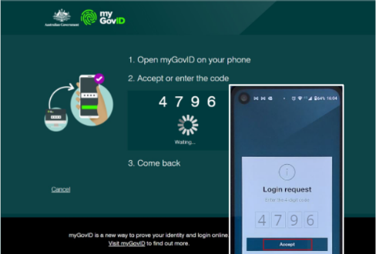

1. If your myGovID is linked to more than one business in RAM, you will be prompted to select the business that you are acting on behalf of.

*NOTE: If you select the wrong ABN, you will need to need to clear your internet browser’s cache and restart the registration process.*

1. Click ‘Continue’.

**RESULT**: The User Security Declaration will display.

1. Read the declaration and check ‘I Accept’.
2. Click ‘Submit’.

**RESULT:** You will receive a notification that you have successfully registered your account.

1. Return to the ADMS login page and log in with your Digital Identity.

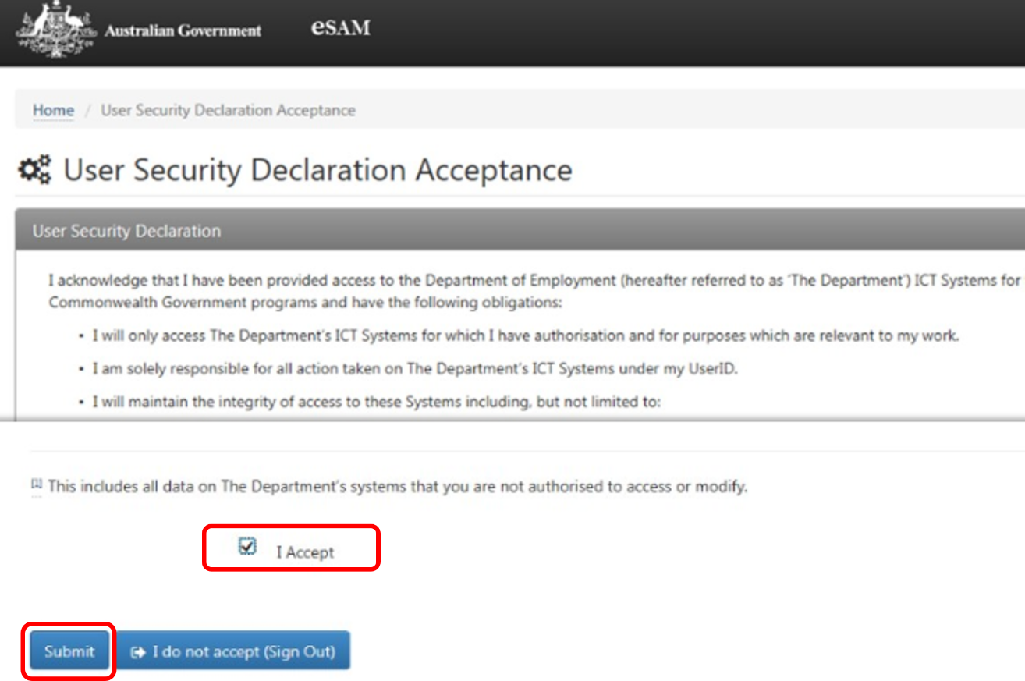

# Support

For assistance with ADMS, contact the National Customer Service Line (NCSL) on **1800 020 108**.

For feedback on this quick reference guide, contact [ADMSEngagement@dese.gov.au](mailto:ADMSEngagement@dese.gov.au).