

Key Apprenticeship Program
Eligible Apprentices may receive up to $10,000 over their apprenticeship journey.
The Key Apprenticeship Program (KAP) is available to Australian Apprentices working in either the clean energy sector or the housing construction sector. There are over 65 occupations listed as clean energy and/or housing construction on the Australian Apprenticeships Priority List.
The Clean Energy Sector​ includes but is not limited to designing, developing, constructing, and operating the infrastructure for generating, storing, transmitting, and distributing energy from renewable, zero or low emissions energy sources and reducing or managing energy use​.
The Housing Construction Sector involves building, repairing and remodelling structures that are intended to operate as a fixed dwelling including but not limited to houses, apartments, nursing homes.

Eligibility
To be eligible for the Key Apprenticeship Program, you must:
- meet all primary eligibility requirements.
- commenced or recommenced on or after 1 July 2025.
- be undertaking a qualification at the Certificate III, Certificate IV Diploma or Advanced Diploma level listed on the Priority List and identified as new energy or housing construction qualification.
- employed by an organisation who can provide meaningful exposure, experience, and work in the relevant KAP sector (clean energy or housing construction).
To become a New Energy or Housing Construction Apprentice, contact your Apprentice Connect Australia Provider. By starting a New Energy or Housing Construction apprenticeship your employer may be eligible for the Priority Hiring Incentive.

Case study
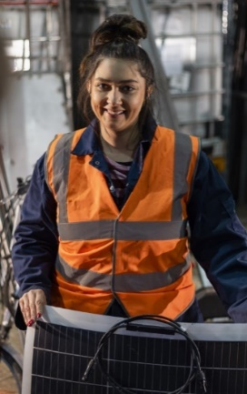 | Rebecca has started a 4-year apprenticeship to become a Carpenter. Rebecca is studying towards a Certificate III in Carpentry and working full-time in residential housing.  As part of the Key Apprenticeship Program, Rebecca is eligible for:  - Up to $10,000 ($2,000 at 6, 12, 24 and 36 months and on completion)  - Personalised non-financial support services (peer-support, networking).  - An income contingent loan, as part of the Australian Apprenticeship Support Loan program.  Rebecca’s employer is eligible to receive a Priority Hiring Incentive of up to $5,000.
The Key Apprenticeship Program is part of the Australian Government’s commitment for a Future Made in Australia. Building the workforce Australia needs for the future by backing apprentices to complete their trade in the clean energy or housing construction sectors.

