

Redundancy
  - Your rights and considerations
Losing your job can be a difficult time. This is a general guide to redundancy and other support services available to help you figure out what you’re entitled to and how you can restart your career.
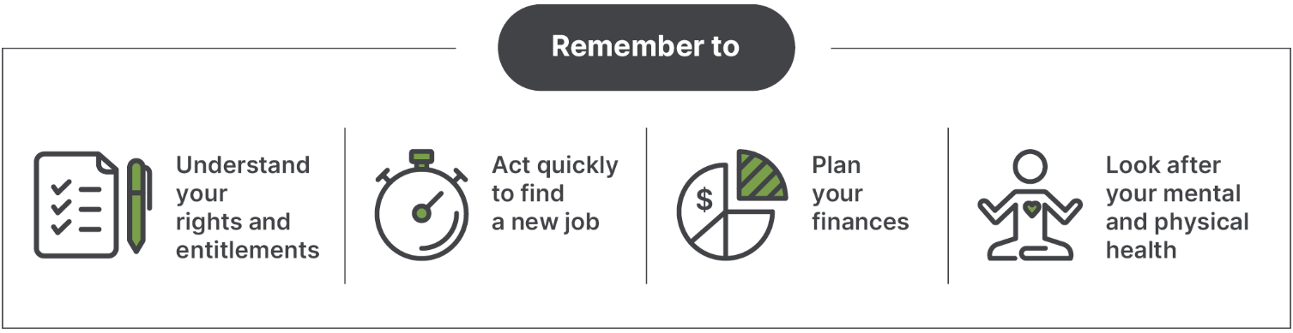

Understand your rights
and entitlements

When can redundancy happen?
Redundancy happens when a business no longer needs a job done by anyone. It can also happen when the business becomes bankrupt.
If you think your redundancy is not genuine, you can log a claim with the Fair Work Commission within
21 days. Visit www.fwc.gov.au for more information.

How can I determine my redundancy pay and entitlements?
The Fair Work Ombudsman has a simple online tool
to help you calculate your entitlements. Go to www.calculate.fairwork.gov.au/EndingEmployment to access the tool.
Visit www.fairwork.gov.au/redundancy for more information about your redundancy rights and entitlements or call 13 13 94 from 8am to 5.30pm Monday to Friday.

How much redundancy pay should
I get?
Depending on how long you have worked for your employer, you may be entitled to redundancy pay.
The National Employment Standards, your employment contract, an enterprise agreement
or a Modern Award may outline these entitlements.
The National Employment Standards does not provide redundancy pay entitlements to:
- employees with less than one year of service
- employees of a small business with less than
15 staff
- casual employees.
The redundancy pay is based on how long you have worked for your employer.
Example of redundancy pay
Period of continuous service | Redundancy Pay
Between 1 and 2 years | 4 weeks
Between 2 and 3 years | 6 weeks
Between 3 and 4 years | 7 weeks
Between 4 and 5 years | 8 weeks

How much notice should I be given?
There are minimum notice periods based on how
long you have worked for your employer. Casual employees, contractors, and some construction
and meat industry workers are not entitled to notice by the National Employment Standards.
Example of the standard minimum notice
Period of continuous service | Notice Period
1 year or less | 1 week
Between 1 and 3 years | 2 weeks
Between 3 and 5 years | 3 weeks
More than 5 years | 4 weeks

What if my full entitlements have
not been paid?
- If the business is still operating, contact the
Fair Work Ombudsman by visiting www.fairwork.gov.au or calling the Fair Work Infoline on 13 13 94.
- If your former employer has become bankrupt
or entered liquidation, you may be eligible for financial assistance through the Fair Entitlements Guarantee. For more information, visit www.dewr.gov.au/fair-entitlements-guarantee or call 1300 135 040.
You should also check your superannuation fund
to ensure your employer has paid your contributions. If you are concerned your superannuation hasn’t been paid or is incorrect, you can contact the Australian Taxation Office on 13 10 20 or visit www.ato.gov.au/super

Act quickly to look for a new job
Acting quickly to find a new job is important. Update your résumé to include all your skills and highlight skills that a new employer may value.

Where can I get help to find a new job?

Workforce Australia
The Australian Government’s Workforce Australia employment services will give individuals the knowledge and tools they need to get a job, learn
new skills or access the extra support if they need it.
If you are a job-ready job seeker you will be placed
in our online employment services. If you need more support to get job ready an Employment Service Provider will support you with tailored services
to help you find and keep meaningful work.
If you would like to know more, including the details
of your local providers, visit www.workforceaustralia.gov.au or call the Digital Support Contact Centre (DSCC) on 1800 314 677.

What’s Next? website
The What’s Next? website has resources for retrenched workers. This includes information on careers, training opportunities, help with résumés
and practical tips for finding a new job. Go to www.WhatsNext.dewr.gov.au to find out more.

Plan how to best use your finances
It is important to get your finances in order quickly
so you have enough money to last until you find another job. These resources can help you with financial advice and aid:
- Money Smart is a government website with tips and tools to help make the most of your finances. Visit www.moneysmart.gov.au
- Services Australia Financial Information Service. Visit www.servicesaustralia.gov.au
- Financial Counselling Australia can link you to free financial counsellors in your area. Visit www.financialcounsellingaustralia.org.au
The Australian Taxation Office can provide advice
on taxation of redundancy payments.
Visit www.ato.gov.au

What help can Services Australia provide?

Services Australia can assist you with:
- income support options
- effect of redundancy payment on receiving income support
- waiting periods (depending on the amount
of money you have to support yourself)
- adjusting your Family Tax Benefit estimate
or adjusting Child Support information
- Youth Allowance entitlements for dependent children.
For more information, go to www.servicesaustralia.gov.au or call 13 28 50.

Employment Separation Certificate
Your employer can provide you with an employment separation certificate or letter of termination when you stop work. Services Australia, other government agencies, or employment services providers can
use this certificate to determine if you can receive more help.

Look after your health and wellbeing
You can expect to have a range of reactions to losing your job. It is important to take care of your health and wellbeing as well as your family’s. If you or someone you know is having problems, including domestic and family violence, talking to someone
is an important first step.
- If you are in immediate danger, please call 000.
- You can call 1800 RESPECT (1800 737 732 or www.1800respect.org.au) to speak to a domestic violence counsellor and access local support services.
- Your local GP.
- Lifeline provides online, phone and face-to-face crisis support. You can call them on 13 11 14
or visit www.lifeline.org.au
- Beyond Blue provides free support services and information on depression and anxiety for all age groups. You can call them on 1300 22 46 36 or visit www.beyondblue.org.au
- MensLine provides telephone and online support, information, and referral services. You can call them on 1300 78 99 78 or by visiting www.mensline.org.au

