

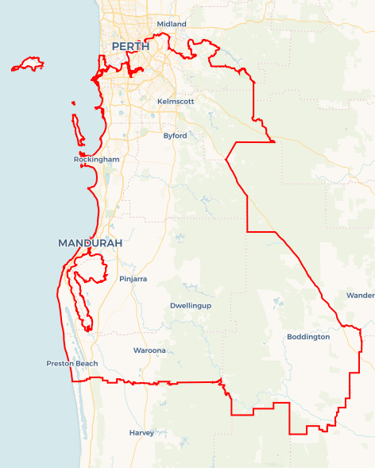Local Jobs Plan

Perth South ****Employment Region**** | WA | ****July 2025****

Workforce Australia Local Jobs (Local Jobs) is a program that supports tailored approaches to accelerate   
reskilling, upskilling and employment pathways in response to current and emerging local workforce needs.

## Local Jobs elements

### Local Jobs Plan

The Local Jobs Plan sets out the skills and employment challenges and priorities of the region, and associated strategies that will drive the design and implementation of activities to be implemented to address these challenges.

### Job Coordinators

Job Coordinators and Support Officers support the delivery of the program by bringing together key stakeholders including businesses, employment services providers, higher education and training organisations.

### Local Jobs and Skills Taskforce

Each Employment Region has its own Taskforce. Representatives include local stakeholders who have demonstrated experience in upskilling, reskilling, and an ability to represent, connect and collaborate with others in the region to meet labour market needs.

### Program Funds

The Local Initiatives Fund enables targeted local investments that support local labour market functioning. Further, from 2025/26, a central grants-based fund will respond to local needs and help progress broader employment service reform objectives.

Explore labour market insights for the  
[Perth South](https://www.jobsandskills.gov.au/data/employment-region-dashboards-and-profiles/monthly-labour-market-dashboards) Employment Region

## Local labour market challenges in the region

* There are skills and people shortages across main employing industries in the Perth South Employment Region such as healthcare and social assistance including the care sector, construction, education and training, mining, manufacturing including Defence industry, accommodation and food services, transport and logistics.
* Lack of affordable housing and accommodation is impacting current and future labour supply.
* Low unemployment and the prevalence of fly-in fly-out roles creates a challenge to connect people to jobs in the region.
* Where some people live is not where suitable jobs, training opportunities and industries are. There is also limited public transport in some suburbs including Waroona, Boddington and Forrestdale.
* There is below average workforce participation and/or a growing rate of disengagement for several cohorts in the region including First Nations, female, culturally and linguistically diverse (CALD), mature age, people with disability and youth.

## Local jobs and skills priorities and strategies in the region

### Priority 1 – Engage with stakeholders across the top 5 employing industries to identify the needs of employers and individuals, informing the development of strategies which maximise sustainable and meaningful local job placements

#### What are our challenges and opportunities?

Perth South Employment Region is experiencing skills and people shortages across main employing industries such as healthcare and social assistance including the care sector, construction, education and training, mining, manufacturing including Defence industries, accommodation and food services, transport and logistics.

#### How are we responding?

* We are running targeted recruitment roundtables for business, contractors and sub-contractors to showcase employment opportunities to local individuals seeking employment.
* We are showcasing the employment programs that have increased the opportunities for employers and local jobseekers through innovative approaches to recruitment.
* We are advocating and informing policy makers of the cost benefit analysis of the innovative programs to mainstream national / state employment strategies.
* We are identifying skills shortages and gaps in the health care and social assistance, construction, mining, education and training and retail trade and mapping current skills of participants to meet training requirements and upskilling opportunities.
* We are identifying opportunities to transition retrenched workers in the Perth South Employment Region and ensuring skill shortage areas are met from this labour source.
* We are collaborating with the Department of Education (WA Government), Department of Training and Workforce Development (WA Government), TAFEs, Jobs and Skills Centres and Registered Training Organisations (RTOs) to implement training to meet operational requirements and needs.
* We are engaging with local RTOs and Group Training Organisations to connect with industry and stakeholders.
* We are identifying the factors that inhibit access to employment for individuals, assisting employers to consider reviewing internal policies and practices to enhance engagement.
* We are identifying key construction projects, meeting business and/or organisations and identifying vacancies and opportunities.

### Priority 2 – Creating opportunities for local people to be adequately skilled, prepared and supported for current and growth industries, including apprenticeship and traineeship pathways

#### What are our challenges and opportunities?

The Perth South Employment Region has a growing rate of disengagement across several cohorts in the region including youth, First Nations, people with disability and CALD. There is an opportunity to engage these cohorts in current opportunities in the top 5 employing industries; and upcoming training and employment initiatives, with a focus on the Defence and net zero economy industries.

#### How are we responding?

* We are identifying opportunities to develop initiatives in key industries to support people into employment in current and future industry skill needs.
* We are working with business and Skills for Education and Employment (SEE) Providers to assist with upskilling new and existing workers with language, literacy, numeracy and digital levels.
* We are creating industry exposure events for people to learn about the types of jobs and industries that are available to them.
* We are building, strengthening and sustaining ongoing relationships with Apprentice Connect Providers and assisting businesses and individuals to better understand the benefits and how to navigate apprenticeship and traineeship pathways.

### Priority 3 – Leverage existing Australian and Western Australian government programs to create pathways into local growth industries and broker employment and education opportunities for priority groups not participating in the labour market

#### What are our challenges and opportunities?

The Perth South Employment Region has an over-representation of individuals not in work across several cohorts in the region including First Nations, female, CALD, mature age and people with disability, as well as a growing rate of disengagement within the youth cohort.

#### How are we responding?

* We are identifying and collaborating with appropriate community, social organisations and businesses that assist in addressing the challenges people are experiencing.
* We are promoting the use of existing federal and state government funding to support transition of individuals seeking employment into occupations that are in local demand.
* We are hosting monthly information sessions to inform and educate Workforce Australia Employment Services Providers (providers) and offer business the opportunity to showcase current vacancies in industry‑specific forums.
* We have created a platform for Australian Government program representatives to showcase new and existing initiatives to Perth South stakeholders and providers.
* We will work with the Construction Training Fund to create cohort-specific industry tours of the Construction Training Futures Centre.
* We are supporting individuals and businesses to build entrepreneurial capability and innovate in response to new and emerging economic opportunities in the region.

### Priority 4 – Understand the needs of individuals with the capacity to work and the under employed and provide an individualised and holistic approach to assist in building capacity

#### What are our challenges and opportunities?

Training pathways and upskilling, as well as support into employment can be lacking on a localised level.

#### How are we responding?

* We are facilitating connections and linkages between local stakeholders, enabling collaboration on employment opportunities and training pathways.
* We are identifying local training organisations that deliver funded skill sets and training and connecting to business and providers.
* We are identifying gaps and opportunities to connect stakeholders across community and supports in the region.
* We are working with our Perth South Taskforce to connect with providers.
* We are collaborating with SEE Providers to provide support to individuals in accredited training.
* We are collaborating with the Department of Training and Workforce Development (WA Government), TAFE and Jobs and Skill Centres to encourage flexible training options and locations.
* We have created a platform for Australian Government program representatives to showcase new and existing initiatives to Perth South stakeholders and providers to assist with training and upskilling.
* We are collaborating with organisations that support licensing opportunities to assist mobility amongst individuals who need licencing support.

## Want to know more?

* Contact: Rosie Hegarty, Perth South Job Coordinator: localjobs@pslocaljobs.com.au
* Visit: [Local Jobs](https://www.dewr.gov.au/local-jobs) or [Workforce Australia](https://www.workforceaustralia.gov.au/)