


Online Job Seeker Classification Instrument Trial

Evaluation Report

ISBN
978-1-76114-089-1 [PDF]
978-1-76114-088-4 [DOCX]
With the exception of the Commonwealth Coat of Arms, the department’s logo, any material protected by a trade mark and where otherwise noted all material presented in this document is provided under a Creative Commons Attribution 4.0 Australia licence.
The details of the relevant licence conditions are available on the Creative Commons website (accessible using the links provided) as is the full legal code for the CC BY 4.0 AU licence.
The document must be attributed as the Online Job Seeker Classification Instrument Trial Evaluation Report.

Acknowledgements
The evaluation was conducted by the RED Support and Strategic Research team in the Evaluation, Research and Evidence Branch, Quality, Integrity and Evidence Division.
Contributors to this report were Lixin Cai, Michael Bathgate, Cathy Gong, Leo Vance, Patricia Barber, Dan Ngoc Ho, Yusuf Muharram, Minh-Ha Nguyen, Caroline Daley and Scott Burrow.
The department would also like to acknowledge the contribution to this report of commissioned research undertaken by the Social Research Centre and Wallis Market and Social Research.

Contents
Executive summary 2
Departmental response to the evaluation findings 5
Chapter 1. Introduction 7
Chapter 2. The evaluation of the Online JSCI Trial 12
Chapter 3. The efficiency and effectiveness of the Online JSCI Trial 18
Chapter 4. Accessibility: factors affecting online completion 25
Chapter 5. Job seeker and Services Australia views and perceptions 37
Chapter 6. Conclusion 45
Bibliography 48
List of abbreviations and acronyms 50
Glossary 52
List of tables 54
List of figures 55
Appendix A: The Job Seeker Snapshot (JSS) questions (online JSCI version as at 26 June 2018) 56
Appendix B: Workflow diagram of Online JSCI Trial 65
Appendix C: Data sources 66
Appendix D: Factor analysis on digital literacy 70
Appendix E: Multivariate logistic regression model predicting online JSCI completion 72

Executive summary

About the Online JSCI Trial
The Job Seeker Classification Instrument (JSCI) classifies job seekers for employment services, based on a measure of their relative labour market disadvantage determined by their responses to a series of questions. The Online JSCI Trial (the Trial) was designed to investigate whether job seekers could effectively and efficiently complete the JSCI online. Previously, the JSCI was completed through a phone or face-to-face interview with Services Australia or an employment service provider.
The Trial was implemented through the Job Seeker Snapshot (JSS), which is an online version of the JSCI accessed via the jobactive website. The JSS captures the same information as the interview-based JSCI, but the wording and sequencing of some questions have been adapted to the online environment.
From July 2018 to March 2020, Services Australia randomly selected job seekers who were applying for income support through myGov to complete their JSCI using the JSS on the jobactive website. Online completion was voluntary, and job seekers who did not complete the JSS would instead complete the JSCI at a participation interview with Services Australia or an employment service provider.

Key findings

The JSS was time efficient and regarded as easy to use
More than 98% of those who commenced the JSS completed it, and more than 90% of trial participants who completed the JSS (‘completers’) found that it was easy to use and navigate. It generally took about 10 to 15 minutes to complete the JSS, and two-thirds (66%) of the JSS completers and attempters would recommend it to others. This proportion was higher among younger people.

JSS completers had more consistent JSCI scores and streaming outcomes
When JSCI responses were re-tested through a follow-up survey using Computer Assisted Telephone Interviewing (CATI) as part of the evaluation, the vast majority of both the JSS completers and the comparison group were consistently allocated into the streams. Nonetheless, the JSS completers had statistically significantly more consistent JSCI scores than the comparison group, resulting in slightly greater consistency in streaming outcomes for online completers. This could be due to the nature of online completion, which allowed more time for job seekers to consider their responses.

JSS completion had limited or no direct impact on labour market outcomes
JSS completers had slightly higher exit rates from employment services (52% compared to 49% at six months) and/or income support (46% compared to 45% at six months) than the comparison group. However, it seems unlikely that JSS completion itself had any direct impact on labour market outcomes. Instead, it is more likely that completers were less disadvantaged (e.g., they generally had a higher level of digital literacy and higher levels of educational qualifications), resulting in a higher exit rate from income support. This is consistent with our prior expectation that online completion of the JSS would not have a discernible impact on labour market outcomes.

About one in 10 trial participants reported barriers to JSS completion
Major barriers reported by JSS completers and attempters included:
- difficulties in logging into the JSS via myGov/jobactive
- encountering technical glitches
- low awareness and/or understanding of the purpose, benefits and process of completing the JSS
- limited access to assistance from Services Australia frontline staff
- being asked to provide duplicated information
- low levels of English proficiency
- low levels of digital literacy among certain groups
- severe sickness associated with having a disability or medical condition.

Digital literacy was the main factor in whether a job seeker completed their JSCI online
Regression analysis found that digital literacy was the most important determinant of JSS completion and could account for most of the differences across demographic groups. However, being younger than 20 years of age (qualitative research suggests this group may have been less likely to engage, due to passive detachment), having a disability or having experienced an unstable living situation remained significantly correlated with failure to complete. Although older people and Indigenous Australians were less likely to complete the JSS, the analysis found this was entirely due to lower digital literacy.

Suggested improvements to the JSS
Trial participants suggested several ways to improve the JSS, including:
- providing reassurance that income support claims were progressing appropriately
- providing more rationale, feedback and validation
- providing assistance through an online chat function or a special phone line, with Services Australia frontline staff assuming the role of ‘navigators’ of the system, especially in cases with complex circumstances
- prefilling important information from previous applications or online government systems
- removing the separate login for the JSS and adding a capacity to save and edit at any time
- allowing job seekers to provide additional information in relation to JSS responses for complicated questions
- providing more information to state clearly the purpose and process of the JSS, the benefits of doing the JSS online, and the links between the JSCI, the Trial, income support claims and the jobactive employment services program.

Summary
Increased online servicing is part of the government’s transition to the new employment services model and in line with the government’s digital transformation agenda.
The evidence from the Trial suggests that job seekers who are digitally literate and are able to should be encouraged to complete their JSCI online, while job seekers who have low levels of digital literacy or need extra support should still have the opportunity to do an interview-based JSCI.
Online servicing is not for everyone. An interview-based JSCI will often be more suitable for those who are older, have low levels of digital literacy, have low English proficiency, have disabilities or medical conditions, or are experiencing unstable living situations.
Digital literacy training for job seekers could help support increased use of online services.

Departmental response to the evaluation findings
A key focus of the Australian Government is to make better use of technology to make it easier to access the government services Australians depend on.
Government employment services are being transformed to deliver better services to job seekers and employers and a better system for providers, with a new employment services model to commence nationally from July 2022. The new model provides a predominately digital service for the most job-ready job seekers, freeing up resources to allow employment service providers to deliver more intensive, structured and tailored services for more disadvantaged job seekers.
The Job Seeker Snapshot, an online version of the Job Seeker Classification Instrument (JSCI), was introduced as a trial to reduce the dependence on interview-based delivery of JSCI and to increase the availability and usage of digital self-servicing for job seekers. The Job Seeker Snapshot is an easy-to-access online self-assessment tool that allows job seekers to simply and easily complete their own assessment in their own time.
The department acknowledges that the introduction of the Job Seeker Snapshot has achieved its intended goals, including to make JSCI completion time efficient and easy to use, and that job seekers’ disclosure and subsequent streaming results are comparable with those of job seekers who complete JSCIs administered by a provider or Centrelink.

Safeguards and enhancements
The government recognises that digital service delivery may not be appropriate for some job seekers, such as those with limited digital access or low levels of digital literacy. Job seekers who are unable to complete their Job Seeker Snapshot will be able to access the telephone and face-to-face interviews currently conducted by Services Australia or by employment service providers.
The department acknowledges some of the technical issues that faced the system soon after the introduction of the Job Seeker Snapshot. As the Trial expanded and the Job Seeker Snapshot became the default assessment process for job seekers, the department worked with Services Australia behind the scenes to address the technical issues.
Furthermore, the department is working with the Department of Social Services and with Services Australia to identify how best to reduce duplication and inefficiencies in the income support application and employment services assessment processes. This will allow the Job Seeker Snapshot to be pre-populated as part of the online claim workflow and enhance the user experience. The introduction of enhancements will be subject to consideration of the impact on social security legislation. Any pre-population and data-sharing process will consider the privacy implications for the sharing of job seeker information with additional Commonwealth entities.
The department has conducted user research into Job Seeker Snapshot messaging and citizen experiences with online assessments. We have considered the information we provide to job seekers on the purpose of the Job Seeker Snapshot, the benefits of doing the Job Seeker Snapshot, and what further explanatory information should be presented alongside the Job Seeker Snapshot. The department has already actioned many of the resulting recommendations and will continue to draw on these learnings as it develops the new job seeker assessment framework for 2022.

Chapter 1. Introduction

1.1 Digital trends in government services
Digital technology is changing service delivery around the world. International practice provides useful insights into the philosophy behind, and rationale for, online servicing. Despite differences across settings, there are common benefits from the successful delivery of online services. These include potential benefits for both governments and end users, such as:
- improved efficiency and convenience for end users
- time and cost benefits for users, and cost savings to government
- enhanced coverage of government services, for example to rural and remote areas
- more efficient record keeping (including reducing the burden of record keeping for citizens) and administrative work
- data driven policy development
- greater transparency
- the development of improved digital literacy among individuals.
With digital technology transforming the global and Australian economies, workplaces and jobs, the Australian Government has adopted an e-government agenda and digital transformation strategy. In 2015, the Digital Transformation Agency was formed to focus on enhancing service delivery and as a central repository for open government data, including myGov, which is a simple and secure way to access government services online with one login and one password.
The move towards e-government –– more responsive, comprehensive and integrated government operations and service delivery –– requires a transformation of business processes to adopt and respond to new technologies. In this environment, the business case for a whole-of-government approach to ICT investment and governance is strengthened.
(Australian Public Service Commission, 2018)
In January 2018, an Employment Services Expert Advisory Panel was established to provide options for a future mainstream employment services model to commence when the current employment services contracts expire in mid-2022.
To inform the future of the new employment services model, the department commenced two trials in July 2018 to test the online delivery of some elements of employment services: the Online Employment Services Trial (OEST) and the Online Job Seeker Classification Instrument Trial (the Trial). An evaluation of the OEST has been completed and its findings were presented in a separate report.

1.2 The Job Seeker Classification Instrument
The Job Seeker Classification Instrument (JSCI) is a questionnaire used to collect information to:
- measure a job seeker’s relative difficulty in gaining and maintaining employment
- help identify what level of support the job seeker will need to help them find work
- identify job seekers who have complex or multiple barriers to employment that need further assessment.
Job seekers complete the JSCI when they first claim for income support with Services Australia, and update it at any time they experience a change in their circumstances that might affect their JSCI score. The JSCI quantifies the relative level of labour market disadvantage expected to be experienced by job seekers. Table 1.1 lists the factors covered in the JSCI questionnaire.
Table 1.1 Topics and factors in the JSCI questionnaire
Section | Factor
Work experience | Recent work experience, and work history
Education and qualifications | Educational attainment
Work capacity | Disability/medical conditions
Descent and origins | Country of birth, Indigenous status,
Language | English proficiency
Living circumstances | Stability of residence, living circumstances
Transport | Access to transport
Personal factors | Age, gender, geographic location, proximity to a labour market, phone contactability, criminal convictions, and other personal factors
Source: JSCI questionnaire. See Appendix A for more details.
The JSCI assesses a range of factors that likely affect the probability of a job seeker finding employment, such as access to transport, English proficiency, vocational qualifications, work experience, and physical capacity to work. A logistic regression model is used to estimate the relative weights of the factors that have been identified as being associated with long-term unemployment. By combining the weights and the risk factors, a job seeker gets a JSCI score, which is the primary determinant of the stream that the job seeker is placed into for targeted services.
Historically the JSCI was administered as an interview-based questionnaire. It is normally conducted when job seekers apply for an income support payment after they have submitted their initial claim. Most interviews (75%) occurred over the phone, with 25% occurring face to face.
Each JSCI factor is given a numerical weight or points which indicate the average contribution that factor makes to a job seeker’s difficulty in finding and maintaining employment. The points are added together to calculate the JSCI score, which reflects a job seeker’s relative level of disadvantage in the labour market. A higher score indicates a higher likelihood of the job seeker remaining unemployed for at least another year. Based on their JSCI scores, job seekers are initially allocated to either Stream A (where job seekers are the most job ready) or Stream B (where job seekers need a greater level of support to help them become job ready).
The JSCI also identifies whether a job seeker has multiple or complex barriers to employment that may require further assessment via an Employment Services Assessment (ESAt). The ESAt determines whether a job seeker should be placed into Stream A or B consistent with their JSCI score, or if they require more intensive support through jobactive Stream C (where job seekers have work capacity and personal issues requiring case management) or should be placed into other programs such as Disability Employment Services (DES).
The department requires a reassessment or review of JSCI responses, known as a Change of Circumstances Reassessment (CoCR), when a job seeker discloses new information or has a major change of circumstances.
The New Employment Services Trial (NEST) – discussed in section 1.4.1 – uses the JSCI to identify job seekers most suitable to receive servicing under Digital First, Digital Plus or Enhanced Services. ParentsNext also uses the JSCI to determine program eligibility. Since April 2020, job-ready job seekers, also identified through the JSCI, have been referred to the Online Employment Services (OES) platform to self-manage job search and compliance activities.

1.3 The Online JSCI Trial
The Online JSCI Trial commenced on 1 July 2018 and was initially expected to run for 18 months. The purpose of the Trial was to assess the feasibility of delivering the JSCI online. During the Trial, Services Australia randomly selected job seekers who were applying for income support through myGov to complete their JSCI using the Job Seeker Snapshot (JSS) on the jobactive website. Following completion of their initial income support claim, job seekers were presented with pop-up screens asking them to log into the JSS via the myGov website. While invitation to undertake the JSS was by random selection, online completion was optional, so those who completed the JSS were not a random sample of eligible job seekers.
To be eligible to participate in the Trial, job seekers had to meet the following criteria:
- had submitted an online claim for income support, such as Newstart (now JobSeeker Payment), Youth Allowance (Other) or other payments
- did not need an interpreter
- did not live in an area serviced by the Community Development Programme.
Eligible job seekers selected for the Trial were expected to complete their JSS questionnaire prior to their participation interview with Services Australia. Those who completed the JSS are denoted as trial ‘completers’ in the report. Job seekers who were selected for the Trial but did not complete the JSS (denoted as trial ‘non-completers’) completed an interview-based JSCI. Job seekers who were eligible but not selected for the Trial are included in the comparison group (for more details, see Appendix B).
The JSS is the online form of the JSCI, developed as an alternative to the interview-based JSCI. Both collect the same information. However, the wording and sequencing of questions in the JSS were adjusted for online use. Participation in the Trial was voluntary, and job seekers who did not complete the JSS could complete a JSCI in a participation interview with Services Australia or an employment service provider.
With the advent of the COVID-19 pandemic, demand for employment services changed rapidly and dramatically. As discussed in section 1.4.2, since April 2020 the JSS has been rolled out broadly as part of OES and the Trial has been terminated.

1.4 Recent developments
Since the two trials (the OEST and the Online JSCI Trial) were announced, the digital employment services environment has changed fundamentally.

1.4.1 New Employment Services Trial
Informed by the OEST and the Online JSCI Trial, as well as earlier work, the NEST is trialling key elements of the new employment services model in two regions, Adelaide South (South Australia) and Mid North Coast (New South Wales), from 1 July 2019.
As part of the NEST, job seekers who are job ready and digitally literate are placed into Digital First to self-manage their activities and job search in the Digital Service. Job seekers who need some extra support can access Digital Plus, where digital servicing is supplemented by additional support. This includes access to a contact centre to arrange training to help them use the digital service, work skills training, and funding to pay for tools and licences – or a training provider as needed. More disadvantaged job seekers receive enhanced services delivered through employment service providers.

1.4.2 Online Employment Services
The impact of the COVID-19 pandemic fast-tracked digital provision of employment services. Created in April 2020 because of a rapid increase in demand for income support payments and employment services, OES became the Australian Government’s mainstream employment servicing platform for job-ready job seekers. As at 30 September 2020, 1.25 million job seekers had been referred to OES.
Once job seekers are referred to OES they will complete a JSS and a Digital Literacy Assessment (DLA). The JSS and DLA will identify job seekers who require provider support.
OES enables job seekers to self-manage their job search and reporting requirements online. Participation in OES is time limited. Job seekers will normally be referred to a provider after a maximum of 12 months in OES (compared to six months in OEST). However, there are exceptions – for example, job seekers who are earning or learning will remain in OES.

Chapter 2. The evaluation of the Online JSCI Trial
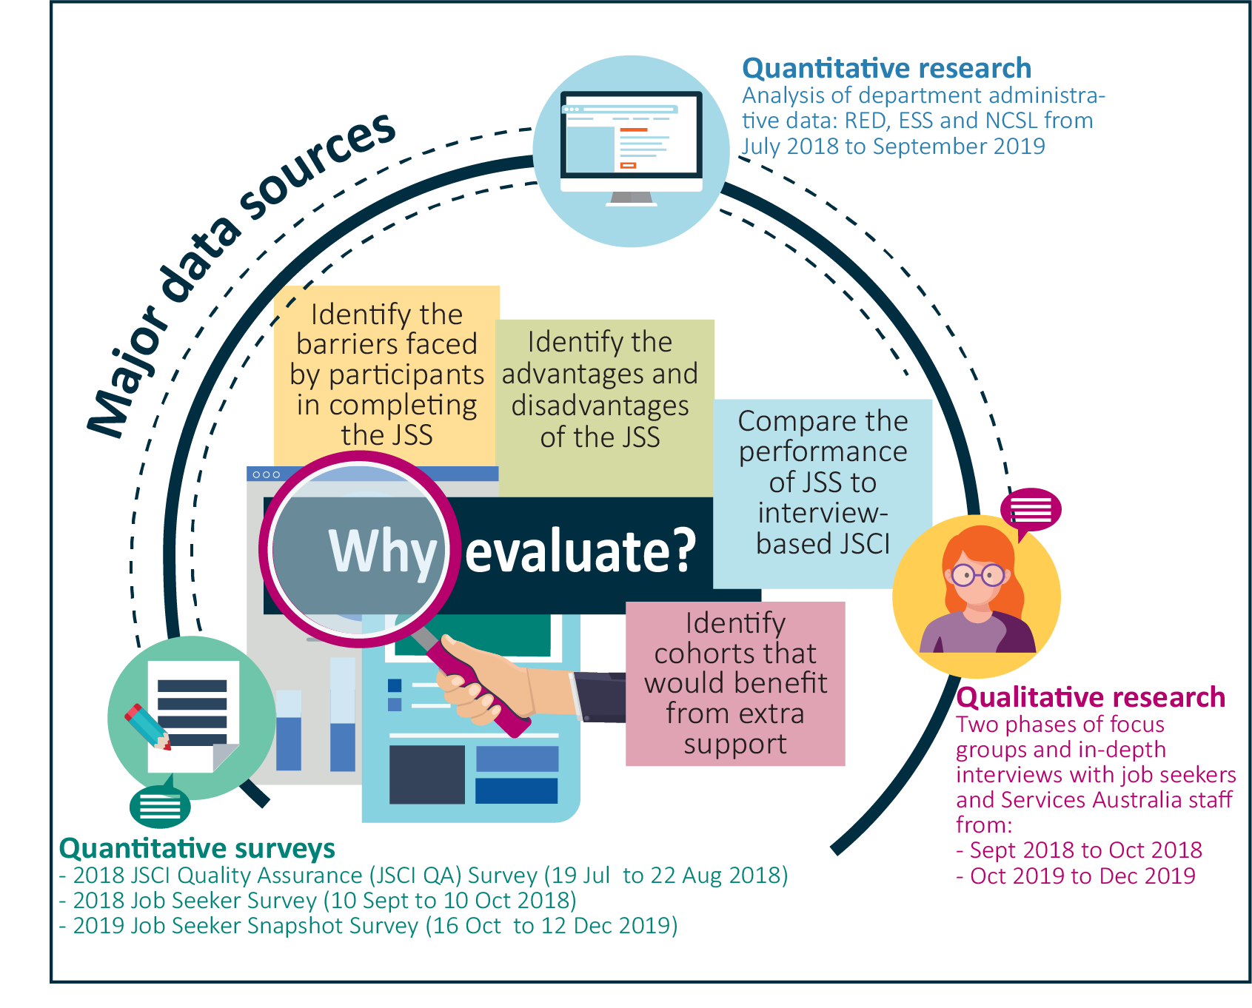
This chapter details the evaluation approach, including the use of mixed-methods analysis and data sources in the evaluation. A profile of the characteristics of the study population is featured in this chapter.

2.1 Aims of the Online JSCI Trial evaluation
The objectives of the evaluation were to assess the efficiency, effectiveness, accessibility and participant experiences of the Trial from 1 July 2018 to 30 September 2019, by:
- identifying the advantages and disadvantages of the JSS for job seekers
- identifying cohorts that would benefit from extra support or tailoring of the JSS
- comparing the outcomes of JSS completion to the outcomes of face-to-face and telephone-based JSCI completions, in terms of effectiveness and consistency of responses, and identifying any unintended consequences
- identifying barriers or issues faced by job seekers when completing the JSS, and suggesting improvements.

2.2 Key evaluation questions
The evaluation sought to address the following questions and examine whether the results varied across different cohorts of job seekers.
Efficiency
- Did participating in the Trial improve efficiency?
- Was the Trial more time efficient for job seekers compared to other delivery methods?
- Did delays in completing the JSS lead to delays in a job seeker connecting to a provider or receiving income support? How did the time to service vary between the treatment and control groups?
Effectiveness
- How did JSCI outcomes compare between the delivery methods?
- How did the JSCI score distribution and stream allocation compare between the JSCI delivery methods?
- Did the number of referrals for ESAts vary between the JSCI delivery methods? If so, why?
- Which questionnaire responses varied between the delivery methods, and why?
- Did the JSS impact on the disclosure of personal factors?
- Which delivery method obtained more ‘accurate’ JSCI scores? Why?
- Was participating in the Trial related to labour market outcomes?
- Did the income support exit rate vary between the online completers and the comparison group? Why?
- Did the exit rate from employment services vary between the online completers and the comparison group?
Accessibility
- Completion of the JSS – did some groups find it more challenging?
- Were there any issues with self-completion?
- Were there particular cohorts that have difficulty completing the JSS?
- What did data from the National Customer Service Line (NCSL) suggest about job seeker experiences with the Trial?
Participant experiences
- What were job seeker and Services Australia perceptions and experiences of the Trial?
- What were job seekers’ overall views of the JSS?
- What were the job seekers’ perceived advantages and disadvantages of JSS completion?
- What were job seekers’ preferences in regard to online completion?
- What were the job seekers’ suggested improvements to the JSS?
- What were the views of Services Australia about delivering the JSCI online?

2.3 The study population
Using departmental administrative data, a population of 375,381 people was defined over the period from 1 July 2018 to 30 September 2019 (Figure 2.1). The sample was limited to those with a JSCI classification whose claim had been processed by Services Australia and whose income support status was ‘active’, ‘inactive’ or ‘pending’.
Around 29% of this population (107,719 out of 375,381) were randomly selected to participate in the Trial over the period from 1 July 2018 to 30 September 2019 (Appendix C).
Among the job seekers selected for the Trial, around 49% (52,309 out of 107,719) completed a JSS – this formed the main study population of ‘completers’ for the evaluation. Since completion was voluntary, this was not a randomly selected sample, and the results of the study are likely influenced to some degree by selection bias. Most completers (92%) completed the JSS immediately after they commenced it. For more details on the workflow, see Appendix B.
The other 51%, who did not complete the JSS, were categorised as non-completers in this evaluation and subsequently completed a JSCI during an interview with Services Australia frontline staff either by phone or face-to-face (for more information see Appendix C). A few non-completers (3%) had attempted the JSS. Differences between completers and non-completers are discussed in Chapter 4.
Those who were not selected to participate in the Trial made up the comparison group.

Figure 2.1 Online JSCI Trial study population
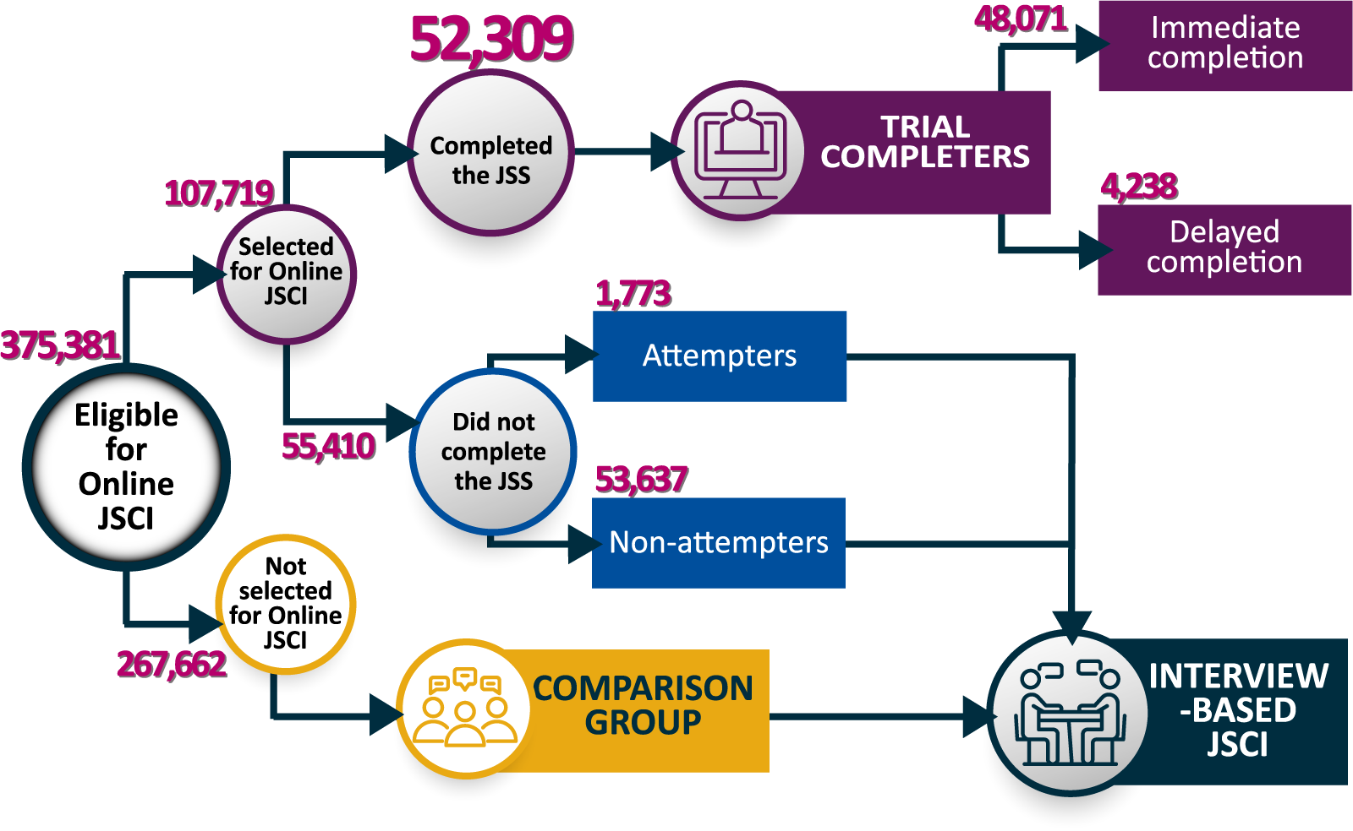
Source: DESE administrative data from 1 July 2018 to 30 September 2019

2.4 Methodology
The evaluation of the Trial adopted a mixed-methods approach. It included:
- qualitative research that analysed the perceptions and experiences of the Trial from focus group discussions and in-depth interviews with trial completers, non-completers and stakeholders
- quantitative surveys that provided further information about the experiences of job seekers with the jobactive website
- analysis of departmental administrative data from the Employment Services System (ESS) and the Research and Evaluation Database (RED).

2.4.1 Qualitative research
The department commissioned qualitative research in 2018 and 2019 to gain an in-depth understanding of job seekers’ perceptions and views about the JSS and trial participants’ experiences when using the JSS.
In total, 19 focus groups and 72 in-depth interviews explored views and opinions from 180 job seekers and staff from Services Australia (Table 2.1). Participants in qualitative research were selected from a list of job seekers provided by the department and/or opted in after completing their quantitative surveys. Each focus group included both completers and non-completers, and broad representation across age, gender, location and cultural background.
Table 2.1 Participants in qualitative research
Phase | Focus group | In-depth interview | Total
Phase 1: 2018 | 9 focus groups  27 completers  30 non-completers | 32 interviews  6 completers  26 non-completers | 89 participants  33 completers  56 non-completers
Phase 2: 2019 | 10 focus groups  31 completers  20 non-completers | 40 interviews  21 completers  19 non-completers | 91 participants  52 completers  39 non-completers
Total | 19 focus groups  58 completers  50 non-completers | 72 interviews  27 completers  45 non-completers | 180 participants  85 completers  95 non-completers
Source: 2018 qualitative research by the Social Research Centre (SRC); 2019 qualitative research by Wallis Group
Note: Two small groups of staff members from Services Australia also participated in the 2018 qualitative research

2.4.2 Quantitative surveys
Quantitative survey data was used to analyse reasons for completion and non-completion, as well as to obtain feedback on participant experiences. Three quantitative surveys were commissioned (see Table 2.2):
- 2018 JSCI Quality Assurance Survey: Job seekers who had recently undertaken the JSS or interview-based JSCI were surveyed shortly after to assess the consistency of their responses to the JSCI questions between the survey and their initial responses when completing it online or through an interview.
- 2018 Job Seeker Survey: Information was collected about job seekers’ experiences during the early stages of the Trial.
- 2019 Job Seeker Snapshot Survey: The survey supplemented the 2018 Job Seeker Survey to investigate the reasons for completion and non-completion of the JSS. The survey also collected more detailed information on job seekers’ digital literacy.
Using the 2019 Job Seeker Snapshot Survey data, logistic regression modelling was conducted to analyse the impact of digital literacy on the likelihood of job seekers completing the JSS.
Table 2.2 Quantitative surveys
Quantitative survey | Researcher | Participants | Date | Methodology
2018 JSCI Quality Assurance Survey | SRC | Completers: 321  Non-completers: NIL  Comparison: 400 | 19 Jul to 22 Aug 2018 | CATI
2018 Job Seeker Survey | SRC | Completers: 400  Non-completers: 350  Comparison: 250 | 10 Sep to 10 Oct 2018 | Online (25%)  CATI (75%)
2019 Job Seeker Snapshot Survey | Wallis | Completers: 1,552  Non-completers: 1,553  Comparison: NIL | 16 Oct to 12 Dec 2019 | Online (84%)  CATI (16%)
Note: Completers and non-completers in this table are classified according to administrative data. Survey data has been weighted to reflect the underlying population.

2.4.3 Quantitative analysis of departmental administrative data
The department conducted quantitative analysis of administrative data for the Trial evaluation, comparing online completers with the comparison group (and non-completers where appropriate).
Two administrative datasets managed by the department were used: RED and ESS. RED is a longitudinal dataset on recipients of Australian Government income support payments. ESS contains jobactive administrative data, providing insights about people’s interactions with employment services through transactions recorded by employment service provider staff.
The analysis explored:
- characteristics of job seekers who completed the JSS
- how online completion affected JSCI scores and streaming outcomes
- whether labour market outcomes varied by how the JSCI was completed
- the consistency of job seekers’ responses to survey questions with their JSS responses.

Longitudinal analysis
The analysis of exits from income support and employment services examined job seekers’ employment services and income support status six months after they commenced employment services. Job seekers who commenced the services during the period from 1 July 2018 to 30 September 2019 were included for this analysis.

Chapter 3. The efficiency and effectiveness of the Online JSCI Trial
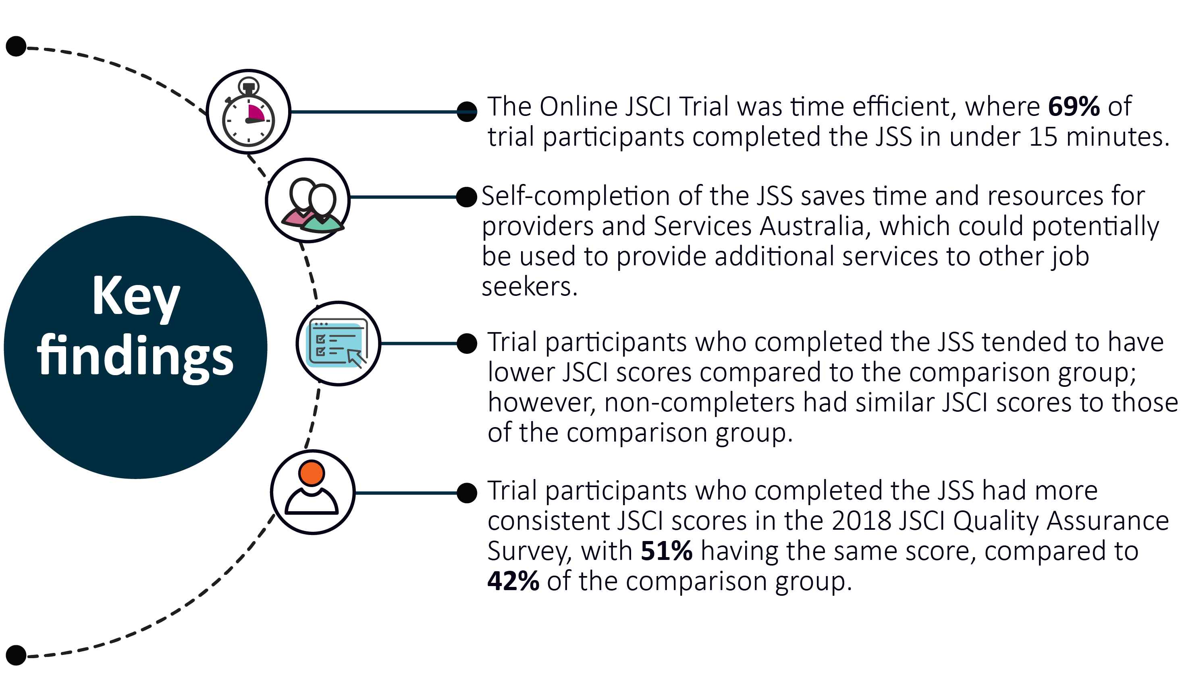
This chapter explores whether JSCI scores and streaming outcomes differed between Trial participants who completed the JSS and job seekers who completed an interview-based JSCI. The evaluation compared distributions of JSCI scores and streaming outcomes between the Trial and comparison groups. It also explored whether completing the JSS was associated with exits from employment services and income support over the following six months. The following questions were addressed:
- Did participation in the Trial improve efficiency?
- How did JSCI outcomes compare between the delivery methods?
- Was participating in the Trial related to labour market outcomes?

3.1 Time efficiency
The JSS was completed quickly by most trial participants, with over two-thirds (69%) reporting they took no more than 15 minutes to complete it (Figure 3.1). This was comparable to the interview-based JSCI.
Yeah. I found it quite easy I remember, maybe 5 or 10 minutes.
(Job seeker, 2019 qualitative research)
However, 9% took 30 minutes or more to complete the JSS. People who took longer were typically those with a low level of digital literacy or those who were Indigenous or in older age groups. These groups also expressed a higher preference for an interview-based JSCI by phone or face-to-face.
Figure 3.1 Time spent on completing the JSS
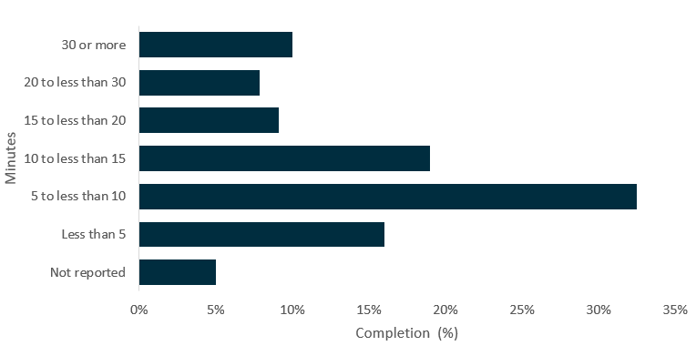
Source: 2018 Job Seeker Survey
Note: Selected trial participants who completed the JSS online (n=329)

3.1.1 Connecting to a service provider
As most job seekers who completed the JSS did so immediately after their online application for income support, JSS completion was expected to result in a quicker connection to an employment service provider when compared to the comparison group. It was found that it took an average of 8.2 days for JSS completers to be referred to a provider after their submission for income support, which was lower than the average 9.4 days for the comparison group and the 8.9 days for JSS non-completers. The median number of days it took for an online completer to be referred to a service provider was also less than the median for the comparison group. This data suggests that it took longer for some job seekers in the comparison group and non-completers to be connected with a provider than for the completers.

3.2 JSCI scores, stream allocations and ESAt referrals

3.2.1 Distribution of JSCI scores
Based on departmental administrative data, analysis of the overall JSCI score distribution by method of completion showed that JSS completers tended to have lower JSCI scores (Figure 3.2). However, non-completers and the comparison group had a similar distribution of JSCI scores. This could be due to the fact that completers were less disadvantaged as a group. As shown in Chapter 4, JSS completers tended to have higher digital literacy, better education and more stable living situations and were less likely to have a disability.
Figure 3.2 Distribution of JSCI overall score, by delivery method
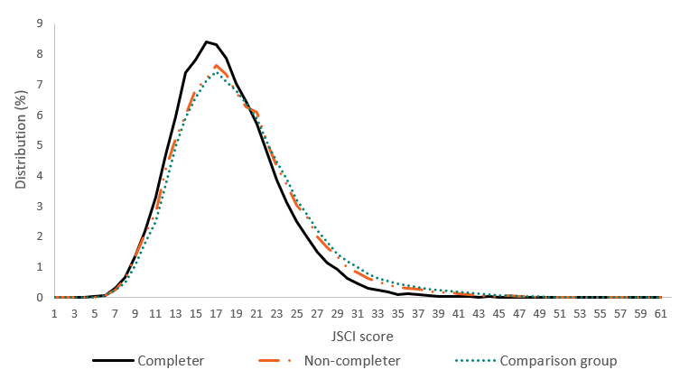
Source: DESE administrative data from 1 July 2018 to 30 September 2019
Note: Completers (n=52,309); non-completers (n=55,410); comparison group (n=267,662)

3.2.2 Stream allocations and ESAt referrals
As noted, JSS completers had lower JSCI scores and were therefore more likely to be allocated into Stream A than both the non-completers and the comparison group (Table 3.1). JSS completers were also less likely to be referred to an ESAt or other employment programs (e.g. DES) than the comparison group.
Table 3.1 Streaming outcomes and ESAt referrals
Group | Stream A  (%) | Stream B  (%) | Stream C  (%) | Other program (e.g. DES)  (%) | ESAt referral  (%) | Eligible job seekers  (N)
JSS completers | 85.3 | 6.2 | 0.5 | 8.0 | 21.9 | 52,309
JSS non-completers | 79.8 | 8.1 | 0.8 | 11.3 | 28.5 | 55,410
Comparison group | 77.5 | 9.2 | 2.4 | 11.0 | 26.5 | 267,662
Source: DESE administrative data

3.2.3 Responses to JSCI questions
Departmental administrative data was also used to examine how questionnaire responses might vary by delivery methods. Differences were generally minimal for the more ‘objective’ questions, such as questions on working capacity (hours), criminal record, usability of previous work-related qualifications, living relationships and change of address.
JSS completers had a lower incidence of some potential barriers to employment, such as an unstable living situation, limited English proficiency, no post-school education, caring roles, or medical conditions impacting capacity to work.
This could be a result of JSS completers being less disadvantaged than other job seekers, as suggested by higher levels of educational attainment and digital literacy.

3.3 Consistency of JSCI outcomes

3.3.1 Consistency of JSCI scores
As mentioned earlier, the 2018 JSCI Quality Assurance Survey research was undertaken to examine the consistency of a job seeker’s responses to the JSCI questions between the survey and their initial responses when they completed the JSCI online or through an interview with Services Australia. When the results from the 2018 JSCI Quality Assurance Survey (by phone) were compared with their initial responses recorded in the departmental administrative data (Table 3.2), half of the JSS completers (51%) had the same overall JSCI score. This was significantly higher than the result for the comparison group (42%). This may partly be a result of the comparison group having higher overall JSCI scores, implying a higher level of disadvantage and less stable personal circumstances. Having more time to understand JSCI questions and consider responses might also have contributed to the greater consistency in JSCI responses, scores and streaming outcomes among online completers, although the interviews took a similar amount of time.
As discussed in Chapter 1, the JSCI covers topics such as education, work, housing and a range of other personal circumstances. Compared with the comparison group, the online completers gave significantly more consistent responses on recent work experience. Except for Indigenous status, JSCI factor scores were more consistent for JSS completion compared with the interview-based JSCI, but the differences were statistically insignificant.
Table 3.2 Consistency in JSCI scores between administrative data and follow-up survey
Consistency in JSCI scores by factor (%) between administrative data and follow-up survey | JSS completers  (n=321) | Comparison group  (n=400) | Difference  in percentage points (%)
Overall score | 51 | 42 | 9*
Factor scores in: | – | – | –
Recent work experience | 78 | 70 | 8*
Educational attainment | 78 | 72 | 6
Vocational qualifications | 80 | 75 | 5
English proficiency | 97 | 95 | 2
Indigenous status | 97 | 99 | -2*
Access to transport | 87 | 84 | 3
Stability of residence | 96 | 96 | 0
Living circumstances | 84 | 79 | 5
Criminal convictions | 97 | 95 | 2
Personal factors | 99 | 99 | 0
Carer for adults | 99 | 98 | 1
Source: 2018 JSCI Quality Assurance Survey and DESE administrative data
Note: *Indicates results significantly differed between the JSS completers and the comparison group, with a p-value <0.05

3.3.2 Consistency of stream allocations
Allocations of job seekers to streams were analysed by comparing departmental administrative data with job seeker responses in the 2018 JSCI Quality Assurance Survey. As a result of greater consistency in JSCI scores, stream allocations were also slightly more consistent among JSS completers (98%) than for the comparison group (96%) (Table 3.3), although these differences were statistically insignificant.
Table 3.3 Consistency in stream allocations between administrative data and follow-up survey
Consistency of streaming outcomes between administrative data and follow-up survey (%) | JSS completers  (n=321) | Comparison group  (n=400)
All streams | – | –
Allocated in the same stream | 98 | 96
Allocated in a different stream | 2 | 4
Original Stream A | – | –
Allocated in Stream A consistently | 100 | 98
Allocated in a different stream | 0 | 2
Source: 2018 JSCI Quality Assurance Survey and DESE administrative data
All trial completers (100%) in Stream A were also allocated to Stream A in the follow-up survey. This proportion was 98% for the comparison group. This strongly suggests that job seekers are not disadvantaged by completing the JSS online.

3.3.3 Consistency of ESAt referrals
Departmental administrative data and the 2018 JSCI Quality Assurance Survey were also used to compare ESAt referrals between the completers and the comparison group. This showed that 89% of JSS completers had the same outcome (either flagged for referral or not flagged for referral to an ESAt) and this was also the case for 88% of the comparison group (Table 3.4). This supports the general finding that trial participants’ responses were consistent.
Table 3.4 Consistency in ESAt referral between administrative data and follow-up survey
Consistency between administrative data and follow-up survey (%) | JSS completers  (n=321) | Comparison group  (n=400)
ESAt referral | 89 | 88
Source: 2018 Job Seeker Follow-up Survey data and DESE administrative data

3.4 Reporting major changes of circumstances
Online completion should simplify reporting of changes of job seekers’ circumstances, which could have a significant impact on their JSCI scores. This could help to ensure servicing is targeted on the basis of the most current and relevant information.
Analysis based on departmental administrative data showed that half of the JSS completers (51%) reported changes that led to a Change of Circumstances Reassessment (CoCR), resulting in a JSCI score change, which was significantly higher than for the comparison group (29%, Table 3.5). These results might reflect the fact that JSS completers were able to update their JSCI responses more readily than the comparison group, who needed to contact Services Australia.
Table 3.5 Proportion of job seekers with major changes of circumstances
Group | Job seekers who had a JSCI score change  (%) | Job seekers who had a stream change  (%) | Total eligible job seekers  (N)
Comparison group | 29.2 | 5.4 | 267,662
JSS completers | 50.9 | 4.2 | 52,309
JSS non-completers | 29.9 | 5.4 | 55,410
Source: DESE administrative data
Note: CoCR outcomes for eligible job seekers that occurred between 1 July 2018 and 30 September 2019 are reported here. The percentage in this table is the share of job seekers in the relevant category with CoCRs resulting in a JSCI score or stream change
Despite the higher number of changes in JSCI scores, only 4% of JSS completers had a change in stream allocation due to a CoCR, similar to the comparison group (5%). This might suggest that, while more changes were being reported, these changes were not of such a magnitude as to increase the likelihood of a change in stream allocation.

3.5 Exits from employment services and income support
Exits from employment services and income support were examined to investigate whether online completion of the JSCI was related to employment outcomes.
Exit rates from income support were similar for both the comparison group and the JSS completers, while exit rates from employment services were slightly higher among the JSS completers than the comparison group and non-completers (Table 3.6). Overall, there was little evidence from the exit analysis, suggesting that online completion of the JSCI resulted in better employment outcomes for job seekers.
Table 3.6 Exits within six months from employment services and income support, by stream
Group | Stream A exits from services | Stream B exits from services | Both streams exits from services (A+B) | Stream A exits from income support | Stream B exits from income support | Both streams (A+B) exits from income support
Comparison group | 50.4 | 39.6 | 49.3 | 46.5 | 30.7 | 44.7
JSS completers | 53.0 | 42.3 | 52.3 | 47.1 | 28.8 | 45.7
JSS non-completers | 49.6 | 40.4 | 48.7 | 43.6 | 28.6 | 42.1
Source: DESE administrative data
Notes: Job seekers who completed their JSCI, claimed for income support and commenced employment services under Stream A/B with the jobactive program from 1 July 2018 to 30 September 2019. The exit percentage is the number of exits in the subgroup, expressed as a percentage of the total number who commenced employment services and income support in the same subgroup

3.6 Chapter summary
The Trial generally found similar or slightly better outcomes from online servicing in terms of time to complete the JSS, time to connect to a service provider and consistency of scores between the completers and the comparison group. Given the time and resource savings associated with online completion (discussed in section 5.4), this represents the same or better outcomes at a reduced cost. The consistency of scores, stream allocations and exit rates further suggests online completion did not reduce the effectiveness of the JSCI in allocating job seekers to appropriate levels of servicing, and that job seekers were not disadvantaged by completing the JSS online. Furthermore, completing the JSCI online without an interview freed up providers’ and Services Australia’s time and resources to provide additional services to other job seekers.

Chapter 4. Accessibility: factors affecting online completion
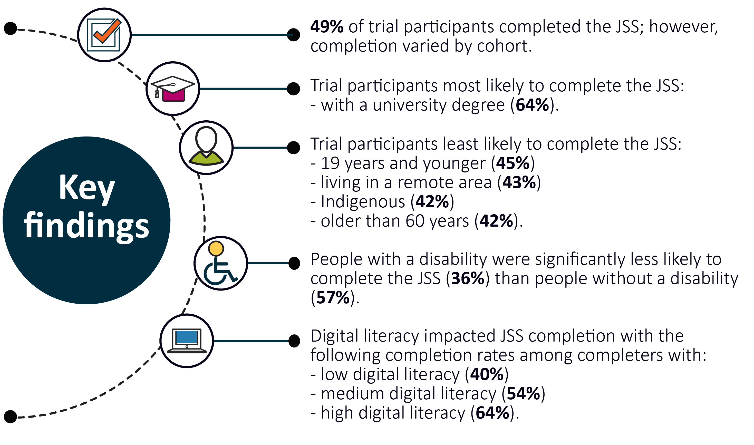
This chapter examines JSS completion rates by demographic and other characteristics of job seekers, and their reasons for completion or non-completion.
It aims to answer the following key evaluation question:
- Completion of the JSS – did some groups find it more challenging?

4.1 Completion of the JSS by personal characteristics
About half (49%) of trial participants completed the JSS, but completion varied significantly by cohort (Table 4.1). Participants’ online completion rates were lower if they:
- were older than 60 years
- were 50 to 59 years old
- were 19 years and under
- were living in Remote Australia
- were living in Outer Regional Australia
- had a vocational qualification as their highest level of educational attainment
- had not completed year 12.
Table 4.1 Completion and non-completion, by characteristics, 2018–19
Characteristic | Completers  (%) | Non-completers  (%) | Job seekers selected for the Trial  (N)
Gender | – | – | –
Female | 51.3 | 48.7 | 46,354
Male | 46.5 | 53.5 | 61,365
Age
19 years and under | 45.0 | 55.0 | 15,707
20 to 29 years | 51.6 | 48.4 | 34,490
30 to 39 years | 51.5 | 48.5 | 18,724
40 to 49 years | 48.0 | 52.0 | 16,015
50 to 59 years | 45.8 | 54.2 | 14,497
60 plus | 41.9 | 58.1 | 8,286
Income support first-time claimer | – | – | –
Previous claimer | 48.9 | 51.1 | 87,855
First-time claimer | 47.1 | 52.9 | 19,864
Location
Major Cities of Australia | 49.7 | 50.3 | 72,301
Inner Regional Australia | 46.7 | 53.3 | 24,287
Outer Regional Australia | 45.9 | 54.1 | 10,305
Remote Australia | 42.8 | 57.2 | 780
NA | 37.0 | 63.0 | 46
Education | – | – | –
University degree | 64.0 | 36.0 | 20,023
Vocational education and training | 41.1 | 58.9 | 34,402
Year 12 | 51.3 | 48.7 | 21,943
Less than Year 12 | 45.8 | 54.2 | 26,877
NA | 39.4 | 60.6 | 4,474
Culturally and linguistically diverse (CALD) | – | – | –
Born in Australia | 48.7 | 51.3 | 83,888
Born overseas (English speaking country) | 50.6 | 49.4 | 7,924
Born overseas (non-English-speaking country) | 46.7 | 53.3 | 15,907
Total | 48.6 | 51.4 | 107,719
Source: DESE administrative data
Note: NA = not applicable
By contrast, trial participants’ JSS completion rates were higher if they:
- had a university degree
- had completed year 12 but had no post-school qualifications
- were women
- were 20 to 29 years of age
- were 30 to 39 years of age.

4.1.1 Cultural and linguistic diversity
Online completion was similar for trial participants born in Australia (49%) and those born overseas (48%). However, immigrants from English-speaking countries (51%) were more likely to complete the JSS than immigrants from non-English-speaking countries (47%).
Culturally and linguistically diverse (CALD) participants did not have consistent views on whether language was a potential barrier to online use, as was evident from the 2018 qualitative research.
I prefer doing it online, but then sometimes I get stuck, then I have to go and see them in person … I wasn’t born here, so I don’t have perfect English (Job seeker, 2018 qualitative research)
I can explain myself very well online, as compared to talking to someone from – I can’t explain myself very well. I can’t explain my condition. I can explain online well about everything but on the phone, I don’t think so. (Job seeker, 2018 qualitative research)

4.1.2 Indigenous status
Indigenous Australians had a significantly lower rate of JSS completion than average (Table 4.2). While 49% of non-Indigenous job seekers completed the JSS, only 42% of Indigenous job seekers completed it. However, as discussed in section 4.1.6, regression analysis found that this was entirely a result of lower levels of digital literacy.
Table 4.2 Completion rates, by Indigenous status, 2019
Indigenous status | Job seeker (n) | Completer  (%) | Non-completer  (%)
Indigenous | 7,283 | 41.6 | 58.4
Non-Indigenous | 100,436 | 49.1 | 50.9
Source: DESE administrative data

4.1.3 Disability
The 2019 Job Seeker Snapshot Survey found that job seekers with a disability were less likely to complete the JSS (Table 4.3). Among non-completers who had a disability, 25% identified being seriously ill as a main reason for not attempting the JSS, compared to only 3% of non-completers who did not have a disability.
Table 4.3 Selected characteristics of online completers and non-completers, 2019
Selected characteristics | Job seeker (n) | Completer  (%) | Non-completer  (%)
Living situation* | – | – | –
Stable | 2,031 | 56.1 | 43.9
Unstable | 763 | 49.6 | 50.4
Disability status | – | – | –
With a disability | 383 | 35.8 | 64.2
Without a disability | 2,459 | 56.7 | 43.3
All observations** | 3,105 | 53.8 | 46.2
Source: 2019 Job Seeker Snapshot Survey
Notes: *Unstable means answered yes to survey question ‘‘Have you ever experienced not having a permanent place to live?” **Full sample, includes some observations with no data on living situation and disability status.

4.1.4 Unstable living situation
The 2019 Job Seeker Snapshot Survey also found that job seekers who had experienced unstable living arrangements were less likely to complete the JSCI online (Table 4.3). Of those who had experienced an unstable living situation, only 50% completed the JSS, compared to 56% of those who had not experienced an unstable living situation.

4.1.5 Digital literacy
Research on the use of digital services found that an adequate level of digital literacy among users is critical to enable the effective rollout of e-government services (Thomas et al. 2018; Van Dijk, Peters & Ebbers, 2008). Based on six questions relating to digital activity and digital confidence in the 2019 Job Seeker Snapshot Survey, a digital literacy index was created to measure the level of digital literacy of the survey participants (see Appendix D). Analysis using the digital literacy index showed that digital literacy had a significant impact on the completion of the JSS, with completion rates of 40%, 54% and 64% for those with low, medium and high levels of digital literacy, respectively.
This result held across age groups (Figure 4.1). Completion rates across age groups ranged from 53% to 72% for those with high digital literacy, compared with 22% to 49% for those with low digital literacy. Differences in completion rates based on digital literacy were more pronounced for older people.
Figure 4.1 JSS completion, by digital literacy and age group
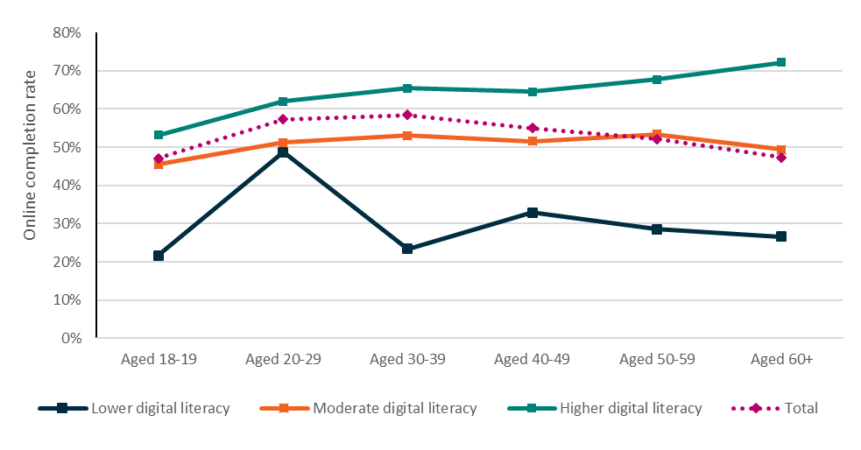
Source: 2019 Job Seeker Snapshot Survey
Note: 3,105 job seekers

4.1.6 Regression model for online completion
Table 4.1 shows how online completion varied across demographic characteristics. But these correlations might not hold after controlling for other factors. For example, while older people were less likely to complete the JSS, it might be that this was because age was negatively correlated with digital literacy, rather than because of age per se. To explore this possibility, regression modelling was undertaken for the department by Wallis Group (see Appendix E).
The results confirmed that the most important difference between the completers and non-completers was digital literacy. The regression results showed that confidence using devices and low online job search activity were significant predictors of online completion (Figure 4.2).
Figure 4.2 Statistically significant characteristics contributing to JSS completion (odds ratio)
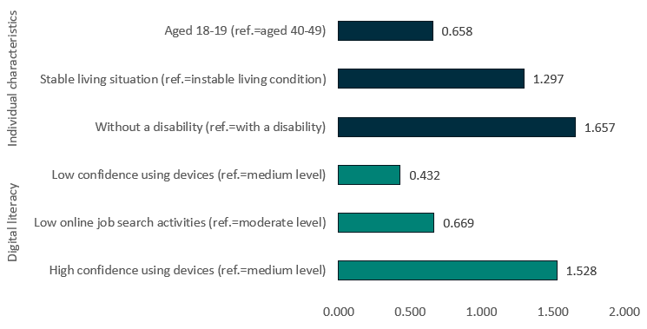
Source: 2019 Job Seeker Snapshot Survey
Notes: All respondents (n=3,105), of whom 739 had missing values, and 2,366 were finally included in the regression model. This figure uses the statistically significant coefficients with a p-value <0.05 estimated from the multivariate regression model of online completion using the 2019 Job Seeker Snapshot Survey data. For more details on the regression model, see Appendix E. If the odds ratio is above 1 then the cohort is more likely to complete the JSCI online (relative to the reference group). If the odds ratio, is below 1 then the cohort is less likely to complete online. For example, job seekers with a stable living situation are about 1.25 times more likely to complete the JSS than job seekers with an unstable living situation.
Further, digital literacy accounted for most of the observed differences in completion across cohorts. After controlling for digital literacy variables, a range of personal characteristics such as age, gender, education, location, Indigeneity, and applying for income support for the first time were insignificant. In other words, while older, less educated and Indigenous Australians (among others) were less likely to complete the JSS, the analysis suggested this was essentially because they were less digitally literate.
The other factors that remained significant after controlling for digital literacy were having recently experienced an unstable living situation, having a disability or being younger than 20, all of which reduced the likelihood of online completion, even after accounting for differences in digital literacy.
The results indicate that improving digital literacy among job seekers could yield better completion rates. The benefits of this would have to be weighed against the possibility that time spent improving digital literacy could be spent on job search or on other forms of education and training which might have a more direct link to employment outcomes.

4.2 Reasons for completion
According to the 2019 Job Seeker Snapshot Survey, most completers (80%) believed that the JSS was a compulsory requirement of the overall income support claim process (Figure 4.3). These findings were also reflected in the 2019 qualitative research.
But I’m in the situation where I need financial assistance, so, I just felt like I had to do it if I wanted the financial assistance, which I desperately need.
(Job seeker, 2019)
Over a quarter of trial participants who completed the JSS module (27%) believed that it would be faster and more efficient, and this theme also emerged from the qualitative research.
To be honest I don't remember if I thought it was compulsory or not, but I assumed that it would save me time to do it then and there rather than having to do it some other time.
(Job seeker, 2019)
Figure 4.3 Reasons for completing the JSS
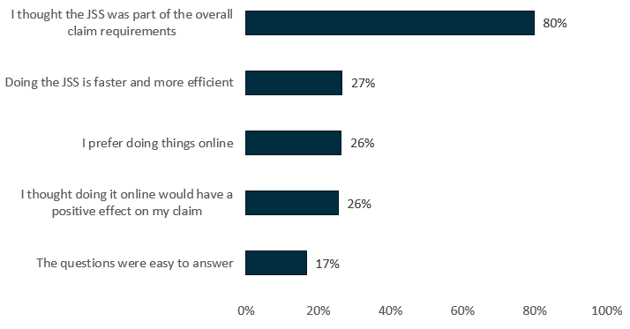
Source: 2019 Job Seeker Snapshot Survey
Note: All correctly self-recalled completers (n=911). Multiple responses were allowed.
Another quarter of completers (26%) indicated they completed the JSS because they preferred an online platform, and a similar number of participants thought completing the JSS would have a positive impact on their claim for income support (26%). Fewer than one in five (17%) did so because they found the questions easy to answer.

4.3 Reasons for non-completion
As previously discussed, around half (51%) of job seekers referred to the Trial did not complete the JSS, with about 97% of non-completers not attempting the JSS at all. The 2018 Job Seeker Survey revealed that the main reasons cited for not completing the JSS were related to a lack of understanding of the JSS, a lack of instructions, and technical limitations, although there were a wide range of responses to the survey question.
Among the non-completers, 19% were not aware that they had to complete it, 9% could not find enough instructions on how to do it, 10% had problems with the website, and 8% had problems with their devices (Table 4.4).
Table 4.4 Top five reasons for not completing the JSS, 2018
Top five reasons for not completing the JSS | Correctly self-recalled non-completers (%)  (n=341)
I didn’t know I had to complete it online | 19
I had problems with the website | 10
I was contacted by Services Australia before I had a chance to do it | 10
I didn’t have enough instructions on how to do it | 9
I had problems with accessing or using my device | 8
Source: 2018 Job Seeker Survey
Note: Multiple responses were allowed

4.3.1 Low awareness and understanding
In the 2018 qualitative research some job seekers identified difficulties in understanding the purpose of the JSS. They expressed concerns over whether disclosure of personal information (e.g. mental health, drug use) would impact their eligibility for income support payments.
Depends on what the purpose they’re asking it for, because I’m not clear what they’re asking for. If they have got an addiction on gambling that I wouldn’t really actually want to divulge … I wouldn’t want an employer or people to know that … you think if you’re going to give that kind of information it’s going to penalise you.
(Job seeker, 2018)
Some job seekers (in the 2019 qualitative research) interpreted the notice ‘Your claim has been successfully submitted’ as a signal for them to disengage from the JSS process. Other job seekers reported that the non-compulsory nature of the JSS was a disincentive for them to complete it.
When the snapshot came up, I just said ’no’ because they told me that I didn’t have to look for work and so I didn’t feel it necessary to go and fill it all out. (Job seeker, 2019)

4.3.2 Technical problems
As noted above, the 2018 Job Seeker Survey (Table 4.3) found that a significant proportion of non-completers reported technical issues, including website problems, problems accessing or using devices, no internet access or not noticing the JSS pop-up.
There were three main types of website problems encountered by trial participants: logging into myGov, the related issue of jumping across multiple platforms, and technical glitches.

Logging into myGov and crossing platforms
As discussed above, when an income support claim was done online, a window appeared on the computer screen, prompting the user to complete the JSS module. The 2019 Job Seeker Snapshot Survey found that the myGov set-up/sign-in procedure was troublesome, with 11% of non-attempters reporting they had problems logging into myGov/jobactive and 27% reporting that they did not get around to logging in.
The necessity of jumping across different platforms within myGov between the initial claim for income support and completing the JSS, including via the myGov set-up/sign-in page, was viewed as being troublesome. Changing platforms also raised some concerns among an increasingly privacy and security aware public.
That jump will put people off. Where am I going? Why do I have to do this? … (Job seeker, 2019)

Technical glitches
Some participants indicated that they encountered a technical ‘glitch’ or ‘bug’ before the system registered them as an ‘attempter’. In the 2019 qualitative research, participants frequently identified technical errors which had prevented them from accessing or completing the JSS.
There’s a bug … there’s a bug in the link between the Centrelink claim and the Job Snapshot, or whatever it’s called. When you … when you go in there, and it says ’go over to the Job Start and put in your Snapshot’, that’s fine, that works, but it doesn’t feedback that you’ve done it. So, every time I go into the claim, to see what the status is, or to add information, or whatever it might be, it asks me to do that again. So, it’s not recognising the fact that I’ve already done it.
(Job seeker, 2019)
Some participants reported trying to access the system multiple times, or on different devices, and some others adopted the mindset that ‘if it’s important, someone will follow up with me’.
There was also a log in issue that I had, where I didn’t have my phone on quite quickly enough to get the verification code to skip on through, and after that I got stuck in a loop where, and it didn’t tell me what the issue was, when I put that code in it timed out, it had just timed out, or something. It didn’t say anything like your code has timed out, it was just like error. There were some functionality issues that made me feel less confident.
(Job seeker, 2019)

4.4 Methods of completion and sources of assistance

4.4.1 Method of completion
Around 86% of completers had undertaken the JSS at home because it was easier and faster to complete it in the comfort of their own home. This reflected the fact that 97% of completers had internet access at home (as did 95% of non-completers). Eleven per cent completed the JSS at Services Australia. Completion was generally on a laptop (40%) or mobile device (38%).
I think I’d rather do it in the comfort of my own home in 10 minutes than have to drive in, wait for an hour and a half, and then talk to someone for 30 seconds then drive home.
(Job seeker, 2019)
The particulars of this comment may reflect job seeker perceptions of long waits followed by brief interactions – as noted above, the JSCI interview generally takes 10 to 15 minutes.

4.4.2 Sources of assistance
In the 2019 Job Seeker Snapshot Survey, most job seekers (94%) indicated that they completed the JSS on their own without assistance, but a few participants (about 5%) received assistance.
Among those who required assistance to complete the JSS, a majority received help from a family member (51%). Other sources of assistance included Services Australia staff (32%), jobactive provider staff (18%), a friend (13%) and the NCSL (4%) (Figure 4.4).
Well, for me, because I don’t have much skills on computer and I have to depend on my friend to help me out, so, it’s easy like that. At the same time, I’m learning and using technology, so it takes a while for me to get through.
(Job Seeker, 2019)
Figure 4.4 Sources of assistance when completing the JSS, 2019
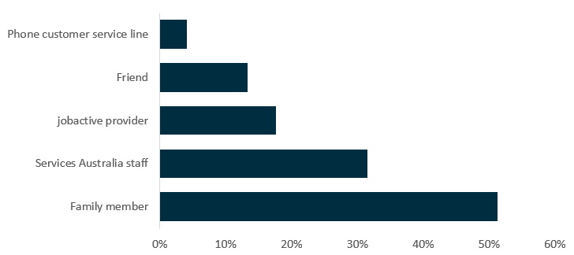
Source: 2019 Job Seeker Snapshot Survey
Note: All correctly ‘self-recalled’ attempters and completers requiring assistance to complete JSS, n=54. Multiple responses were allowed.
While there may have been an expectation that self-completion would increase calls to the NCSL, only a small number of job seekers who were selected for the Trial sought assistance during the period from 1 July 2018 to 30 September 2019 (although it is worth noting data is limited).

4.5 Chapter summary
The evaluation found that while people who were older, Indigenous, less educated or living in regional areas tended to have lower rates of completing the JSS, most demographic variables were not statistically significant in a regression that controlled for digital literacy. In other words, while older people were less likely to complete the JSS, the regression analysis suggests this was entirely due to having lower digital literacy. Factors that remained significantly correlated with completion after controlling for digital literacy were being aged 18 to 19, having a disability and having experienced an unstable living situation.

Chapter 5. Job seeker and Services Australia views and perceptions
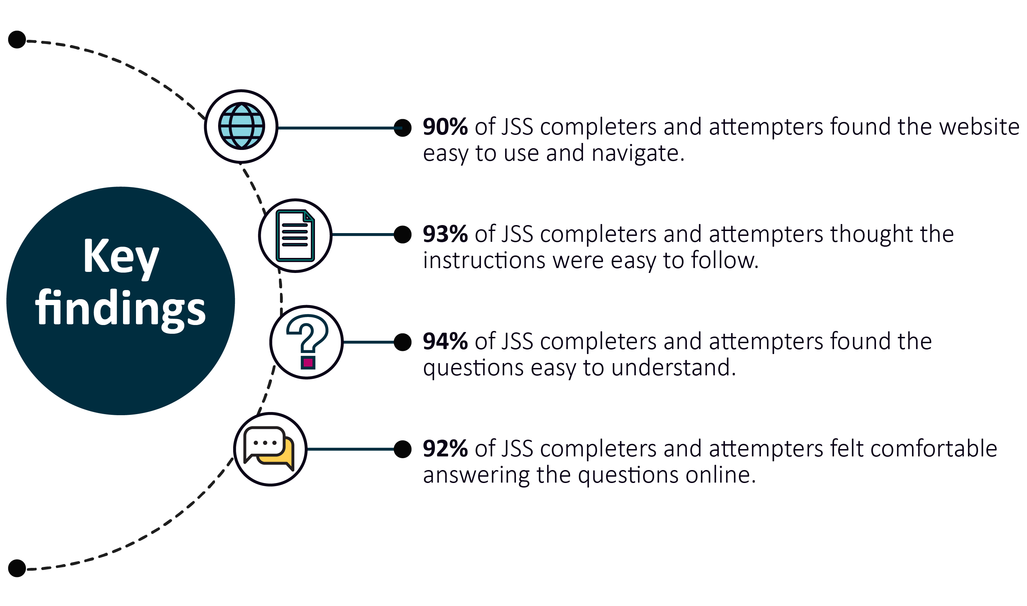
This chapter explores job seekers’ views of the JSS system, and the perceived advantages and disadvantages of online completion. It aims to answer the key evaluation question:
- What were job seeker and Services Australia perceptions and experiences of the JSS?

5.1 Job seeker views on the JSS

5.1.1 Job seeker preferences
Most trial completers had a positive experience with the JSS. A vast majority of the 2018 Job Seeker Survey respondents (72%) stated that online would be their preferred way to complete the JSCI if they made another claim, well above the figure for the comparison group (21%).
Further, two-thirds (66%) of JSS completers and attempters in the 2019 Job Seeker Snapshot Survey would recommend the JSS to other job seekers. This proportion was higher among younger groups, likely reflecting differing digital literacy across generations.

5.1.2 Ease of use
The JSS had a very low drop-out rate after commencement (less than 2%), indicating that it worked well once participants were engaged with it.
This was reinforced by the 2018 Job Seeker Survey results, which showed that most job seekers who completed or attempted the JSS found it easy to use (Table 5.1). Completers were more likely to agree on the ease of navigating and responding to the JSS (93% to 96%) than attempters (82% to 87%).
Table 5.1 Job seeker views on the ease of use of the JSS
Statements (agreed) | Attempters  (n=101) | Completers  (n=338) | Total  (n=439)
 | % | % | %
The Job Seeker Snapshot website was easy to navigate | 82.2 | 92.9 | 90.4
The instructions were easy to follow | 86.1 | 95.3 | 93.2
The questions were easy to understand | 87.1 | 96.4 | 94.3
I felt comfortable answering the questions online | 84.4 | 93.8 | 91.6
Source: 2018 Job Seeker Survey
Note: Both self-classified completers and self-classified attempters
In the 2018 qualitative research, participants did not raise any significant issues in terms of navigating the website or understanding the JSCI questions. Participants also reported feeling comfortable with answering these questions online.
Similar results were found in the 2019 survey (Figure 5.1), in which almost three-quarters (74%) of correctly self-recalled respondents reported that they felt comfortable providing the information as requested and almost two-thirds (64%) agreed that the steps were clear and easy to follow. However, 13% found it difficult to log in.
Despite the JSS being generally easy to use, some participants in qualitative research reported experiencing challenges with its presentation on different devices, such as mobile phones.
I completed the Job Seeker Snapshot on a mobile phone. I found the layout made it extremely difficult to complete. There appeared to be little logic to how questions and options were presented for completion, and the presentation frequently hindered completion of the questions.
(Job seeker, 2019)
Figure 5.1 Job seeker views of the JSS
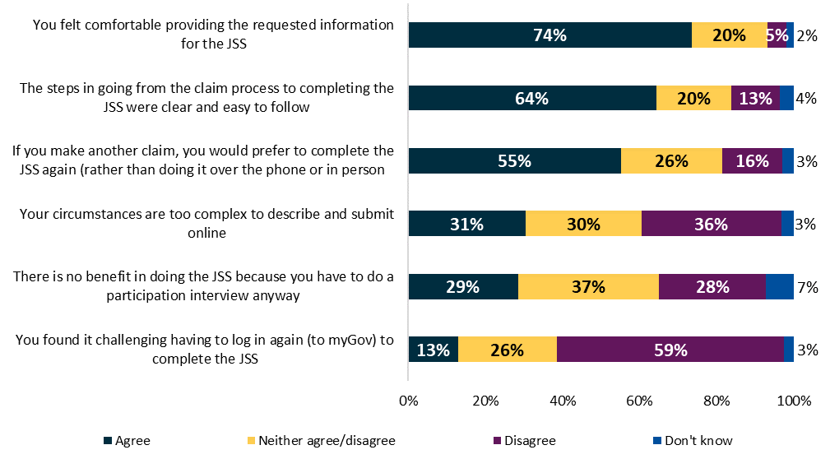
Source: 2019 Job Seeker Snapshot Survey
Note: n=1,147 (bases vary as not all statements applied to all respondents)

5.2 Perceived advantages and disadvantages of the JSS
In focus group discussions and in-depth interviews conducted as part of the 2018 qualitative research, participants were asked to list advantages and disadvantages of the JSS. The following were five main advantages.
- Convenience – being able to answer the questions at home, at a time of their choosing, as opposed to visiting a Services Australia site or waiting to be contacted by Services Australia.
- Comfort and privacy – being able to answer some sensitive questions in private, without feeling judged, inhibited or self-conscious, particularly with health and ‘other personal factors’ questions.
- Consideration of responses – being able to take more time to read and answer questions more precisely, without feeling under pressure to answer immediately, particularly for participants for whom English was not their first language, and for others who felt less confident speaking to people on the phone or in person.
- Efficiency – both job seekers and staff reported the JSS was more efficient as it saved the time used in phone calls, face-to-face contact and waiting times for appointments.
- Accuracy – having control over the responses selected, as opposed to not being able to see which response was reported by a third party.
The five main disadvantages identified by trial participants were:
- Inability to explain answers in more detail – participants with more complex circumstances (e.g. complex employment history, or health problems) reported that the JSS did not enable them to provide more clarity or details on why they had selected a particular response.
- Limited access to help for more information – some participants were concerned by a lack of explanation as to why certain questions were being asked and what the information would be used for.
- Limited digital literacy – some participants, particularly older participants, preferred phone or face-to-face contact, due to limited IT skills.
- No access to technology – in a small number of cases, participants did not have a home computer and were concerned about where they could complete the JSS. In these cases, they preferred completing it over the phone with assistance from Services Australia.
- Privacy and security concerns – some participants had concerns about the privacy and security of disclosing their personal information online. However, others recognised that their information was already in the ‘system’, regardless of whether it was entered into the computer by them or by a third party.

5.3 Job seeker suggestions for the JSS
Trial participants suggested five main areas for improvement (Table 5.2):
- enabling direct login and prefilling of information
- providing additional information and explanation to job seekers
- providing greater system feedback
- ensuring availability of staff assistance
- enabling job seekers to provide additional details.

5.3.1 Enabling prefilling of information and direct login
About two-thirds of job seekers completing the JSS online (66%, Table 5.2) suggested their personal information should be automatically prefilled when already available online for government agencies; 60% of non-completers of the JSS shared this view.
Don’t we already give this out when we’re starting a claim in the DHS-Centrelink? And then we have to give this again in jobactive.
(Job seeker, 2019)
If the government knows your tax file number, your other details, yeah that’s fine. If you already provided them previously it should be there. It shouldn’t, like, me doing it again online, fill all these details out.
(Job seeker, 2019)
In addition, about one-third of completers and non-completers (28% and 37% respectively) suggested the system would be easier to navigate if they did not need to log in separately to complete the JSS.

5.3.2 Providing additional information and explanation to job seekers
As shown in Table 5.2, both completers and non-completers felt there were benefits to receiving more information, including being told about:
- the JSS process at the start (51% and 56% respectively)
- the benefit of doing the JSCI online (50% and 57% respectively)
- why each voluntary question should be answered (51% – completers only).
Tell us there are multiple steps and not just one step to do so that we know we’ve done everything we need to do. Make everything a bit clearer. Sometimes when I was on there I didn’t understand where I needed to go, needs clearer instructions, it’s like swimming through murky water.
(Job seeker, 2019)
Job seekers wanted more information about the purpose of questions asked in the JSS, as discussed in Chapter 4. While a range of information is publicly available on the department’s website, there is limited information available on the JSS landing page, over the phone or through face-to-face conversations about the purpose of the questions. In particular, job seekers expressed concerns about the purpose of asking personal and sensitive questions (such as about living circumstances and criminal history) and how this information would be used. Providing more information could help job seekers to have a better understanding of the JSS and increase their willingness to complete the JSS.

5.3.3 Providing increased feedback during online completion
Participants proposed that there should be increased feedback, both from the department/system to the job seeker and from the job seeker to the department. Over half of the completers (58%) proposed that a feedback form be available at the end of the JSS process to enable job seekers to raise any issues for further discussion with their provider or Services Australia staff (Table 5.2).
The 2019 qualitative research also highlighted participants’ frustration at a lack of system feedback on:
- whether their online claims for income support were proceeding properly
- whether they had correctly filled in their forms.
What would be significantly better would be to actually send you an email to confirm the documents that you’ve sent through so that if they don’t have the document, then you can see, ‘that’s gone through’ … When it’s uploaded, you know you’ve done it and you can see on screen.
(Job seeker, 2019).
Table 5.2 Support for potential improvements to the JSS system, 2019
Suggested improvements | Completers (% yes) (n=911) | Non-completers (% yes)  (n=235)
(1) It automatically filled in the JSS with information you have given previously | 66.0 | 59.6
(2) There was a feedback form at the end of the JSS where you can mention any problems | 58.3 | NA
(3) There was a ‘chat’ function to help you to complete the JSS | 52.3 | NA
(4) You were told about the JSS process at the start of the claim for benefits | 51.2 | 56.0
(5) You were given information on why each voluntary question is being asked | 51.1 | NA
(6) You were given more information on the benefits of doing the JSS rather than with Services Australia | 50.4 | 56.5
(7) You didn’t have to login to myGov/jobactive to complete the JSS | 27.5 | 37.3
(8) You were given online training | 23.6 | 32.3
Source: 2019 Job Seeker Snapshot Survey
Note: NA = not applicable

5.3.4 Ensuring availability of online training and staff assistance
About 24% of completers and 32% of non-completers suggested more online training should be available, and over half of the job seekers (52%) who completed the online JSS agreed that a ‘chat’ function could be provided to assist with queries during the JSS completion (Table 5.2). However, job seekers participating in the qualitative research were often dismissive of the capabilities of an automated chat-box, preferring human interactions instead.
I was at Centrelink and there were a few questions that I couldn’t answer and needed help to navigate through. I would never have been able to do that at home.
(Job seeker, 2019)
One of the strong themes that emerged was the important role that Services Australia staff played in helping job seekers to navigate the processes. Staff were able to explain the purpose of questions, clarify what kind of information was sought and identify suitable steps to ensure a smooth experience. Staff were also able to suggest ‘workarounds’ and solutions based on their deep knowledge of the system.
I was informed by a Centrelink employee that I did not have to do it because I had submitted a medical exemption. They told me when the window popped up, I could close it as I did not have to worry about it.
(Job seeker, 2019)

5.3.5 Enabling job seekers to provide additional detail
Some job seekers suggested including open text responses to allow for more detailed answers to JSS questions that could require more complicated explanations by job seekers, such as questions on work, education and transport. For example, one participant in the 2018 qualitative research noted that they had a licence and owned a car but were reluctant to drive due to severe migraines.
Both the JSS and the interview-based JSCI asked the job seeker to detail specific issues that may affect their capacity to work which were not already addressed by the standard questions. However, it is worth noting that free text responses to all questions are not a feature of the traditional interview-based JSCI either, and that the use of free text fields in the JSS could reduce efficiency gains from online completion, as the free text would need to be read and interpreted by a human being.

5.4 Services Australia perspectives
Overall, Services Australia staff who participated in the research were very supportive of moving the JSCI online. Frontline staff indicated that they encouraged job seekers to complete things online as often as possible. Staff research participants noted that the time saved from conducting the JSCI online would allow them to potentially process more claims per day.
Services Australia staff also noted that there was a lack of understanding among job seekers as to what the JSCI was used for. This was mentioned as a potential barrier to completion. As explained by one senior staff member, if job seekers were aware that completing the JSS online would circumvent a later phone conversation, they would be more likely to complete it online. There was agreement among senior staff that the purpose of the JSCI was not well understood –– in some cases by Services Australia staff.
The consensus among Services Australia senior staff was that, so long as job seekers were given an adequate explanation as to why the questions were being asked, moving the JSCI online would be preferable.

5.5 Chapter summary
Most job seekers were happy with the JSS, with 72% indicating that they would prefer online completion, and 66% indicating that they would recommend it to other job seekers. Online completion was perceived to be convenient, comfortable and efficient, and only 2% of job seekers who commenced the JSS dropped out without completing it. However, the transition across platforms from the income support claim to the JSS appeared to be an issue for some job seekers. In the qualitative research, job seekers highlighted possible improvements in a number of areas, such as enabling prefilling of information, additional explanation and opportunities for feedback, and the option of including free text responses to more complex questions. Services Australia staff were generally supportive of the move online, emphasising potential time savings, but noted the need for better communication of the purpose of the JSS and the benefits of online completion.

Chapter 6. Conclusion
This chapter summarises learnings from the Trial and discusses the relevance of evaluation findings to future changes to employment services.

6.1 What are the learnings?
The evaluation found that it is generally as efficient and effective for job seekers to complete the JSCI online as an interview-based JSCI, either face-to-face or phone. Trial participants mostly took less than 15 minutes to complete the JSS, similar to the interview-based method.
JSS completers were at least as consistent in their responses to JSCI questions, and hence in their stream allocation, as those who completed an interview-based JSCI. Similar outcomes in terms of stream allocation suggests that job seekers were not disadvantaged by completing online.
Further, a key consideration in the provision of employment services is cost-effectiveness.
Given that the JSS had similar results in terms of JSCI scores and appeared to have had little or no effect on exits from employment services and income support, this indicates that administering the JSCI online is an efficient option for job seekers, especially those who are more digitally literate.

6.1.1 What worked?
More than 90% of trial participants found the JSS easy to use and navigate. About two-thirds of completers and attempters indicated that they would use the JSS again or would recommend the JSS to other job seekers. An overwhelming majority of participants reported that JSS instructions were easy to understand. They reported the main benefits of the JSS were convenience, privacy, efficiency and accuracy, as well as allowing more time to consider responses.

6.1.2 What did not work?
There was low awareness of the purpose and benefits of doing the JSS online, not only among JSS completers but also among Services Australia staff members and job seekers doing their JSCI by phone or face-to-face.
Some participants reported barriers to online completion, including having difficulty logging into the JSS via the myGov website, encountering technical glitches, or having limited access to extra assistance from Services Australia staff.

6.1.3 Who did not complete?
While online servicing is an increasing global trend, including in Australia, not everyone is able to participate. This evaluation identified low levels of digital literacy as the main barrier to online engagement. The evaluation also found that individuals aged under 20, those with unstable living arrangements and those with a disability were less likely to complete the JSS.

6.1.4 Limits of the learnings
It is important to note that while trial participants were selected randomly, online completion was opt-in. As such, the findings could be influenced by selection bias and might not apply to all job seekers. Results for completers may not be a reliable guide to how quickly and accurately non-completers could have undertaken the JSS.
Consequently, given that only half the participants selected for the Trial completed the JSS, it is difficult to determine whether the differences in outcomes observed were due to a causal effect from online completion, or to differences in the sample populations due to self-selection of less disadvantaged job seekers into completion of the JSS.

6.2 Future directions
Since the New Employment Services Model was announced in March 2019, the digital employment services environment has changed fundamentally.

6.2.1 The Online JSCI Trial evaluation and the future of employment servicing
As discussed in Chapter 1, the use of digital servicing has significantly expanded since the Trial was announced. The department is trialling key elements of the new employment services model in two regions, and OES was rolled out in April 2020 as the Australian Government’s mainstream online employment servicing platform for job-ready job seekers.
Central to both the rollout of the OES and the ongoing development of the new employment services model is the ability to effectively distinguish more job-ready job seekers from more disadvantaged job seekers. Traditionally, this would have been the role of the interview-based JSCI. However, just as government services are becoming more digital, so are assessment tools like the JSCI.
This trial has shown that job seekers are generally able to undertake online self-assessments efficiently and effectively. However, it is important to note that half of the trial participants did not complete the JSS. Consistent with the international literature, those with low digital literacy were far less likely to complete the online assessment.
This suggests that in the rollout of the JSS, and other online assessments, consideration should be given to alternatives, support and/or checks needed to ensure those who are less digitally literate or are unable to complete online for other reasons can be properly assessed for servicing.

Bibliography
Australian Public Service Commission (2018). Australian Government Use of Information and Communication Technology. Canberra. https://www.apsc.gov.au/australian-government-use-information-and-communication-technology
Barth, M., & Veit, D. (2011). Electronic Service Delivery in the Public Sector: Understanding the Variance of Citizens’ Resistance. Hawaii International Conference on System Sciences. Kauai, USA. https://www.researchgate.net/publication/224221252_Electronic_Service_Delivery_in_the_Public_Sector_Understanding_the_Variance_of_Citizens'_Resistance, accessed 07/07/20.
Bekkers, V., & Homburg, V. (2007). The Myths of E-government: Looking Beyond the Assumptions of a New and Better Government. The Information Society, 23(5), 373–382. doi: 10.1080/01972240701572913. https://www.researchgate.net/publication/220175531_The_Myths_of_E-Government_Looking_Beyond_the_Assumptions_of_a_New_and_Better_Government, accessed 07/07/20.
Chen, J. (2017). Breaking Down Barriers to Digital Government: How Can We Enable Vulnerable Consumers to Have Equal Participation in Digital Government?. Australian Communications Consumer Action Network (ACCAN). https://accan.org.au/Breaking%20Down%20Barriers%20to%20Digital%20Government.pdf
Colesca, Sofia (2009). Understanding Trust in E-government. Engineering Economics, 3, 7–15. https://www.researchgate.net/publication/228867440_Understanding_Trust_in_e-Government, accessed 07/07/20.
Ebrahim, Z., & Irani, Z. (2005). E‐government Adoption: Architecture and Barriers. Business Process Management Journal, 11(5), 589–611. doi: 10.1108/14637150510619902. https://www.researchgate.net/publication/235254120_E-government_adoption_Architecture_and_barriers, accessed 07/07/20.
Joseph, S. (2015). Advantages and Disadvantages of E-government Implementation. International Journal of Marketing and Technology, 5(9), 18–34.
Merhi, M., & Koong, K. (2016). E-government Effectiveness: A Rocket Model of Contributing User-Related Factors. International Journal of Services and Standards, 11(1), 1. doi: 10.1504/ijss.2016.076968. https://www.researchgate.net/publication/303909258_E-government_effectiveness_A_rocket_model_of_contributing_user-related_factors, accessed 07/07/20.
Quinn, B. (2018). The ‘Nudge Unit’: The Experts that Became a Prime UK Export. The Guardian, 11 November 2018. https://www.theguardian.com/politics/2018/nov/10/nudge-unit-pushed-way-private-sector-behavioural-insights-team
Särndal, Carl-Erik, et al. (2003). Stratified Sampling. Model Assisted Survey Sampling. New York: Springer. pp. 100–109.
Shahrokh Esfahani, Mohammad, & Dougherty, Edward R. (2014). Effect of Separate Sampling on Classification Accuracy. Bioinformatics, 30(2), 242–250. doi: 10.1093/bioinformatics/btt662. PMID 24257187. http://bioinformatics.oxfordjournals.org/content/30/2/242
Solinthone, P., & Rumyantseva, T. (2016). E-government Implementation. MATEC Web Conference. doi: 10.1051/matecconf/20167901066.
Stragier, J., Verdegem, P., & Verleye, G. (2010). How Is E-government Progressing? A Data Driven Approach to E-government Monitoring. Journal of Universal Computer Science, 16, 1075–1088. 10.3217/jucs-016-08-1075. https://www.researchgate.net/publication/220348920_How_is_e-Government_Progressing_A_Data_Driven_Approach_to_E-government_Monitoring, accessed 07/07/20.
Teicher, J., & Dow, N. (2002). E-government in Australia: Promise and Progress. Information Polity, 7(4), 231–246.
Thomas, J., Barraket, J., MacDonald, T., Mundell, M., Tucker, J., & Ewing, S. (2018). Measuring Australia’s Digital Divide: The Australian Digital Inclusion Index 2018. Melbourne: Telstra.
United Nations (2018). United Nations E-government Survey 2018: Gearing E-government to Support Transformation towards Sustainable and Resilient Societies. New York: UN. doi: 10.18356/d54b9179-en. https://www.un-ilibrary.org/democracy-and-governance/united-nations-e-government-survey-2018_d54b9179-en, accessed 080720.
Van Dijk, J., Peters, O., & Ebbers, W. (2008). Explaining the Acceptance and Use of Government Internet Services: A Multivariate Analysis of 2006 Survey Data in the Netherlands. Government Information Quarterly, 25(3), 379–399. doi: 10.1016/j.giq.2007.09.006. https://www.researchgate.net/publication/248544637_Explaining_the_acceptance_and_use_of_government_Internet_services_A_multivariate_analysis_of_2006_survey_data_in_the_Netherlands, accessed 08/07/20.

List of abbreviations and acronyms
Abbreviation | Description
CATI | Computer Assisted Telephone Interviewing
CALD | Culturally and linguistically diverse
CoCR | Change of Circumstances Reassessment
DHS | Department of Human Services, now Services Australia
DES | Disability Employment Services
DESE/the department | Department of Education, Skills and Employment (and its predecessors)
ESAt | Employment Services Assessment
ESS | Employment Services System
JSCI | Job Seeker Classification Instrument
JSS | Job Seeker Snapshot (online JSCI module)
n | Survey sample size
N | Population number
NCSL | National Customer Service Line
OEST | Online Employment Services Trial
RED | Research and Evaluation Database
IT | Information technology
SRC | Social Research Centre
Wallis/Wallis Group | Wallis Market and Social Research

Glossary
Term | Description
Attempters | Trial participants who attempted the JSS but did not complete it.
Completers | Online JSCI Trial participants who completed a JSS, both immediate and delayed.
Comparison group | Eligible job seekers who were not selected for the Online JSCI Trial.
Delayed completers | Online JSCI Trial participants who completed the JSS but did not complete it immediately when prompted.
Employment Services System (ESS) data | The ESS administrative data contains current and historic caseload information (e.g. job seeker demographics, referrals, commencements and paid outcomes) and payment transactions (e.g. claims for service, outcome fees and wage subsidies). This data is one of the major sources for evaluating and reporting on the government’s employment service programs and labour market policies.
ESAt | The Employment Services Assessment (ESAt) is a comprehensive assessment that identifies an individual’s barriers to finding and maintaining employment, their work capacity and assistance that may be of benefit to improve their current work capacity. The ESAt process ensures that disadvantaged job seekers are referred to the most appropriate employment service assistance (e.g.. jobactive Stream C or Disability Employment Services (DES)).
Immediate completers | Online JSCI Trial participants who completed the JSS immediately when prompted.
Inflow population | The jobactive inflow population is the primary study population used in this report for the analysis of exits from employment services and income support. It contains commenced jobactive periods of assistance, from 1 July 2018 to 30 September 2019.
jobactive | jobactive is the Australian Government’s mainstream employment services program in place during the period of the Online JSCI Trial.
jobactive provider | A jobactive provider is an organisation contracted by the department to deliver employment services under jobactive.
JobSeeker Payment | The main unemployment benefit paid to unemployed people aged between 22 and 64 years from 20 March 2020. JobSeeker Payment has replaced NewStart Allowance as the main unemployment benefit since 20 March 2020.
NewStart Allowance (NSA) | The main unemployment benefit paid to unemployed people aged between 22 and 64 years before 20 March 2020. From 20 March 2020, JobSeeker Payment has replaced NSA as the main unemployment benefit.
Non-attempters | Trial participants who did not attempt the JSS.
Non-completers | Online JSCI Trial participants who did not complete the JSS. These include participants who attempted and did not attempt the JSS.
Program guidelines | Program guidelines provide information on administering employment services and programs.
Referrals | In this report, referrals are people who have been referred to ESAt or other employment programs.
Research and Evaluation Database (RED) | RED is one of the primary administrative data sources used in this report on the analysis of completion and non-completion by characteristics, JSCI scores, streaming and referring outcomes, and major changes of circumstances.
Stream A | Stream A participants are the most job ready. They receive services to help them understand what employers want and how to navigate the local labour market, build résumés and look for jobs.
Stream B | Stream B participants need their jobactive provider to play a greater role to help them become job ready and will be referred for case management support.
Stream C | Stream C participants have a combination of work capacity and personal issues that need to be addressed and will get case management support so that they can take up and keep a job.
Trial participants | Both completers and non-completers of JSS.
Youth Allowance | Income support payment for young people who are aged 24 years or younger and a student or Australian apprentice, or 21 years or younger and looking for work.
Youth Allowance (Other) | The primary income support payment for young people aged under 22 years who are looking for paid work, undertaking other activities to improve their employment prospects or temporarily incapacitated for work or study.

List of tables
Table 1.1 Topics and factors in the JSCI questionnaire 8
Table 2.1 Participants in qualitative research 16
Table 2.2 Quantitative surveys 17
Table 3.1 Streaming outcomes and ESAt referrals 21
Table 3.2 Consistency in JSCI scores between administrative data and follow-up survey 22
Table 3.3 Consistency in stream allocations between administrative data and follow-up survey 22
Table 3.4 Consistency in ESAt referral between administrative data and follow-up survey 23
Table 3.5 Proportion of job seekers with major changes of circumstances 23
Table 3.6 Exits within sixsix months from employment services and income support, by stream 24
Table 4.1 Completion and non-completion, by characteristics, 2018––19 26
Table 4.2 Completion rates, by Indigenous status, 2019 27
Table 4.3 Selected characteristics of online completers and non-completers, 2019 28
Table 4.4 Top five reasons for not completing the JSS, 2018 33
Table 5.1 Job seeker views on the ease of use of the JSS 38
Table 5.2 Support for potential improvements to the JSS system, 2019 42
Table A1 Online JSS questions 56
Table C1 Number of job seekers in the trial and comparison groups, by selected characteristics 66
Table D1 Eigenvalues from Principal Component Analysis 70
Table D2 Loadings from Principal Component Analysis 71
Table D3 Proportion of job seekers by level of digital literacy, by age group 71
Table E1 Multivariate regression model on completion of the JSS 73

List of figures
Figure 2.1 Online JSCI Trial study population 15
Figure 3.1 Time spent on completing the JSS 19
Figure 3.2 Distribution of JSCI overall score, by delivery method 20
Figure 4.1 JSS completion, by digital literacy and age group 29
Figure 4.2 Statistically significant characteristics contributing to JSS completion (odds ratio) 30
Figure 4.3 Reasons for completing the JSS 32
Figure 4.4 Sources of assistance when completing the JSS, 2019 36
Figure 5.1 Job seeker views of the JSS 39
Figure B1 Paths through the Online JSCI Trial from claim to commencement 65

Appendix A: The Job Seeker Snapshot (JSS) questions (online JSCI version as at 26 June 2018)
The JSCI is based on a questionnaire comprising 48 questions broadly grouped into eight sections:
- Work experience
- Education and qualifications
- Work capacity
- Descent and origins
- Language
- Living circumstances
- Transport
- Personal factors.
Each job seeker will answer up to 48 questions based on their circumstances. The jump from one question to another has been set up automatically online.
Table A1 presents the online JSCI module, or the Job Seeker Snapshot (JSS). The contents are the same as in the JSCI questionnaire;; however, there were slight differences in how questions in the JSS were worded in order to suit an online platform.
Table A1 Online JSS questions
Work Experience | –
Question 1 | In the past 2 years, what have you been doing most?
Response  (Select one response only) | a) Paid work (includes full time, part time or casual work, employment overseas, seasonal work or still working)  b) Working while in prison or other detention  c) Unpaid work (includes volunteering but not caring)  d) Unemployed (i.e. not working but looking for work)  e) Community Development Programme (CDP)  f) Studying part-time  g) Studying full-time  h) Caring  i) Parenting  j) Not working and not looking for work
 | Think about the whole two years, not just about what you have done lately. Did you work, study, take time off to look after kids?
– | –
Question 2 | In your most recent job, how many hours did you mostly work per week? (Participants who answered ‘Paid work’ to Question 1)
Response  (Select one response only) | a) 30 hours or more  b) 8 hours or more but less than 30 hours  c) Less than 8 hours  d) Casual, irregular or seasonal employment
 | Include any overseas employment.
– | –
Question 3 | Have you done any paid work (in Australia or overseas) in the last 2 years?
Response | a) Yes  b) No
– | –
Education and Qualifications | –
Question 4 | What is the highest level of schooling you have completed?
Response  (Select one response only) | a) Year 12/13 or equivalent (e.g. Form 6)  b) Year 11 or equivalent (e.g. Form 5)  c) Year 10 or equivalent (e.g. Form 4)  d) Less than Year 10 or equivalent  e) Special school / support unit in school or equivalent  f) Did not go to school
– | –
Question 5 | Have you completed any other qualification(s)?
Response | a) Yes  b) No
– | –
Question 6 | Have you completed any of the following qualifications?
Response  (Select all applicable responses) | a) Doctoral degree or equivalent  b) Master degree or equivalent  c) Graduate Diploma, Graduate Certificate or equivalent  d) Bachelor degree  e) Diploma, Advanced Diploma, Associate Degree or equivalent  f) Tradesperson’s qualification  g) Certificate II  h) Certificate III or IV  i) Certificate I  j) Industry-specific license or ticket  k) Course run by private or community organization  l) None of the above
– | –
Question 7 | Can you still use these qualifications for work?
Response | a) Yes  b) No
– | –
Question 8 | What is preventing you from using your qualifications?  (Participants who answered “no” to Question 7)
Response  (Select all applicable responses) | a) Disability or health related reasons  b) Low English language proficiency  c) Qualification suspended/terminated  d) Qualification not recognised (including overseas qualification(s) not recognised)  e) Qualification outdated or irrelevant
– | –
Work Capacity | –
Question 9 | Do you have any disabilities or medical conditions that affect the hours you are able to work?
Response | a) Yes  b) No  c) Not sure/don’t know  d) Do not wish to answer
– | –
Question 10  (For those answering yes in Q9) | What is the most likely number of hours per week you think you are able to work?
Response | a) 30 hours or more  b) 15-29 hours  c) Less than 15 hours
Note/ Instruction | If less than 30 hours you may need to provide evidence (e.g. a report from a doctor)
– | –
Question 11 | Do you have any disabilities or medical conditions that affect the type of work you can do?
Response | a) Yes  b) No  c) Not sure/don’t know  d) Do not wish to answer
– | –
Question 12 | Given your disability or medical condition, do you need additional support to help you at work?
Response | a) Yes  b) No  c) Not sure/don’t know
– | –
Question 13 | How long will your condition(s) affect your ability to work?
Response | a) Less than 3 months  b) 3 months or more  c) Not sure / don’t know
– | –
Question 14 | What are the conditions?
Response | [Job seeker can select from the list]
– | –
Descent and Origins | –
Question 15 | Are you Aboriginal or Torres Strait Islander?
Response | a) Yes  b) No  c) Do not wish to answer
– | –
Question 16 | Indigenous status
Response  (Select all applicable responses) | a) Aboriginal  b) Torres Strait Islander
– | –
Question 17 | Have you ever been granted an Australian refugee or humanitarian visa?
Response | a) Yes  b) No  c) Not sure/don’t know  d) Do not wish to answer
– | –
Question 18  (For those answering yes to Q17) | From which country did you arrive?
Response | Record here:
 | Record the country from which you arrived as a refugee or humanitarian entrant – this may not be the last country you lived in.
– | –
Question 19 | Was this more than 5 years ago?
Response | a) Yes, more than 5 years ago  b) No, 5 years ago or less  c) Not sure/don’t know
– | –
Language | –
Question 20 | Did you speak English at home as a child?
Response | a) Yes  b) No
– | –
Question 21 | What language(s) did you first speak as a child?
Response  (For those answering yes to Q20) | [Job seeker can select from the list]
Note/ Instruction | Make your selection from the list …
– | –
Question 22 | How well do you speak English?
Response | a) Very well  b) Well  c) Not well  d) Not at all
– | –
Question 23 | How well do you read English?
Response | a) Very well  b) Well  c) Not well  d) Not at all
– | –
Question 24 | How well do you write English?
Response | a) Very well  b) Well  c) Not well  d) Not at all
– | –
Question 25 | Have you done any courses or classes to help improve your English language skills in the last 6 months?
Response | a) Yes  b) No
– | –
Living Circumstances | –
Question 26 | Have you been living in rented accommodation or your own home for the past 12 months?
Response | a) Yes  b) No  c) Not sure/don’t know
– | –
Question 27 | Are you currently staying in emergency or temporary accommodation?
Response  (Select all applicable responses) | a) No  b) Yes, a refuge, emergency, transitional or supported accommodation  c) Yes, a hotel, hostel, boarding house or rooming house  d) Yes, short stays in caravan park  e) Yes, temporarily staying with friends (or couch-surfing)  f) Yes, living in a squat, car or tent  g) Yes, have nowhere to stay  h) Yes, other
– | –
Question 28 | How often have you moved in the past 12 months?
Response  (Select one response only) | a) I have not moved in the past 12 months  b) 1-3 moves  c) 4 or more moves
– | –
Question 29 | Do you currently live on your own?
Response | a) Yes  b) No
– | –
Question 30 | Who currently lives with you?
Response  (Select all applicable responses) | a) Partner/spouse (includes same-sex partner)  b) Dependent child/children under 16 years of age  c) Dependent full-time student(s) aged between 16 and 24 years  d) Parent(s)/guardian(s)  e) Other family member(s) or relative(s)  f) Others, not family
 | Select anyone who currently lives with you …
– | –
Question 31 | Are you the main caregiver for this child/these children?
Response | a) Yes  b) No  c) Care is shared equally with another person
– | –
Question 32 | What is the date of birth of your youngest child?
Response | Type here:
– | ––
Transport | –
Question 33 | Do you have a valid driver’s licence?
Response | a) Yes  b) No
– | –
Question 34 | Do you have your own car or motorcycle?
Response  (Select one response only) | a) No, don’t own a car/motorcycle  b) Yes, I have my own car/motorcycle  c) Yes, own a car/motorcycle but cannot afford running costs/maintenance
– | –
Question 35 | Thinking about getting to and from work, what modes of transport can you access?
Response  (Select all applicable responses) | a) Own car/motorcycle  b) Own non-motorised transport (e.g. bicycle)  c) Other private transport (e.g. friend’s or relative’s car)  d) Public transport (e.g. bus or train)  e) Taxi  f) Other motorised transport  g) No transport (except walking)
– | –
Personal Factors | –
Question 36 | Potential impact of parents’ historical labour force participation: At least one of my parents or legal guardians was regularly in paid employment when I was in my early teens.
Response | a) Yes  b) No  c) Not applicable (e.g. I was raised in an orphanage)  d) Do not wish to answer
– | –
Question 37 | Is there anything else that might affect your ability to work, get work or look for work?
Response | a) Yes  b) No  c) Do not wish to answer
– | –
Question 38 | Please select the factors that might affect your ability to work, get work or look for work.
Response  (Select all applicable responses) | a) Anger issues/temper/violence  b) Caring responsibilities  c) Criminal court action pending/bail/remand  d) Dental issues  e) Domestic violence  f) Drug treatment program (e.g. methadone)  g) Family grief/trauma  h) Gambling addiction  i) Numeracy issues  j) Pregnancy  k) Relationship breakdown  l) Risk of homelessness  m) Self-esteem/motivation/presentation issues  n) Severe stress  o) Sleep problems/insomnia
– | –
Question 39 | For any other factors not included in the list above, please provide details:
Response | (Enter response here, open response)
– | –
Question 40 | Have you spent time in prison in the last 2 years as a result of a criminal conviction?
Response | a) Yes  b) No  c) Do not wish to answer
– | –
Question 41 | Was your sentence 14 days or less?
Response | a) Yes, 14 days or less  b) No, more than 14 days
– | –
Question 42 | Have you been convicted of a criminal offence in the last 5 years but received a non-custodial sentence?
Response | a) Yes  b) No  c) Do not wish to answer
– | –
Question 43 | Have you spent time in prison since turning 21 years of age as a result of a criminal conviction?
Response | a) Yes  b) No  c) Do not wish to answer
– | –
Question 44 | Was your sentence 14 days or less?
Response | a) Yes, 14 days or less  b) No, more than 14 days
– | –
Question 45 | Have you been convicted of a criminal offence since turning 18 years of age but received a non-custodial sentence?
Response | a) Yes  b) No  c) Do not wish to answer
– | –
Question 46 | Have you spent time in prison in the last 7 years as a result of a criminal conviction?
Response | a) Yes  b) No  c) Do not wish to answer
– | –
Question 47 | Was your sentence 14 days or less?
Response | a) Yes, 14 days or less  b) No, more than 14 days
– | –
Question 48 | Have you been convicted of a criminal offence in the last 10 years but received a non-custodial sentence?
Response | a) Yes  b) No  c) Do not wish to answer

Appendix B: Workflow diagram of Online JSCI Trial
Figure B1 Paths through the Online JSCI Trial from claim to commencement
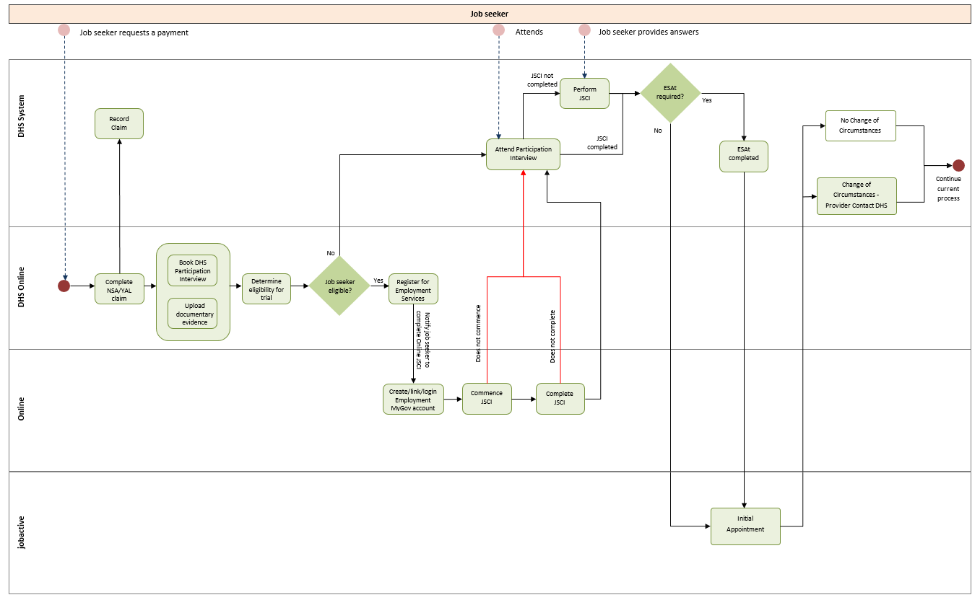

Appendix C: Data sources
Analyses of both quantitative and qualitative data are used for the evaluation. Quantitative data include departmental administrative data and information collected through surveys. Qualitative data were collected through focus groups and interviews.

C1 Departmental administrative data
The Research and Evaluation Database (RED) and jobactive inflow population data were linked to create the departmental administrative data used for this evaluation.
The RED is a longitudinal dataset that commenced on 1 July 1998. The data contained in the RED include details of:
- income support history
- customer demographics
- entitlements, including some non-income support payments and services
- payment circumstances, including details of activities for those looking for work
- personal circumstances, including medical and work capacity assessments
- employment and non-employment income
- education and study
- the partners and children of people included in the RED.
The jobactive inflow population data was sourced from the department’s Employment Services System, which is the IT system the department uses to deliver and manage the jobactive program. The inflow population covers job seekers who commenced employment services in the period from 1 July 2018 to 30 September 2019.
The administrative data covers 375,381 eligible job seekers, including both trial participants and the comparison group (see Table C1). It includes information on demographics, JSS completion status, responses to all the JSCI questions, JSCI scores, streaming outcomes, referrals to ESAt or other employment programs, and major changes in circumstances (CoCRs), as well as exits from income support and employment services.
Table C1 Number of job seekers in the trial and comparison groups, by selected characteristics
Characteristics | Completers | Non-completers |  | Trial participants |  | Comparison  group |  |  | Eligible job seekers
– – | A |  | B |  | C=A+B |  | D | E=C+D
Total | 52,309 |  | 55,410 |  | 107,719 |  | 267,662 | 375,381
Gender | – |  | – |  | – |  | – | –
Female | 23,767 |  | 22,587 |  | 46,354 |  | 116,268 | 162,622
Male | 28,542 |  | 32,823 |  | 61,365 |  | 151,394 | 212,759
Age | – |  | – |  | – |  | – | –
19 years and under | 7,075 |  | 8,632 |  | 15,707 |  | 33,216 | 48,923
20 to 29 years | 17,805 |  | 16,685 |  | 34,490 |  | 79,176 | 113,666
30 to 39 years | 9,640 |  | 9,084 |  | 18,724 |  | 49,254 | 67,978
40 to 49 years | 7,683 |  | 8,332 |  | 16,015 |  | 44,458 | 60,473
50 to 59 years | 6,638 |  | 7,859 |  | 14,497 |  | 39,610 | 54,107
60 plus | 3,468 |  | 4,818 |  | 8,286 |  | 21,948 | 30,234
Indigeneity | – |  | – |  | – |  | – | –
Non-Indigenous | 49,281 |  | 51,155 |  | 100,436 |  | 248,167 | 348,603
Indigenous | 3,028 |  | 4,255 |  | 7,283 |  | 19,495 | 26,778
Income support first-time claimer | – |  | – |  | – |  | – | –
No | 42,959 |  | 44,896 |  | 87,855 |  | 224,754 | 312,609
Yes | 9,350 |  | 10,514 |  | 19,864 |  | 42,908 | 62,772
Location | – |  | – |  | – |  | – | –
Major Cities of Australia | 35,900 |  | 36,401 |  | 72,301 |  | 177,242 | 249,543
Inner Regional Australia | 11,331 |  | 12,956 |  | 24,287 |  | 60,743 | 85,030
Outer Regional Australia | 4,727 |  | 5,578 |  | 10,305 |  | 27,230 | 37,535
Remote Australia | 334 |  | 446 |  | 780 |  | 2,261 | 3,041
NA | 17 |  | 29 |  | 46 |  | 186 | 232
Education | – |  | – |  | – |  | – | –
NA | 1,764 |  | 2,710 |  | 4,474 |  | 23,297 | 27,771
Less than Year 12 | 12,321 |  | 14,556 |  | 26,877 |  | 66,081 | 92,958
Year 12 | 11,262 |  | 10,681 |  | 21,943 |  | 48,069 | 70,012
University degree | 12,809 |  | 7,214 |  | 20,023 |  | 37,370 | 57,393
Vocational | 14,153 |  | 20,249 |  | 34,402 |  | 92,845 | 127,247
Mode of JSCI completion | – |  | – |  | – |  | – | –
Face to face | –– |  | 1,201 |  | 1,201 |  | 17,340 | 18,541
Online | 52,309 |  | –– |  | 52,309 |  | –– | 52,309
Phone | –– |  | 54,170 |  | 54,170 |  | 249,614 | 303,784
Other | –– |  | 39 |  | 39 |  | 708 | 747
Source: DESE administrative data
Notes: 375,381 eligible job seekers, including both Online JSCI Trial participants and the comparison group during the period from 1 July 2018 to 30 September 2019
NA = not applicable
*JSCI forms were sent to some job seekers who were not available for online, phone or face-to face interviews

C2 Quantitative survey data
The department conducted three quantitative surveys. In 2018, the Social Research Centre (SRC) was commissioned by the department to undertake the 2018 JSCI Quality Assurance Survey (n=1,451) and the 2018 Job Seeker Survey (n=1,000). In 2019, due to the extension of the Trial, Wallis Consulting Group was commissioned to undertake the 2019 Job Seeker Snapshot Survey with a larger sample size (n=3,105) and an in-depth analysis of digital literacy, barriers to online JSCI completion and suggestions for improvements to the JSS.

C2.1 2018 JSCI Quality Assurance Survey
The 2018 JSCI Quality Assurance Survey contacted 1,451 job seekers by phone in July and August 2018, shortly after their completion of the JSS (321 job seekers) or by interview (phone or face-to-face) with Services Australia staff (848) or jobactive providers (282). In the follow-up survey, job seekers were asked to repeat their responses to JSCI questions using Computer Assisted Telephone Interviewing (CATI). Outcomes obtained from this follow-up survey, including JSCI scores, streaming results and ESAt referrals (if any) or referrals to other employment services, were then compared with the original JSCI outcomes recorded in the departmental administrative data. Only outcomes obtained from the follow-up survey for 321 JSS completers and 400 comparison group job seekers were used for comparison in this report.

C2.2 2018 Job Seeker Survey
The 2018 Job Seeker Survey interviewed 1,000 job seekers in September and October 2018 either online (25%) or using CATI (75%). This survey included job seekers who had completed their JSCI online (40% completers) or who were selected for the Trial but did not complete their JSCI online (35% trial non-completers), and job seekers in the comparison group (25% eligible but not selected for the Trial). Information was collected on job seekers’ preference and experience of using the JSS, their reasons for not attempting or not completing the JSS and their suggestions for improvements.

C2.3 2019 Job Seeker Snapshot Survey
The 2019 Job Seeker Snapshot Survey was conducted from October to December 2019, with 3,105 trial participants using an online survey (84%) or CATI (16%). The survey investigated reasons behind completion and non-completion of the online JSCI. Participants’ experiences, digital literacy, barriers to online completion and individual attitudes towards online services were also explored.

C3 Qualitative research
The department commissioned qualitative research in 2018 and 2019 to gain an in-depth understanding of trial participants’ perceptions and views about the Online JSCI Trial, including their experiences and barriers encountered when completing the JSS. Focus groups and individual in-depth interviews were used to explore issues and canvass attitudes of both job seekers and staff from Services Australia. In total, 19 focus groups and 72 in-depth interviews were conducted with 180 job seekers and a small number of Services Australia staff.
Qualitative research participants were reasonably distributed across age, gender, location and cultural background. Sample selection also ensured that each focus group comprised both completers and non-completers.

C3.1 2018 qualitative research
The 2018 qualitative research was undertaken to explore job seekers’ attitudes and reasons for completion and non-completion of the JSS, barriers to online completion and the impact of digital literacy (89 job seekers). Services Australia staff also participated in two discussion groups that explored how they interacted with trial participants and their awareness of the Trial. Two-thirds of the qualitative research participants were recruited from job seekers who completed the 2018 Job Seeker Survey and were willing to further participate in qualitative research; the remaining one-third were from the list of job seekers supplied by the department.

C3.2 2019 qualitative research
Between October and December 2019, further qualitative research was undertaken to explore job seeker attitudes towards providing information online, the impact of digital literacy, and experiences in completing the JSS. Research participants (91 job seekers) were recruited after completing their 2019 Job Seeker Snapshot Survey.

Appendix D: Factor analysis on digital literacy
In order to determine whether various specific survey measures of digital literacy aligned to a single underlying factor, designated as ‘digital literacy’, an exploratory Principal Component Analysis (PCA) was undertaken using the 2019 Job Seeker Snapshot Survey data for 3,105 job seekers who had completed their JSCI, either online or by interview. PCA is a helpful technique to combine highly correlated variables into a single index.
The following specific digital literacy variables were included in this analysis:
- confidence in using the internet when looking for work
- frequency of digital device use
- confidence in digital device use
- the number of ‘everyday activities’ undertaken online
- frequency of online job search
- attitudes to technology.
The results indicated that each of the specific survey measures points to a single unobserved ‘factor’, which was designated as ‘digital literacy’.
As shown in Table D1, Component 1 was selected and extracted as the new index due to its highest eigenvalue (2.480) and relatively strong power (41.3%) in explaining variations of all the original variables.
Table D1 Eigenvalues from Principal Component Analysis
Components | Eigenvalues | Explanation for total variances (%)
C1 | 2.480 | 41.3
C2 | 0.946 | 15.8
C3 | 0.895 | 14.9
C4 | 0.739 | 12.3
C5 | 0.605 | 10.1
C6 | 0.335 | 5.6
Source: 2019 job seeker snapshot survey (n=3,105)
Based on the analysis, a new ‘digital literacy’ score was generated for each person. These scores were then divided into three broad categories: low, medium and high. Table D2 shows that the ‘digital literacy’ score was highly correlated with confidence in using the internet when looking for work (0.826) and average confidence in using digital devices (0.823), as well as other relevant variables.
Table D2 Loadings from Principal Component Analysis
Variables | Variation explained  (%) | Loadings
Q12 Confidence in using internet when looking for work | 68 | 0.826
Q6 The frequency of use for the most frequently used devices | 29 | 0.541
Q7 Average confidence in using devices | 68 | 0.823
Q10 Count of number of online activities | 38 | 0.619
Q11 Average frequency of online activities | 29 | 0.541
Q14 Summative scale of attitudes to technology | 15 | 0.388
Source: 2019 Job Seeker Snapshot Survey (n=3,105)
Results from this digital literacy analysis show that levels of digital literacy varied greatly by age (Table D3). Participants aged 50 and over were more likely to have low digital literacy, while those aged 20 to 49 were more likely to have high digital literacy.
Table D3 Proportion of job seekers by level of digital literacy, by age group
Level of digital literacy | 18––19 (%) | 20––29 (%) | 30––39 (%) | 40––49 (%) | 50––59 (%) | 60+  (%) | Total
Low digital literacy | 31.5 | 19.3 | 18.9 | 29.0 | 41.7 | 56.9 | 29.1
Moderate digital literacy | 46.7 | 37.6 | 29.6 | 31.5 | 30.6 | 27.7 | 33.9
High digital literacy | 21.9 | 43.1 | 51.5 | 39.5 | 27.7 | 15.4 | 37.0
Source: 2019 Job Seeker Snapshot Survey (n=3,105)

Appendix E: Multivariate logistic regression model predicting online JSCI completion
As discussed in the main report, there were clear relationships between various demographic characteristics and JSS completion, while relationships were also observed based on measures of digital literacy. Logistic regression modelling was undertaken to explore the joint factors predicting the completion of the JSS.
The model was based on 2019 Job Seeker Snapshot Survey data on all 3,105 respondents, in which 739 had missing values, and 2,366 were included in the final regression model. The dependent variable was the completion of the Online JSCI Trial through the JSS. Predictors included variables on both demographics and digital literacy.
The regression results (Table E1) based on the 2019 Job Seeker Snapshot Survey data show that after controlling for all the variables available, variation in digital literacy explains most of the variation in online completion across cohorts. Age groups (except for under 20 years), gender, education, location, speaking English at home, Indigeneity, and applying for income support for the first time all became insignificant. Some other factors remained statistically significant.
- While the demographic factors appeared to have strong relationships with completion from descriptive analysis, the regression model revealed that digital literacy measures, especially around confidence in using devices and job search activities online, were two strong and significant predictors.
- The youngest job seekers (under 20 years) were significantly less likely to complete the JSS. Qualitative research suggested they were more challenging to engage due to passive detachment.
- Those who had experienced unstable living arrangements (homelessness) in the recent past or were identified as having a disability were less likely to complete the JSS.
These findings confirmed that the major difference between the completers and non-completers was digital literacy.
Table E1 Multivariate regression model on completion of the JSS
Predictors | Values | Coefficient | Standard error | P-value
Age | Aged 18––19 (*) | -.418 | .183 | .022
– | Aged 20––29 | -.258 | .141 | .068
– | Aged 30––39 (ref.) | – | – | –
– | Aged 40––49 | -.115 | .156 | .461
– | Aged 50––59 | .009 | .141 | .948
– | Aged 60+ | .226 | .163 | .165
Gender | Male (ref.) | – | – | –
– | Female | .101 | .088 | .249
Aboriginal or Torres Strait Islander (ATSI) status | Yes (ref.) | – | – | –
– | No | .206 | .233 | .377
Highest education | Pre-Year 12 (ref.) | – | – | .129
– | Year 12 | .052 | .133 | .697
– | Trade qualification | -.124 | .130 | .342
– | University qualification | .164 | .145 | .260
Disability status | With disability (ref) | – | – | –
– | No disability (*) | .505 | .137 | .000
Housing status | Homelessness (ref) | – | – | –
– | Not homelessness (*) | .260 | .101 | .010
Speaking English at home | No (ref.) | – | – | –
– | Yes | .052 | .152 | .733
First time applied for income support | No (ref.) | – | – | –
– | Yes | .088 | .092 | .338
Internet access | Yes (ref) | – | –
– | No | -.277 | .315 | .379
Confidence in using internet to look for work | Not confident (ref.) | – | – | –
– | Confident | .038 | .083 | .644
Need help when doing things online | Don’t need help (ref.) | – | – | –
– | Need help | -.211 | .122 | .083
Frequency of use of devices | Daily | – | – | .134
– | Weekly | -.208 | .205 | .310
– | Monthly or less | -.688 | .375 | .067
Confidence in using devices | Middle confidence (ref.) | – | – | –
– | Lower confidence (*) | -.840 | .169 | .000
– | Higher confidence (*) | .424 | .108 | .000
Count of online activities | Medium (ref.) | – | – | .410
– | Low count | -.001 | .107 | .990
– | High count | .137 | .113 | .226
Job search activities online | Middle frequency (ref.) | – | – | .000
– | Lower frequency (*) | -.402 | .113 | .000
– | Higher frequency | .059 | .106 | .580
Towards technology | More positive (ref.) | – | – | .922
– | Medium positive | -.027 | .100 | .789
– | Less positive | -.046 | .118 | .698
Constant | – | -1.855 | .671 | .006
Sample size | – | 2366 | – | –
Nagelkerke R-square | – | 0.109 | – | –
Cox & Snell R-square | – | 0.082 | – | –
Source: 2019 Job Seeker Snapshot Survey (n=3,105), in which 739 had missing value, and 2,366 were finally included in the regression model due to missing information
Note: (*) Variables and estimates with significance with a p-value <0.05

This analysis was limited to those who correctly recalled that they had completed or attempted the JSS when their response to a survey question was compared to departmental administrative data (n=912).
The 2019 Job Seeker Snapshot Survey assessed the level of digital literacy based on six questions asked in the survey on digital use and confidence among 3,105 job seekers (see Appendix D).
Since the introduction of the JSCI assessment tool in 1998, the model has been re-estimated with each iteration of the mainstream employment services program. For example, the model was re-estimated when jobactive was introduced to replace its predecessor, Job Services Australia, in July 2015.
The attempting non-completers and not attempting non-completers were 2.0% and 51.3% among all job seekers born overseas in non-English-speaking countries, compared to 1.6% and 49.7% among all job seekers born in Australia.
In the departmental administrative data, many job seekers did not report whether they had experienced an unstable situation or have a disability. Consequently, survey data is used to get a more complete picture.
See Appendix D for details on how the different levels of digital literacy are defined.
Results from this digital literacy analysis show that levels of digital literacy varied greatly by age. Participants aged 50 and over were more likely to have lower levels of digital literacy, while those aged 20 to 49 were more likely to have higher levels.
If a p-value is smaller than 0.05, the coefficient is statistically significant at the 5% level.
If a p-value is smaller than 0.05, the coefficient is statistically significant.
Correctly ’self-recalled’ completers here.
Correctly ’self-recalled’ non-completers here.
Correctly ’self-recalled’ non-completers here. Correctly ’self-recalled’ attempters and completers.
Correctly ‘self-recalled’ attempters and completers.
This section uses the views and ratings of completers (and attempters) who correctly ‘self-recalled’ completing/attempting the JSS. In other words, participants who completed (or attempted) the JSS but did not recall this are excluded from the analysis.
According to the 2019 qualitative research, Services Australia staff supported moving to the online JSCI. Frontline staff reported they encouraged job seekers towards digital self-servicing as much as possible. Staff noted that the time saved from conducting the JSCI would allow them to process more applications per day.
https://docs.employment.gov.au/documents/new-employment-services-model
These included two group discussions held with a small number of Services Australia staff at a service centre in Melbourne. One. One discussion involved frontline staff, and the other involved senior staff and ‘technical officers’ who had experiences with the Online JSCI Trial.
For social behaviour study, the R-square 0.2––0.4 shows an excellent fitness. Our model has an R-square 0.10, which is good enough to investigate how digital literacy and major characteristics explained the variation in online completion.
Other variables which were controlled for in the multivariate regression model but were insignificant included access to the internet at home, confidence in using the internet when looking for work, whether the respondent would reach out for external help with technology, frequency of use of devices, number of different online activities undertaken, and general attitude towards technology.

