

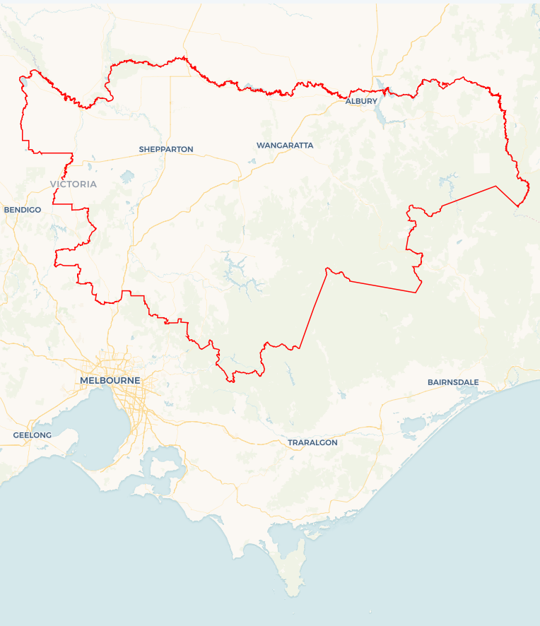Local Jobs Plan

Goulburn Murray ****Employment Region**** | VIC | ****April 2025****

Workforce Australia Local Jobs (Local Jobs) is a program that supports tailored approaches to accelerate   
reskilling, upskilling and employment pathways in response to current and emerging local workforce needs.

## Local Jobs elements

### Local Jobs Plan

The Local Jobs Plan sets out the skills and employment challenges and priorities of the region, and associated strategies that will drive the design and implementation of activities to be implemented to address these challenges.

### Jobs Coordinators

Job Coordinators and Support Officers support the delivery of the program by bringing together key stakeholders including businesses, employment services providers, higher education and training organisations.

### Local Jobs and Skills Taskforce

Each Employment Region has its own Taskforce. Representatives include local stakeholders who have demonstrated experience in upskilling, reskilling, and an ability to represent, connect and collaborate with others in the region to meet labour market needs.

### Program Funds

The Employment Region’s Local Initiatives Fund enables targeted local investments that support local labour market functioning. Further, from 2025/26, a central grants-based fund will respond to local needs and help progress broader employment service reform objectives.

Explore labour market insights for the   
[Goulburn Murray](https://www.jobsandskills.gov.au/work/employment-region-dashboards-and-profiles/monthly-labour-market-dashboards) Employment Region

Explore labour market insights for   
Goulburn Murray Employment Region

## Local labour market challenges in the region

* Health care and social assistance, construction, education and training, retail trade and manufacturing are Goulburn Murray’s primary employing industries. High skilled industries like health care and social assistance, construction and manufacturing reduce the availability of entry-level roles.
* Limited public transport options and challenges in obtaining driver’s licences affects workforce participation, especially in smaller regional areas.
* Industries such as agriculture, forestry and fishing, education and training, health care and social assistance are facing an ageing workforce. Workforce planning is required to attract and train new workers.
* Culturally and linguistically diverse (CALD) individuals often encounter difficulties in accessing the labour market and finding secure employment due to language challenges and skills gaps.
* Goulburn Murray has a significant requirement for seasonal workers across industries such as agriculture, forestry and fishing, accommodation and food services. A shortage of seasonal workers impacts the productivity and efficiency of businesses.
* The region faces affordable housing shortages, particularly affecting low-income earners and seasonal workers. These challenges make it difficult for businesses to attract and retain workers.
* There are many First Nations organisations and support services available throughout the Goulburn Murray area, yet community awareness of these services can be limited.
* Mature age individuals represent a significant portion of the caseload in the Goulburn Murray. There is an increasing need to acquire digital skills to remain active in the workforce.

## Local jobs and skills priorities and strategies in the region

### Priority 1 – Growth and emerging industries

#### What are our challenges and opportunities?

Goulburn Murray growth industries including accommodation and food services, transport, postal and warehousing, manufacturing, construction, preschool education and school education, health care and social assistance and agriculture are currently operating below capacity. Businesses experience challenges in attracting, recruiting and retaining both skilled and unskilled workers. Emerging sectors, like the electricity and energy sector, will require reskilling and upskilling of the current and future workforce.

#### How are we responding?

* We are engaging with businesses and industry stakeholders to review their workforce planning strategies and recruitment practices.
* We are connecting businesses to Workforce Australia Employment Services Providers (providers), activities and programs to optimise outcomes for both businesses and individuals.
* We are collaborating with providers, Registered Training Organisations (RTOs) and industry stakeholders to develop industry-specific ‘taster programs’ that expose individuals to educational institutions and local business.
* We are promoting clean energy employment pathways and net zero events with community organisations and businesses across the region. The first promotion of clean energy pathways to students will occur April 2025.

### Priority 2 – Address complex challenges of long-term unemployed individuals

#### What are our challenges and opportunities?

#### Long-term unemployed individuals often face complex challenges to employment which may include housing insecurity, transport challenges, mental health conditions, low self-esteem and low educational outcomes. Building resilience and self-confidence is essential for re-entering the workforce.

#### How are we responding?

* We are consulting with providers and community groups to understand the complex challenges for individuals and specific cohorts to sustainable employment.
* We will facilitate quarterly forums to identify opportunities for interagency cooperation to support individuals receiving government payments.
* We are developing localised workshops and supporting events that equip and empower individuals to build confidence and readiness for work.
* We are raising awareness of local services that support individuals facing housing instability.
* We are collaborating with providers and RTOs to develop activities that offer industry-relevant training and provide insights into workplace expectations.

### Priority 3 – First Nations peoples

#### What are our challenges and opportunities?

#### The Goulburn Murray Employment Region has a range of First Nations support services and organisations. There is an opportunity to increase awareness of local support services to improve employment outcomes and economic participation for First Nations across the region.

#### How are we responding?

* We are collaborating with organisations and the community to strengthen relationships and understand the cultural needs of First Nations people.
* We will first consult with First Nations peoples to develop a community activity in Albury Wodonga for 2025.
* We are consulting with the First Nations community, RTO’s, industry and businesses to assist the development of culturally appropriate recruitment models, activities and pre-employment programs.
* We continue to promote existing programs with the First Nations community that empower and upskill First Nations peoples to meet current and future workforce demands.

### Priority 4 – Culturally and linguistically diverse individuals

#### What are our challenges and opportunities?

#### The CALD community is growing significantly in Goulburn Murray Employment Region. Many CALD individuals face challenges to employment which may include language barriers, cultural differences and gaps in skills or qualifications. Creating inclusive workplaces for CALD individuals is essential for fostering diversity, equity and productivity.

#### How are we responding?

* We are facilitating interagency collaboration and supporting the CALD community by encouraging resource sharing. Multicultural Talent Hub activities are anticipated to be held in Albury Wodonga and Shepparton in the next 6 months.
* We are promoting new and existing programs and initiatives that support employment and training pathways for CALD communities. This includes promoting CALD individuals as a local talent pool to growth industries and seasonal employment opportunities.
* We are consulting with local industry, RTOs and CALD community groups to co-design solutions and activities that create upskilling, training and employment opportunities that address the specific needs of the CALD community.

### Priority 5 – Mature age individuals

#### What are our challenges and opportunities?

#### As industries evolve, new skills and technologies are essential in today’s changing labour market. There is opportunity to support mature age individuals to identify their transferrable skills, update their qualifications, enhance their digital skills to meet current industry demands to successfully enter in today's job market.

#### How are we responding?

* We are working with industries to review recruitment practices and encourage job flexibility while promoting the benefits of employing mature age candidates as a local talent pool.
* We are engaging with RTO’s, businesses and industry representatives to develop activities that support mature age individuals to create upskilling and training opportunities and identify their transferrable skills and building digital competency and self-esteem to create pathways into sustainable employment.
* We will engage key stakeholders to develop a workshop that connects mature age individuals to local supports and programs across the region. The first workshop will be completed in June 2025 and will leverage existing programs that have provided sustainable employment outcomes.

## Want to know more

* Contact: Faye D’Helin, Goulburn Murray Job Coordinator: faye.dhelin@goulburnmurraylocaljobs.com.au
* Visit: [Local Jobs](https://www.dewr.gov.au/local-jobs) or [Workforce Australia](https://www.workforceaustralia.gov.au/)