Local Jobs Plan

## Murray Riverina Employment Region | NSW | July 2025

Workforce Australia Local Jobs (Local Jobs) is a program that supports tailored approaches to accelerate reskilling, upskilling and employment pathways in response to current and emerging local workforce needs.

**Local Jobs elements**

**Local Jobs Plan**

The Local Jobs Plan sets out the skills and employment challenges and priorities of the region, and associated strategies that will drive the design and implementation of activities to be

implemented to address these challenges.

**Local Jobs and Skills Taskforce**

Each Employment Region has its own Taskforce. Representatives include local stakeholders who have demonstrated experience in upskilling, reskilling, and an ability to represent, connect and collaborate with others in the region to

meet labour market needs.

**Job Coordinator**

Job Coordinators and Support Officers support the delivery of the program by bringing together key stakeholders including businesses, employment services providers, higher education and training organisations.

**Program Funds**

The Employment Region’s Local Initiatives Fund enables targeted local investments that support local labour market functioning. Further, from 2025/26, a central grants-based fund will respond to local needs and help progress broader employment service reform objectives.

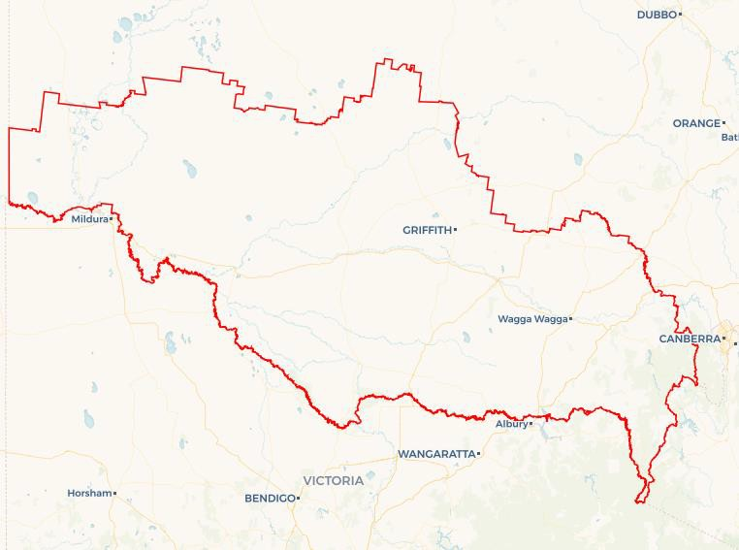

Explore labour market insights for the [Murray Riverina](http://www.jobsandskills.gov.au/work/monthly-labour-market-dashboards) Employment Region

# Local labour market challenges in the region

* Multiple major projects are competing for workers into high demand sectors such as manufacturing, freight and logistics, construction, renewables and health.
* Community service organisations – including aged care, disability services and the early childhood sector, continue to face challenges in meeting the growing demand for skilled workers.
* Strategic workforce planning for major infrastructure projects must be integrated down to the local level across the region to allow effective upskilling of individuals against future demand.
* A significant proportion of individuals engaged with Workforce Australia Employment Services have experienced long-term unemployment, highlighting the importance of

sustained engagement to support their journey back into the workforce.

* Increased demand for accommodation presents an opportunity to explore innovative housing solutions, as the region experiences strong infrastructure growth. With several major projects underway and a competitive rental market, there is a timely need to expand and diversify available housing options, including short-term and transitional accommodation.
* Transport is a significant barrier to workforce participation, due to:
  + affordability for professional driver training for those that are not eligible to receive subsidised support.
  + Restrictions or loss of license not recoverable through Work Development Orders (WDO)
  + limited availability of public transport within and between regional centres across NSW.

# Local jobs and skills priorities and strategies in the region



## Priority 1 – Boost local workforce and apprenticeships

### What are our challenges and opportunities?

Actively pursue pathways into local employment and training through concentrating on barriers such as skills gaps, mental health challenges, transport issues and housing instability. At the same time, make the most out of the growing number of job opportunities created by major infrastructure and renewable energy projects across the region.

### How are we responding?

* **Promoting local apprenticeships and incentives:** We are working with business chambers, peak bodies, industry groups and government communication channels to raise awareness of available apprenticeship opportunities and employer and employee incentives. This includes distributing information through newsletters, local business networks and direct outreach to encourage uptake across the region.
* **Creating pathways through collaborative partnerships:** In partnership with industry, NSW Government, local councils, and education and training providers, we are developing clear and practical pathways into apprenticeships, traineeships, and entry-level roles. This includes promotion of career expos, coordinating targeted information sessions, and encouraging direct employer engagement at events. We are also supporting programs that promote gender diversity, such as initiatives to increase the participation of women in male-dominated trades.
* **Reducing barriers to participation:** We are connecting jobseekers with existing support services that address common barriers such as mental health challenges, transport limitations, and housing instability. By working with community organisations and local service providers, we ensure individuals have the wraparound support needed to engage in training and employment opportunities.
* **Aligning with regional labour demand:**

We are actively engaging with infrastructure and renewable energy projects to identify workforce needs and tailor training opportunities accordingly. This includes,

collaborating with project managers and training providers to ensure local people have access to relevant pre-employment programs, upskilling opportunities, and pathways into future jobs.

## Priority 2 – Create employment pathways into growth industries

### What are our challenges and opportunities?

Strengthen employment and training pathways to prepare a job ready workforce needed to meet both current and future labour needs across the aged care, childcare, disability, construction, manufacturing, transport, logistics and renewables sectors.

### How are we responding?

### ****Improving access to jobs and training:**** We are working with local businesses in manufacturing, construction, and renewables to develop tools that make job and training opportunities easier to find. We also support pre-employment programs that lead to real job placements for eligible participants.

### ****Aligning training with workforce needs:**** We are partnering with employers and training providers to ensure local courses match current and future industry demand. This includes exploring flexible training options to suit different learning needs.

### ****Driving collaboration through the Taskforce:**** We have established a working group under the Local Jobs Program Taskforce aimed at creating employment pathways into high-growth industries. The group brings together key stakeholders to drive targeted, region-specific solutions.

## Priority 3 – Support migrants and refugees into training and employment

### What are our challenges and opportunities?

Build clearer pathways to employment and training opportunities for migrants and refugees in the Employment Region and provide integrated supports to individuals over the longer term.

### How are we responding?

* **Building clearer employment pathways:** We are working with community leaders, employment services, and training providers to identify barriers faced by migrants and refugees, and to co-design practical pathways into local jobs and training. This includes understanding cultural, language and qualification recognition challenges to tailor support and improve outcomes.
* **Strengthening communication and connections:** We are creating stronger links between employers, community representatives, service providers, and training organisations. We share relevant job and training opportunities quickly and clearly, ensuring communities are aware of region-wide employment trends and how to access them.
* **Driving targeted action through a working group:** We have established a dedicated working group under the Local Jobs Program Taskforce to focus on migrant and refugee employment outcomes. This group brings together stakeholders together to align efforts, share insights, and implement strategies that support long-term workforce participation.

## Priority 4 – Create opportunities for First Nations peoples

### What are our challenges and opportunities?

Codesign pathways to employment and training opportunities for First Nations peoples and provide culturally appropriate (localised to Traditional Aboriginal lands) integrated supports to individuals over the longer term.

### How are we responding?

* **Strengthening access to local opportunities:** We are building clearer and more coordinated pathways to employment and training for First Nations peoples by linking them with significant, upcoming employment projects and aligning these with relevant training opportunities.
* **Aligning workforce and training needs:** We are collaborating with businesses and training providers to ensure that current and future workforce demands are matched with accessible and appropriate training options for First Nations participants.
* **Embedding mentoring and tailored support:** We are partnering with programs that already provide culturally appropriate mentoring and wraparound support to help First Nations participants successfully transition into training and employment.
* **Building business capacity:** We are continuously building on our relationships with First Nations stakeholders, which in turn will ensure we are promoting initiatives that will strengthen First Nation participants opportunities across the region.
* **Driving outcomes through procurement policy:** We are promoting the use of Commonwealth and NSW Government social procurement targets to ensure that high-value infrastructure and service projects include employment and training opportunities for First Nations people.

# Want to know more?

* Contact: Nadine Whalan, Murray Riverina Job Coordinator: nadine.whalan@murrayrivjobs.com.au
* Visit: [Local Jobs](https://www.dewr.gov.au/local-jobs) or [Workforce Australia](https://www.workforceaustralia.gov.au/) or [Murray Riverina — Local Jobs Hub](https://www.localjobshub.com.au/mrhome-1)



*The Department of Employment and Workplace Relations acknowledges the traditional owners and custodians of country throughout Australia and their continuing connection to land, waters and community. We pay our respects to them and their cultures, and Elders past, present and emerging.*