

Skills Assessment Pilots

Interested in a FREE and FAST-TRACKED skills assessment?
If you are in Australia on a family, partner, refugee, or humanitarian visa, you could get your overseas qualifications recognised for free.
- Take part in the Skills Assessment Opportunities for Migrants Pilot
- Get your overseas qualifications recognised
- Improve your employment opportunities
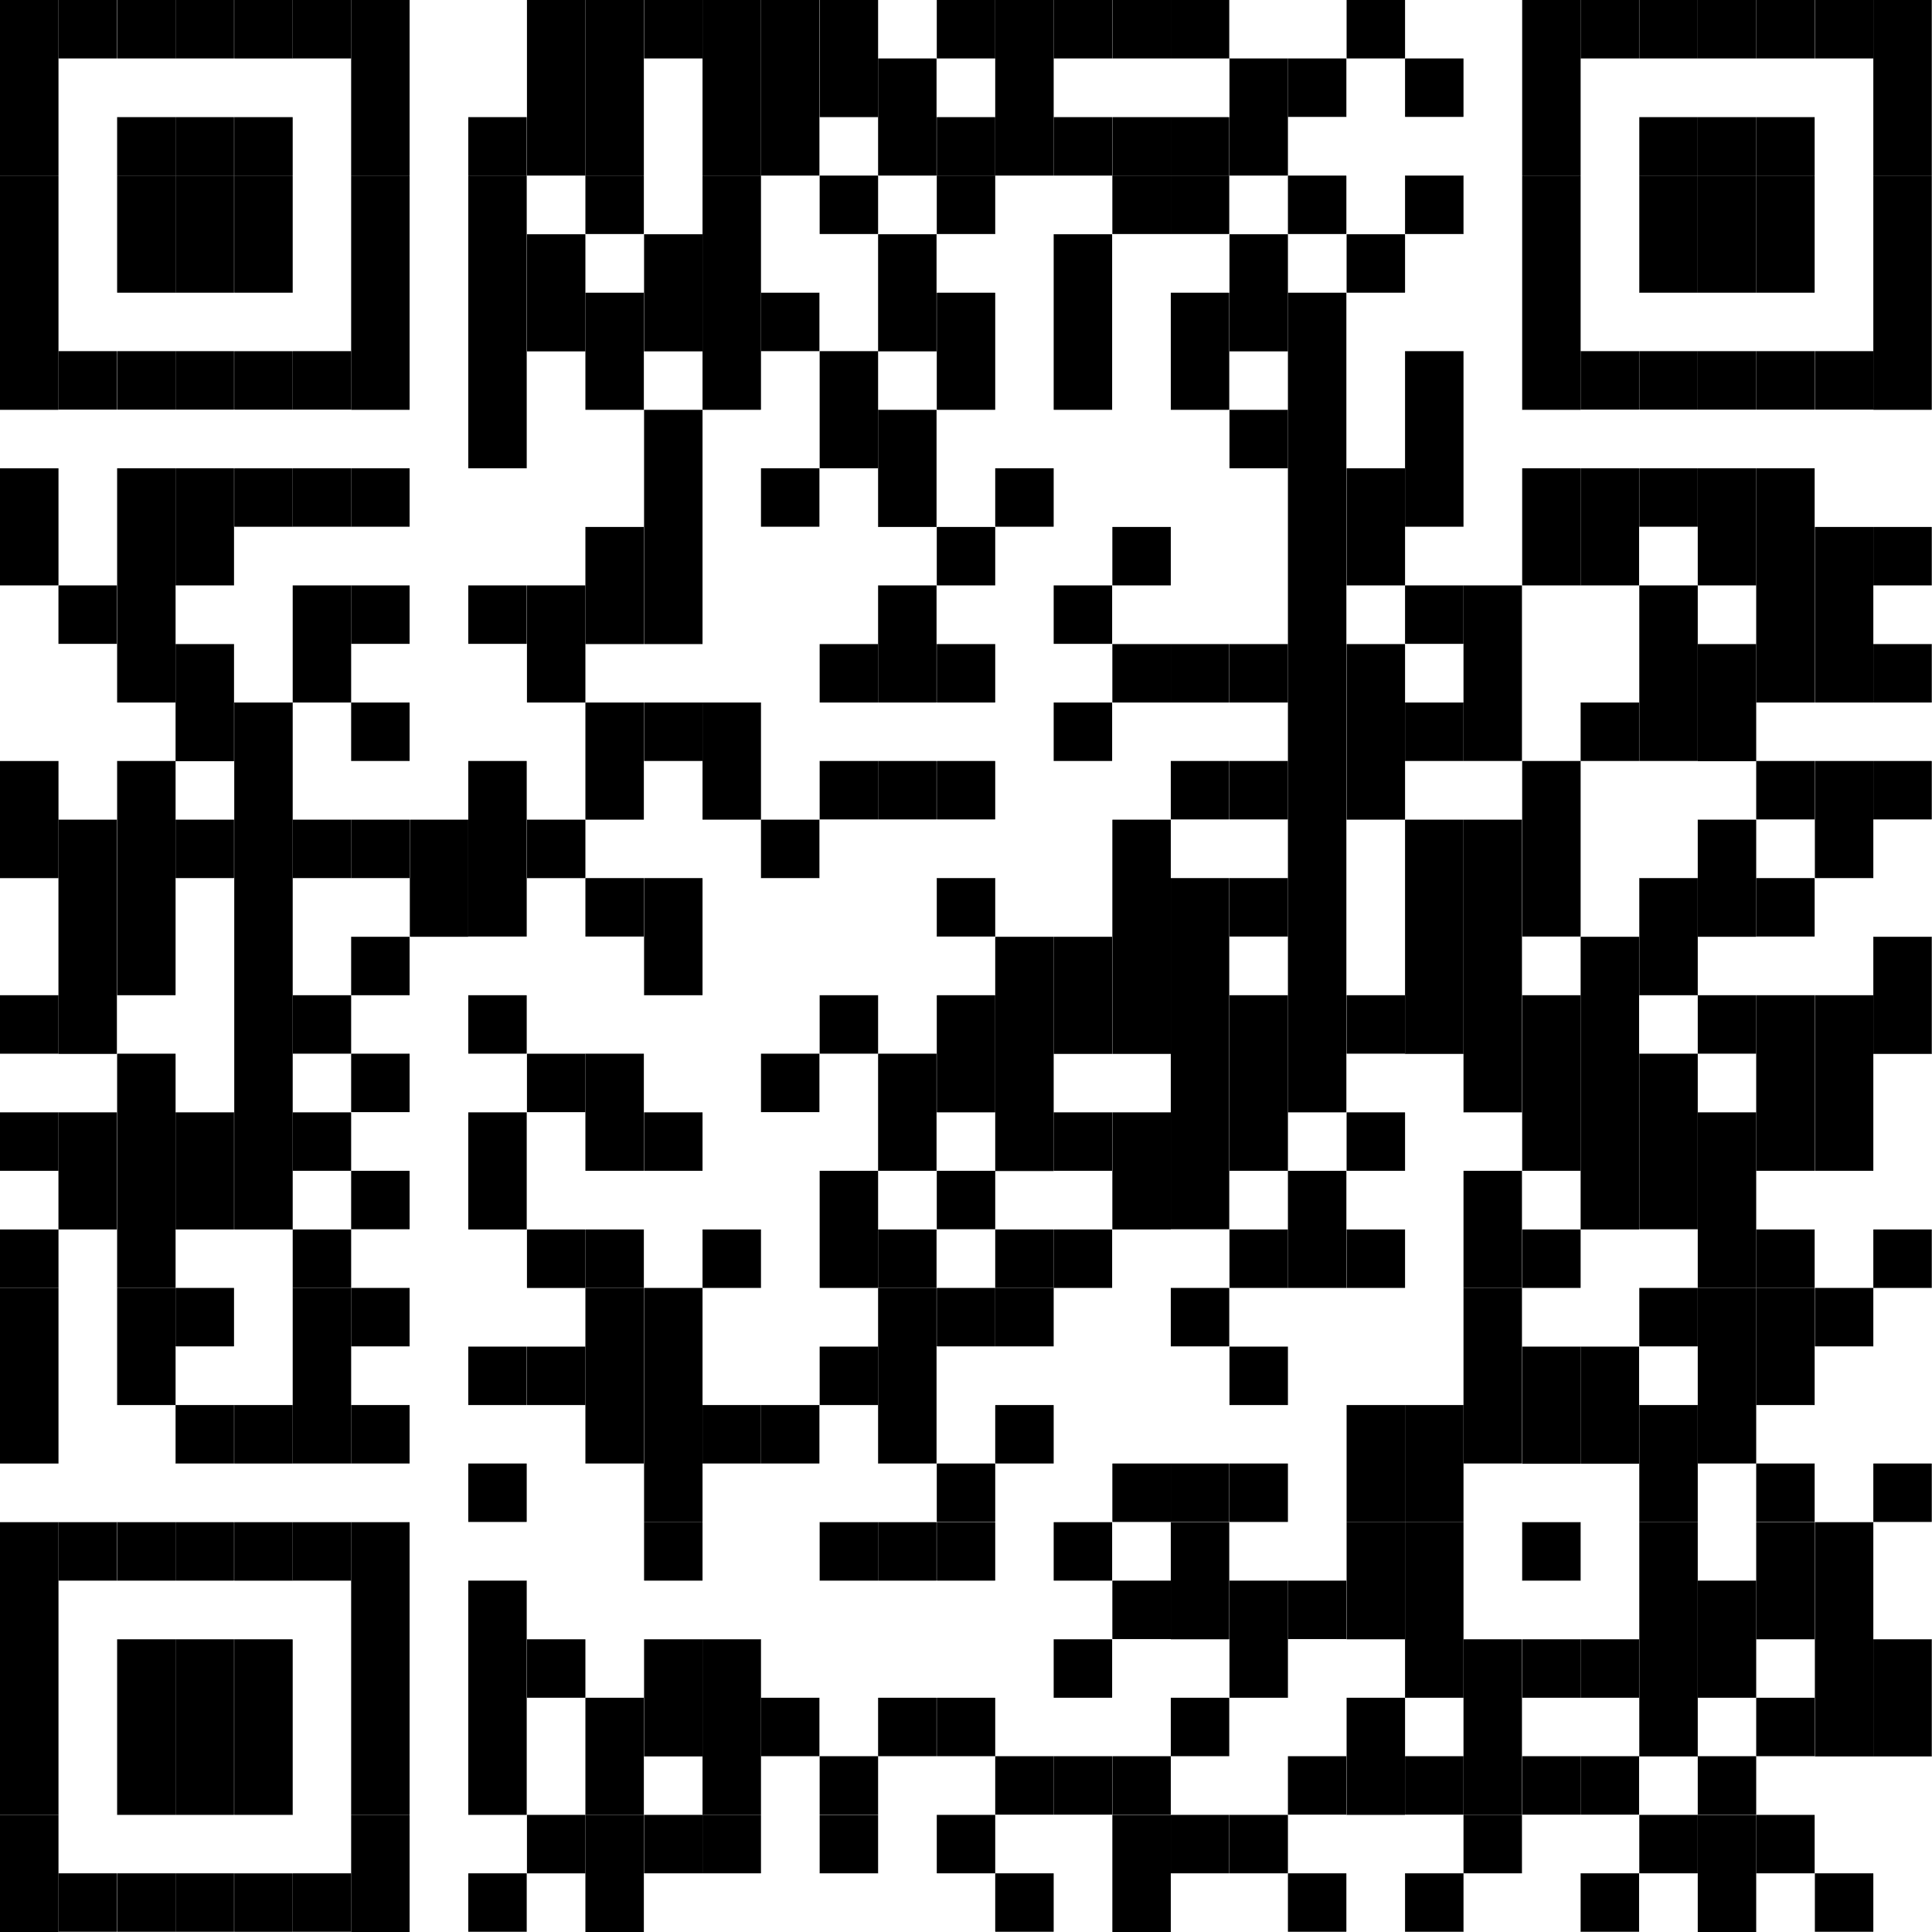 | APPLY NOW!  Scan the QR code for more information

