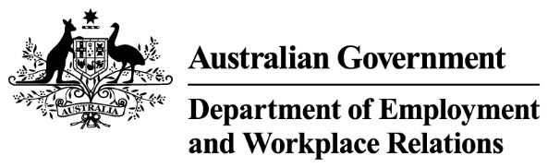
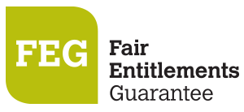
How do I access FEG IP Online Services
FEG IP Online is the system that the Department of Employment and Workplace Relations and insolvency practitioners use to exchange information relating to claims for assistance under the Fair Entitlements Guarantee (FEG) scheme. (https://fegiponline.dewr.gov.au/).

Accessing the portal
1. | Users accessing this portal for the first time from 21 May 2025, will need to create a new Azure B2C account using the email address issued to them by their System administrator. | Open the FEG IP Online portal (https://fegiponline.dewr.gov.au/) and click on the Continue button.
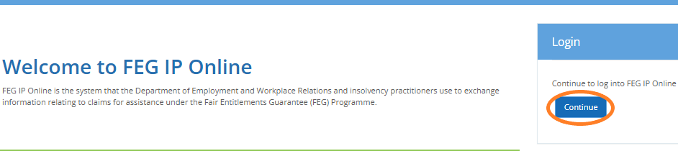
2. | Click Sign up now to begin the registration process. | 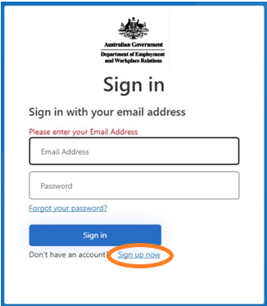

3. | Accurately complete all fields and then click Send verification code. Discuss with your System Administrator which email address you will use to register.
4. | Once your registration is successful a verification code will be emailed to your nominated email address. | 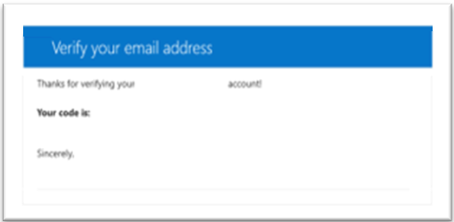

NOTE: Your registration email address is a unique identifier which your online services account is registered under. Once you have created an FEG IP online services registration using a particular email address, no one else can use the same email address to register for FEG IP Online Services.
5. | Enter the verification code contained in the email and click Verify code. | 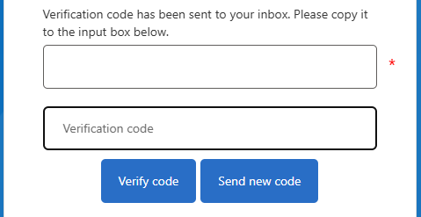

6. | Accurately complete all fields and then click Create. Your password must contain:  - 8-16 characters,  - Contain 3 out of the 4 following:  - lowercase characters  - uppercase characters  - digits (0-9)  - one or more of the following symbols:  @ # $ % ^ & * - _ + = [ ] { } | \ : ' , ? / ` ~ " ( ) ; |  | 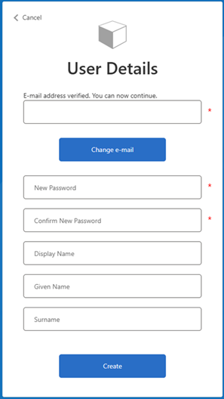
7.  8. | Download your preferred multi-factor authentication application* from your App store. Scan the QR code with your nominated multi-factor authentication application on your smart device. You will be required to enter the one time verification code displayed on your smart device.  * Examples of a multi-factor authentication application are:  - Microsoft Authenticator  - Google Authenticator  - Duo Mobile  - Authenticator App  - Okta Verify  Once you have successfully linked your smart device, you will be redirected to the firm Dashboard or Profile selection if attached to multiple profiles.  Note. If you see a message saying there is no account matched please contact your system adminsistrator to have your account created or updated. |  | (sample only)  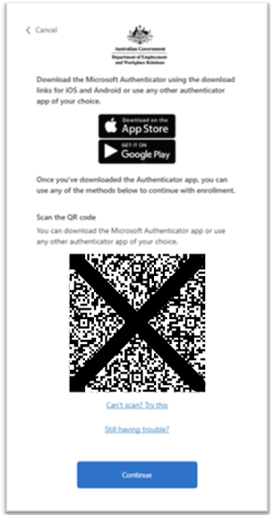
For further assistance with setting up your Azure account see the FEG Frequently Asked Questions or contact your System Administrator.

Further information about FEG is also available on the FEG website (https://www.dewr.gov.au/fair-entitlements-guarantee/).

