


Complaints service
  - 31 October 2024 – 30 April 2025

Acknowledgement of Country
The Department of Employment and Workplace Relations acknowledges the traditional owners and custodians of Country throughout Australia and their continuing connection to land, waters and community. We pay our respects to them and their cultures, and Elders past, present and emerging. We extend that respect to the First Nations peoples who have so generously shared their wisdom, time, knowledge and lived experience with us in developing this service.
With the exception of the Commonwealth Coat of Arms, the Department’s logo, any material protected by a trade mark and where otherwise noted all material presented in this document is provided under a Creative Commons Attribution 4.0 International https://creativecommons.org/licenses/by/4.0/) licence.
The details of the relevant licence conditions are available on the Creative Commons website (accessible using the links provided) as is the full legal code for the CC BY 4.0 International (https://creativecommons.org/licenses/by/4.0/legalcode)
The document must be attributed as the Complaints service report.

Contact us
For enquiries about the licence and use of this report, email the Complaints Resolution Branch at complaintsfeedback@dewr.gov.au.
If you would like to make a complaint or obtain further information about the complaints service, contact us:
- online via https://www.dewr.gov.au/complaints
- by phone at 1800 805 260 (toll free from landlines)
- in writing at: The NCSL Manager
Department of Employment and Workplace Relations
GPO Box 9828
Canberra ACT 2601

Reader’s guide
This report provides information on complaints about employment services and pre-employment services received by the Department of Employment and Workplace Relations (the department) between 31 October 2024 and 30 April 2025.
This report only relates to programs managed by the department. Complaints relating to other programs, including Disability Employment Services (replaced by Inclusive Employment Australia from 1 November 2025) managed by the Department of Social Service and the Community Development Program managed by the National Indigenous Australians Agency, are not included in this report as they are the responsibility of another agency.

Part 1: Chief Complaints Officer
This part contains a letter from the Chief Complaints Officer introducing this report and explaining the performance of the complaints service since its establishment on 31 October 2024.
Part 2: Consultation on service design
This part summarises our consultation with the public and stakeholders about the design of the new complaints service. It lists themes from responses to our discussion paper and describes how we have responded.
Part 3: Complaints service overview
This part provides a high-level overview of how the complaints service works. It includes our purpose and aim, how we are organised within the department, and who we answer to. It also provides information about the complaints handling process.
Part 4: Complaints received
This part provides information about the complaints we received about employment and pre-employment services, including demographic information about the people who made a complaint.
Part 5: Outcomes and themes in complaints
This part explores the different ways that complaints were addressed and the key themes in complaints received about employment and pre-employment services.
Part 6: What’s next
This part summarises what we do with the complaints we receive, and what we intend to do next.
Part 7: Appendices
This part includes some background information about the data used in this report, as well as a glossary of key terms.

Contents
Acknowledgement of Country 2
Contact us 3
Reader’s guide 4
Key statistics 7
Chief Complaints Officer 8
Consultation on service design 9
Complaints service overview 11
Our aim 11
Our principles 11
Our structure 11
Our complaints process 12
How complaints are received 13
How complaints are recorded 14
Complaint handling timeframes 15
Complaint reviews 16
Complaints received 17
Who made a complaint? 17
Gender 18
Cohorts 19
Age group 20
Time in employment services 21
Program 22
All complaints 23
Complaints by program 25
Workforce Australia Services 25
Workforce Australia Online 27
Transition to Work 29
Parent Pathways 31
Other complaints 33
Outcomes and themes in complaints 35
Complaint outcomes 35
Complaint supported 36
Complaint unsupported 37
Information provided 37
Complaint withdrawn 37
Themes in complaints 38
Service satisfaction 39
Mutual obligations and compliance 39
Behaviour 40
Funding 40
Transfers, referrals and eligibility 40
System satisfaction 40
Complaints process 40
Referred to another organisation 41
Privacy 41
What’s next 42
Appendices 43
Appendix A: Data used in this report 43
Appendix B: Complaints received on 31 October 2024 44
Appendix C: Glossary of key terms 45
Abbreviations and acronyms 45
Glossary 45

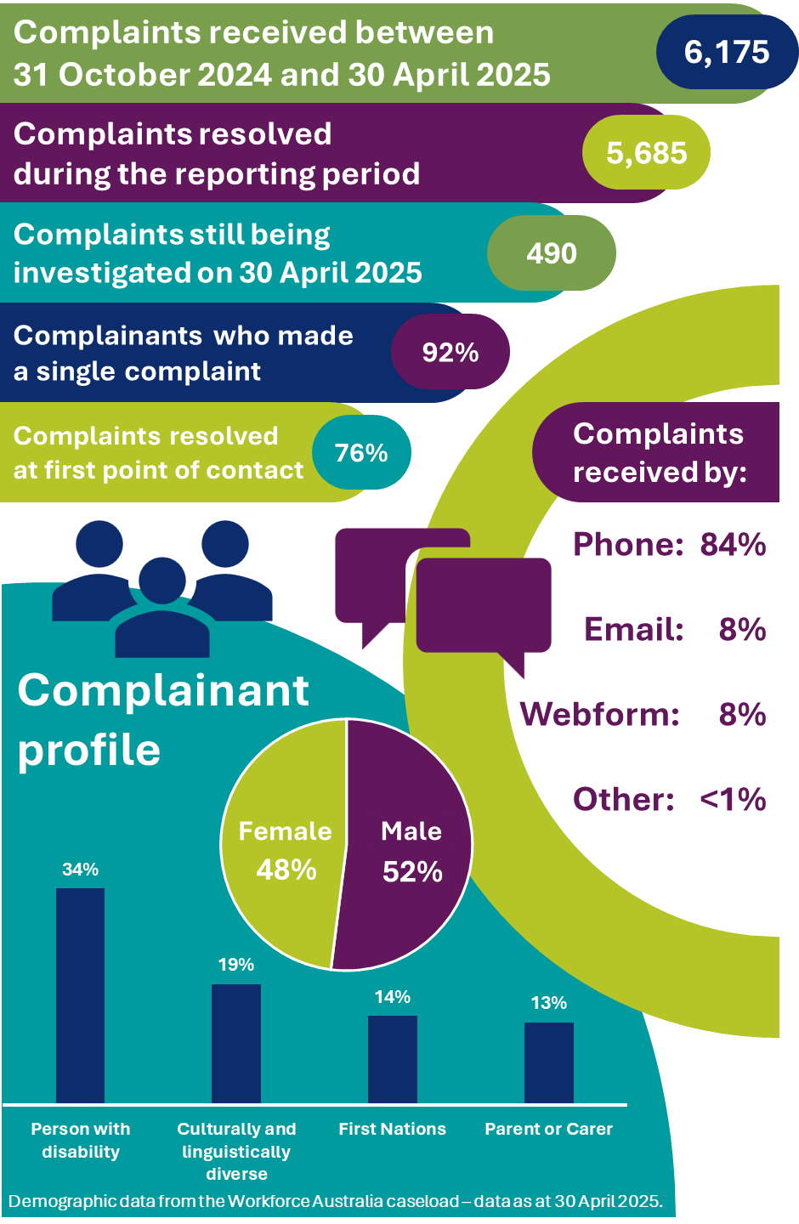
Key statistics
An infographic presenting key statistics from the complaints service, including:
- 6175 complaints received between 30 October 2025 and 30 April 2025
- 5685 complaints resolved during the reporting period
- 490 complaints still being investigated on 30 April 2025
- 92% of complainants made a single complaint
- 76% of complaints resolved at first point of contact.
The infographic provides a profile of complainants, with demographic data taken from th Workforce Australia caseload as at 30 April 2025. Complainant demographics include:
- 48% female and 52% male
- 34% person with disability
- 19% culturally and linguistically diverse
- 14% First Nations
- 13% Parent or Carer.
The infographic breaks down the proportion of complaints received by various channels, including:
- 84% by phone
- 8% by email
- 8% by webform
- Less than 1% by other means.

Chief Complaints Officer
I am pleased to share the inaugural report on the new complaints service for employment and pre-employment services in Australia. The complaints service was established in response to the House Select Committee on Workforce Australia Employment Services reports: Your Future Planning and Rebuilding Employment Services.
The complaints service has been designed to embed a user-centred approach to complaints handling. It is focused on creating an accessible, transparent, and responsive process that prioritises the needs of employment service participants. Enhancing individual agency is central to the service. We are committed to offer a complaints process that is fair and to deliver a more streamlined process for complaints to be made to increase support for individuals.
Complaints offer a valuable channel for participants using employment and pre-employment services across the country to share their experiences and concerns. Our focus is enabling our employment services further to facilitate positive outcomes for Australians who are seeking employment, in turn boosting a person’s capacity for social and economic participation into the future.
The insights shared by participants through complaints are essential to help us understand what is working well and what needs improvement so we can continually enhance the services we offer. The first 6 months of data shared in this report will be used to inform enhancements to departmental policy and programs where change may be needed.
Effective and timely handling of complaints is important for all parties to a complaint, including participants and employment services providers. Central to our complaints service is the principle of fairness. We aim to offer a process that deals fairly and professionally with all complaints. We welcome your feedback on how well we deliver against this aim.
As the Chief Complaints Officer, I am committed to helping the people who engage with our employment services system to have trust and confidence that if something doesn’t seem right, they can contact us and we will listen and effectively manage their complaint.
As the complaints service matures I look forward to sharing ongoing improvements. Future enhancements to reporting will present trends over time, volumes of complaints and where certain topics and themes emerge from the data, resolution timeframes and complaints outcomes.
Lisa Schofield
L Schofield
Chief Complaints Officer

Consultation on service design
The department is committed to open, inclusive and genuine consultation with stakeholders, and ensuring a user-centred approach to the complaints service. The initial service design was informed by a range of work, including an environmental scan and desktop research on comparable complaints services, engagement with other agencies with subject matter expertise, conversations with social services advocacy groups, user testing of our new complaints webform and feedback from employment services providers and peak bodies.
In December 2024, we published a discussion paper inviting feedback on the new complaints service. The aim of seeking feedback was to help continuously improve the services we currently provide and to create a new complaints service that meets the needs and expectations of all people who connect with employment and pre-employment services.
Submissions on the discussion paper closed on 7 February 2025. We received 11 submissions to the consultation from the following categories of respondents, noting that some respondents are members of multiple categories: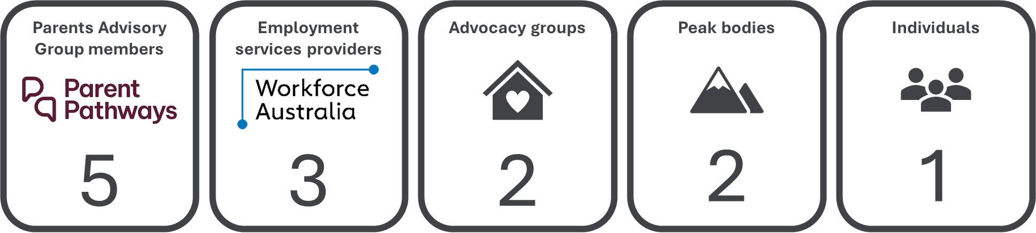
Respondents gave feedback on a range of topics related to the complaints service, and on some areas outside the scope of the service. Feedback about other areas of the department has been provided to the relevant teams.
Reporting on complaints data
Most suggestions received were about how the department should report on complaints data. Some respondents proposed that the complaints service should publish an annual report, while others suggested a report every 3 months to align with other public data releases made by the department. The government has committed to routine public reporting to provide transparency around complaint numbers and user experience, with complaints data to inform how services are assessed and rated.
Respondents expressed interest in a range of complaints data to help identify where issues occurred – especially where issues were the responsibility of the department or of providers – and to inform participants’ choice of provider. This report is the first public release of complaints data, which will be built on as the complaints service matures.
Communicating about the complaints service
Respondents said it is important that all parties to a complaint understand how the complaints process works and how long each step in the process takes. This means developing information in appropriate formats for complainants, employment services providers, the public, and other community stakeholders.
Many suggestions relating to communication were about employment services providers. A key area of interest was how the department has communicated the launch of the new complaints service and the way the current system works to providers. Respondents also made a few suggestions about how the service should be communicated to the public, such as publishing more information and providing more resources on the complaints process for different audiences.
Enhancing service design
Most respondents made suggestions about how the department could enhance the design of the complaints service and complaint handling processes. Respondents made a range of suggestions for small changes to processes that would lead to a better user experience for complainants. Other proposals in this category included improving cooperation between government agencies to ensure that there was ‘No Wrong Door’ for complaints, and that information, processes and complaints handling best practices were appropriately shared across relevant departments and agencies.
A key area of interest in service design improvement was finding ways to seek out and make use of real-time data from complaints service users, but also from people who contacted the department with general feedback or compliments. There was keen interest that the department commit to use this information to inform continuous improvement of the complaints service itself, and the broader employment services system.
Improving service accessibility
Respondents said that the complaints service should be widely accessible and easy to use. Suggestions to make the service more accessible included providing information in a range of formats, and more ways to submit complaints and feedback through different channels that accounted for different levels of access, literacy and understanding. The launch of the complaints service webform is one way the department has recognised different accessibility needs among complainants.
Another key suggestion in this category was to consider a more flexible approach to anonymity in complaints, that included the option to be identifiable to the department but not the target of a complaint. This would allow complainants to receive updates on a complaint, while ensuring they feel safe in bringing their concerns forward.
Building a user-centred service with a healthy complaints culture
Many suggestions were about how the service could continue to build on its user-centred design to ensure there is a healthy complaints culture within the department. Respondents encouraged the department to embed a culture of feedback that goes beyond individual provider performance but also puts people’s lived experiences at the centre and informs how the employment services system is improved.
Respondents encouraged the complaints service to support a healthy complaints culture and user-centred design by making appropriate resources, training and support available for complaints officers and other parties to complaints – such as employment services providers. Other key suggestions were to ensure the workload of a complaint did not rest unfairly on a complainant, and that there would be equal access, and the same level of empathy and respect, provided to all people who engaged with the service.
As part of a healthy complaints culture, we regularly consult with stakeholders and users to ensure the complaints service is continuously improved.

Complaints service overview

Our aim
We aim to deliver a complaints service that is accessible and considers the needs of complainants, including those who experience a vulnerability, and that handles complaints impartially, confidentially and with empathy.

Our principles
We are committed to deliver a complaints service that is:
- Fair – focused on achieving fair outcomes for each complaint. We’ll handle each complaint fairly, confidentially, and with respect for all parties involved.
- Accessible – easy for you to make a complaint. You can make a complaint online, by email, over the phone or by letter.
- Efficient – prompt in addressing your complaint and communicating proactively with you. We’ll let you know if we need more time or if there is a delay.
- Transparent – open and honest with you about your complaint. We’ll keep you informed at each stage of the complaints process and explain the outcome of your complaint, including any findings that we make.

Our structure
The complaints service is part of the department’s Employment and Workforce Group, which is responsible for employment and pre-employment services.
The complaints service is overseen by the Chief Complaints Officer – a senior departmental official who is independent of program delivery and contract management. The Chief Complaints Officer is the final decision-maker on complaints received by the service.
The service has staff in the National Customer Service Line (NCSL) who receive, assess and action less serious complaints, and a separate complaints management team reporting to the Chief Complaints Officer who investigate more serious, sensitive or complex complaints.

Our complaints process
We consider a complaint to be when a person tells us they are dissatisfied with something about employment or pre-employment services and they would like, or are entitled to, a response. Complaints can be simple – about a single issue – or can be more complex and raise multiple issues at the same time.
When we receive a complaint, we work to understand what happened and if something different should have happened. Our complaints process has several key steps (see Figure 1 below).
1
Receiving a complaint: We receive most complaints by phone call to our NCSL, however we also receive complaints through our online complaints form, email and post, and from Members of Parliament on behalf of constituents.
2
Assessing the complaint: When we receive a complaint, we assess it to make sure that we are the right people to respond. If someone else should respond, we help the complainant get in contact with them. If we are the right people to respond, we assign a complaints officer to address the complaint, where we can’t provide a solution at the first point of contact.
3
Helping to find a solution early: If we can, we try to address a complaint at the first point of contact or as soon as possible after we receive more information that helps us understand the complaint. Sometimes we can help address an issue early by providing more information to a complainant about a process or policy, or by facilitating a transfer to a new employment services provider.
4
Investigating the complaint: If we can’t find a solution early, we investigate the complaint. We may need to ask for more information from the complainant, another party to the complaint like an employment services provider, or another team in the department. More complex or sensitive complaints may take longer to investigate.
5
Communicating the outcome: We tell the complainant and other parties to a complaint about the outcome in writing. We also provide information about a complainant’s right to request a review of the handling of the complaint if they aren’t satisfied with the outcome.
Figure 1: Our complaints process
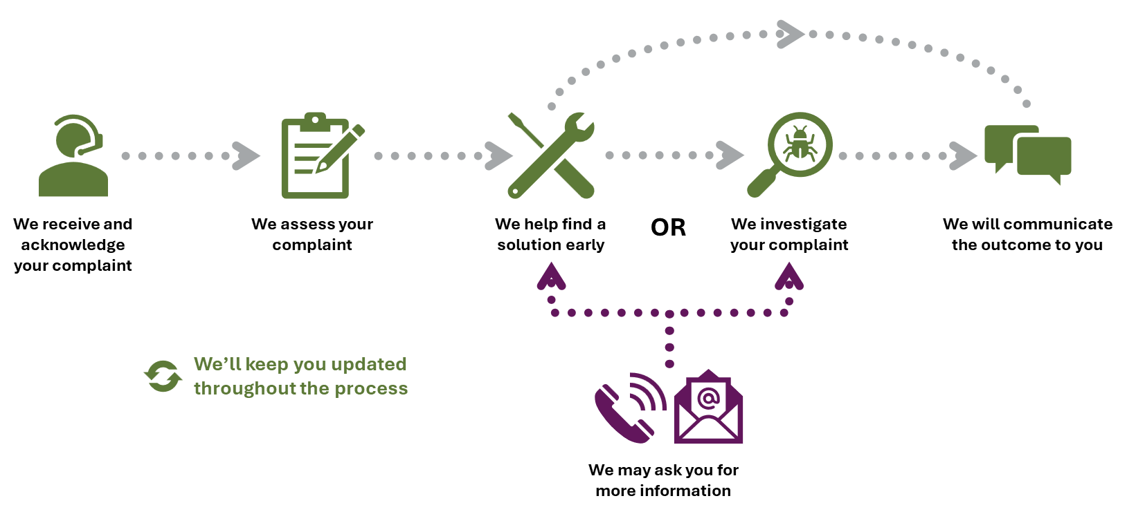

How complaints are received
More than four-fifths of the complaints received were by phone call to the NCSL. Contact by phone call is our most common complaint channel and means that most complaints are addressed quickly, at the first point of contact.
The rest of the complaints received were by the following channels:
- 8% were received through our webform
- 8% were received by email
- <1% were received by mail
- <1% were received from a Minister’s Office on behalf of a constituent or other department
- <1% were received from other sources.
Figure 2: Complaint receipt methods
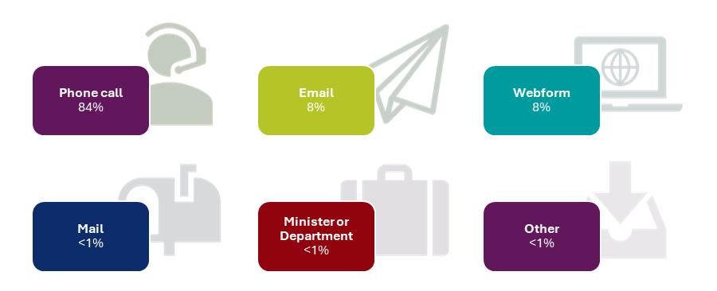

How complaints are recorded
When we receive a complaint, we capture information in our system to help us understand what might need to change or what could be done better to address the complaint.
As we work to address a complaint, we keep track of:
- details about the complaint, including:
  - who made it and who else was involved
  - what it was about
  - when and where did it happen
  - why the complainant is dissatisfied.
- what outcome the complainant is seeking
- each time we contact someone about the complaint
- what actions we took because of the complaint.
We use this information, which we call complaints data, to understand what about the employment services system people aren’t satisfied with and who we need to inform.
We also use complaints data to understand who is best placed to address a complaint.
Where employment services providers are found to be in breach of their contractual responsibilities, the department will take action in accordance with the Deed and guidelines.
A note on complaints data
To protect individuals' privacy, the numbers presented in this report have been rounded to the nearest 5 and proportions have been rounded to the nearest whole number. This may result in non-additivity for some totals. Zeros are actual zeros.
Appendix A: Data used in this report Appendix A: Data used in this report provides more information about the data confidentiality procedures used in this report and our data revisions policy.

Complaint handling timeframes
The Commonwealth Ombudsman’s Better Practice Complaint Handling Guide (the Guide) suggests establishing benchmarks for timeliness to mitigate the risk of unnecessary delay in complaint handling.
The Guide does not establish specific timeliness benchmarks but instead recommends they ‘should be efficient but allow sufficient time for complaints to be handled properly’, and that ‘agency data will help establish and refine the most appropriate benchmarks.’
The following suggested benchmarks in the Guide provide a helpful framework:
- acknowledgement
- simple complaint resolution
- urgent and priority complaint resolution
- complex and sensitive complaint resolution
- notify complainant of a delay.
Over the next 12 months, we will be developing appropriate benchmarks in consultation with complaints service users and stakeholders, and in consideration of the complaints data we have collected since the launch of the service.
We will incorporate timeliness benchmarks in line with the Guide in future public reporting.

Complaint reviews
Once a complaint has been resolved and all parties are informed of the outcome, if the complainant is not satisfied, they can ask for a review of the way the complaint was handled.
The complainant will be asked what they disagree with, why they think the complaint has not been resolved, and for any additional information they have to support the review.
Figure 3 below shows the different review pathways available to complainants if they are not satisfied with the outcome of a complaint. The department may also undertake reviews of some decisions, including administrative decisions, without a request being made by a complainant.
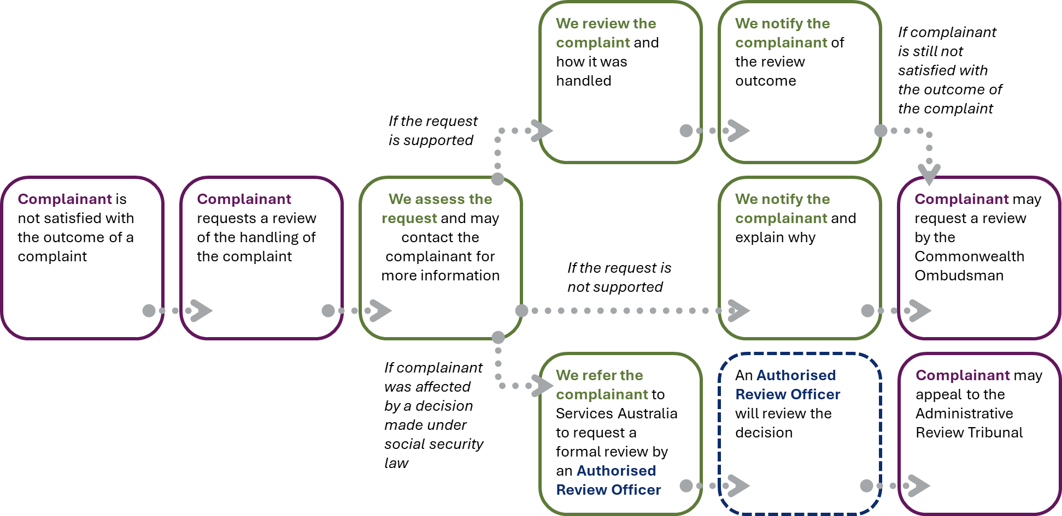
Figure 3: Complainant review request pathways
We assess each request for a review and may contact complainants for more information.
If we decide – based on the information we have – that we will not review a complaint, we notify the complainant and let them know why we have made that decision.
If we decide to review a complaint, we notify the complainant and let them know the outcome. After the review, we might recommend a different outcome or agree that the original outcome was correct.
If we have reviewed our handling of a complaint, or decided that we will not conduct a review, and the complainant is still not satisfied with the outcome, they can contact the Commonwealth Ombudsman.
The Commonwealth Ombudsman can investigate complaints about the actions and decisions of Australian Government agencies and can seek remedies for people.
If we find that the complainant was affected by a decision made under the social security law, we cannot review the complaint. Instead, the department will refer the complainant to Services Australia to request a formal review.
If the complainant is unsatisfied with the outcome of a formal review, conducted by an Authorised Review Officer, they can appeal the decision to the Administrative Review Tribunal.

Complaints received

Who made a complaint?
Most people who made a complaint (98%) were participants in an employment or pre-employment services program. Among the remaining complaints, a small number were made by employers (1%), people who chose to remain anonymous (1%) and other individuals (<1%), including members of the public and representatives from community organisations.
Because most of the complaints we received were from employment services participants, we can compare the characteristics of the group of complainants who told us their Job Seeker ID to the characteristics of the Workforce Australia caseload to see if there are any similarities or differences between people who made a complaint and people participating in employment services.
Examining complaints by characteristics, like gender or age group, can indicate whether some groups of people experienced more issues with employment services than others because of a shared characteristic.
Comparing caseloads to complaints
It is important to note when interpreting the data shown in this section (pp. 17–22) that caseload percentages are the percentage of the people on the caseload at the end of the reporting period (point in time). Complaint percentages are the percentage of complaints received over the full 6-month reporting period.

Gender
The Workforce Australia caseload and group of complainants had similar proportions of individuals by gender, as shown in Figure 4 below.
Figure 4: Comparison of Workforce Australia caseload to complaints service by gender
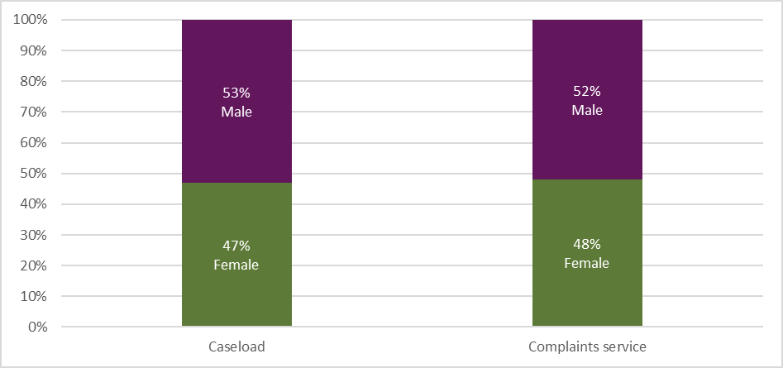Note: Caseload percentages are the percentage of the people on the caseload at the end of the reporting period (point in time). Complaint percentages are the percentage of complaints received over the full 6-month reporting period.

Cohorts
Figure 5 below shows the proportion of individuals on the Workforce Australia caseload who belonged to a specific cohort, compared with the proportion of complainants who belonged to those same cohorts.
People with disability made up a larger proportion of complainants, compared with their proportion of the Workforce Australia caseload.
People who identified as culturally and linguistically diverse, First Nations, or as a parent or carer made up similar proportions compared with their proportions of the Workforce Australia caseload.
Figure 5: Comparison of caseload to complaints service by cohort proportion
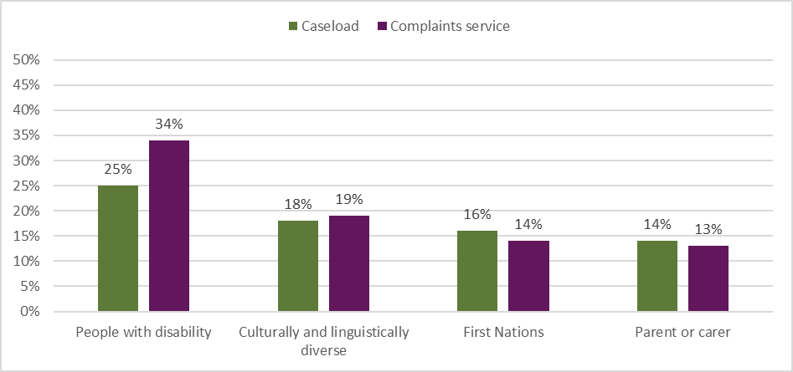 Note: Caseload percentages are the percentage of the people on the caseload at the end of the reporting period (point in time). Complaint percentages are the percentage of complaints received over the full 6-month reporting period. Cohorts are not mutually exclusive; an individual may belong to multiple cohorts.

Age group
Figure 6 below shows the proportion of individuals on the Workforce Australia caseload compared with the proportion of complainants by gender and age group.
In general, the proportions of each age group of complainants and individuals on the Workforce Australia caseload were similar.
Females under the age of 25 years and males under the age of 25 years made up a slightly larger proportion of complainants, compared with their proportions of the Workforce Australia caseload.
Figure 6: Comparison of caseload to complaints service by gender and age-group proportion
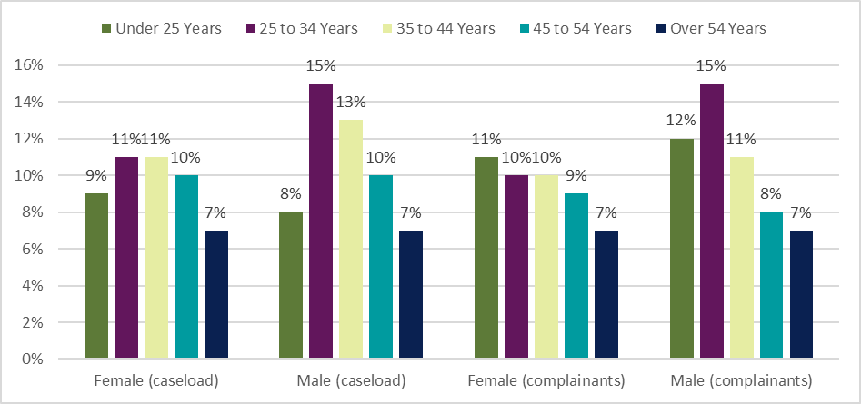 Note: Caseload percentages are the percentage of the people on the caseload at the end of the reporting period (point in time). Complaint percentages are the percentage of complaints received over the full 6-month reporting period.

Time in employment services
Figure 7 below compares the proportion of individuals on the Workforce Australia caseload with the proportion of complainants by the amount of time they have been in employment services.
People who were in employment services for less than 12 months made up a smaller proportion of complainants, compared with their proportion of the Workforce Australia caseload.
People who were in employment services for 12 months or more made up a larger proportion of complainants, compared with their proportion of the Workforce Australia caseload.
Figure 7: Comparison of caseload to complaints service by time-in-service proportion
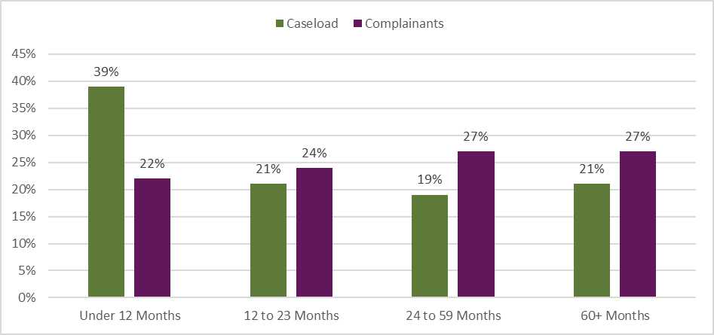 Note: Caseload percentages are the percentage of the people on the caseload at the end of the reporting period (point in time). Complaint percentages are the percentage of complaints received over the full 6-month reporting period.

Program
Figure 8 below compares the proportion of individuals on the Workforce Australia caseload – which includes the Workforce Australia Services, Workforce Australia Online and Transition to Work programs – with the proportion of complainants participating in each program.
People participating in Workforce Australia Services made up a larger proportion of complainants, compared with their proportion of the Workforce Australia caseload.
People participating in Workforce Australia Online and Transition to Work made up smaller proportions of complainants, compared with their proportion of the Workforce Australia caseload.
About one in every hundred Workforce Australia Services participants engaged with the complaints service, compared to just over one in every seven hundred and fifty Workforce Australia Online participants, and just under one in every four hundred Transition to Work participants.
Figure 8: Comparison of caseload program to complainant program by proportion
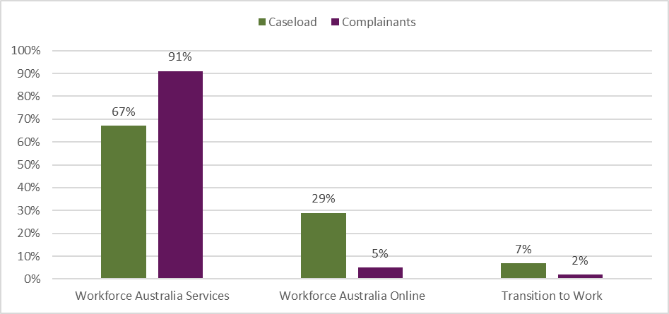Note: Caseload percentages are the percentage of the people on the caseload at the end of the reporting period (point in time). Complaint percentages are the percentage of complaints received over the full 6-month reporting period.

All complaints
Workforce Australia is the Australian Government’s primary employment service, which replaced jobactive from 4 July 2022. Workforce Australia has a range of services available to help all Australians, not just people on income support, to find, keep, change jobs or create their own job.
Individuals who are on income support and have mutual obligations, are referred to an appropriate employment service depending on their individual needs. These include:
- Workforce Australia Services: individuals who require additional support will be connected to a provider who will tailor the support needed
- Workforce Australia Online: supports eligible individuals to access online tools and resources based on their own personal needs
- Transition to Work: helps young people aged 15–24 into work (including apprenticeships and training) or education.
Parents or carers of young children who are not working can volunteer to participate in Parent Pathways. Parent Pathways is a voluntary service that provides personalised assistance and financial support to eligible parents and carers of children up to the age of 6 years.
The complaints service also handles complaints for other Workforce Australia-branded programs, such as Career Transition Assistance, Self-Employment Assistance and Work for the Dole, and stand-alone DEWR programs like Skills for Education and Employment. Complaints relating to these programs managed by the department are reported in the other complaints section below.
Table 1: All complaints received
All programs | 31 Oct 24 – 30 Apr 25
Complaints received | 6,175
Complaints resolved | 5,685
Complaints open at end of reporting period | 490
Most employment services participants who made a complaint submitted a single complaint, however about two out of every twenty-five complainants submitted multiple complaints.
Figure 9: Number of complaints received by month – all programs
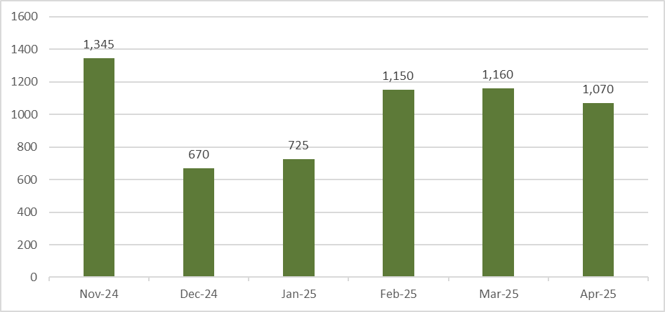Note: Fewer complaints were received in December 2024 and January 2025 due to the holiday period and unplanned system outages that temporarily paused mutual obligation requirements. Note that October 2024 is excluded from graphs in this section – see Appendix A for further information.
How we handled all complaints is reported by proportion in Table 2 below.
When we can address a complaint at the first point of contact, we will. We may address a complaint at the first point of contact by helping a person to transfer to a different employment services provider, or by providing a more detailed explanation of employment services policy and programs.
If we need to contact someone else like an employment services provider or another team in the department, to help us understand why a complaint has been made, we will ask them for information. When we receive a response, we follow up with the complainant to address the complaint.
When a complaint is more urgent or complex in nature, contains serious allegations of misconduct, or a minor is involved, the complaint is referred to a specialist team of complaints officers who are trained to handle complaints of this nature.
Table 2: Complaint handling categories
Category | Proportion of complaints
Addressed at first point of contact | 76%
More information required to resolve complaint | 19%
Referred to specialist complaint management team | 5%

Complaints by program

Workforce Australia Services
Individuals on income support with mutual obligation requirements may be connected to a Workforce Australia Services provider who tailors support to help get them job-ready, and find suitable, secure employment.
Providers guide individuals to manage their participation in the program, including helping them understand how to use the Points Based Activation System to meet their points target and job search requirement each reporting period. Providers can also offer:
- advice based on an individual’s situation and plans for the future
- help accessing study or training opportunities
- help to develop the skills to prepare for, find and keep a job, or to run a business
- access to a range of activities, workshops and work experience opportunities
- help accessing financial support.
In some locations there are specialist providers to deliver personalised services to cohorts including culturally and linguistically diverse (CALD), First Nations people, ex-offenders, and refugees.
The overall proportion of complaints was higher for Workforce Australia Services than other programs, comprising about 85% of all complaints received. This is likely due to the nature of the program, where individuals must interact with a provider regularly, creating more touchpoints for potential dissatisfaction than other programs that have less intensive support, fewer requirements, or that are self-managed or voluntary. Complaints about Workforce Australia Services represented about 1.1% of the caseload, or eleven complaints for every one thousand individuals who were participating in the program.
Table 3: Complaints received about Workforce Australia Services
Workforce Australia Services | 31 Oct 24 – 30 Apr 25
Complaints received | 5,245
Complaints resolved | 4,845
Complaints open at end of reporting period | 400
Table 4: Top 5 themes in complaints about Workforce Australia Services
Theme | Proportion of complaints
Service satisfaction | 79%
Mutual obligations and compliance | 23%
Behaviour | 21%
Funding | 10%
Transfers, referrals and eligibility | 10%
Figure 10: Number of complaints received by month – Workforce Australia Service
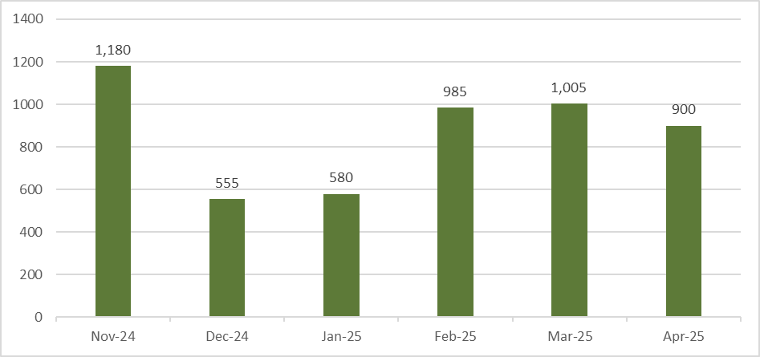

Workforce Australia Online
Individuals who are assessed as being more job-ready are referred to Workforce Australia Online to access tools, information and training to help them manage their mutual obligations and move into secure employment.
Everyone accessing Workforce Australia Online is supported by dedicated staff from the department’s Digital Services Contact Centre (DSCC). The DSCC helps guide participants with:
- information and technical support for all users of the service
- assistance to tailor their points target and manage their mutual obligation requirements to better reflect their personal circumstances
- access to education and training and other supports
- access to the Digital Employment Fund, to get certain items to find and start a job, or to move for a new job.
Importantly, individuals using online servicing can choose to move to a provider for additional support at any time and for any reason.
Complaints about Workforce Australia Online represented about 0.2% of the caseload, or around one complaint for every five hundred individuals who were participating in the program.
Table 5: Complaints received about Workforce Australia Online
Workforce Australia Online | 31 Oct 24 – 30 Apr 25
Complaints received | 435
Complaints resolved | 400
Complaints open at end of reporting period | 35
Table 6: Top 5 themes in complaints about Workforce Australia Online
Theme | Proportion of complaints
Service satisfaction | 42%
Mutual obligations and compliance | 27%
System satisfaction | 16%
Transfers, referrals and eligibility | 14%
Behaviour | 12%
Figure 11: Number of complaints received by month – Workforce Australia Online
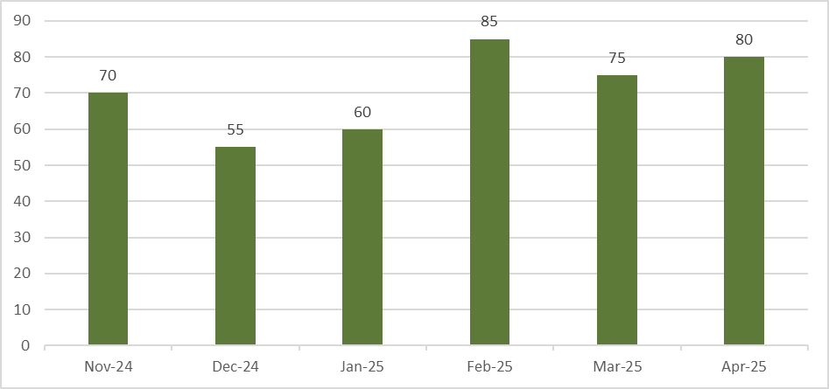

Transition to Work
Transition to Work helps young people aged 15–24 into work (including apprenticeships and training) or education. Transition to Work participants receive intensive, pre-employment support to develop practical skills to get a job, connect with education or training, find local job opportunities and connect with relevant local community services.
Complaints about Transition to Work represented about 0.2% of the caseload, or around one complaint for every five hundred individuals who were participating in the program.
Table 7: Complaints received about Transition to Work
Transition to Work | 31 Oct 24 – 30 Apr 25
Complaints received | 95
Complaints resolved | 90
Complaints open at end of reporting period | 5
Table 8: Top 5 themes in complaints about Transition to Work
Theme | Proportion of complaints
Service satisfaction | 84%
Behaviour | 21%
Transfers, referrals and eligibility | 21%
Mutual obligations and compliance | 11%
Funding | 11%
Figure 12: Number of complaints received by month – Transition to Work
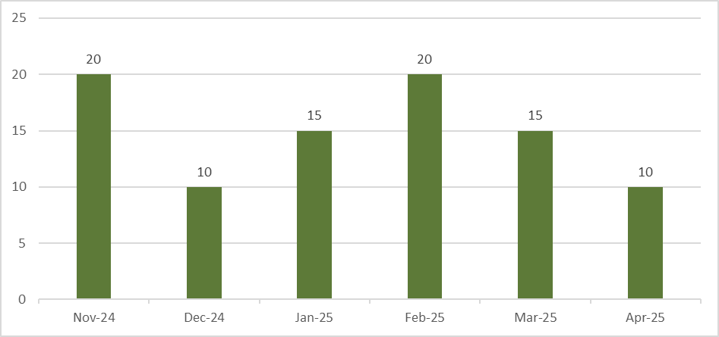

Parent Pathways
Parent Pathways is a voluntary service that provides personalised assistance and financial support to eligible parents and carers of children up to the age of 6 years.
Parent Pathways is about parents and carers and their individual needs. With the help of a qualified mentor, participants can receive flexible support to assist with any study or work goals.
Complaints about Parent Pathways represented about 0.3% of the caseload, or just over one complaint for every three hundred individuals who were participating in the service.
Table 9: Complaints received about Parent Pathways
Parent Pathways (including ParentsNext) | 31 Oct 24 – 30 Apr 25
Complaints received | 55
Complaints resolved | 45
Complaints open at end of reporting period | 10
Table 10: Top 2 themes in complaints about Parent Pathways
Theme | Proportion of complaints
Service satisfaction | 73%
Funding | 45%
Figure 13: Number of complaints received by month – Parent Pathways
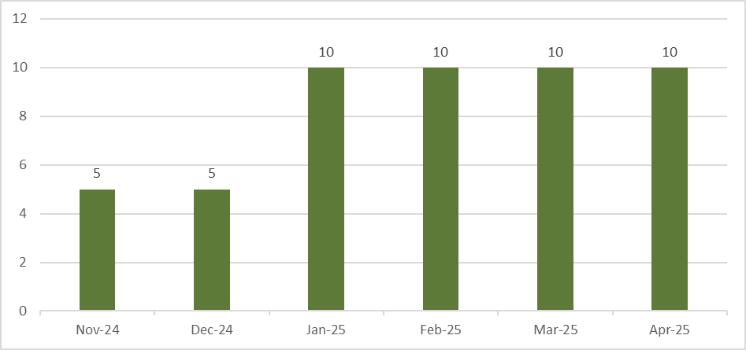

Other complaints
We track complaints separately for several smaller programs, including Career Transition Assistance, Self-Employment Assistance and Work for the Dole. These programs are Workforce Australia branded programs but have policy settings that mean participants may have a different experience of employment services. We also receive some complaints for stand-alone programs managed by the department, like Skills for Education and Employment. Due to the small number of complaints about these programs, they are reported together in this section.
Complaints about the Workforce Australia website, smartphone app, and other things related to employment services but not connected to a specific program are also reported in this section as other complaints.
Table 11: Other complaints received
Other complaints | 31 Oct 24 – 30 Apr 25
Complaints received | 345
Complaints resolved | 315
Complaints open at end of reporting period | 30
Table 12: Top 5 themes in other complaints
Theme | Proportion of complaints
Service satisfaction | 53%
Mutual obligations and compliance | 16%
Behaviour | 14%
System satisfaction | 14%
Transfers, referrals and eligibility | 12%
Figure 14: Number of complaints received by month – other complaints
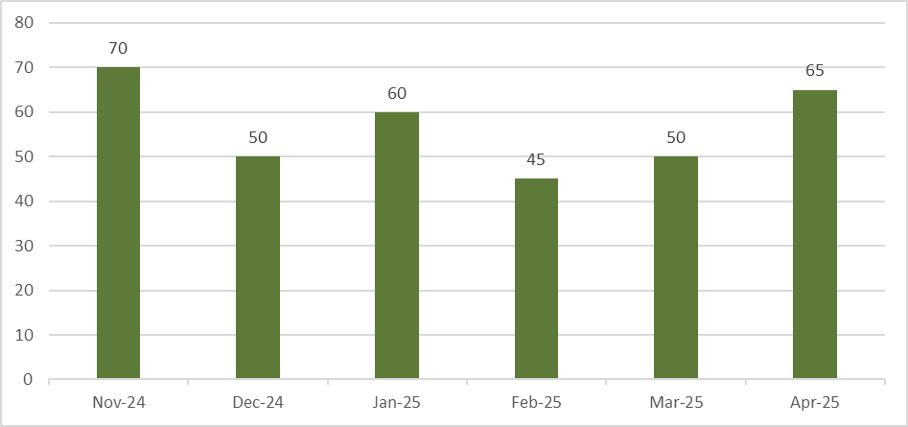

Outcomes and themes in complaints

Complaint outcomes
Since the launch of the new complaint service, complaint outcomes have been progressively implemented in the complaints information system. Outcomes explain how a complaint was resolved for the complainant, including whether evidence was provided to support a complaint or not.
An outcome is recorded when a complaint is finalised. As noted in the ‘Our complaints process’ section, a single complaint can raise multiple issues. Because of this, more than one outcome may be captured when the case is resolved. Outcomes are reported as proportions because there’s not always a one-to-one relationship between a single complaint case and a single outcome.
Outcomes that can be assigned are:
- supported – when action is taken to change something for a complainant, including where evidence is provided or found supporting a complaint.
- unsupported – when evidence is not provided or found supporting a complaint at the time, noting that action may still be taken in response to the content of the complaint.
- information provided – when the complainant is given more information to help them understand employment services policy or program settings, addressing the complaint.
- complaint withdrawn – when the complainant asks us to stop progressing a complaint.
At the end of our first reporting period, just under a third of resolved complaints were assigned at least one outcome. Now that complaint outcomes are fully implemented in the complaints system, outcomes will be included for all complaints received in future reporting periods.
In employment and pre-employment services, if a participant feels like they are not getting the right help from their current provider, they can choose to transfer to a new provider. When a participant is supported by the complaints service to transfer to a new provider, this is recorded as a complaint because it represents dissatisfaction with their current servicing arrangement. It should be noted that a participant transferring to a new provider cannot be assumed to mean their original provider was doing something wrong, but that the service was not the right fit for that individual.
Complaints that are resolved without requiring a response from a provider are handled by the complaints service directly.
Table 13: Complaint outcomes by proportion of resolved complaints with an outcome
Complaint outcomes | Proportion of complaints
Supported | 60%
Unsupported | 22%
Information provided | 23%
Complaint Withdrawn | 1%
Interpreting data on complaint outcomes
The proportions reported in this section may add up to more than 100%. This is because complaints can be assigned multiple outcomes, which means a single complaint may be counted in more than one outcome category.
For example, a person might call the NCSL to make a complaint. During the call, they say they believe their mutual obligation requirements aren’t tailored to their circumstances. They also mention dissatisfaction with the response they received when they contacted their provider to discuss their concern.
The complaints officer handling the complaint might assign an ‘information provided’ outcome if they explain mutual obligation policy to help the complainant understand their requirements, and a ‘supported’ outcome if the provider apologises for the complainant’s earlier unsatisfactory experience. In this example, the single complaint would be counted in 2 separate outcome categories.
Complaints data are treated for confidentiality to uphold the department’s legal obligation to keep personal information protected. Appendix A provides more information about the data confidentiality procedures used in this report.

Complaint supported
Among resolved complaints with an outcome assigned, three in five were ‘supported’. This means there was some evidence to support the complaint being made, or there was something for the department or a provider to change or fix.
When the complaints service receives a complaint that requires input or action from a provider, this is sent to the provider to consider and respond to, including informing the department of any actions they have taken to address the complaint. When the complainant is informed of the outcome of the complaint, the provider is also informed that the complaint is closed.
Almost nine in ten supported outcomes were resolved with a transfer to another provider, an opt-out from a service, or referral to a more appropriate service. This means that a complainant was unsatisfied with the service they were receiving or not receiving the appropriate service, and the complaints service helped them to find a different provider, exit from a service, or find a more appropriate service.
About one in every fifty complaints with a supported outcome related to a decision made by a provider that did not comply with the Deed or guidelines of the relevant service. In these cases, the decision was changed or a recommendation made to vary the decision, such as approving a payment or activity. These decisions are also referred to the relevant part of the department for further consideration and action where necessary.
The department is developing processes to enable monitoring of outcomes into the future to identify and action systemic issues identified through complaints.

Complaint unsupported
Among resolved complaints with an outcome assigned, just over a fifth had an ‘unsupported’ outcome. This means evidence was not provided to support a complaint, a transfer or opt-out could not be actioned at that time, or the complainant could not be contacted for more information.
More than half of unsupported outcomes were because a transfer or opt-out could not be actioned. This could be because a complainant wanted to transfer to a service they weren’t eligible for, or they requested a transfer to a provider that was too far away or who had a full caseload at the time.
About one in five unsupported outcomes were because the complainant could not be contacted again. Several attempts are made over several days to make contact using a complainant’s preferred method of communication, but if they cannot be contacted, the complaint is resolved as unsupported. When this occurs, complainants are welcome to get back in contact with the complaints service to provide more information.

Information provided
Among resolved complaints with an outcome assigned, just over a fifth had an ‘information’ outcome. This means the complaint was resolved by providing more detailed information to a complainant about policy or program settings, including their mutual obligation requirements.
This means that a complainant had a concern about employment services, but things were working the way they were designed to. These are recorded as complaints, because it means the department may be able to improve communication about how things are supposed to work.
Data about information outcomes are shared with teams in the department who are responsible for relevant policies and programs, who use it to identify where improvements can be made to the way employment services programs are communicated and explained.

Complaint withdrawn
Among resolved complaints with an outcome assigned, about one in every hundred were ‘withdrawn’. This means that the complainant asked us to stop pursuing their complaint.
Complainants may ask us to withdraw a complaint for a range of reasons, and they are not required to provide a reason when they ask for a complaint to be withdrawn. Complainants are allowed to make anonymous complaints, and the complaints service can also progress some complaints confidentially.

Themes in complaints
When a complaint is entered into the complaints system, complaint topics are assigned to help us understand the primary reason for the complaint and who needs to be informed about the concerns that have been raised. It is expected that over time as new programs are launched and issues are addressed, topics will evolve. These will be captured in future reports as the need arises.
Topics are grouped together to create themes, which give an idea of what aspects of the employment services system are generating concern. The themes presented in this section are the most common concerns complainants have raised with the service.
Interpreting data on complaint themes:
The proportions reported in this section may add up to more than 100%. This is because complaints can be assigned multiple topics, which means a single complaint may be included in more than one theme.
Complaints data are treated for confidentiality to uphold the department’s legal obligation to keep personal information protected. Appendix A provides more information about the data confidentiality procedures used in this report.
Table 14: Complaint themes by proportion
Complaint theme | Proportion of all complaints
Service satisfaction | 74%
Mutual obligations and compliance | 22%
Behaviour | 20%
Funding | 10%
Transfers, referrals and eligibility | 10%
System satisfaction | 4%
Complaints process | 4%
Referred to another organisation | 3%
Privacy | 1%

Service satisfaction
Just under three quarters of complaints included concerns about a person’s level of satisfaction with a service delivered by an employment services provider, the department, or another organisation or individual.
Just over two fifths of complaints included a service satisfaction concern about an employment services provider staff member. Because most participants in employment services are matched with a Workforce Australia Services provider, it makes sense that when a person has a complaint about employment services it involves a provider staff member. In many cases, the provider staff member is enacting their company or departmental policy, so it is important to recognise that the volume of complaints does not necessarily reflect poor performance by individuals.
About one in a hundred complaints included a service satisfaction concern about a department staff member. Even though almost three in ten participants use Workforce Australia Online to manage their own job search, the service only received 5% of complaints overall from this cohort.
The most frequent concerns in complaints about service satisfaction included:
- the suitability of jobs that providers referred participants to, or the lack of referrals to jobs
- the amount of information given to participants about employment services or policies
- difficulty participants had getting in contact with a provider.

Mutual obligations and compliance
Just over a fifth of complaints included concerns about a person’s mutual obligation requirements or the consequences they experienced because of a suspected failure to meet an obligation.
Just under three in every twenty complaints included concerns about mutual obligation requirements, such as appointments, job searches and other activities. These complaints may be because a person had concerns about the appropriateness of their mutual obligation requirements, such as the scheduling of appointments they had to attend, the number of jobs they had to apply for in a reporting period, or the requirement to enrol in and complete training to improve their job readiness.
About one in every ten complaints included concerns about compliance actions, such as a payment suspension, re-engagement requirement, or a compliance or demerit decision. These complaints may be because a person felt their income support payment was paused incorrectly, or they had a good reason for failing to meet a requirement that was not properly considered.
About one in every hundred complaints included concerns about a points target, which is the number of points an employment services participant with mutual obligation requirements must earn to meet their requirements in each reporting period. These complaints may be because a person thought their points target was not tailored to their circumstances.

Behaviour
One fifth of complaints included concerns about another person’s behaviour, such as an employment services provider staff member, department staff member, employer, or job seeker. About nine in ten of these complaints included concerns about unprofessional behaviour by a provider staff member.
About one in fifty complaints included allegations of suspected serious misconduct, such as bullying, harassment, discrimination, violence, or sexual misconduct. All complaints, especially those involving suspected serious misconduct, are taken seriously by the department.
As noted above, where providers are found to be in breach of their contractual responsibilities, such as by failing to maintain a safe environment for participants, the department will take action in accordance with the Deed and guidelines.

Funding
About one in ten complaints included concerns about funding provided through employment services. Most of these complaints related to the Employment Fund, which providers and the DSCC can access to purchase a wide range of relevant goods and services to help people find and retain a job.
Most complaints received about funding were about a funding request being declined or delayed by a provider, or what goods and services the funds could be used to purchase.

Transfers, referrals and eligibility
About one in ten complaints received were about transfers between employment services providers, referrals to different employment services programs, and eligibility for enrolment in a program.
Among complaints about transfers, most were about the process of transferring to a new provider, or a decision about whether a transfer could be actioned.

System satisfaction
About one in every twenty-five complaints received were about the Workforce Australia website, smartphone app, or another system used to deliver employment services. These complaints included concerns about notifications sent by providers and by the department.
Most system satisfaction complaints were about notifications, and these concerns were mostly about notifications not being received, or about the amount of time provided to take an action in a notification.

Complaints process
About one in every twenty-five complaints received were about the complaints process itself. This includes complaints about the time taken to resolve a complaint.
About six in ten of these complaints were about the department’s handling of a complaint. This information is used to continuously improve the complaints service.

Referred to another organisation
About three in every hundred complaints received were more appropriately handled by another organisation. Complainants are provided information on how to get in contact with the appropriate organisation when a complaint is made about something they have responsibility for.
Most of these complaints were about changes in personal circumstances, including cases where a person needed to be assessed by Services Australia to determine their eligibility for a program or make changes to their mutual obligation requirements.

Privacy
About one in every hundred complaints received were about privacy concerns, including alleged privacy breaches.

What’s next
The complaints data in this report paints a picture that generally participants are satisfied with employment services being provided to them, with some areas where the department and providers can make improvements to how services are provided for individuals.
The complaints service will work to improve how we share detailed information about complaints to policy and program teams in the department, to ensure they are aware of any concerns with the programs they manage. Complaints comprise just one type of administrative data held by the department that is used to understand the overall health of the employment services system.
Where the department has complaints data that will help providers to improve the way they offer services to individuals, this will be made available, including trends in data over time. The department is developing processes in consultation with stakeholders to make this information available to providers.
At the heart of the complaints service is a commitment to continuous improvement – for the employment and pre-employment services provided to individuals and for the complaints service itself. If individuals have a complaint, compliment, or feedback, they are encouraged to contact the department so that we can continue to refine what we do, to deliver a complaints service for all Australians who engage with employment services.

Appendices

Appendix A: Data used in this report
Data revisions policy
Data are sourced from several departmental systems. Data can be dynamic and there can be delays in transmission of information from the department's employment service providers.
Data are considered to be provisional and may be revised in future publications. Data used in this report were extracted from the system on the dates below:
- Complaint case data was last updated on 2 May 2025.
- Complaint topics data was last updated on 14 May 2025.
- Complaint outcome data was last updated on 22 June 2025.
- Workforce Australia caseload data as at 30 April 2025.
Confidentiality
Data used in this report are treated for confidentiality to uphold the department’s legal obligation to keep personal information protected. The department’s privacy policy and additional information about our commitment to protecting the personal information we hold can be accessed at: https://www.dewr.gov.au/using-site/privacy-notice
To protect the privacy of individuals, all numbers are rounded to the nearest 5. Proportions are calculated from rounded numbers. This may result in non-additivity for some totals. Zero cells are actual zeros.

Appendix B: Complaints received on 31 October 2024
The new complaints service launched on 31 October 2024 and introduced changes to the way complaints were handled by the NCSL. These changes included counting a request from an employment services participant to transfer to a different provider as a complaint, because it indicated dissatisfaction with their current servicing arrangement.
Additionally, ParentsNext ceased on 31 October 2024, with Parent Pathways commencing from 1 November 2024. While ParentsNext complaints received on 31 October are included with Parent Pathways complaints in this report, they reflect dissatisfaction with different program and policy settings than in the Parent Pathways program that commenced the next day.
Because complaints received prior to 31 October 2024 were not categorised in the same way as complaints received on, and following, 31 October, we are unable to compare complaints received on 31 October with complaints from the rest of the month.
For these reasons, while complaints from October 31 are included in the overall count of complaints for the reporting period, the month of October is excluded from any graphs in this report, as only one day would be represented.
Complaints received on 31 October are presented by complaint category in Error! Reference source not found. below. These numbers have been rounded to the nearest 5 to protect individuals’ privacy.
Table 15: Complaints received by category on 31 October 2024
Complaint category | Complaints received
Addressed at first point of contact | 45
More information required to resolve complaint | 15
Referred to specialist complaint management team | 5

Appendix C: Glossary of key terms

Abbreviations and acronyms
Term | Definition
App | Application
DSCC | Digital Services Contact Centre
NCSL | National Customer Service Line

Glossary
Term | Definition
Activity | Courses, training, work experience and other programs that help participants in employment services build skills and prepare for work.
Administrative Review Tribunal | An independent body that can review decisions about a Centrelink payment, allowance or benefit that a person affected by the decision doesn’t agree with, if it has first been reviewed by a Centrelink Authorised Review Officer.
Advocacy group | An organisation that works to influence public opinion and policies on specific issues.
Anonymity | The situation in which someone's name is not given or known.
Career Transition Assistance | An employment services program designed to help people 45 years and over to improve their confidence and skills to become more competitive in the local labour market.
Caseload | The total number of individuals enrolled in an employment services program.
Cohort | A group of individuals who share a common characteristic (such as ‘gender’ or ‘age group’).
Commonwealth Ombudsman | The Ombudsman can investigate complaints about actions and decisions of Australian Government agencies to see if they are wrong, unjust, unlawful, discriminatory or just plain unfair. The Ombudsman also seeks remedies for those affected by administrative deficiency and acts to improve public administration generally.
Commonwealth Ombudsman’s Better Practice Complaint Handling Guide | A resource shared by the Commonwealth Ombudsman to help the public service ensure it has effective and customer-focused complaint handling systems. Read the Better Practice Complaint Handling Guide.
Stakeholder | An individual, group, peak body or organisation that is affected by the actions, decisions or performance of government program or policy.
Complainant | A person who makes a complaint for themselves or a business.
Complaint outcome | Explains how a complaint was resolved for a complainant, including whether evidence was provided to support a complaint or not.
Complaint receipt methods | How complaints are received by the department, including by telephone, webform, email and letter.
Complaint themes | Patterns or similarities across complaints that highlight the underlying issues people are dissatisfied with.
Complaints process | The steps involved in receiving, assessing, investigating and resolving complaints.
Complaint Withdrawn | A complaint outcome that means the complainant asked us to stop progressing their complaint.
Compliance | In relation to a person, compliance refers to the processes used by the department to check if people receiving income support are meeting their obligations and to encourage them to take action if they are not.  In relation to a provider, compliance refers to whether a provider is meeting requirements under a Deed and Guidelines.
Data confidentiality procedures | Steps taken to protect data from unauthorised access and disclosure, including by protecting personal and private information.
Deed | A Deed is a contractual arrangement between the department and a provider organisation to offer an employment or pre-employment service.
Guidelines | Guidelines specify detailed provider obligations to deliver employment and pre-employment services, and support providers to meet their Deed obligations.
Demerit | A record of an employment services participant’s failure to meet their mutual obligations without a valid reason.
Digital Services Contact Centre | The department’s contact centre that provides support to individuals participating in the Workforce Australia Online program.
Employment Fund | The Employment Fund is a flexible pool of funds available to Workforce Australia Employment Services providers (providers) and staff in the DSCC to offer support tailored to the needs of each person, employer, and the local labour market.
Employment Services Program | A set of measures designed to assist individuals to find and maintain work, and that helps employers to connect with job candidates.
Employment Services Provider (Provider) | An organisation that has a contract to help individuals find and maintain work by offering job searching assistance, skills development, and support to meet mutual obligation requirements.
Income Support Payment | A regular payment from the government, administered by Centrelink, to help individuals with living costs while looking for work, or when they are unable to fully support themselves.
Payment on Hold | When an income support payment is temporarily held while a participant in an employment services program fixes their missed mutual obligation requirements.
jobactive | An employment services program that ended in July 2022 and was replaced with Workforce Australia employment services.
Job search | The number of job searches (applications) a participant is required to complaint to meet their job search requirement each reporting period.
Job Seeker | A person who is actively seeking work and may be receiving an income support payment while doing so.
Job-ready | When a person has the necessary skills, qualifications, and mindset to effectively perform in a job or industry.
Literacy | A person’s level of ability to read, write, speak and listen.
Minor | A person under the age of 18 years old.
Mutual Obligations Requirements | Tasks and activities that people receiving income support payments must undertake to help them become job-ready or find employment.
National Customer Service Line | The department’s contact centre whose primary responsibility is to provide a point of contact to help people with their employment services enquiries.
No Wrong Door | A principle where any point of contact with the department is acceptable, and individuals are assisted to access the service they need.
Notifications | Messages sent to participants by email, SMS, online platforms or letter.
Parent Pathways | A voluntary pre-employment service that provides personalised assistance and financial support to eligible parents and carers of children up to the age of 6 years, assisting with personal, study or work goals.
Parents Advisory Group | A group of stakeholders including representatives with relevant lived experiences who contribute to continuous improvement of the Parent Pathways service by providing feedback to ensure parents’ needs are met.
ParentsNext | An employment services program for parents and carers of young children that was discontinued in October 2024 and replaced by Parent Pathways.
Peak Body | A representative, non-government organisation that acts as a voice for a specific industry.
Points Based Activation System | A system that gives choice and flexibility in how a person meets their mutual obligation requirements, allowing people to complete tasks and activities to earn the points needed to meet an individual tailored points target.
Points target | The set number of points a participant is required to earn and report to meet their points requirement each reporting period.
Privacy breach | Unauthorised access to or disclosure of personal or sensitive information.
Provisional | For the present time but likely to change; temporary.
Re-engagement requirement | A condition that a participant in employment services must engage with their provider within 5 business days if points target or an appointment with the provider is missed, to continue receiving income support payments.
Reporting period | The number of days a participant in employment services has to meet and report their mutual obligation requirements in return for income support.
Self-Employment Assistance | A program designed to help individuals start, develop, and grow a small or micro-business.
Skills for Education and Employment | An employment services program that delivers free language, literacy, numeracy and digital skills training to eligible Australians.
Social Security Law | The Social Security Act 1991 and the Social Security (Administration) Act 1999 govern entitlement to and administration of employment services programs and income support payments.
Target of a complaint | The person or organisation that a complaint has been made about.
Time-In-Service | The total length of time an individual has been enrolled in an employment or pre-employment services program.
Timeliness benchmark | A performance target that defines how long a process or task should take to be completed.
Transition to Work | An intensive pre-employment and employment service that helps people aged 15–24 into work (including apprenticeships and training) or education.
User-centred design | An approach to designing products, services or systems that prioritises the needs, wants and limitations of the people that will use them.
Vulnerability | A non-vocational circumstance (such as homelessness or domestic violence) that may mean a person needs additional support.
Webform | A digital form on the department's website for complainants to submit a complaint online.
Workforce Australia Online | An employment service program for those determined to be more job-ready and who have the capability to self-manage their mutual obligation requirements online.
Workforce Australia Services | An employment service program that helps individuals to find and maintain secure work by connecting them with a provider who offers a range of support.

Some examples of complaints that might be categorised as urgent or priority, according to the Guide, include where there are wellbeing, health or safety implications for an individual or the broader community, time limits for achieving a practical outcome, or a risk of escalation unless the complaint is actioned promptly.
The Workforce Australia caseload includes all individuals who are enrolled in the Workforce Australia Services, Workforce Australia Online, or Transition to Work employment services programs.
To protect individuals’ privacy, the number and proportion of individuals on the caseload and in complaints data who identify as neither male nor female is withheld.
Some people on income support with mutual obligations may be referred to Disability Employment Services or the Community Development Program, depending on their circumstances.
As outlined on p. 14, data is rounded to the nearest 5. Please refer to Appendix A for more information.
‘Resolved’ means the complaint has been finalised.
These complaints were received during the reporting period but not resolved by 30 April 2025. The department aims to resolve complaints in a timely manner, but more complex or sensitive complaints may take longer to resolve.
As noted in the ‘Our complaints process’ section, complaints can be simple and raise a single issue, or they can be more complex and raise multiple issues at the same time.
As outlined on p. 14, data is rounded to the nearest 5. Please refer to Appendix A for more information.
These complaints were received during the reporting period but not resolved by 30 April 2025. The department aims to resolve complaints in a timely manner, but more complex or sensitive complaints may take longer to resolve.
As outlined on p. 14, data is rounded to the nearest 5. Please refer to Appendix A for more information.
These complaints were received during the reporting period but not resolved by 30 April 2025. The department aims to resolve complaints in a timely manner, but more complex or sensitive complaints may take longer to resolve.
As outlined on p. 14, data is rounded to the nearest 5. Please refer to Appendix A for more information.
These complaints were received during the reporting period but not resolved by 30 April 2025. The department aims to resolve complaints in a timely manner, but more complex or sensitive complaints may take longer to resolve.
The ParentsNext program ended on 31 October 2024 and was replaced by the voluntary Parent Pathways program on 1 November 2024. Given the very small number of ParentsNext complaints, these are counted with Parent Pathways complaints in this report and will not be included in future reports. See Appendix B for more information.
As outlined on p. 14, data is rounded to the nearest 5. Please refer to Appendix A for more information.
These complaints were received during the reporting period but not resolved by 30 April 2025. The department aims to resolve complaints in a timely manner, but more complex or sensitive complaints may take longer to resolve.
Due to the small number of complaints received about Parent Pathways, themes are not reported where they could be identifying.
As outlined on p. 14, data is rounded to the nearest 5. Please refer to Appendix A for more information.
These complaints were received during the reporting period but not resolved by 30 April 2025. The department aims to resolve complaints in a timely manner, but more complex or sensitive complaints may take longer to resolve.
In these circumstances, a new complaint will be created with the original and additional information.
Due to the gradual implementation of outcomes in complaints data, this report does not provide a breakdown of outcomes by theme. This is intended for inclusion in future reporting.

