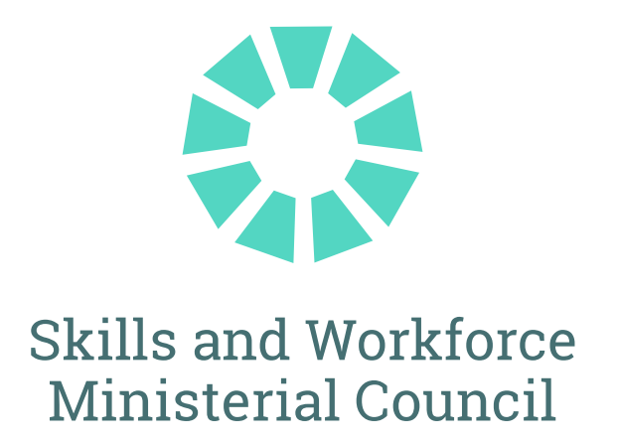

The Hon Minister Giles MP
Minister for Skills and Training
The Hon Minister Hood MP
South Australia
Minister for Education, Training and Skills

The Hon Minister Whan MP
New South Wales
Minister for Skills, TAFE and Tertiary Education

The Hon Minister Brooks
Victoria
Minister for Skills and TAFE

The Hon Minister Bates MP
Queensland
Minister for Finance, Trade, Employment and Training

The Hon Minister Ellis MP
Tasmania
Minister for Skills and Jobs

The Hon Minister Hersey
Northern Territory
Minister for Education and Training

Minister Pettersson MLA
Australian Capital Territory
Minister for Skills, Training and Industrial Relations

Senior officials from Western Australia observed the meeting.

JOINT COMMUNIQUÉ
19 June 2026

COMMUNIQUE

MEETING OF FEDERAL, STATE AND TERRITORY SKILLS MINISTERS
Skills Ministers met today in Adelaide to progress shared priorities for Australia’s vocational education and training (VET) sector.
National TAFE Network
Ministers endorsed the 2026 National TAFE Network Annual Workplan, which includes 17 projects that will benefit TAFEs in every jurisdiction. The projects in the Workplan span a broad range of focus areas and will help strengthen the quality, relevance and accessibility of the VET system by enhancing skills recognition, enabling smoother workforce transitions, strengthening learner readiness and completion, and improving access for cohorts facing structural barriers to training and employment.
VET Data Streamlining Legislation and Policy
Ministers agreed to legislative and policy amendments required to enable Phase 1 of the VET Data Streamlining (VDS) Program to commence in October 2026. The VDS program is a foundational element of the National Skills Agreement Enhanced VET Data and Evidence Initiative, and delivers a significant reform to improve the timeliness, quality and security of VET data submissions by registered training organisations.
Tertiary Harmonisation
Ministers met with Professor Barney Glover AO, interim Chief Commissioner of the Australian Tertiary Education Commission, to discuss progress toward a Tertiary Roadmap and National Credit Recognition Framework. Ministers reaffirmed the importance of having VET and higher education on equal footing in a harmonised tertiary system, providing real recognition of prior learning between systems and ensuring that tertiary qualifications are aligned with Australia’s future skills needs.
Delivering Housing Supply and Apprenticeships
Ministers were briefed by Jobs and Skills Council, BuildSkills Australia, on new research exploring where the skills and training portfolio can most effectively contribute to Australia’s housing supply priorities.
The Hon Steve Whan, NSW Minister for Skills, TAFE and Tertiary Education led a discussion where Ministers agreed to continue to strengthen apprenticeships and traineeships by commissioning focused activity in 2026 to: create coherent national construction supervisor training settings; examine national Group Training Organisation standards to ensure they remain fit for purpose; and increase gender diversity in construction industries. Ministers agreed this will build on current skills initiatives including Free TAFE and TAFE Centres of Excellence, and the actions outlined in the National Skills Plan and Jurisdictional Action Plans.
Quality and Integrity in VET
Ministers agreed to further strengthen the quality and integrity architecture of the VET system by investigating additional measures aimed at building public confidence, support quality uplift and improve system responsiveness. This builds upon recent actions undertaken by the Australian Skills Quality Authority. As an immediate priority, Ministers agreed to advance work on a national data and information-sharing protocol to strengthen collaboration and regulatory intelligence sharing to further enhance regulatory practice.

FRIDAY, 19 JUNE 2026

MEDIA CONTACTS:
Minister Giles (Commonwealth):
Alex Collum
0468 795 648
alex.collum@dewr.gov.au

Minister Whan (NSW):
Anthony Puntoriero
0466 504 142
anthony.puntoriero@minister.nsw.gov.au

Minister Brooks (Vic):
Beth Poulter
0422 643 870
beth.poulter@minsatff.vic.gov.au

Minister Bates (Qld):
Joe Hill
0408 962 453
joe.hill@ministerial.qld.gov.au

Minister Sanderson (WA):
Claire Deale
0448 298 197
Claire.Deale@dpc.wa.gov.au

Minister Hood (SA):
Tom Angley
0431 704 801
tom.angley@sa.gov.au

Minister Ellis (Tas):
Will Sanderson
0487 190 927
will.sanderson@dpac.tas.gov.au

Minister Hersey (NT):
Zac Webster
0466 102 011
zac.webster@nt.gov.au

Minister Pettersson (ACT):
Jonathan Goodwin
0421 749 612
jonathan.goodwin@ act.gov.au

