


Proposed licensing system
for the New Employment Services Model
  - Discussion paper

ISBN
978-1-76051-987-2 [PDF]
978-1-76051-988-9 [DOCX]
With the exception of the Commonwealth Coat of Arms, the Department’s logo, any material protected by a trade mark and where otherwise noted all material presented in this document is provided under a Creative Commons Attribution 3.0 Australia licence.
The details of the relevant licence conditions are available on the Creative Commons website (accessible using the links provided) as is the full legal code for the CC BY 3.0 AU licence.
The document must be attributed as the Proposed licensing system for the New Employment Services Model: Discussion paper.

Contents
Introduction 5
Purpose of this Discussion Paper 6
Consultation process 6
Chapter 1 – Overview and objectives of the licensing system 7
Overview of the licensing system 7
Objectives of the licensing system 8
Chapter 2 – Establishing a panel 9
What is a panel? 9
Why establish a panel? 9
How the panel would work 9
Sub-panels in each Employment Region 10
When the panel would be used 11
Chapter 3 – Issuing contractual licences 13
How contractual licences would operate 13
Licence duration 13
Service coverage 13
How many licences would be available 14
When licences would be offered 15
Adding new licences 15
Chapter 4 – Licence Reviews 17
How Licence Reviews could work 17
Frequency of Licence Reviews 19
Scenarios 22
Chapter 5 – Specialist licences 25
Overview of cohort specialists 25
Types of cohort specialists 25
Where cohort specialists would operate 26
Interaction with complementary programs 28
Overview of workforce specialists 28
Chapter 6 – Market share 31
How market share could operate 31
Chapter 7 – Red tape reduction 33
Key improvements in the licensing system 33
Making it easier for smaller organisations, and encouraging diversity 33
Chapter 8 – Performance Framework and cyber security 36
Performance framework 36
Ensuring cyber security among providers 37
Chapter 9 – Next steps 40
Responding to this Discussion Paper 40
The final licensing system 40
Transition to the New Employment Services Model 41
Glossary 43
Appendices 46
Appendix A – Previous approaches to procurement 46
Appendix B – Other key features of the New Employment Service Model 49

Introduction
In March 2019, the Australian Government announced that the New Employment Services Model would replace jobactive in July 2022, featuring a licensing system. This licensing system will reform the traditional approach to procuring employment services providers and make it more flexible.
A licensing system for employment services providers was recommended by the Employment Services Expert Advisory Panel. This independent panel of experts was established in January 2018. The panel’s December 2018 report included several recommendations on improving the design of the provider market. This included: the introduction of a licensing framework and greater competition and diversity between providers. Other recommendations were to account more for regional / local variation, and for providers who consistently do not meet benchmarks or quality standards to be exited.
The procurement approach used for jobactive and earlier employment services involved a large open tender, typically every three to five years. Opportunities for organisations to become a provider after the initial tender process were often limited. A summary of previous approaches to the procurement of employment services is at Attachment A.
This discussion paper explores an approach that involves contractual licences. This new approach seeks to:
- reduce red tape
- simplify the approach for providers to enter and exit the market
- ensure high quality services for job seekers and employers
- encourage diversity in the provider market
- establish a market of suitable organisations that can flexibly and responsively meet the needs of the labour market.
The new employment services model will be considerably different to jobactive and previous mainstream employment services. The most job-ready job seekers will be primarily self-managing online via Digital Services and will not have a dedicated provider. Job seekers assessed as having significant vocational and/or non-vocational barriers to work will be referred to an Enhanced Services provider.
Enhanced Services are expected to involve upfront, early investment in each job seeker. They would receive individually tailored case management from their provider. Job seekers and providers would have greater flexibility to undertake a range of activities to help job seekers to prepare for and move into work.
While key elements of the new model are being tested as part of the New Employment Services Trial, the licensing system is not part of this trial.

Purpose of this Discussion Paper
The purpose of this Discussion Paper is to provide a wide range of stakeholders the opportunity to contribute their views on the proposed licensing system. The Discussion Paper includes proposed features and settings for the licensing system, as well as potential alternative options.
The licensing system described in this paper is proposed for discussion – it is not finalised, and its various elements may change based on the feedback received and subsequent decisions of Government.
This Discussion Paper concentrates on the proposed licensing system, it does not focus on other key aspects of the new model such as the provider payment structure, digital platform functionality, job seeker activation, or the targeted compliance framework. A summary of the other key features of the new model is at Appendix B.
The licensing system proposed in this Discussion Paper is for the mainstream employment service that is due to replace jobactive in 2022. No changes are currently proposed to the suite of existing employment programs that complement jobactive, such as Transition to Work, ParentsNext, Disability Employment Services, Community Development Program, Vocational Training and Education Centres, etc.
Please see Chapter 9 for how to provide a submission to this Discussion Paper.

Consultation process
The Department of Education, Skills and Employment is currently developing policy for the licensing system and undertaking widespread consultation as part of this process. This Discussion Paper is a central component of the consultation process but will be complemented by a range of other activities, including webinars for potential provider organisations, question and answer sessions, and meetings with stakeholders. For those stakeholders that have been unable to participate in webinars held to date, recordings and transcripts of webinars and reference documents (including frequently asked questions) are available on the department’s website at https://www.employment.gov.au/consultation-inform-new-employment-services.
All feedback received during consultation, including submissions to this Discussion Paper, will feed into the final design of the licensing system.
The department also plans to release an Exposure Draft of the Request for Proposal in mid-2021. This will provide a further opportunity for stakeholders to give feedback on the details of the new model, including more operational aspects of the licensing system.

Chapter 1 – Overview and objectives of the licensing system

Overview of the licensing system
The proposed licensing system would include a national panel of organisations established through an open tender process. Organisations would submit a single application that includes information about which Employment Regions they are seeking to deliver services in. Organisations that apply would be assessed and, if found suitable in one or more Employment Regions, would join the panel by signing a Deed of Standing Offer. Selected organisations on the panel may be offered contractual licences by the department to deliver employment services in specific Employment Regions.
Contractual licences would be specified in a schedule under the Deed of Standing Offer. Each licence would stipulate which locations a provider is contracted to deliver services from and the agreed market share that the provider has been allocated. To help identify which panel members have been assessed as suitable to deliver services in a particular Employment Region, it is proposed that a sub-panel for each Employment Region would sit below the national panel. Each sub-panel would include both providers who are licensed to deliver services in the Employment Region, and panel members who do not currently have a licence but who may be offered a licence in the future, should one become available.
Licences would be issued for an initial three years, with extensions offered to high performing providers after an annual Licence Review. Low performing providers would typically be exited from a region once their licence lapsed and be replaced from the relevant sub-panel.
The performance framework for providers is under development, but would recognise both employment outcomes, as well as progressing job seekers along the pathway to work (increasing their employability). Assessments would occur at the Employment Region level, meaning a provider could be offered a licence extension for one region and not another.
The proposed licensing system would feature both generalist providers, as well as two categories of specialist providers. These would be cohort specialists (that target support to a particular group of job seekers) and workforce specialists (that target assistance to a particular industry, large scale project, region or large employers).
The department would manage competition in the provider market by allocating each provider a set market share of job seeker referrals for each contracted Employment Region. Job seekers and employers would still have choice in which provider they use, where possible.
The licensing system would seek to cut red tape in a number of ways. It would include a streamlined application process for organisations that want to become a provider. There would be a more concise Deed and program guidelines. Digital technology would be harnessed to help reduce manual processes, to save users time and money.
Panel members would be expected to satisfy several criteria on a periodic basis to remain on the panel. Among other requirements, providers would need to meet quality and cyber security accreditation standards when issued a licence.

Objectives of the licensing system
In introducing a licensing system for the New Employment Services Model (the Model), the Australian Government has three major objectives:
- Driving quality outcomes for job seekers and employers
- Simplifying the approach for providers to enter and exit the market
- Reducing the cost and disruption of procurement

Design principles


A number of design principles will help shape the licensing system:

Streamlining procurement


Responding to local needs

Providing choice for
job seekers and employers
Encouraging greater
diversity of providers

Rewarding strong performance

Harnessing specialist expertise

Balancing flexibility
and market stability
Leveraging new and
improved digital capabilities

Chapter 2 – Establishing a panel

What is a panel?
A panel arrangement is a method used in procurement whereby a number of suppliers are selected, each of which are able to supply identified goods or services to an entity. A panel is generally established by open tender and is usually established through Deeds of Standing Offer with contracts formed under those deeds when the goods or services are acquired.
Under the proposed licensing system, the Australian Government is procuring organisations to deliver employment services to job seekers and employers on its behalf.

Why establish a panel?
Establishing a panel of organisations increases the responsiveness of the model by allowing the prompt introduction of a provider in a particular location when required. A panel removes the need to run a tender exercise every time a new provider is needed, which can be time consuming, expensive and deter smaller organisations.

How the panel would work

A single national panel
The proposed approach is to have a single national panel covering all of Australia not classed as remote.
Any organisation assessed as suitable to deliver services in at least one Employment Region would be offered a place on the national panel. All panel members would be required to sign the Deed of Standing Offer.
The panel would include both generalist and specialist providers (see Chapter 5 for further information on specialist licences). It would be possible for a provider to have a generalist and a specialist licence in the same Employment Region.

Panel duration
The duration of the national panel is proposed to be six years, to enable sufficient time for the market to mature and the Licence Review and extension process to run its course. The panel or parts thereof may be extended, at the department’s discretion, beyond the initial six years.

Alternative options for the duration of the panel include:
- Shorter than six years (e.g. 3–5 years). This could potentially reduce the ability to cut red tape and realise efficiencies that could be gained from having fewer procurement exercises. It could, however, provide greater flexibility to change policy settings in the model.
- Longer than six years (e.g. 7–10 years). This could potentially slow down the flow of new entrants into the provider market and the innovations and new perspectives they might offer.

Requirements to remain on the panel
Panel members could be required to satisfy several criteria on an annual basis to remain on the panel. Panel members allocated a licence or licences as a result of the Request for Proposal process would be required to demonstrate compliance against the Request for Proposal conditions of participation, commercial and legal capability, and quality and other accreditation(s).
Panel members not allocated a licence as a result of the Request for Proposal process would be required to confirm eligibility and interest in retaining panel membership periodically. These requirements could be partially automated to reduce the administrative burden on panel members.
Panel members would also be expected to confirm their ability and willingness to obtain quality and cyber security accreditation if offered a licence (see Chapter 8 for further information).
While not wanting to overburden panel members (who may not be delivering employment services), it will be important to ensure that if a panel member is offered a licence, they are able to deliver services without extensive delay or difficulty.

Joining the panel through a panel refresh
New organisations could potentially join the panel through a panel refresh process, in accordance with the Commonwealth Procurement Rules. The department may refresh the panel from time to time, to ensure it has the diversity and depth needed to meet emerging labour market and industry demands.
A panel refresh could be limited to a particular Employment Region, or multiple regions, and include generalist and specialist organisations, depending on the circumstances. A panel refresh provides the chance for organisations unsuccessful in joining the panel at the start of the model to join later.

Sub-panels in each Employment Region
Sitting under the national panel, each Employment Region would have its own sub-panel. These sub-panels would be used to help identify which panel members have been assessed as suitable to deliver services in the Employment Region. This would enable the department to readily fill any vacant licences that may arise. Without sub-panels, it may not be as clear to all interested parties, which panel members would be considered in the first instance to a fill vacant licence in a particular location.
A sub-panel may or may not include specialist organisations. An organisation could be on multiple sub-panels.
Figure 2.1 illustrates how an organisation could interact with the licensing system, including being offered panel membership, being added to sub-panels and being issued licences across multiple Employment Regions.
It is anticipated that the 51 Employment Regions that operate under jobactive (and the New Employment Services Trial) would remain substantially the same under the new model.

Number of organisations on each sub-panel
The maximum number of organisations that the department would appoint on each sub-panel would primarily depend on the size and labour market characteristics of the region. It would also depend on the quantity and quality of responses to the Request for Proposal.
Decisions would require careful consideration and need to weigh up factors including suitability and value for money offered by the organisations applying. For example, while wanting to be flexible, there may be little merit in having a large number of panel members in a region where only 2–3 licences would be viable.

When the panel would be used
Being on the national panel would not guarantee that an organisation receives a licence.
The panel would be used for the initial allocation of licences and then when a new licence becomes available. This could occur when a new licence is added to a region, an existing provider hands in its licence, a provider does not have its licence renewed, or a provider has its licence terminated.
All members of the sub-panel for an Employment Region would be considered for a licence should one become available in the region. In certain circumstances, the department could also consider other organisations on the national panel. For example, for a specialist licence where no suitable organisation exists on the relevant sub-panel.
Where a licence becomes available the department may ask organisations on the panel to supply some updated information. This process would be less involved than the initial response to the Request for Proposal.
Having an established panel for employment services could allow the Australian Government the opportunity to use the panel for other programs in the future.
Figure 2.1 – Example of an organisation (Provider X) interacting with the licensing system
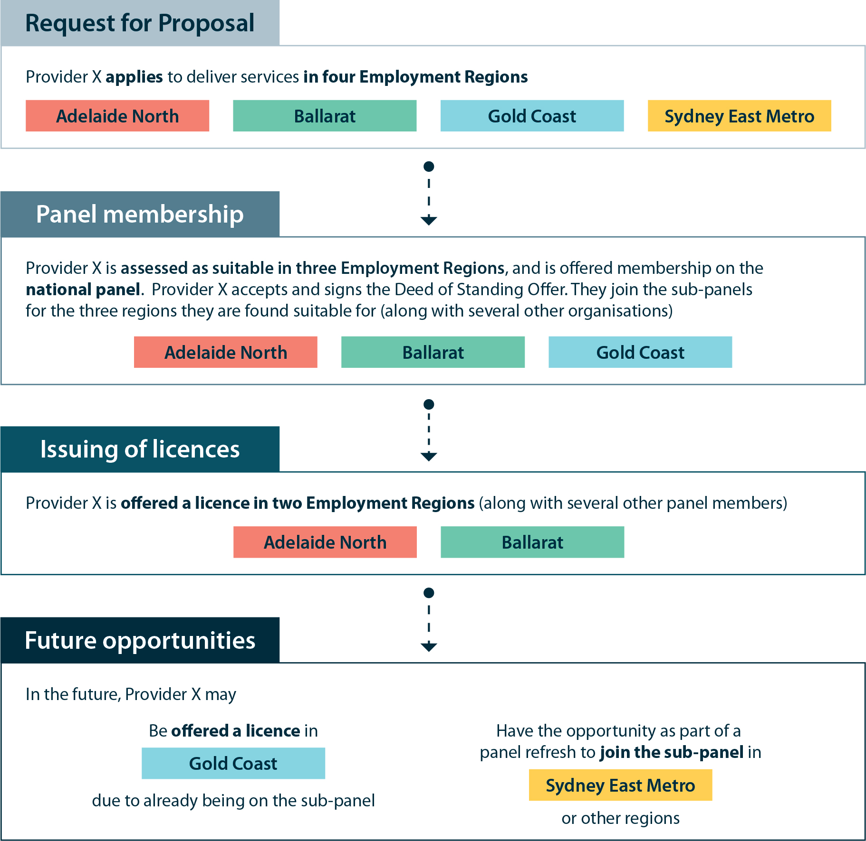
- Guiding questions
  - Should generalist and specialist organisations be included on the same panel?
  - How long should the panel be in place for?
  - In what circumstances should a panel refresh occur?
  - How else could the panel be used?

Chapter 3 – Issuing contractual licences

How contractual licences would operate
Licences issued under the new model would be contractual licences, meaning that they would be contracts to deliver employment services under the terms of the Deed of Standing Offer.
Under the Deed of Standing Offer, the department would issue a contractual licence to selected panel members assessed as being the most suitable for each Employment Region. This means that a panel member could potentially be issued with multiple licences across multiple Employment Regions. All licences would be subject to the same Deed of Standing Offer.

Licence duration
It is proposed that licences be issued for an initial three years.
This allows providers time to establish themselves in the market and also gives the department time to accumulate sufficient performance data to reliably measure how a provider is performing.
Alternative options for licence duration include:
- Issuing licences for a minimum of two years. This may result in a more dynamic market, with more providers entering and exiting. However, this may offer less stability for all stakeholders involved and deter some organisations from applying.
- Issuing licences for a minimum of four years. This may result in a more static market, but with greater certainty for providers. However, low performing providers could continue to operate for longer, resulting in worse outcomes for job seekers and employers.
The department would still have the ability to terminate a provider’s licence early under certain circumstances. For example, for contractual non-compliance, including gross misconduct or significant underperformance (see Chapter 4 for further details).

Service coverage
In their response to the Request for Proposal, organisations would indicate their proposed service delivery locations, including whether sites would be full-time, part-time or outreach sites. Outreach sites are typically used on a monthly, seasonal or ‘as needed’ basis. The new model will need to balance ensuring that there is adequate service coverage across the Enhanced Services network with offering greater flexibility in service delivery.
It is not necessarily expected that all providers would service an entire Employment Region. This means that licences may be issued to organisations that deliver services within an area smaller than an Employment Region, even from a single site if appropriate. This may encourage smaller organisations with closer ties to the local community to bid for business. For example, there may be some Employment Regions with one provider servicing the entire region, and a mix of providers covering specific locations. Other Employment Regions may have a few providers servicing the entire region or any combination that still achieved coverage for the Employment Region.
Irrespective of how many sites a provider is operating from, each provider would be allocated a certain market share for the relevant Employment Region (for further detail see Chapter 6).
Evidence from jobactive and the Transition to Work program shows that providers with a small geographic footprint can still deliver high quality services and be financially viable. Strong local networks with employers and with other social services are often a key factor in their success.
Under the New Employment Services Trial, some providers chose to reduce the number of sites, in response to the smaller caseload in Enhanced Services compared to jobactive.
The department plans to undertake comprehensive analysis to inform the approximate number of licences issued in each Employment Region at the start of the new model. This analysis would include looking at income support data, jobactive caseload data, labour market data, financial viability modelling and coverage of existing employment and other services.
The actual number of licences issued would also depend on the number, size, nature, and quality of responses to the Request for Proposal for each Employment Region. The number of specialist licences to be issued and financial viability is covered in more detail in Chapter 5.
The department may need to negotiate with some organisations about their proposed service locations to make sure there is adequate service coverage in all Employment Regions.

Flexible service delivery
The impact of the COVID-19 pandemic has seen employment services shift from traditional face-to-face services to greater use of phone and online servicing of job seekers. This trend towards digital service delivery is expected to continue under the new model.
While it is expected that providers would still offer individualised support and intensive case management where required, providers could benefit from adopting a flexible service delivery approach. Providers could use a mixture of digital, phone and face-to-face engagement depending on the needs and preferences of each job seeker. The improved digital platform, a feature of the new model, would support this by offering tools for all job seekers, including those in Enhanced Services.

How many licences would be available
The department proposes to place a cap on the number of licences issued in each Employment Region, to ensure a reasonable level of market stability.
While having an uncapped market could improve choice, it could also lead to oversupply of providers in certain regions and locations. This could result in a poorer overall service for employers, as employers are approached by large numbers of providers. It could also mean poorer service for job seekers, if providers focus on marketing themselves at the expense of service delivery. It could also challenge the financial viability of providers.
The exact number of licences issued would vary from region to region and would depend on how many Enhanced Services job seekers are located in the region as well as local labour market conditions.
The department expects to indicate in the Request for Proposal approximately how many licences it expects to issue in each Employment Region. The final number of licences may be influenced by the scale and mix of applicants.

When licences would be offered
The initial offering of licences would occur once the assessment of responses to the Request for Proposal have been finalised and any negotiations have concluded. The initial offering of licences is likely to occur at the same time as offers of panel membership.
It is proposed that further licence offers would occur around the regular Licence Review points (see Chapter 4).

Adding new licences
The department may add to the number of licences in an Employment Region in certain circumstances. For example, the COVID-19 pandemic saw rapid changes in the labour market and a surge in the numbers of unemployed people. A similar scenario in the new model could potentially result in some new licences being issued.
As outlined in Chapter 2, panel members on the relevant sub-panel would be the first organisations considered for any licence added to an Employment Region.
In certain circumstances there may also be scope for the department to reduce the number of licences in an Employment Region. For example, due to a natural disaster that led to large numbers of people and businesses leaving the region.
An alternative option for adding new licences:
- Short-term licences could be issued in a particular region in response to short-term events. This flexibility would allow the department to respond quickly to major redundancy events such as a natural disaster or closure of an industry or large employer. A provider could be engaged for shorter durations (e.g. 12 months) to work directly with companies, industries and regions to deliver pre-retrenchment advice, services and transition support. Targeted, timely pre-retrenchment support for workers could help them move to their next job quickly and reduce the number of retrenched workers joining the caseload.
- Guiding questions
  - How long should licences be issued for initially?
  - Should an organisation be allowed to service areas smaller than an Employment Region?
  - Should the number of licences be capped in each Employment Region?
  - When should new licences be added to a region?
  - In what circumstances should short-term licences be issued?

Chapter 4 – Licence Reviews

How Licence Reviews could work
Regular Licence Reviews are proposed, and would have three main functions:
- To assess the performance of providers
- To offer licence extensions to high performing providers
- To determine if an Employment Region requires a change to the number of licences in operation.
These reviews are proposed to occur mid-year, every year. In addition to the annual Licence Review, key performance data would be given to providers on a more frequent basis.
Based on a provider’s performance as part of a Licence Review, they may be offered a licence extension. Licence extensions would have several benefits including providing an incentive for providers to perform, and giving providers greater financial surety when discussing financing, leases for premises, and workforce planning.
The Licence Review could see low performers exited from an Employment Region via non-renewal of their licences.

Performance groupings
Each Licence Review would place providers into one of three proposed performance groupings: high, moderate and low.
Alternative options for the number of performance groupings include:
- More than three performance groupings (e.g. four or five). The existing Star Ratings system used in jobactive has five stars. However, there may be limited value in having multiple groupings with the same benefits for the provider (e.g. same length of licence extension).
- Two performance groupings (e.g. high performing and low performing). While simpler, this may not offer as much incentive for providers that are doing well to continue to improve their performance.

Longer extensions for higher performers
High performing providers would have the ability to obtain a longer licence period through extensions.
As shown in Table 4.1, it is proposed that high performing providers could receive a licence extension of up to two years. This would result in them typically having three years remaining on their licence.
Table 4.1 – Outcomes of Licence Reviews
Performance grouping | Licence Review outcome
High performance | Licence extended by up to 2 years
Moderate performance | Licence extended by up to 1 year
Low performance | Licence extended after further consideration
Low performance | Licence not extended after further consideration

Moderate performing providers could receive a licence extension of up to one year. This would result in them typically having two years remaining on their licence.
Low performing providers would be in-scope for non-renewal of their licence. This would, in most circumstances, mean that a low performing provider’s licence is not extended when it lapses.
The proposed three year initial licence (see Chapter 3 for more detail) allows sufficient time for a provider to establish themselves.
Past extensions for a provider could impact on future extensions. For example, from one Licence Review to the next a provider might move from being a high performer to a moderate performer in the relevant Employment Region. In this case it is proposed that a provider would not be granted a further licence extension at that point but would still have two years remaining on their licence.
It is proposed that performance data from a longer period could be taken into account to assess a provider’s performance to reduce the impact of any short-term ‘spikes’ in the data and better capture their overall performance.
It is intended that extensions could be offered well in advance of licences lapsing to offer certainty. For moderate and high performing providers, this would typically be one or two years in advance of licences lapsing. This is illustrated in Figures 4.2 to 4.4.

Regular performance data
Providers would receive data on their performance at regular intervals in addition to the formal Licence Reviews. Key performance assessment results would be made publicly available on a regular basis. Providers would have access to more detailed underlying data about their own performance on a more frequent basis.

Supporting low performing providers
One of the Government’s objectives is to lift overall provider performance. Should a provider be assessed as low performing, the department may identify areas for improvement, potential causes of low performance and help the provider develop strategies to strengthen their processes.

Exiting low performing providers
Providers that are assessed as being low performers would be at risk of losing their licence. It is expected that in the majority of cases, this would be done by not extending their licence when it is due to expire. Low performing providers would be given time to rectify their underperformance before their licence expires.
Providers would be given advance notice through regular performance data releases and via performance discussions with the department. When a low performing provider has around 12 months remaining on their licence, it is proposed that they would be given formal notification that their licence may not be extended if performance does not improve in the subsequent six months.
It is proposed that at around six months prior to a licence lapsing, a final decision would be made on whether to extend the licence or not. If the licence is extended, this would be for another 12 months from the current end date. If the licence is not extended, a formal notification would be given to the provider, and transition arrangements would gradually commence. Transition arrangements would be designed to ensure a smooth transition for job seekers and employers in the region.
It is important to note that reasons other than performance may lead to a decision not to extend a licence. For example, changes to projected labour market conditions and contractual non-compliance.
The department would also have the ability to terminate a provider’s licence early for reasons including contractual non-compliance and significant underperformance.

Replacing exiting providers
It is anticipated that prior to a provider exiting the market or a particular Employment Region, the department would (subject to need) conduct an assessment of which organisation on the panel is best suited to replace the exiting provider. There may be cases where it is not appropriate to substitute one provider for another. For example, due to changes in the number or type of job seekers in the Employment Region.
In order to allow sufficient time for a potential new provider to prepare for the delivery of services in the region, any new provider would also be given reasonable notice prior to them being issued a licence. Figure 4.4 illustrates how this could potentially work. The department would work closely with both the exiting provider and new provider to ensure a smooth transition.
There may be instances where a provider needs to be replaced at short notice, for example, when a provider goes into liquidation. In such circumstances a flexible approach may be required to manage the transition of job seekers to a new provider.

Frequency of Licence Reviews
It is proposed that Licence Reviews would occur annually, at the end of the financial year.
Alternative options for the timing of Licence Reviews include:
- Every 18 months. This may result in less incentive to perform well compared to annual reviews, and lower overall performance among providers. Under jobactive, business reallocation processes were held every 18 months, resulting in some low performing providers losing business.
- Every 24 months. This may limit performance incentives and reduce the number of opportunities for new entrants to enter the market.

The first Licence Review
Evidence from previous models showed that robust performance data is typically not available until after at least nine months for larger organisations, and even longer for smaller organisations. This is due to the time required to achieve long-term outcomes (e.g. 26 week outcomes). Initial performance data is also likely to be impacted by the transition from jobactive to the new model.
Evidence from previous employment programs also shows it can take providers up to
12 months to become familiar with policy settings and establish effective service processes.
In recognition of this, it is proposed that the outcomes of the first Licence Review would be different to subsequent Licence Reviews:
Table 4.2 – Outcomes of First Licence Review
Performance grouping | First Licence Review outcome
High performance | Licence extended by 1 year
Moderate performance | No licence extension
Low performance (in-scope) | No licence extension

The first Licence Review could be conducted slightly later than mid-year, around September 2023 (approximately 15 months into the new model) to allow more time for providers to establish themselves.
Several alternative options for the first Licence Review are possible, including:
- Applying the same Licence Review extensions proposed for later years (outlined at Figure 4.1) at the first Licence Review. This would involve providers in the high performance category offered extensions of two years and providers in the moderate performance category offered one year extensions at the first Licence Review. Given the amount of time it takes for robust performance data to become available, this could mean that some providers with strong early performance settle into lower performance categories shortly after the first Licence Review, but could still have more than three years on their licence.
- Issuing extensions of one year to moderate performing providers in addition to high performing providers. This could reduce the incentive for providers to achieve the highest performance category but would give more providers the benefits of a licence extension earlier.
- Making results of the first Licence Review ‘indicative only’ and not linked to licence extensions. While this would avoid potential negative consequences outlined in the other options, it may remove the performance incentive of receiving a licence extension. It could also increase uncertainty for all providers, as they would have only around 12 months left on their licence before receiving a licence extension.

Subsequent Licence Reviews
The second licence review is proposed for July 2024, and from then on, it is proposed that licence reviews would be conducted every 12 months (see Figure 4.1).
Figure 4.1 – Proposed Timeline of Licence Reviews
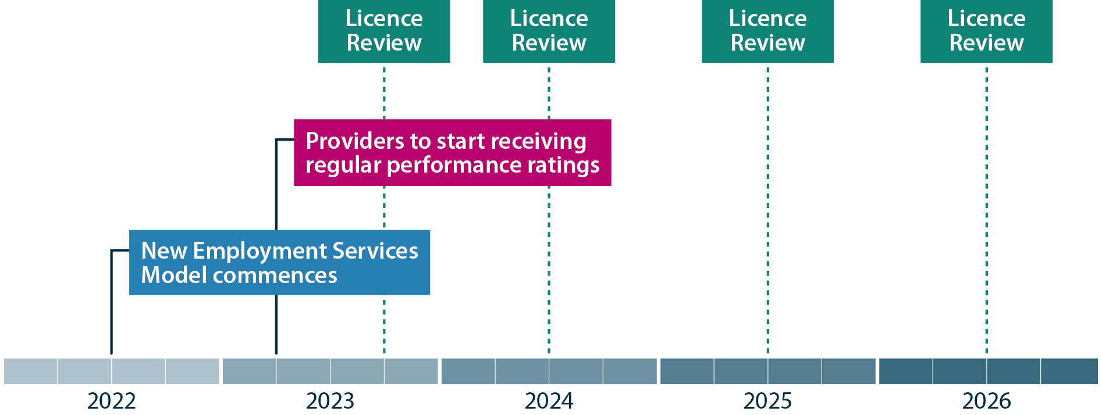

Scenarios
The following scenarios illustrate how the proposed licence extension process could work, depending on the performance of the provider over time.
Should any of the alternate options explored above be adopted, these scenarios would change. The diagrams assume the panel would be extended after six years.
Figure 4.2 – Scenario 1: High performing provider
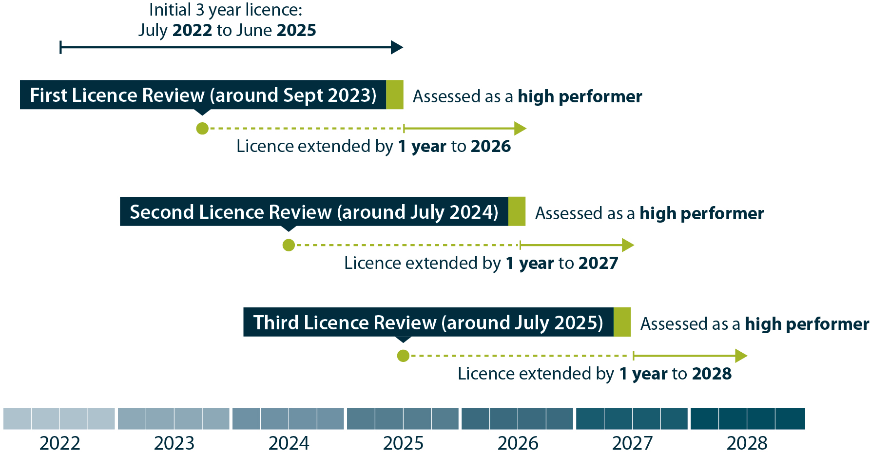
Figure 4.3 – Scenario 2: Moderate performing provider
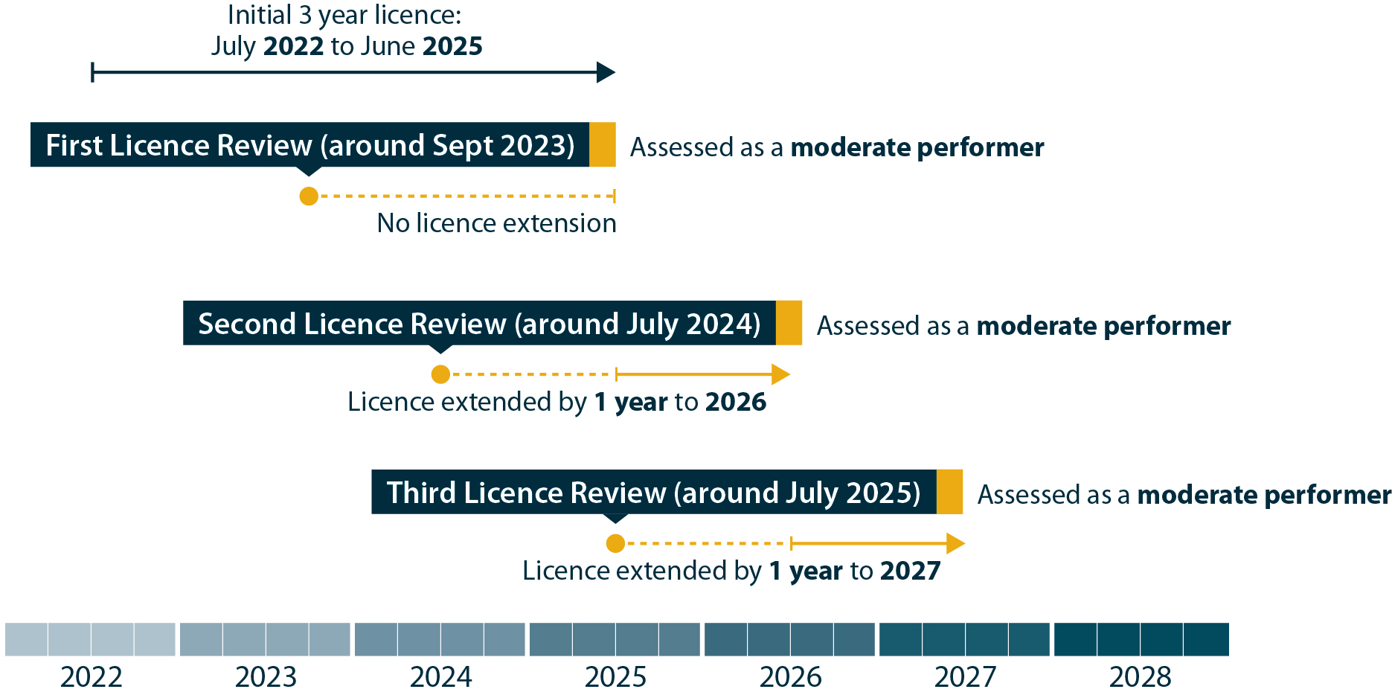
Figure 4.4 – Scenario 3: Low performing provider
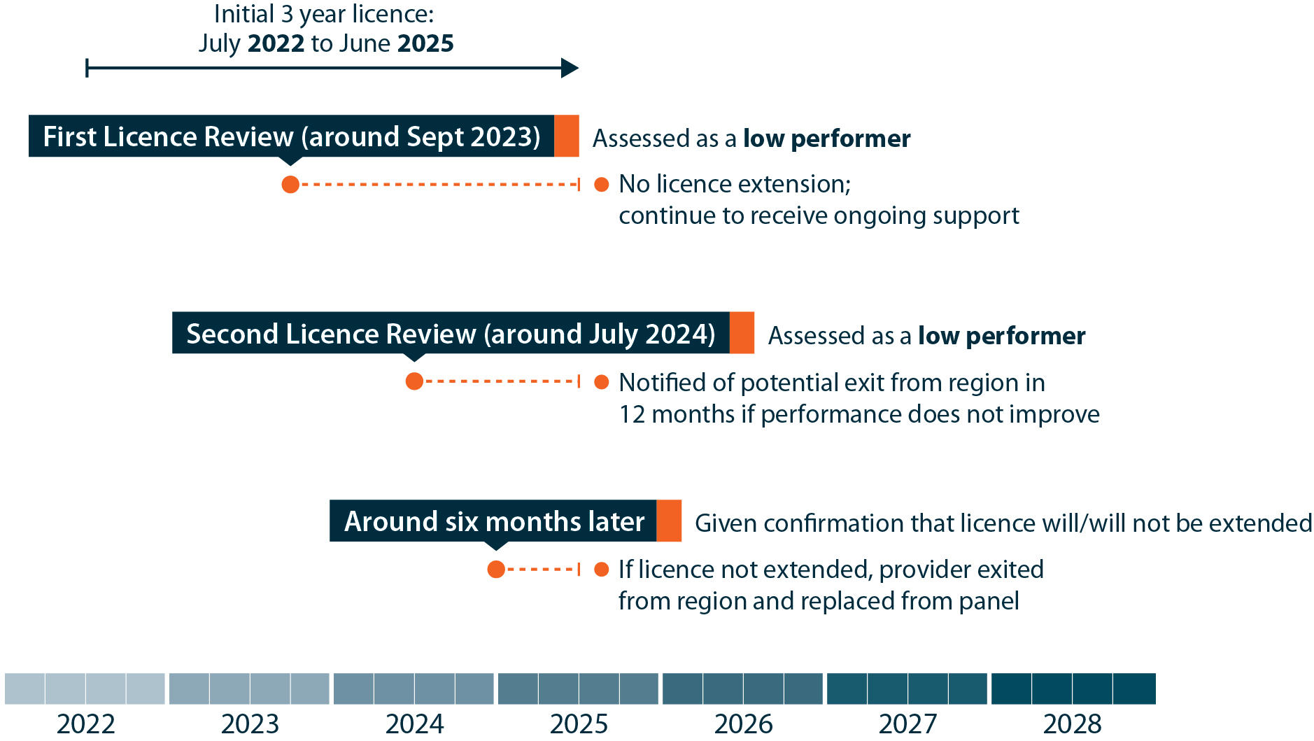
Figure 4.5 – Scenario 4: Provider that improves from low to moderate performance
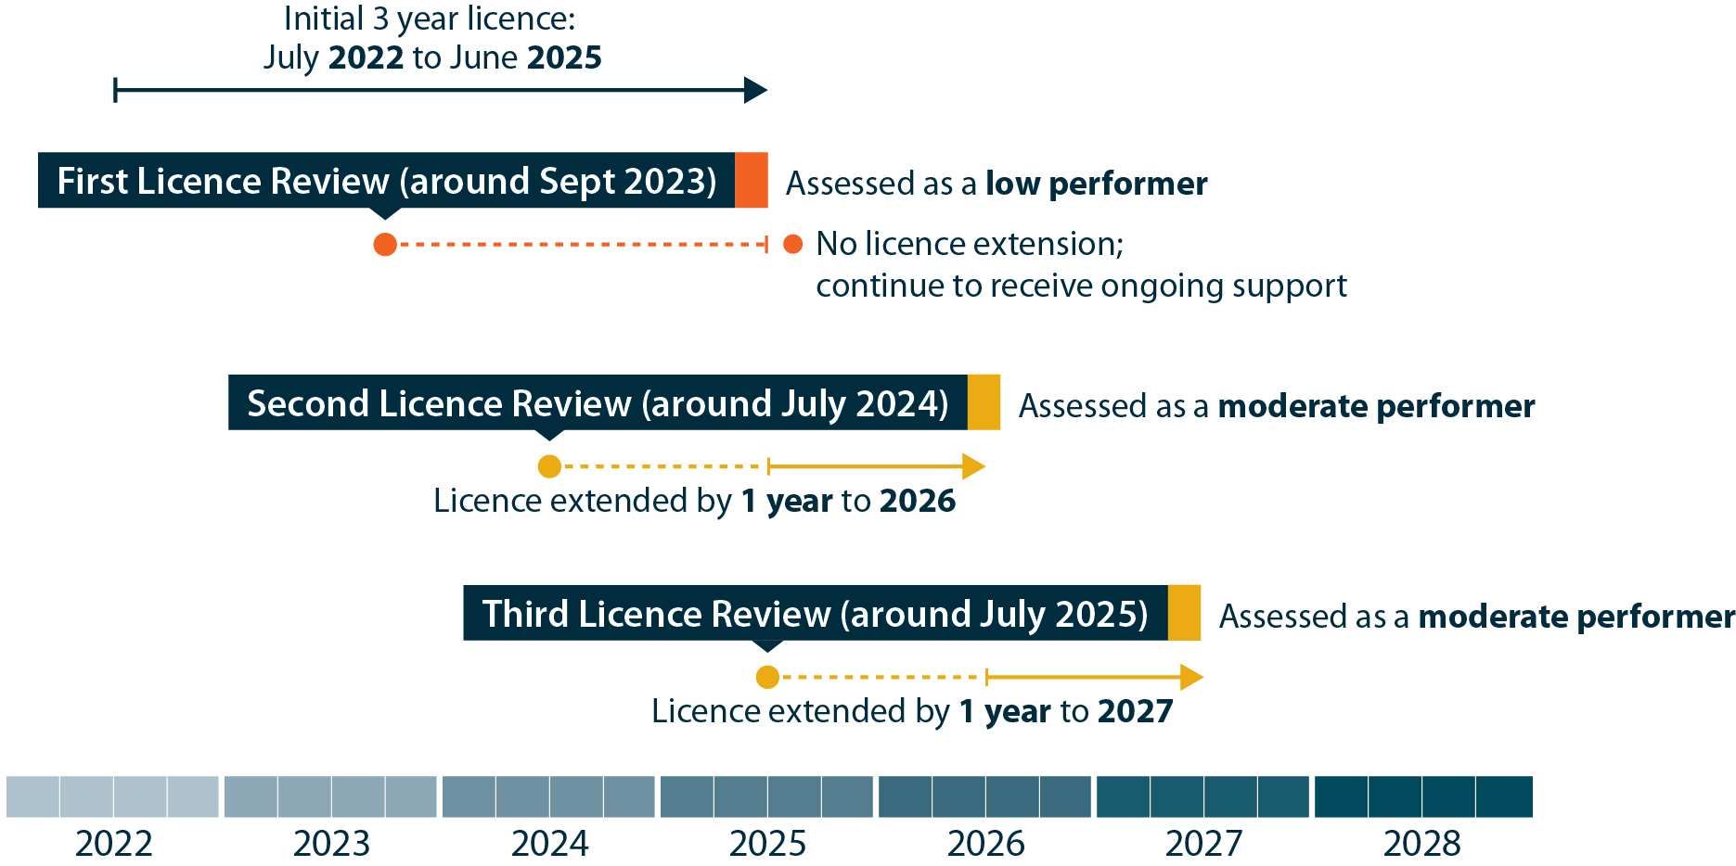

- Guiding questions
  - How many performance groupings should there be?
  - How frequently should Licence Reviews occur?
  - How often should providers receive performance data?
  - Should provider performance be publicly accessible?
  - When should the first Licence Review occur?
  - Should the first Licence Review be any different to later reviews?

Chapter 5 – Specialist licences
Two main categories of specialist licences are proposed in the new model: cohort specialists and workforce specialists.

Overview of cohort specialists
Cohort specialist providers would operate under the new model to provide more specialised support to particular groups of job seekers that may have different needs to other job seekers. These job seekers may benefit from the support of providers with detailed understanding of and expertise in working with that particular group.
To assist cohort specialist providers to capitalise on their expertise in the delivery of services to best meet the needs of their target cohort, it is proposed that they would only be referred job seekers from their targeted cohort. For example, an Indigenous specialist provider would only receive referrals of Aboriginal and Torres Strait Islander job seekers.
This is different to the approach taken for cohort specialist providers under Job Services Australia (JSA), which was the Australian Government’s funded employment service between 2009 and 2015. JSA included cohort specialist providers that were referred both specialist and generalist job seekers, with mixed results. Specialist providers were more likely to be low performers early in the contract. However, by 2013, specialist providers tended to outperform generalist providers for their specialist cohort, whereas generalist providers tended to perform better overall.
Job seekers and employers would continue to be able to choose a provider in a region. It is proposed that job seekers from a particular cohort would not be mandatorily referred to a specialist but could instead choose a generalist provider. If an eligible job seeker made no choice, the job seeker would be referred to a relevant cohort specialist provider by default.
Employers would be free to choose which services they use and when.
Having only one cohort of job seekers would reduce the potential caseload size for a provider, but this does not mean it would be financially unviable for them. For example, a cohort specialist provider may only have a contractual licence to operate from an area with a high concentration of their particular job seeker cohort. A cohort specialist could also use outreach services to reach a larger number of job seekers from its target cohort.
An alternative option to cohort specialists could involve:
- A generalist provider being able to offer ‘areas of speciality’ within its servicing arrangements that it could promote to potential job seeker and employer clients.

Types of cohort specialists
It is proposed that several different types of cohorts would have specialist licences assigned. Potential cohorts could include:

- Indigenous Australians
- Culturally & Linguistically Diverse (CALD)
- Refugees
- People with Disability
- Ex-offenders
- Youth (<25)
- Retrenched workers

It will be important to balance the needs of each cohort with that of other cohorts, given job seekers can belong to more than one group. A minimum number of job seeker referrals would be required to keep a specialist cohort provider financially viable.
For example, it may not be feasible for an Employment Region deemed suitable for CALD, people with disability, and youth specialist licences to have all three types of cohort specialists. The department may decide that one or two cohort specialist licences would be viable in such a region.
It may be that some regions have no cohort specialist providers.

Where cohort specialists would operate
Cohort specialist providers would be limited to locations with an identified need.
Analysis of where cohort specialist providers may operate would take into account several factors, including where particular cohorts of job seekers are more heavily concentrated.
Figure 5.1 shows the concentration of CALD jobactive participants in certain parts of Sydney. The red areas in south-western Sydney indicate where greater numbers of CALD jobactive participants are.
Figure 5.1 – Concentration of CALD job seekers in jobactive
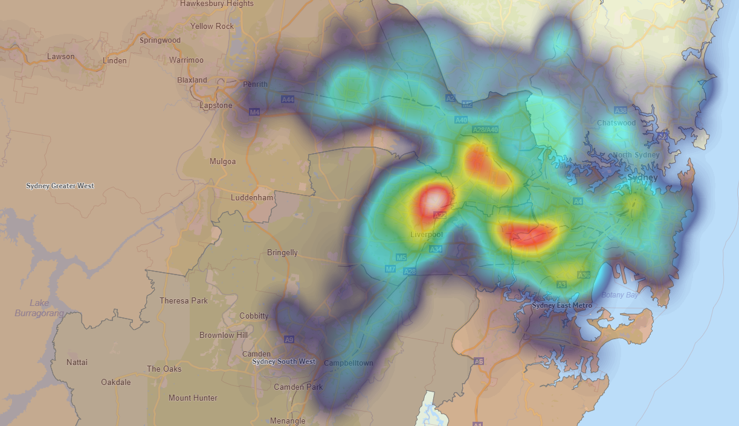
Source: Departmental administrative data, as at 31 August 2020.

The projected number of job seekers from each cohort would not be the only factor when determining where cohort specialist licences would be offered.
Other factors that may be considered by the department include:
- the existing presence of other specialist services (including those administered by commonwealth, state and territory governments, local governments, and/or community organisations)
- the existing presence of organisations likely to apply for cohort specialist licences
- where outcomes for particular cohorts are lower than average in jobactive (potentially indicating the need for more tailored assistance)
- local labour market conditions and employment opportunities.

Financial viability
While in some areas the proportion of job seekers from a particular cohort may be high, the total number may be relatively low when compared with the broader population (for example, in sparsely populated areas). This may mean such areas are not suitable for cohort specialist providers due to financial viability risks for the provider. In these circumstances, the department expects that generalist providers would address the needs of different cohorts of job seekers through an individualised and inclusive service offer.
For example, in a regional centre with a high proportion of Indigenous Australian job seekers but no cohort specialist provider, the generalist provider(s) would be expected to have Indigenous-specific service strategies to reflect the needs of their clients. This could include Indigenous staff recruitment, working with local community groups and Indigenous employment strategies.
The department is undertaking financial viability analysis to determine the circumstances where it is financially viable to deliver the intensive employment services required under the new model.

Indicating where specialists may operate in the Request for Proposal
As part of the Request for Proposal process, the department proposes to indicate the locations in which it may require cohort specialist providers. This may involve the provision of data that would assist in determining locations where cohort specialist providers would be most needed or viable.
Alternative options to determining the location of cohort specialists could involve:
- The department not indicating locations where it may require cohort specialist providers, but instead allowing an organisation, in its response to the Request for Proposal, to propose locations where it wishes to deliver specialist services. The department could assess such proposals on a case-by-case basis and potentially award a cohort specialist licence where there is an identified need.
- A combination of the proposed approach and the above option. The department could indicate the locations in which it considers appropriate for a cohort specialist provider, as well as allow organisations to propose additional locations in their response to the Request for Proposal.

Interaction with complementary programs
No changes are anticipated to the suite of existing employment programs that complement mainstream employment services (jobactive). This includes programs that operate separately to jobactive, such as Transition to Work and ParentsNext, as well as programs that can be accessed by jobactive participants, like Work for the Dole and Youth Jobs PaTH.
Many of these programs have different objectives to mainstream services, as well as different eligibility, funding models and contractual arrangements for providers. It will be critical for these programs to complement and work effectively with the New Employment Services Model once it is operational, to meet the diverse needs of job seekers and employers and achieve the best outcomes possible. This includes interactions with specialist providers.

Overview of workforce specialists
The other type of specialist licence proposed for the new model is the workforce specialist. It is proposed that workforce specialists would focus on responding to workforce demand. This would include identifying workforce opportunities, sourcing vacancies, and assisting with the screening, shortlisting and preparation of job seekers from across the Digital Services and Enhanced Services caseloads, to meet the needs of major projects, regions and employers.
Workforce specialists would not have a caseload of job seekers or be responsible for providing individualised case management to job seekers. They could, however, provide post placement support to employers and digital job seekers. Their role would have a coordination and job-matching focus.
Workforce specialists would collaborate with other providers, employers and the department to identify strategies to connect job seekers with employment opportunities on major projects, with large employing businesses and in growing and emerging industries and occupations across the country. They could also connect retrenching employers with those demanding job-ready workers to facilitate smooth the transition of retrenched workers into suitable local job opportunities.
Workforce specialists would be expected to identify and package together existing sources of funding and programs (e.g. wage subsidies) to deliver these strategies. Workforce specialists would be able to use the digital platform to assist with the screening and shortlisting of candidates on behalf of an employer.
While workforce specialists may specialise in a few different industries it is expected that they would have the capacity and capability to cover a very large area (e.g. a whole state) and support cross-industry transition.
Workforce specialists could potentially be paid on an agreed schedule of fees (e.g. per employment outcome), though with no guarantee of funding. They would have flexibility to determine when and how many resources they use to respond to each workforce demand opportunity. It is anticipated that workforce specialists would be organisations that can scale up or down as required.
For example, a large employer could choose a workforce specialist to work with them nationally on its recruitment needs. A major project could involve multiple workforce specialists addressing different labour need. For example, a Western Sydney Airport project could involve construction, retail, and freight industries. As part of a major project, an employer could potentially also negotiate with a workforce specialist to have a staff member embedded within their organisation for the project.
During consultation on the broader model in 2018, a number of stakeholders stated that employers are often looking for a single point of contact and a coordinated approach to recruiting workers (particularly for larger employers or large-scale projects). Workforce specialists (as outlined above) would help address this issue.
Organisations interested in becoming workforce specialists could benefit by drawing on the approaches used in other programs such as the PaTH Industry Pilots and the Regional Employment Trials program.
Under this approach, workforce specialists would operate quite differently to other providers (including generalists and cohort specialists). A different set of contractual terms and conditions, supporting guidelines, payment model and performance framework may be required.

Where workforce specialists would operate
Similar to cohort specialists, workforce specialists would operate only where there is identified significant workforce demand. It is expected that workforce specialists would identify and progress their own leads, while also responding to workforce demand opportunities initiated by the department and approaches from peak bodies.
When the department approaches the market as part of the Request for Proposal process, the department proposes to indicate where it considers there is an identified need for workforce specialists, similar to the process outlined above for cohort specialists.
- Guiding questions
  - Should cohort specialists only be referred job seekers from their target cohort?
  - Which cohort types should have specialists?
  - What factors should determine where specialists are located?
  - How should the new model interact with complementary programs (e.g. Transition to Work, Work for the Dole)?
  - How should workforce specialists operate?

Chapter 6 – Market share

How market share could operate
In order to maintain a reasonable level of surety and financial viability for providers, it is proposed that licences be for a certain portion of the available business within each Employment Region. When responding to a Request for Proposal, organisations would be asked to list their maximum and minimum market share in each region they are seeking a licence. For example, an organisation may seek a licence of between 10 and 20 per cent of the region and be awarded a licence of 15 per cent market share.
The department has commissioned independent research into provider financial viability to ensure the risk of financial failure among providers is mitigated.
Market share could be defined as the portion of business (job seeker referrals) in a region over a certain time period such as 12 or 24 months. This would help to provide surety of the flow of business over the time period. For example, a provider with 10 per cent market share could receive 10 per cent of incoming referrals subject to tolerance.
An alternative option could be to define market share as the proportion of the current caseload. This could provide reward for providers that achieve employment for people on their caseload. In this situation, a provider with 10 per cent market share could have 10 per cent of the caseload subject to tolerance options. By achieving employment outcomes for job seekers, the provider would be able to increase their access to new referrals.

Market share tolerance
It is proposed that market share be subject to tolerance bandwidths. This means that providers would be able to receive business to within a certain amount above or below the market share that they have been licensed for. This helps to limit providers from being locked out of receiving referrals.
Market share could be set initially with tolerance bandwidths of within 20 per cent, with potential to loosen market share arrangements once the model is bedded down.
Alternative options include:
- Tighter bandwidths of within 10 per cent. This could have the effect of providing more surety of business but could increase instances where providers are temporarily locked out of receiving new referrals.
- Wider bandwidths such as 30 or 40 per cent. This could have the effect of providing more potential business for each provider. However, they could also have less surety in the amount of business.

Leaving some market share unallocated
An alternative option for consideration is allocating a minimum market share only and leaving a small portion of market share in each region unallocated. The unallocated portion of the market would continue to be referred to providers, but could make it easier for the department to add licences to a region at a later date. This would make it easier for new entrants, making sure they are not starting with a contracted market share of zero. This would also prevent existing providers from having a portion of their contracted market share taken from them. Additionally, this may provide a further incentive for providers to deliver high quality services so that job seekers would be more likely to choose them.
- Guiding questions
  - How should market share operate?
  - How should tolerance work?
  - Should a portion of market share remain unallocated?

Chapter 7 – Red tape reduction

Key improvements in the licensing system
In response to consistent feedback that more needs be done to reduce the administrative burden of delivering employment services, the licensing system would be designed to cut red tape. This would include:
- a reduction in the frequency of tender applications. Licence extensions would provide stability for providers (dependent on performance)
- having a panel, with organisations ready to fill gaps in service provision should they arise
- the removal of business reallocation processes, which is a time-consuming exercise under jobactive
- harnessing digital technology to simplify and target communications and reduce manual administrative processes
- streamlining the Deed of Standing Offer and supporting guidelines where possible.

Streamlined application process
The department proposes to reduce the cost burden of tendering for employment services under the new model including through:
- An online lodgement Portal that would allow Request for Proposal respondents to save drafts and return to the response as required until finalised and upload requested documents easily; and the inclusion of auto tips and alerts to help respondents complete all requirements prior to response lodgement.
- Original entry data retained allowing information edits rather than re-entry.
- Potential information exchange between relevant government agencies to ensure due diligence and compliance with procurement-connected policies.

Simplified and targeted information
Departmental communications around licences, the Deed of Standing Offer and contractual obligations would also be streamlined where possible in the New Employment Services Model. This could include providing simplified and targeted information to providers, and automated reminders and alerts for panel members to action/update membership information.

Making it easier for smaller organisations, and encouraging diversity
One of the design principles of the licensing system is to encourage diversity in the market of Enhanced Services providers. A range of stakeholders during consultation on the new model raised concerns about the homogenisation of employment services over the past two decades, leading to less tailored servicing.
A key challenge for smaller organisations identified by researchers is the increasing proportion of provider revenue from outcome payments (particularly in jobactive). While this is intended to encourage performance, these payment settings can disadvantage smaller community organisations with fewer capital reserves to remain in or enter the market.
The new payment model (being tested in the New Employment Services Trial) has been designed to encourage more investment in disadvantaged job seekers, such as the long-term unemployed, and to better address their vocational and non-vocational barriers. This includes an upfront engagement fee to support the early investment.
It is intended that the licensing system would also facilitate the issuing of licences for service areas much smaller than an Employment Region. This means a provider could potentially operate out of a single site, reducing administrative overheads when compared to servicing an entire Employment Region through multiple sites. This may also benefit organisations that have strong connections within their local community but lack an established presence in other locations.
The department’s employment services platform will support the digital capability of smaller organisations who may not have the capacity to invest in custom and/or private IT applications.

The Indigenous Procurement Policy
The Government’s Indigenous Procurement Policy would apply to the Deed of Standing Offer. This includes mandatory minimum requirements for both employees and the value of goods and services, for government contracts valued at $7.5 million or more. Organisations responding to a Request for Proposal would be required to provide an Indigenous Participation Plan. Licensed providers would also be required to report against the mandatory minimum requirements each quarter via a central Commonwealth database.
Certain population centres (such as Darwin, Alice Springs and Broome), which fall within the 51 Employment Regions are defined as ‘remote’ for the purposes of the Indigenous Procurement Policy. This means they have higher mandatory minimum requirements.
Further information on the Indigenous Procurement Policy is available at:
www.niaa.gov.au/indigenous-affairs/economic-development/indigenous-procurement-policy-ipp
www.niaa.gov.au/resource-centre/indigenous-affairs/ipp-guide2-suppliers

- Guiding questions
  - How can the licensing system help cut red tape?
  - What would assist smaller organisations to enter the provider market?

Chapter 8 – Performance Framework and cyber security

Performance framework
The Provider Performance Framework will allow the department to determine how a provider is performing for the purposes of making licensing decisions.
The specific performance measures and methodologies that will be used in the performance framework are under development and will be informed by feedback received through consultation. The development of the performance framework will look to enhance the role that quality of service to job seekers and employers contribute to the assessment of a provider’s performance.

Elements of the Provider Performance Framework
While the detailed policy for the performance framework is still being developed, several broad goals are proposed below.

Focused on job seekers and employers
The quality of services provided to job seekers and employers would be a key consideration in provider performance. This includes a focus on achieving employment for job seekers that is sustainable and meets the needs of both job seeker and employer. In addition to achieving employment for job seekers, providers would need to effectively assist job seekers in progressing towards employment.

Accurate, fair and consistent
All providers would have an equal ability to succeed under the Provider Performance Framework. The framework would be able to accurately assess performance for providers with a variety of business models from small specialist organisations operating in regional Australia to larger organisations operating in cities. The proposed framework would account for factors outside the providers control such as caseload composition and the labour market.

Clear, simple and transparent
The performance measures in the framework will be clear so that providers understand how to succeed under the performance framework. Performance measures will be transparent so that providers can direct their efforts and be confident in understanding what is expected in terms of performance.

Performance measures
Examples of performance measures that may be included in the Provider Performance Framework include but are not limited to:
- achieving employment outcomes for job seekers
- progressing job seekers towards employment (e.g. successfully completing designated milestones such as training to increase employability skills)
- quality of service given to job seekers and employers
- job seeker and employer satisfaction
- achieving results for disadvantaged cohorts.
As part of the provider performance framework a Quality Assurance Framework is also proposed. It would measure provider governance, service improvement and job seeker and employer servicing, for example, through quality accreditation such as ISO 9001. It would also be adaptable to a variety of provider business models and market requirements.

Ensuring cyber security among providers
The department is accountable for ensuring the security of each contracted organisation’s IT systems, in line with the Australian Government’s Protective Security Policy Framework. Under the new model, it is proposed that the department would continue to use a risk-based approach to cyber security, known as Right Fit for Risk that covers:
- A providers’ own ICT environment
- Third Party Supplementary IT systems (if used)
- Interactions with cloud services (if used)
- Interactions with Third Party Employment Systems (if used).
The department would work closely with providers to ensure they are able to meet Right Fit for Risk requirements, which are based on a customisation of the ISO 27001 standard, a whole of business approach to IT security. The standard focuses on people and processes, as well as ICT infrastructure.
Figure 8.2 – Right Fit for Risk approach

The ISO 27001 is adaptable and equally well suited to small and medium sized organisations and is globally used by organisations of all sizes.
Cloud services have historically been assessed by the Australian Signals Directorate (ASD). ASD have maintained their Certified Cloud Services List (CCSL) on their website https://www.cyber.gov.au/irap/cloud-services.
ASD have released certification letters to cloud services vendors to be shared with users. These certification letters include relevant details for each user to consider and address to ensure they are using the cloud service safely and securely.
While the CCSL and certification letters expired on the 30 June 2020, the department has assessed that they can still be relied upon for another two years. Organisations seeking to deliver services under the new model must obtain and consider the certification letter covering any relevant cloud services so that any real or perceived gaps and shortcomings can be appropriately addressed in implementation.
Centralised controls within an accredited Third Party Employment System are excluded from the scope of a provider’s assurance activity as they gain accreditation directly with the department. However, interactions between a provider’s own environment and any cloud services or Third Party Employment System used would be within the scope of the provider’s assurance to ensure all transfer points are appropriately safeguarded.

Use of Third Party Employment Systems
Prior to being issued a licence, providers would need to identify any Third Party Employment Systems they currently use or intend to use, and work with the department to have these vendors execute a deed with the department. Providers would be prohibited from using third party vendors that have not been accredited or executed a deed with the department.
Third party vendors would have two options to become accredited by the department:
- an ASAE 3150 type 2 audit opinion (provided by a registered company auditor)
- a customised ISO 27001 Stage 2 Assessment Report by an ISO certification body.
In either case the department would be involved to ensure requirements are appropriately met.

How would Right Fit for Risk work?
As part of their response to the Request for Proposal, organisations would be required to complete a Right Fit for Risk (RFFR) questionnaire. The intent of this questionnaire is to develop a base level of understanding of the security posture of an organisation, including how data is stored and managed.
There are significant resources online that organisations can access (at little or no cost) to assist them, as well as an audit and certification body infrastructure that can be used to obtain assistance implementing ISO 27001 initially, and gaining certification when ready.
Organisations willing and able to continue towards accreditation would be given access to guidance documents and templates developed by the department to facilitate obtaining customised
ISO 27001 assessment reports.
To be granted a licence, the department would require the customised ISO 27001 Stage 2 assessment report and the underlying statement of applicability. The department could review a potential provider’s scope and statement of applicability and give feedback against accreditation requirements prior to commencing the Stage 1 audit, but this is not a requirement.
To maintain their licence, a provider would need to meet the requirements to maintain their customised ISO 27001 certificate. These requirements are detailed within existing ISO 27001 online resources.
- Guiding questions
  - What measures could be included in the Provider Performance Framework?
  - What features in the Provider Performance Framework would support the classification of high, medium and low performance?
  - How can the department ensure job seekers and employers are receiving a quality service?
  - How can providers’ cyber security be improved in the new model?

Chapter 9 – Next steps

Responding to this Discussion Paper
Interested parties are invited to respond to this paper on the proposed licensing system. Lodgement of submissions by email is preferred, and can be sent to Future-Employment-Services@dese.gov.au.
If you cannot submit your response by email, you can send a written submission to:
New Employment Services Division
C14MT4
Department of Education, Skills and Employment
GPO Box 9880
CANBERRA ACT 2601

We value, and welcome different perspectives on how the licensing system for the New Employment Services Model should work. While your submission does not need to respond to the questions raised in this paper, these are designed to cover key aspects of the licensing system under development.

The closing date for submissions is 12:00pm AEDT on Wednesday 28 October 2020.
All submissions will be published on the department’s website. Please indicate when lodging your submission if you do not agree to its publication. If lodging your submission by post, please advise in the covering letter.
We value your privacy. If you do not want your personal details to be published, please advise in your email or covering letter, not in your submission, that you do not want these details published.
If you have questions about how to complete a submission, please email Future-Employment-Services@dese.gov.au.

The final licensing system
Submissions received in response to the Discussion Paper as well as other targeted consultation will feed into the development of the licensing system, as part of the broader New Employment Services Model.
Once finalised, the details of the new model (including the licensing system) are expected to be announced in the second quarter of 2021. This would precede the proposed procurement process, outlined below.

Exposure Draft of the Request for Proposal
Following the announcement of the new model, the department intends to release an Exposure Draft of the Request for Proposal for the New Employment Services Model. This document will seek feedback and comment on the proposed New Employment Services and licensing arrangements (in greater detail than this Discussion Paper).
The public would have the opportunity to comment through written submissions and virtual platforms including online information sessions. The specific dates, times and means of providing comments will be published by the department, including through the website employment.gov.au/employment-services-purchasing-information prior to the release of the Exposure Draft.

Request for Proposal for New Employment Services Panel
Indicative timing for the department releasing the Request for Proposal for the new model is in the third quarter of 2021. The Request for Proposal and submission requirements will be published on AusTender.
It is anticipated that the outcomes of the Request for Proposal would be finalised and successful organisations would be announced by the end of 2021.

Transition to the New Employment Services Model
Transition to the new model will start in the lead up to the end of current jobactive and New Employment Services Trial contracts in June 2022 and will be subject to relevant transition out provisions. During the transition period, the department will:
- transition job seekers to the digital service or provider service
- manage the process for exiting organisations, movement of existing job seekers and finalisation of contracts
- support the transitioning and onboarding of continuing and incoming providers.
It is proposed that the transition process would be managed in accordance with the following core principles:
- Digital Services eligible job seekers would be empowered to primarily self-manage their transition, with support through the digital platform. The Contact Centre, and where appropriate, existing providers, would also be available to assist job seekers.
- Digital Services eligible job seekers would be able to nominate a provider that they wish to transfer to. However, processes would be in place to encourage and support self-management through Digital Services.
- Transition processes should be automated where possible, to alleviate job seeker and provider burden.
- Movement of job seekers amongst providers (both new and existing) would be fair and equitable and reflective of the outcome of the procurement.
The department would work closely with exiting, transitioning and new organisations in the lead up and regular updates would be published to inform stakeholders of the transition process.

- Guiding questions
  - What would ensure an effective transition from jobactive to the new model?
  - What lessons can be learnt from previous program transitions?

Glossary
The definitions for frequently used terms in this Discussion Paper are set out below.
CALD means culturally and linguistically diverse.
Caseload means job seekers who are being assisted through employment services. A provider may have a caseload of job seekers whom they service.
Cohort specialist means a provider licensed to deliver employment services to job seekers from a particular demographic cohort e.g. Indigenous Australians.
Contact Centre means the phone- and web-based support service for job seekers in Digital Services.
Contract means the unique combination of program (i.e. DES-DMS or DES-ESS), organisation, ESA and specialisation.
Contractual licence – see Licence.
Deed of Standing Offer means the deed between the Commonwealth and an organisation that details the general terms and conditions for maintaining an organisation’s membership on the panel and the specific terms and conditions for delivery of employment services under a Licence.
Department means the Australian Government Department of Education, Skills and Employment, which is responsible for designing and administering the New Employment Services Model.
Digital First means the service for job seekers assessed as being the most job-ready and digitally literate. Digital First participants do not have a provider and self-manage online with the support of the Contact Centre.
Digital Plus means the service for job-ready job seekers who may need additional support beyond that available in Digital First. Digital Plus participants do not have a dedicated provider but may be referred by the Contact Centre for training or other services and activities where necessary.
Digital Services means Digital First and Digital Plus.
Employment Region or region means one of the 51 different geographical regions in non-remote Australia where Enhanced Services will operate in the new model. It is proposed that these regions would be based on the existing jobactive Employment Regions which are identified and displayed on the Labour Market Information Portal (lmip.gov.au).
Enhanced Services means the service for job seekers with multiple or significant barriers to work. Enhanced Services participants receive services from a provider to help them prepare for and find sustainable employment.
Exposure Draft means a draft of the Request for Proposal, designed to gather feedback on the finer details of the model (including licensing system). It will include a draft of the Deed.
Generalist provider means an organisation contracted to deliver employment services for all job seekers regardless of which cohort(s) they may belong to.
jobactive is the Australian Government’s current mainstream employment services system that supports job seekers and employers.
Licence means a contractual licence by which a provider is contracted to deliver employment services under the New Employment Services Model. A licence may be limited by location, Employment Region, category (i.e. generalist, cohort specialist or workforce specialist), and specialisation.
Licence extension means the process by which the end date of a provider’s licence is extended to a later date (typically 12 to 36 months from the previous end date, depending on the circumstances).
Licence Review means a proposed annual review undertaken by the department that would consist of assessing provider performance, offering licence extensions where applicable and determining any changes to the number of licences in operation.
Market share means the proportion of all job seeker referrals within an Employment Region that a provider is allocated out of the total available. There is some flexibility in the actual proportion referred, to allow for job seeker choice (see Tolerance).
The model/the new model – see New Employment Services Model.
New Employment Services Model means the Australian Government’s future mainstream employment service, due to replace jobactive in July 2022.
Non-renewal means the contractual licence of a provider is not extended beyond the time period previously agreed to, and lapses.
Panel means the panel of organisations established as a result of the Request for Proposal, from which select organisations would be offered a licence to deliver employment services. The panel is described in Chapter 2.
Panel refresh means an open purchasing exercise whereby new members are added to panel.
Provider means an organisation contracted under the Deed of Standing Offer and issued with a licence to deliver employment services under the New Employment Services Model.
Request for Proposal means documentation that solicits proposals from organisations for the supply of employment services under the New Employment Services Model.
Specialist provider means an organisation contracted to deliver employment services under the New Employment Services Model as either a cohort specialist or a workforce specialist.
Star Ratings means the existing rating system used in jobactive to measure provider performance. Stars range from 1-Star to 5-Stars.
The model/the new model – see New Employment Services Model.
Tolerance means the range or bandwidth of market share above or below the market share a provider is licensed to deliver.
Workforce specialist means an organisation contracted to develop and deliver strategies to connect job seekers and retrenched workers with workforce demand opportunities. Workforce specialists would identify workforce opportunities, source vacancies, and assist with the screening, shortlisting and preparation of job seekers and retrenched workers to meet the needs of major projects, industries and employers.

Appendices

Appendix A – Previous approaches to procurement

jobactive (2015 to present)
The department contracted 44 organisations as jobactive providers, with the program starting 1 July 2015. Deeds were originally for five years but were extended in 2020 until June 2022. The duration of the jobactive program was longer than previous models and was designed to offer financial certainty to the market. Under jobactive, the market is quite static, with new entrants only able to enter the market when there is a tender, or by buying out an existing provider.
Providers for jobactive were procured through an open tender. Tenderers applied for business in Employment Regions with managed market share and referrals. Providers covered entire regions except where partial coverage was negotiated as part of gap filling.
Tenderers responded to selection criteria and provided information such as financial viability, audit history, referees, experience in employment regions, preferred maximum and minimum market share. They were required to demonstrate that their tender provided value for money. This procurement was resource intensive and took over a year to complete.

Job Services Australia (2009 to 2015)
Job Services Australia (JSA) contracts were also awarded following an open tender. Contracts were for three years, with a three-year extension available.
Many JSA providers were very small and by choice, provided specialist services for specific job seeker cohorts, such as for homeless and ex-offenders. However, concerns around financial viability meant that specialist providers were required to service any job seeker referred to them, including job seekers outside their nominated specialty.
In 2009, JSA had 118 providers. By the end of JSA in 2015, this had reduced to 85 providers. Most of the reduction occurred at the July 2012 contract extension point. Proportionally, 48 small providers managed 11 per cent of the caseload, while five very large providers managed 34 per cent of the caseload.
Ten per cent of all providers were smaller, specialist providers. Of the contracts considered to be performing poorly at the three-year business review, 70 per cent were from this cohort. The general poor performance of this cohort reduced their ability to secure contract extensions.
The department later adjusted Star Ratings methodology to try to reduce the disadvantage these specialist providers experienced due to their cohort and standardised the performance framework.

Job Network (1998 to 2009)
The first Government tender for privatised employment services took place in 1997-1998. Contracts for five service types were available: Job Matching, Job Search Training, Intensive Assistance, New Enterprise Incentive Scheme and Entry Level Training Support Services.
A total of 5300 bids were received from more than 1000 organisations. More than 300 organisations were successful, including some public organisations.
Some applicants were concerned that the time between release of the Request for Tender, the closing date for tenders and the start of the market was too short, and that regional labour market information in the Request for Tender was inadequate.
The Request for Tender closed in September 1997, was assessed until January 1998, and contracts were announced in February 1998, three months before Job Network’s implementation began.

Employability Skills Training and Career Transition Assistance
Both of these programs are currently in operation and used panel arrangements to engage service providers.
Employability Skills Training providers supply specific short course training that helps young people aged between 15 and 24 become job ready by providing intensive pre-employment training.
The Career Transition Assistance program is designed to help mature age job seekers to build their confidence and skills to become more competitive in their local labour market. It is for people aged 45 years and older to increase their job readiness by identifying their transferable skills and better targeting their job search to local industries and available jobs.
Individual panel members were procured via responses to selection criteria. A panel was established for each Employment Region. There was no limit on the number of panel members in a region for CTA, though the department aimed for approximately two to three CTA providers per Employment Region. Panel members also have no guaranteed level of business.

Transition to Work
Transition to Work was procured through an open tender process that closed December 2015. Contracts were announced in four phases and covered 51 Employment Regions (Norfolk Island Employment Region was excluded). Contracts were for four years from 2016, with an option to extend until 2022.
When applying, applicants were required to specify what locations they intended to deliver services and nominate the minimum and maximum places they are prepared to service and be funded for. While multiple providers could be in a single Employment Region, each location within that region could only be serviced by one provider. Applicants were able to specify conditionality for requested locations – for example they would only service Location X if they were also granted Location Y.
Applicants were also required to demonstrate their current community networks, demonstrate experience working with difficult to engage young people and have a track record of achieving employment and education outcomes for each location they were bidding in.

Launch into Work
The Launch into Work program delivers pre-employment projects that provide training, work experience and mentoring to support job seekers to increase their skills, experience and confidence. Projects are intended to train job seekers for specific roles within the organisation and may be conducted in a variety of industries. Individual projects generally take between four and 12 weeks to undertake.
Each Launch into Work pre-employment project is individually procured from employers, industry or peak bodies. The department co-designs each project with the applicant before they submit a formal application. In the formal application, applicants need to demonstrate they can meet the requirements of the project. This includes confirming that the applicant represents value for money for the department, can provide positive employment outcomes for all job seekers who complete the project, can collaborate with other stakeholders and can participate in the job seeker selection process.

Empowering YOUth Initiatives
The Empowering YOUth Initiatives (EYI) program aimed to help young people into work by addressing complex barriers and assisting young people in finding and sustaining employment thereby preventing long-term unemployment.
Thirty-nine projects were funded through grants to selected not-for-profit non-government organisations. There were two funding rounds for projects, with round one between April 2016 and June 2018. Round 2 was between May 2017 and June 2019.
Selected initiatives were required to not duplicate existing services delivered through Australian Government employment services. Funding recipients were required to offer innovative activities that complemented these services and to work in partnership with existing providers. EYI projects provided support to young people through a range of activities including mentoring, specialised workshops, career development, work experience and social enterprises.

Appendix B – Other key features of the New Employment Service Model

Digital Services
Job seekers who are job ready and digitally literate will enter Digital First and self-manage online. These job seekers will be able to access online tools to help them make informed choices about their job search, as well as the Contact Centre to help answer questions and provide advice via phone or email.
Regular job seeker assessments will ensure that job seekers continue to receive the right service for them. Job seekers will complete and report their mutual obligations online and can access assistance such as an online jobs board, job matching and training modules.
Job seekers who need some additional support will be referred to Digital Plus, where they will be able to access services online as well as receive face-to-face support from an employment services or training provider as needed. This may include training to help use the digital service, work skills training, or funding to pay for a wage subsidy, tools or a licence. Job seekers may also engage with any other complementary programs they are eligible for, such as PaTH Internships or Career Transition Assistance.

Greater support for the most disadvantaged (Enhanced Services)
The most disadvantaged job seekers will receive Enhanced Services delivered through employment services providers. Providers will deliver a professional, individualised service to help prepare and support job seekers into work.
Providers will help address a job seeker’s barriers to work through services such as career guidance, mentoring, vocational training, and assistance in accessing non-vocational services such as counselling or drug/alcohol rehabilitation. Job seekers will also have access to work experience, job placements and post-placement support.

Flexible activation
The new model will maintain the principle of mutual obligations by introducing a points-based system that requires job seekers to take more responsibility for their pathway to employment. Job seekers may have to undertake activities earlier and more often but will have greater flexibility and choice. The Targeted Compliance Framework will remain in place, ensuring there are consequences for those who choose not to meet their mutual obligations.

New provider payment structure
Consistent with the recommendations of the Employment Services Expert Advisory Panel, the payment structure being tested in the New Employment Services Trial is designed to encourage earlier investment in disadvantaged job seekers, such as the long-term unemployed, and to better address their vocational and non-vocational barriers.
The key features of the new payment model being tested include:
- a one-time upfront engagement fee to support early investment in job seekers
- progress fees and a progress in service bonus to recognise providers who help job seekers make progress towards employment
- a simplified outcome structure that focuses on the achievement of sustainable, long-term employment outcomes
- a bonus payment for achieving outcomes for very long-term unemployed job seekers
- recognition of regional differences through a regional loading on Employment Fund credits.

The Employment Services Expert Advisory Panel’s report ‘I Want to Work: Employment Services 2020’ can be accessed at: https://docs.employment.gov.au/documents/i-want-work
Further information about the New Employment Services Trial is at: https://www.employment.gov.au/NEST
Further information on panel arrangements is available at: https://www.finance.gov.au/government/procurement/buying-australian-government/panel-arrangements.
A map of the existing 51 Employment Regions is available at https://data.gov.au/dataset/ds-dga-85ab9ed6-b5fe-4be9-ab68-a6b8a20af111.
Contractual licences are not the same as statutory licences. A contractual licence is a contract enforceable under the law of contract. By contrast, statutory licences (such as a broadcast licence or a driver’s licence) are issued and enforced under legislation and typically used to grant permission to do something, which would be unlawful without a licence. Licences in the new model would be issued in accordance with the Commonwealth Procurement Rules and not under standalone legislation.
See https://www.employment.gov.au/youth-jobs-path-industry-pilots.
See https://www.employment.gov.au/regional-employment-trials-program.
Considine, M., O’Sullivan, S., McGann, M., and Nguyen, P. (2019), Locked-in or Locked-out: Can a Public Services Market Really Change? Journal of Social Policy, 1-22. doi:10.1017/S0047279419000941
A factsheet on the payment model is available at https://docs.employment.gov.au/documents/fact-sheet-payment-model
A map of what is defined as remote for the Indigenous Procurement Policy is available at https://www.niaa.gov.au/resource-centre/indigenous-affairs/ripp-map-data
Further information on the PSPF is available at: www.protectivesecurity.gov.au
A list of accredited Third Party Employment Systems is available at www.employment.gov.au/digital-information-assurance

