


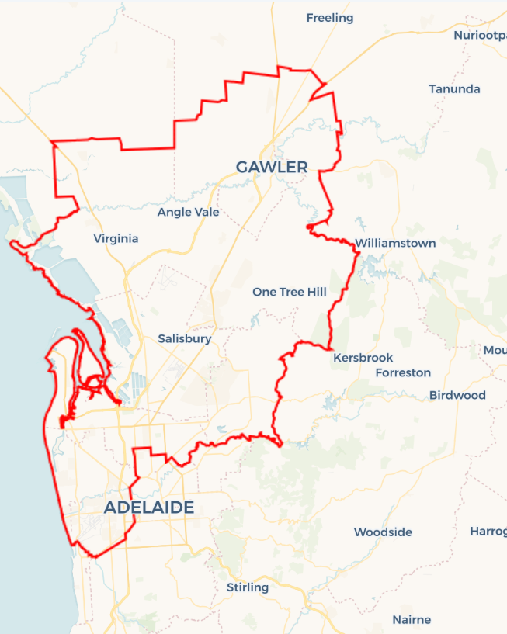
Local Jobs Plan
  - Adelaide North Employment Region | SA | July 2025
Workforce Australia Local Jobs (Local Jobs) is a program that supports tailored approaches to accelerate
reskilling, upskilling and employment pathways in response to current and emerging local workforce needs.

Local Jobs elements

Local Jobs Plan
The Local Jobs Plan sets out the skills and employment challenges and priorities of the region, and associated strategies that will drive the design and implementation of activities to be implemented to address these challenges.

Jobs Coordinators
Jobs Coordinators and Support Officers support the delivery of the program by bringing together key stakeholders including businesses, employment services providers, and higher education and training organisations.

Local Jobs and Skills Taskforce
Each Employment Region has its own Taskforce. Representatives include local stakeholders who have demonstrated experience in upskilling, reskilling, and an ability to represent, connect and collaborate with others in the region to meet labour market needs.

Program Funds
The Employment Region’s Local Initiatives Fund enables targeted local investments that support local labour market functioning. Further, from 2025/26, a central grants-based fund will respond to local needs and help progress broader employment service reform objectives.
Explore labour market insights for the
Adelaide North Employment Region

Local labour market challenges in the region

- High demand for entry level and skilled workers in growth sectors such as healthcare, building, civil construction and defence.
- Below average participation and low completion rates for apprentices and trainees.
- Lower educational achievement in some areas resulting in lower levels of literacy and numeracy, including digital literacy and access.
- Limited public transport outside metropolitan Adelaide and limited access to learner driver support impacting work and training opportunities, particularly affecting young people.
- High degree of labour market challenges experienced by key cohorts such as youth, mature age, people with a disability, culturally and linguistically diverse (CALD) and First Nations peoples across the region.

Local jobs and skills priorities and strategies in the region

Priority 1 – Supply chain – transport and logistics

What are our challenges and opportunities?
The supply chain sector is experiencing challenges in attracting and retaining a skilled workforce to load and unload freight from shipping, rail and trucking and to drive goods across metropolitan, country and interstate regions.

How are we responding?
- Adelaide North Local Jobs is collaborating with shipping, rail and trucking businesses, group training organisations, training companies and other stakeholders to build the profile and raise awareness of employment opportunities in the sector. The Local Jobs and Skills Taskforce and stakeholders are working in collaboration with the First Nation’s community to create pathways into each area of the transport and logistics industry.
- Local Jobs is working with local stakeholders to coordinate the range of training options related to current labour demand in the region to provide people with a single, streamlined pathway to upskilling and reskilling information. Pre-employment training programs in this sector are underrepresented and need more support.
- Local Jobs is working with all levels of government to advocate for the industry in finding funding and program solutions to upskill new and existing workers in the sector including supporting workers impacted by structural adjustment into other roles within the industry.

Priority 2 – Retail and hospitality

What are our challenges and opportunities?
The cost-of-living crisis has significantly impacted the retail and hospitality sectors in the Adelaide North Employment Region, leading to several businesses going into administration. Rising cost of produce, recent tomato virus, an egg shortage, and increased coffee bean prices have contributed to the rise in consumer prices. Despite these challenges, both young people and mature age job seekers continue to view the retail and hospitality sector as a viable entry-level career pathway. However, businesses of all sizes in these industries are struggling to find staff.

How are we responding?
- Local Jobs is collaborating with apprenticeship providers, Transition to Work, Workforce Australia providers, and community organisations to develop programs that create entry-level opportunities in retail and hospitality.
- The Taskforce is working alongside Workforce Australia to organise industry tours and events, offering first-hand insights into the various roles available in retail and hospitality.
- Local Jobs are partnering with local councils to host job expos and workshops that promote employment opportunities, skill development, and training within the industry.

Priority 3 – Building and construction

What are our challenges and opportunities?
The building and construction industry is facing significant workforce demands. Driven by government priorities such as the National Housing Accord, the Australian Skills Guarantee and major infrastructure and community development activities, the need for workers in the sector will continue to grow. In the short to medium term, building and construction of the South Road project continuing from West Thebarton in Adelaide’s west and Defence projects still to be built in Adelaide North and northwest, means the demand for building and construction workers remains significantly high.

How are we responding?
- Local Jobs is working with industry specialists and employers to create partnerships and community groups that will see an increased pipeline in engagement into the sector. Specific First Nations construction programs are in development to attract and retain workforce participation across the large infrastructure projects in the region. Strong promotion for women into apprenticeships in non-traditional trades is also a focus.
- The Taskforce is working together to identify infrastructure projects in the region and gain the understanding of recruitment needs, required skills and timelines. The Employment Facilitator and Support Officer remain involved in current industry working groups targeting diversity and inclusion amongst their workforce and trade/project packages.

Priority 4 – Young people

What are our challenges and opportunities?
Youth unemployment in the Adelaide North Employment Region has remained consistently above national and state averages for decades. There are high levels of disengagement in education, training and employment which have led to additional challenges to participation in the workforce. Tailored approaches are needed in assisting the young people in navigating towards earning and learning opportunities.

How are we responding?
- Local Jobs partner with local services and community groups including First Nations people. Local Jobs have assisted in the creation and co-designing of projects to deliver vocational and non-vocational programs to improve the pipeline and pathways of young people entering education, training, and employment. These are tailored accordingly to the needs of the young people with culturally appropriate delivery and considerations for both First Nations and multicultural young peoples.
- Local Jobs are involved in multiple working groups associated with assisting young people across the community. The network across the working groups range between employers, government agencies, employment services, community services and education.
- Local Jobs are working with stakeholders to create events and forums to improve the knowledge of what is available in the current labour market, along with asking young people for their voice on what they need or what is missing.
- Local Jobs is co-designing tailored workshops promoting how to help individuals into self-employment, work, apprenticeship and traineeship opportunities, site tours, community-based projects, mental health supports and services.

Priority 5 – Culturally and linguistically diverse participants

What are our challenges and opportunities?
The Adelaide North Employment Region has many participants from a migrant and refugee background with underutilised capacity that would assist in the current demands if supported and trained in the local market needs.

How are we responding?
- The Taskforce is working on the development of a video library of different career opportunities in the areas of the highest needs in the region, converting it into the languages of the highest representation across Workforce Australia Employment Services Providers.
- The Taskforce is developing and implementing overarching industry-specific recruitment models in areas of regional skills shortages that expedite business and individual connections. These will be tailored to individual business needs and enable collaboration to increase engagement. We are working with experts in the field of cultural awareness for employers and implementing a better understanding of workplace culture for participants.
- Creating workshops and events that assist in addressing the challenges to employment, including a tailored approach to women from a diverse background on engaging and connecting to appropriate services and pathways to education, training and employment.
- Local Jobs is supporting individuals and businesses to build entrepreneurial capability and innovation in response to new and emerging economic opportunities in the region.

Want to know more?
- Contact: Rosslyn Ward, Adelaide North Job Coordinator: Rosslyn.Ward@employmentfacilitator.com.au
- Visit: Local Jobs or Workforce Australia

