

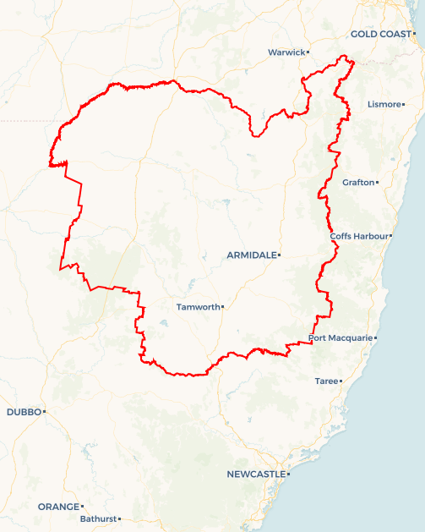Local Jobs Plan

New England and North West | NSW | July 2025

Workforce Australia Local Jobs (Local Jobs) is a program that supports tailored approaches to accelerate   
reskilling, upskilling and employment pathways in response to current and emerging local workforce needs.

## Local Jobs elements

### Local Jobs Plan

The Local Jobs Plan sets out the skills and employment challenges and priorities of the region, and associated strategies that will drive the design and implementation of activities to be implemented to address these challenges.

### Job Coordinators

Job Coordinators and Support Officers support the delivery of the program by bringing together key stakeholders including businesses, employment services providers, higher education, and training organisations.

### Local Jobs and Skills Taskforce

Each Employment Region has its own Taskforce. Representatives include local stakeholders who have demonstrated experience in upskilling, reskilling, and an ability to represent, connect and collaborate with others in the region to meet labour market needs.

### Program Funds

The Local Initiatives Fund enables targeted local investments that support local labour market functioning. Further, from 2025/26, a central grants-based fund will respond to local needs and help progress broader employment service reform objectives.

Explore labour market insights for the   
[New England and North West](https://www.jobsandskills.gov.au/data/employment-region-dashboards-and-profiles/monthly-labour-market-dashboards) Employment Region

## Local labour market challenges in the region

* There are limited public transport services in the region. A drivers licence and vehicle are considered essential by most employers, but not all job seekers have this.
* There is a shortage of workers to fill vacancies in sectors with high demand. This has been exacerbated by historically low unemployment levels across the region.
* Parts of the region have entrenched socio-economic challenges and high proportions of jobless families.
* There is a shortage of affordable accommodation which makes it difficult to attract workers, particularly workers who are required to relocate to take up employment opportunities. Chronic housing shortage across all local government areas has led to increased rates of homelessness.
* A high proportion of the Workforce Australia caseload require help gaining the foundational skills required for employment, including general literacy, numeracy, digital literacy, and employability skills.

## Local jobs and skills priorities and strategies in the region

### Priority 1 – Priority Cohorts

#### What are our challenges and opportunities?

Labour market data indicates that a high proportion of young people and First Nations people in the region experience long-term unemployment. Other cohorts, such as parents, mature age people, and people with a disability also experience barriers to entering or re-entering the labour force.

#### How are we responding?

* We are building clearer pathways to employment and training to support equitable access to the local labour market.
* We are collaborating with stakeholders such as Workforce Australia First Nations specialist providers and First Nations businesses to develop culturally appropriate employment initiatives that support Closing the Gap priorities.
* We are developing strategies to address nonvocational barriers to employment such as unaffordable housing and limited public transport.
* We are leveraging specialist Workforce Australia programs, including Transition to Work, Parent Pathways, and Career Transition Assistance to deliver tailored employment services for young people, parents and mature age people.

### Priority 2 – Health Care and Social Assistance

#### What are our challenges and opportunities?

The region requires stronger pathways to meet employer needs in the health care and social assistance industry. This industry provides the support people need to participate in employment and also provides flexible, part-time and casual employment which can be attractive to job seekers who have caring responsibilities.

#### How are we responding?

* We are collaborating with stakeholders to raise awareness of employment opportunities in the industry.
* We are working with training organisations to co-design employer-led training opportunities. This includes training opportunities for job seekers with limited experience or those who need entry level qualifications.
* We are ensuring Workforce Australia participants and industry stakeholders are included in the design of activities developed to meet Local Jobs priorities.
* We are promoting pre-employment programs, micro-credentialling and traineeships as pathways to employment in the industry.

### Priority 3 – Agriculture

#### What are our challenges and opportunities?

Agriculture, including primary production and secondary processing, is a key sector in the region. This sector provides a range of entry-level positions which do not require formal skills and qualifications, creating a lower threshold of entry for employment opportunities. The seasonal nature of primary production is impacted by weather events and market fluctuations, which can create uncertainty for workers. This is less evident in processing, which has consistent demand for labour.

#### How are we responding?

* We are exploring opportunities to integrate agribusinesses with local infrastructure projects to boost employment options.
* We are mapping seasonal labour market needs and identifying potential collaborative projects.
* We are facilitating partnerships with registered training organisations and educational institutions to upskill the local labour force, and identifying transferrable skill sets that can be brought from other sectors into primary production and processing.
* We are supporting government and industry-led education sessions to inform Workforce Australia participants of the various types of work and career pathways offered in the agriculture sector.
* We are supporting Workforce Australia Employment Service Providers to partner with meat and textile processors to develop pre-employment programs and employment pathways.

### Priority 4 – Reducing Labour Shortages in Tourism and Hospitality

#### What are our challenges and opportunities?

There can be severe labour shortages in peak seasons for tourism and hospitality. Hospitality and customer service roles help people develop practical and soft skills which are transferrable to a range of other industries.

#### How are we responding?

* We are developing employment and training initiatives which align to the Destination Management and Economic Development strategies of local and state governments and support workforce needs for significant regional events.
* We recognise the role that the creative arts and cultural sectors play in enhancing tourism, the night-time economy, regional liveability, and transferrable skill development.
* We are developing an annual calendar of events in the region and we are mapping associated labour market needs.
* We are co-designing training, work experience, and pre-employment programs with businesses and industry.

**Priority 5 – Infrastructure Projects**

**What are our challenges and opportunities?**

Large infrastructure projects have created significant workforce demand in the construction industry which is already experiencing critical labour shortages. These projects include the New England Renewable Energy Zone, the Moree Special Activation Precinct, and the delivery of local government housing initiatives. These projects create opportunities for well-paid employment.

**How are we responding?**

* We are co-designing pre-employment programs and pre-vocational training with employers and industry.
* We are building stronger connections between businesses, Workforce Australia Employment Services Providers, training organisations and the available workforce to address labour and skills shortages.
* We are enabling place-based initiatives through strong linkages with regional associations.
* We are supporting industry and government agencies to meet the recruitment needs of infrastructure and development projects.
* We are collaborating with industry to increase gender diversity.
* We are supporting First Nations businesses and job seekers to participate in state government construction projects.

**Priority 6 – Emerging sectors**

**What are our challenges and opportunities?**

Emerging sectors – including hydrogen production, artificial intelligence, net zero innovations, agritech, and advanced manufacturing – are growing rapidly. There is limited knowledge among job seekers of the employment opportunities these sectors offer and a need to develop employment pathways for these sectors.

**How are we responding?**

* We are maintaining awareness of new and emerging sectors, including pilot projects, and we are building positive relationships with relevant stakeholders.
* We are collaborating with stakeholders to identify transferrable skill sets and develop employment pathways.
* We are connecting Workforce Australia Employment Service Providers and registered training providers with businesses in emerging sectors.
* We are using employment forecasting to develop strategies to support emerging sectors, in collaboration with state and local governments.
* We are working with stakeholders including the NSW Future Jobs and Investment Authority and the Australian Government Net Zero Economy Agency to leverage existing programs and initiatives.

#### Want to know more?

* Contact: Kate McGrath, New England and North West Job Coordinator: [kate@localjobsnenw.com.au](mailto:kate@localjobsnenw.com.au)
* Visit: [Local Jobs](https://www.dewr.gov.au/local-jobs) or [Workforce Australia](https://www.workforceaustralia.gov.au/)