
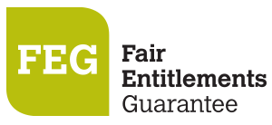
How do I access FEG Online Services
Online lodgement is the easy way to make a claim for assistance under the Fair Entitlements Guarantee (FEG). Lodging a claim online also ensures that we receive your claim as soon as it is submitted. This fact sheet provides a step-by-step guide to using FEG Online Services (https://fegonlineservices.dewr.gov.au/).

Features of FEG Online Services
FEG Online Services provides the following features:
- lodge your FEG claim online
- complete your tax file number declaration online
- provide your bank details
- upload supporting documentation
- check the status of your claim
- update your bank details
- update your tax file number
- update agent details
- update entitlement details
- update contact details
- access letters the department has sent you
- lodge a review of your FEG decision.
If you have already lodged a paper-based claim form you can still register for FEG Online Services to monitor your claim and access letters sent by the department.

Section 1 – Accessing the portal
1. | First time users of this portal will need to register an account. To register go to FEG Online Services (https://fegonlineservices.dewr.gov.au/) and click Continue. | 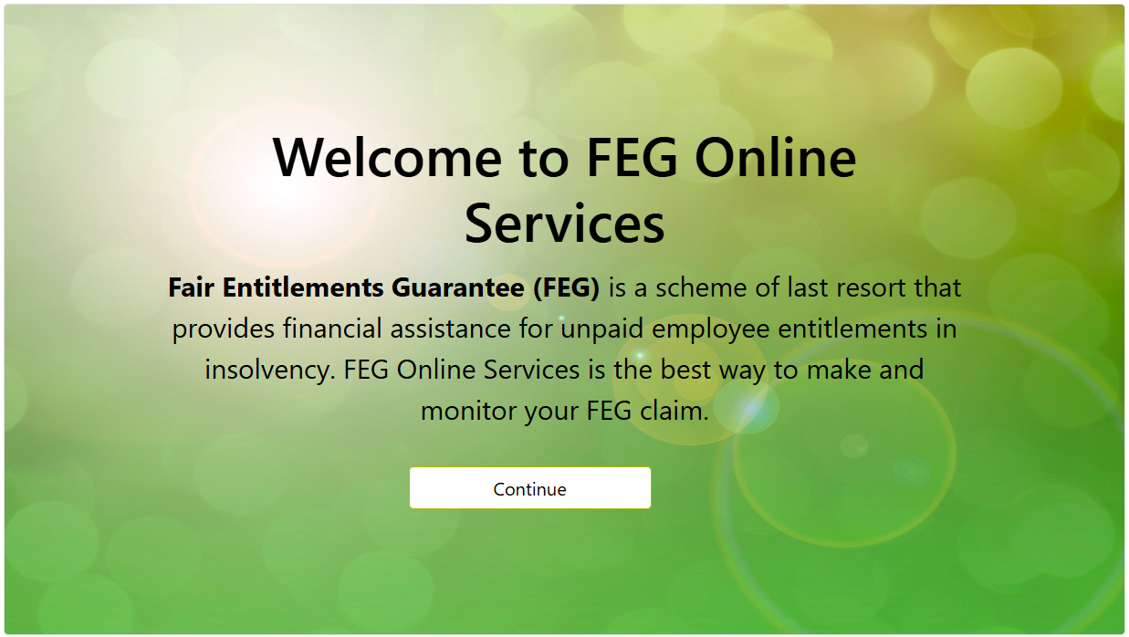

2. | Click Sign up now to begin the registration process. | 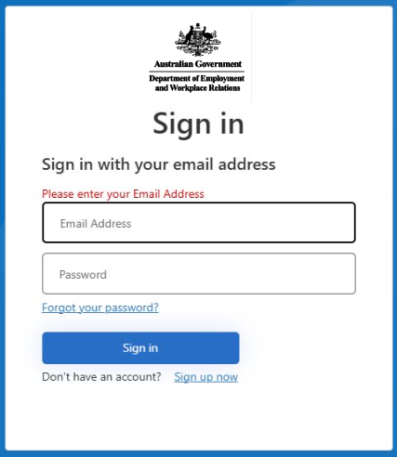

3. | Accurately complete all fields and then click Send verification code. You must provide your legal first and surname (no middle names). These details will flow through to any claim for FEG assistance you submit.

4. | Once your registration is successful a verification code will be emailed to your nominated email address.  NOTE: Your registration email address is a unique identifier which your online services account is registered under. Once you have created an online services registration using a particular email address, no one else can use the same email address to register for FEG Online Services. | 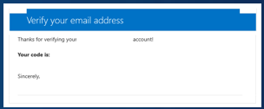

5. | Enter the verification code contained in the email and click Verify code. | 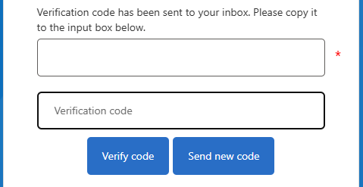

6. | Accurately complete all fields and then click Create. Your password must contain:  - 8-16 characters,  - contain 3 out of 4 of the following  - Lowercase characters,  - uppercase characters,  - digits (0-9), one or more of the following symbols: @ # $ % ^ & * - _ + = [ ] { } | \ : ' , ? / ` ~ " ( ) ; .  NOTE: This is not your application for FEG. To apply for FEG, use your email and password for FEG Online Services to sign in and make a claim | 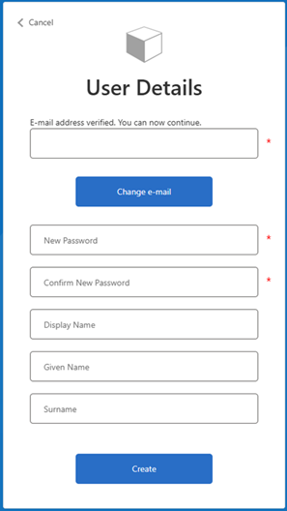

7. | Download your preferred multi-factor authentication application* from your App store. Scan the QR code with your nominated multi-factor authentication application on your smart device. You will be required to enter the one time verification code displayed on your smart device.  * Examples of a multi-factor authentication application are:  - Microsoft Authenticator  - Google Authenticator  - Duo Mobile  - Authenticator App  - Okta Verify and more. | (example)  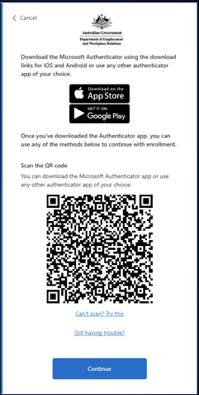

8. | Once you have successfully linked your smart device, for existing claimants, you will be redirected to the FEG Online Services sign in page.  Accurately complete all fields and then click Update. You must provide your legal first, legal surname and email address. These details will flow through to any claim for FEG assistance you initiate. | 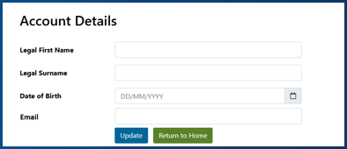

Further information about FEG is also available on the FEG website (https://www.dewr.gov.au/fair-entitlements-guarantee/).
The information contained in this fact sheet is of a general nature and explains, in summary form, the intended operation of the
Fair Entitlements Guarantee Act 2012 - it is not legal advice. Where necessary, you should seek your own independent legal advice relevant to your particular circumstances. The Commonwealth does not make any representation or warranty about the accuracy, reliability, currency or completeness of the information contained in this fact sheet and is not liable for any loss resulting from any
action taken or reliance made by you on the information contained in this factsheet.

